新建项目并运行

2021年10月14日

23:23

1. [vscode启动和调试flutter](https://juejin.cn/post/6844904005320048653" \l "heading-5)
   * Vscode
   * 安装vscode插件Dart,flutter,flutter-materials
   * 手动下载flutter（flutter中集成了dart）
   * Android Studio中配置flutter
   * 设置flutter环境变量
   * 设置变量(是否要配置待定) PUB_HOSTED_URL”和“FLUTTER_STORAGE_BASE_URL

**PUB_HOSTED_URL**=https://pub.flutter-io.cn

**FLUTTER_STORAGE_BASE_URL**=https://storage.flutter-io.cn

* 安装andriod studio
* 输入flutter doctor检查运行环境是否正常
* 创建工程: ctrl+shift+p, 输入 flutter: new project
* 选择设备

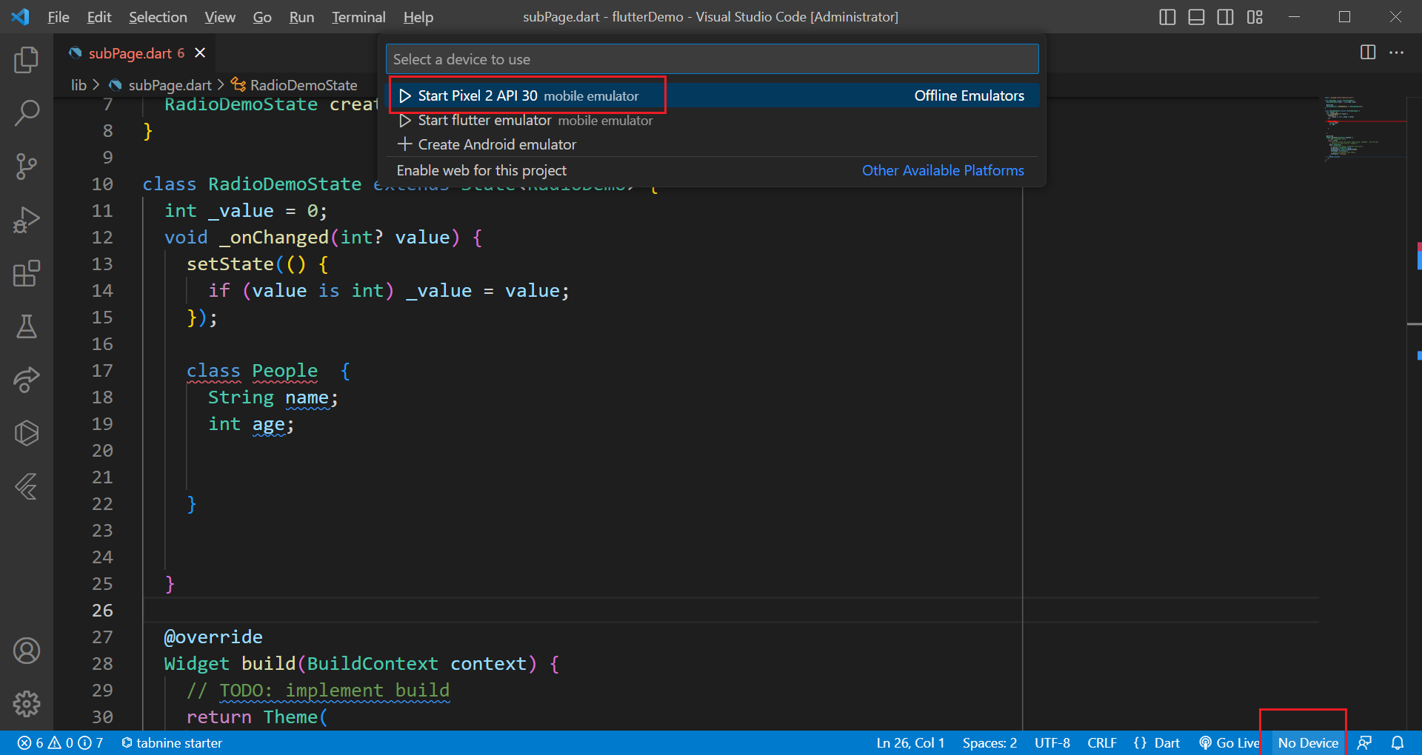

* 启动项目 flutter run
* 调试配置

{

"version": "0.2.0",

"configurations": [

{

"type": "dart",

"name": "Flutter",

"request": "launch"

}

]

}

* 打印



* 容器描线

