Do not send this page in the application
EKHAGASTIFTELSEN
www.ekhagastiftelsen.se
Box 34 012
100 26 Stockholm

Application form

and instructions

Application deadline is May 20th 2017, which is the day we must have received the application. Applications must be sent by mail to our Post Office Box.

NOTE! Messenger or courier services can not deliver to Post Office Boxes. If you want to deliver the application by other means than mail, please contact us by e-mail or by phone (+46 70 240 81 81) at least one week before the deadline.

Applications sent in by e-mail will not be considered.

The application including supplements is to be submitted in seven copies (as the applications are to be distributed to the members of the scientific advisory council).


Staples may not be used in the application. If used, the entire application
can be disqualified!

Please make our work easier by

- Do not staple together the application – use paper clips or plastic folders
- Use both sides of the paper (saves trees and space in our archive)
- Make 7 bundles of the complete application. DO NOT make one bundle with 7 copies of the application form, one bundle with 7 copies of the project description, one bundle with 7 copies of the budget, and so on.

Do not send this page in the application

An application has to have the following parts:

1. Filled in application form
2. Separate project description
3. Detailed budget
4. Qualifications and references of applicant and co-applicants
5. Application data sheet

Instructions for application form:
For use by Ekhaga- stiftelsen – do not fill in!

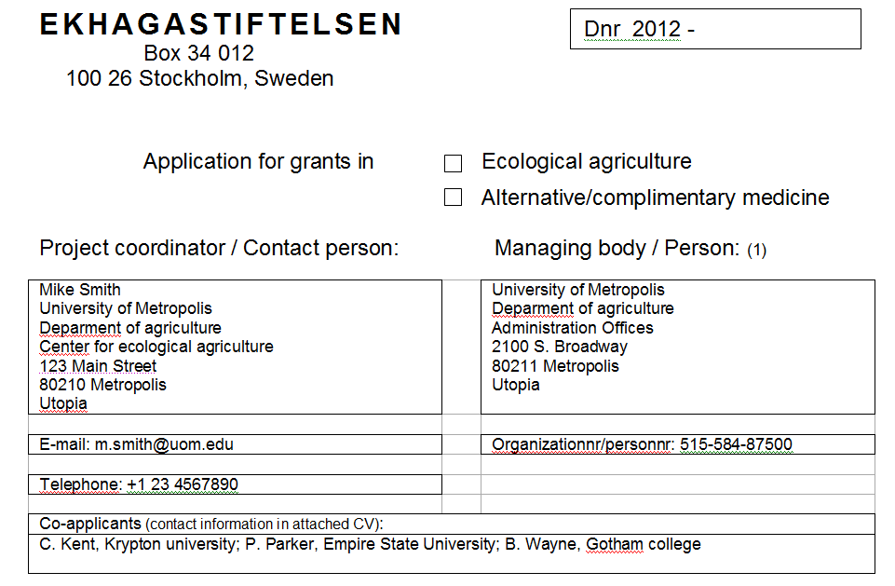
Only mark one alternative
State organization number or personnummer of managing body / person
If there are co-applicants list their names and organization here.

Project coordinator / Contact person:

State name, address, e-mail and telephone to the person that Ekhagstiftelsen should contact.
It is to this address that we will send mail.

There are up to 4 rows available for adress to accomodate for organization, department, unit, etc.

Managing body / Person:

This is the body/organization/person who is responsible for and keeps accounts for the grant – the official applicant.

In many cases this can be the same as stated under project coordinator / contact person, but sometimes maybe the contact person has another address than the official applicant. For scholarship applications contact person and managing body / person should be the same.

If this is an organization please state the organizations main name on the first row. For example “University of Metropolis” before department, unit, etc.

Do not send this page in the application
Project title – no more than 20 words

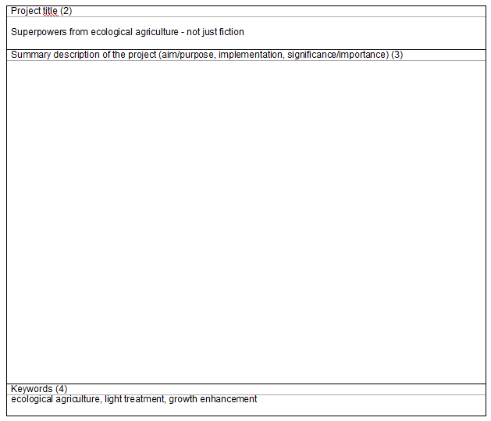
A summary description of the projects, studies or travels aim/purpose, implementation and significance/importance is to be written in this space.

A reference to a supplement is not accepted.

A more detailed project description should, however, be submitted as a separate supplement.

Available space is this half page – the box for summary description can not be made bigger so that it and the box for keywords run over onto page 2 of the application form.
Enter keywords that characterize the project. The keywords will be used for searches in a separate register.

Applications can be made for up to three year long projects. The budget is to be further detailed in a separate document.

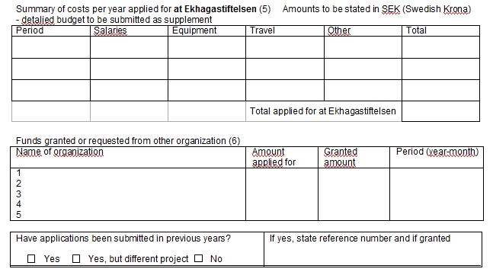
If an application within the same area has been or is to be sent to another organization, the applicant has to specify name of other organization, funds applied for and funds granted. This is in order to be able to coordinate grants with other organizations.
This question is for all previous applications, not just applications for the same / similar projects now applied for!

Do not send this page in the application
Please note that we do not grant funds for periods that have already passed.

Therefore it is no point to apply for funds for a period that starts before we can take a decision on grants.
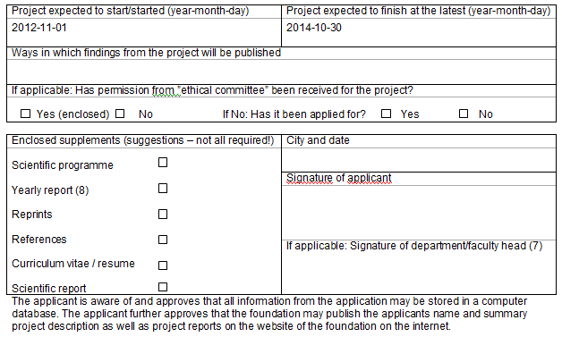
The signature of department/faculty head implies that the organization accepts administrational responsibility for granted funds and places resources necessary for the realization of the project at the disposal of the project.
If a yearly report for an earlier granted project is attached this is not enough to fulfill the reporting requirements of the earlier project. The project has to send in a report separately.

This list is only a suggestion on what supplements can be sent in – there is no requirement to send in all these documents!

Instructions for project description:

A project description of no more than 10 pages shall be included as a supplement to the application. It should describe and answer and the following aspects (if applicable):

- What problem or which question is to be solved/answered? Which idea or vision is to be tested or further developed?
- What is the hypothesis?
- Present situation, current international knowledge/research (including references) and conclusions.
- Goal or purpose/aim
- Material and methods
- Time plan and budget
- Expected results and their importance/significance. How are the results to be evaluated? How will the project be documented and disseminated?

Instructions for detailed budget:

See more detailed information on the foundation website –
Website navigation: Application/Application and Application/Budget

Do not send this page in the application
Instructions for qualifications and references of applicant and co-applicants:

As a supplement the qualifications and references of applicant and co-applicants have to be documented. Usually this is done in the form of a CV (Curricilum vitae).

Instructions for application data sheet:

New for 2012 is that we require all applicants to fill in an application data sheet.

This Excel-document has to be sent by e-mail to info@ekhagastiftelsen.se at the latest may 20th. The data sheet also has to be sent in by mail together with the application.

The Excel-template is available for download at the foundations website.

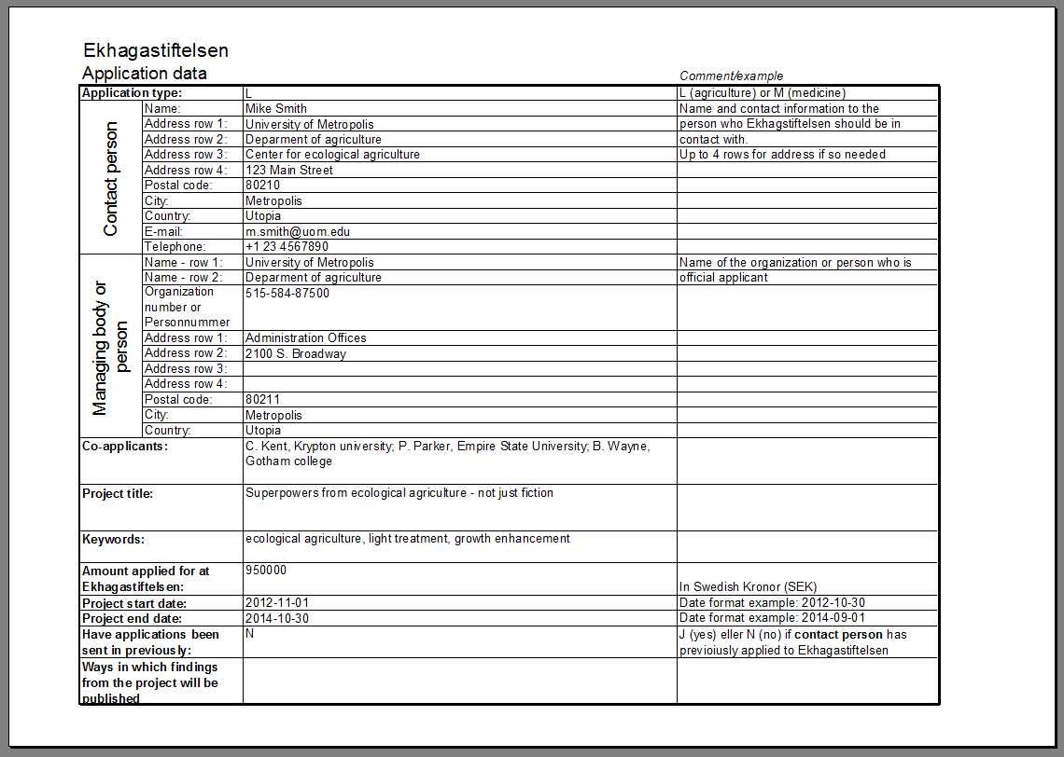

EKHAGASTIFTELSEN

Dnr 2015 -
Box 34 012
100 26 Stockholm, Sweden

Application for grants in Ecological agriculture
Alternative/complimentary medicine

Project coordinator / Contact person: Managing body / Person: (1)

E-mail: |  | Organizationnr/personnr:
Telephone:
Co-applicants (contact information in attached CV):

Project title (2)
Summary description of the project (aim/purpose, implementation, significance/importance) (3)
Keywords (4)

Summary of costs per year applied for at Ekhagastiftelsen (5) Amounts to be stated in SEK (Swedish Krona)
- detalied budget to be submitted as supplement
Period | Salaries | Equipment | Travel | Other | Total
 |  |  | Total applied for at Ekhagastiftelsen

Funds granted or requested from other organization (6)
Name of organization | Amount applied for | Granted amount | Period (year-month)
1
2
3
4
5

Have applications been submitted in previous years?  Yes Yes, but different project No | If yes, state reference number and if granted

Summary information about other submitted material which the applicant wishes to refer to

Project expected to start/started (year-month-day) | Project expected to finish at the latest (year-month-day)
Ways in which findings from the project will be published
If applicable: Has permission from ”ethical committee” been received for the project?
Yes (enclosed) No If No: Has it been applied for? Yes No

Enclosed supplements (suggestions – not all required!) | City and date
Scientific programme

Yearly report (8)

Reprints

References

Curriculum vitae / resume

Scientific report
 | Signature of applicant
 | If applicable: Signature of department/faculty head (7)
The applicant is aware of and approves that all information from the application may be stored in a computer database. The applicant further approves that the foundation may publish the applicants name and summary project description as well as project reports on the website of the foundation on the internet.

