Product Scanner

Use-Case Specification

Version <1.2>

Revision History

|  |  |  |  |
| --- | --- | --- | --- |
| **Date** | **Version** | **Description** | **Author** |
| 03/11/2017 | 1.0 | Initial use-case | Trần Nguyễn Hoàng Ân, Nguyễn Khương |
| 05/11/2017 | 1.1 | Edit use-case | Huỳnh Vĩnh Lộc, Nguyễn Thái Hưng |
| 16/11/2017 | 1.2 | Edit use-case | Trần Nguyễn Hoàng Ân |
|  |  |  |  |

Table of Contents

1. Use-case Model 4

2. Use-case Specifications 4

2.1 Use-case: Show list of price from different sources 4

2.2 Use-case: Get place with the lowest price 4

2.3 Use-case: View related products 5

2.4 Use-case: Add product to cart 5

2.5 Use-case: Calculate total price 6

2.6 Use-case: Add new product 6

2.7 Use-case: Review product 6

2.8 Use-case: Add new price to price list 6

2.9 Use-case: Manage accounts 7

2.10 Use-case: Review and approve for new contribute 7

2.11 Use-case: Log in 7

2.12 Use-case: Create new account 8

2.13 Use-case: Reset password when forget 8

# Use-case Model

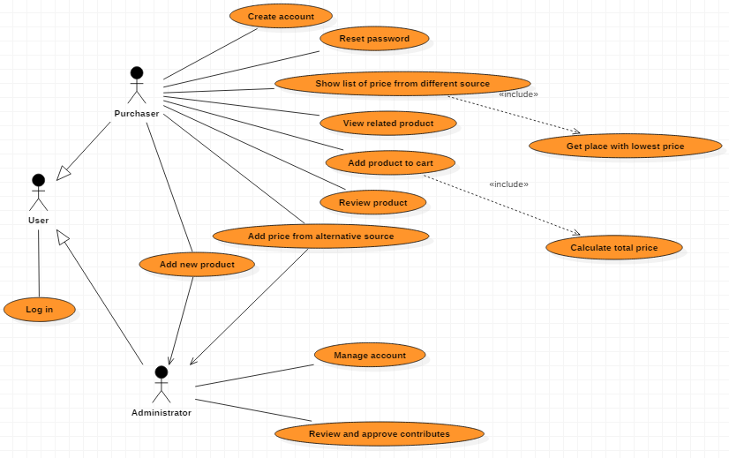

# Use-case Specifications

## Use-case: Show list of price from different sources

|  |  |
| --- | --- |
| Use case Name | Show list of price from different sources |
| Brief description | This use case describes how the Purchaser can see different prices of a product from many sources |
| Actors | Purchaser |
| Basic Flow | 1. Open app and choose scan 2. Scan barcode of product 3. System displays some information of product and then choose price 4. Showing the list of price (sorted from lowest to highest) and owning place |
| Alternative Flows | **Alternative flow 1: Can not find the product**   1. From step #3 of Basic Flow, if there is no product found, show the message 2. Choose add new product, or scan another barcode and continue step #3 |
| Pre-conditions | Actor goes to any place to scan a product’s barcode |
| Post-conditions | Purchasers know price from different places |

## Use-case: Get place with the lowest price

|  |  |
| --- | --- |
| Use case Name | Get place with the lowest price |
| Brief description | This use case describes how the Purchaser can see places having found product with lowest price |
| Actors | Purchaser |
| Basic Flow | 1. Open app and choose scan 2. Scan barcode of product 3. System displays some information of product and then choose price 4. Showing the list of price (sorted from lowest to highest) and owning place 5. Places having found product with lowest price are highlighted |
| Alternative Flows | No alternative flow |
| Pre-conditions | Purchasers want to know where they can buy that product with lowest price |
| Post-conditions | Purchasers know places having found product with lowest price |

## 2.3 Use-case: View related products

|  |  |
| --- | --- |
| Use case Name | View related product |
| Brief description | This use case describes how the Purchaser can see products related to found product |
| Actors | Purchaser |
| Basic Flow | 1. Open app and choose scan 2. Scan the products 3. System shows information of found product 4. Choose Suggestion to see list of related products |
| Alternative Flows | **Alternative flow 1: Can not find that product**   1. From step #3 of Basic Flow, show messages 2. Choose abort product or add new product 3. If choose add new product, continue step #2   **Alternative flow 2: Shopping cart has already contained that product**   1. From step #4 of Basic Flow, adjust new quantity of product 2. Continue step #5 of Basic |
| Pre-conditions | User want to add scanned products to cart |
| Post-conditions | The list of scanned products |

## Use-case: Add product to cart

|  |  |
| --- | --- |
| Use case Name | Add product to cart |
| Brief description | This use case describes how the Purchaser can add product to cart |
| Actors | Purchaser |
| Basic Flow | 1. Open app and choose scan 2. Scan the products 3. .System shows information of found product 4. Choose Add to cart 5. Choose the quantity for that product 6. Choose Add to complete the adding job |
| Alternative Flows | **Alternative flow 1: Can not find that product**   1. From step #3 of Basic Flow, show messages 2. Choose abort product or add new product 3. If choose add new product, continue step #2   **Alternative flow 2: Shopping cart has already contained that product**   1. From step #4 of Basic Flow, adjust new quantity of product 2. Continue step #5 of Basic |
| Pre-conditions | User want to add scanned products to cart |
| Post-conditions | The list of scanned products |

## 

## Use-case: Calculate total price

|  |  |
| --- | --- |
| Use case Name | Calculate total price |
| Brief description | This use case describes how the Purchaser can know the total price of all products in the cart |
| Actors | Purchaser |
| Basic Flow | 1. Open app and choose My cart 2. Choose Total to see the total price |
| Alternative Flows | **Alternative flow 1: The shopping cart has not contained any product**   1. From step #2 of Basic Flow, Choose scan product to find and add to cart 2. Continue step #2 of Basic Flow |
| Pre-conditions | User want to know the total price of all products in the cart |
| Post-conditions | Total price is calculated and showed |

## Use-case: Add new product

|  |  |
| --- | --- |
| Use case Name | Add new product |
| Brief description | This use case describes how the Purchaser can add new products |
| Actors | Purchaser |
| Basic Flow | 1. Scan product 2. If it can not find any product, sign in 3. Fill some information of product (price, place, review…) |
| Alternative Flows | No alternative flow |
| Pre-conditions | Actor scan a product’s barcode |
| Post-conditions | Products are sent to admin to accept |

## Use-case: Review product

|  |  |
| --- | --- |
| Use case Name | Review product |
| Brief description | This use case describes how the Purchasers see reviews of other users or give their reviews |
| Actors | Purchaser |
| Basic Flow | 1. Open app and choose scan 2. Scan barcode of product 3. System displays some information of product 4. Choose comment to see previous evaluation 5. Users may comment their reviews |
| Alternative Flows | **Alternative flow 1: Can not find product**   1. From step #3 - Basic Flow, scan another product or add new one 2. Continue step #5 - Basic Flow   **Alternative flow 2: Account is not signed in**   1. From step #4, Sign in 2. Continues step #5 |
| Pre-conditions | Actor goes to any place to scan a product’s barcode and then he/she want to know the using experience from other users or give own comments |
| Post-conditions | Actor grasp the quality of product through comments of previous users or give the review about product |

## 

## Use-case: Add new price to price list

|  |  |
| --- | --- |
| Use case Name | Add new price to price list |
| Brief description | This use case describes how the Purchaser/ Market’s Owner can add new products |
| Actors | Purchaser |
| Basic Flow | 1. Scan product 2. If it can not find the price with place, choose Add new price 3. Fill price and selling place |
| Alternative Flows | No alternative flow |
| Pre-conditions | Actors have found a product but the price list do not include the price that they see |
| Post-conditions | New price is sent to admin to accept |

## Use-case: Manage accounts

|  |  |
| --- | --- |
| Use case Name | Manage accounts |
| Brief description | This use case describes how the Administrator can manage all accounts and remove any account |
| Actors | Administrator |
| Basic Flow | 1. Choose List of accounts 2. Choose any account to view or remove |
| Alternative Flows | No alternative flow |
| Pre-conditions | Administrator want to view information of an account or want to remove it |
| Post-conditions | Administrator get information or an account is removed |

## Use-case: Review and approve for new contribute

|  |  |
| --- | --- |
| Use case Name | Review and approve for new contribute |
| Brief description | This use case describes how the Administrator can review all new products or prices added by users and decide whether they add them to data or not |
| Actors | Administrator |
| Basic Flow | 1. Scan product 2. If it can not find the price with place, choose Add new price 3. Fill price and selling place |
| Alternative Flows | No alternative flow |
| Pre-conditions | Actors have found a product but the price list do not include the price that they see |
| Post-conditions | New price is sent to admin to accept |

## Use-case: Log in

|  |  |
| --- | --- |
| Use case Name | Log in |
| Brief description | This use case describes how the users can log in to this app |
| Actors | User |
| Basic Flow | 1. Fill username and password 2. Choose Log in |
| Alternative Flows | **Alternative flow 1: The account is wrong**   1. After step #2 – Basic Flow, if the account is wrong, show message to notice 2. Show 2 actions: Create new account and Forget password 3. Do corresponding use case with the chosen action |
| Pre-conditions | User uses the app for the first time |
| Post-conditions | Login is successful and user can use other features |

## Use-case: Create new account

|  |  |
| --- | --- |
| Use case Name | Create new account |
| Brief description | This use case describes how the Purchaser can create new account |
| Actors | Purchaser |
| Basic Flow | 1. Choose Create new password 2. Fill some personal information, username, password and real email 3. Choose create |
| Alternative Flows | **Alternative flow 1: The email has been used**   1. After step #2 – Basic Flow, if the email has been used already, show message to user to change email or Choose Forget password 2. Show 2 actions: Create new account and Forget password 3. Do corresponding use case with the chosen action |
| Pre-conditions | User hasn’t had any account and want to create to use app |
| Post-conditions | Account is created |

## Use-case: Reset password when forget

|  |  |
| --- | --- |
| Use case Name | Reset password when forget |
| Brief description | This use case describes how the Purchaser reset and get new password when forgetting the old one |
| Actors | Purchaser |
| Basic Flow | 1. Choose Forget password 2. Fill email to get new password 3. Check mail |
| Alternative Flows | **Alternative flow 1: The password is not sent after a long time**   1. After step #3 – Basic Flow, if new password has not been sent, choose resend |
| Pre-conditions | Purchaser forgets password |
| Post-conditions | Purchaser gets new password |