**<Barcode Scanner>**

**UI Prototype Document**

**Version <1.0>**

1. 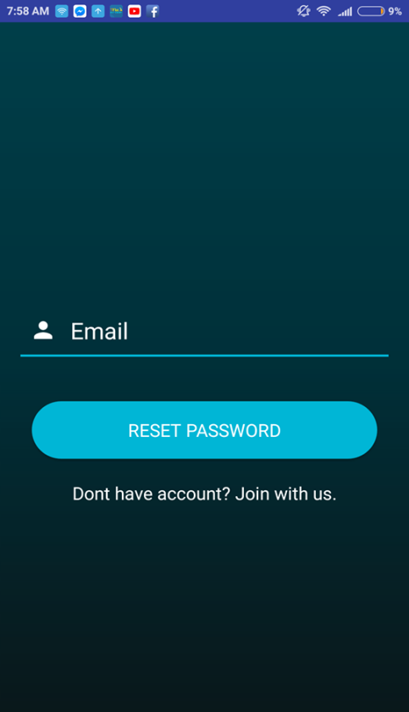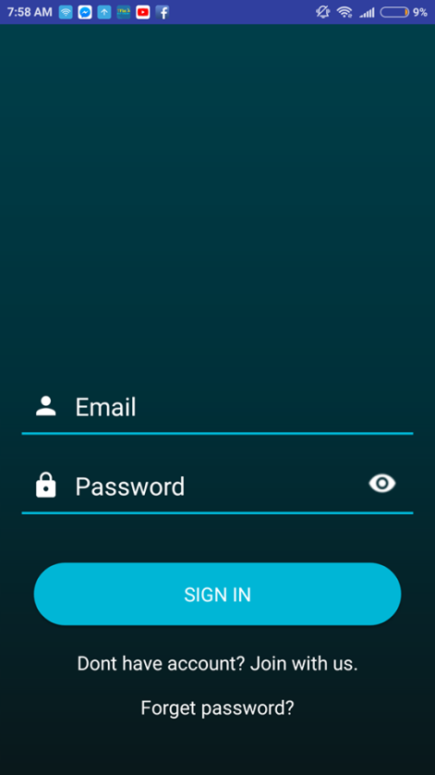**Authentication**

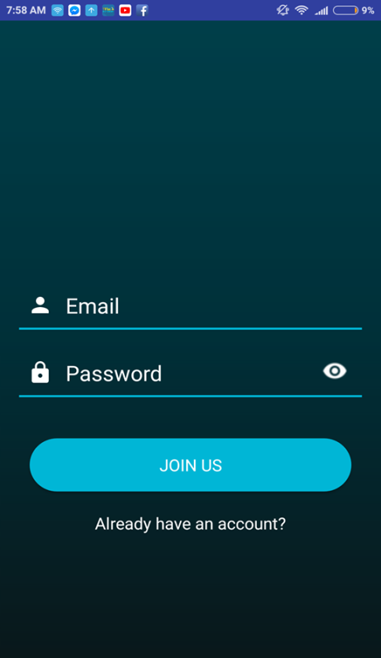

Login Reset Password New Account

Before using, user must login into their account.

In the Login layout, there are 2 edit texts which are used for type email and password. And then click into sign in to login. Normally, the password shows up as a string of * but user can also click on “eye” button to see their original password.

If they cannot remember the password, they can click on Forget password to go to Reset password layout.

The Reset password layout contains an edit text to input email of user. To recover, click button reset password to recover. Old password will be sent into email of users.

New Account layout for those who do not have account. Its layout just the same as Login layout.

1. **Scan Layout**

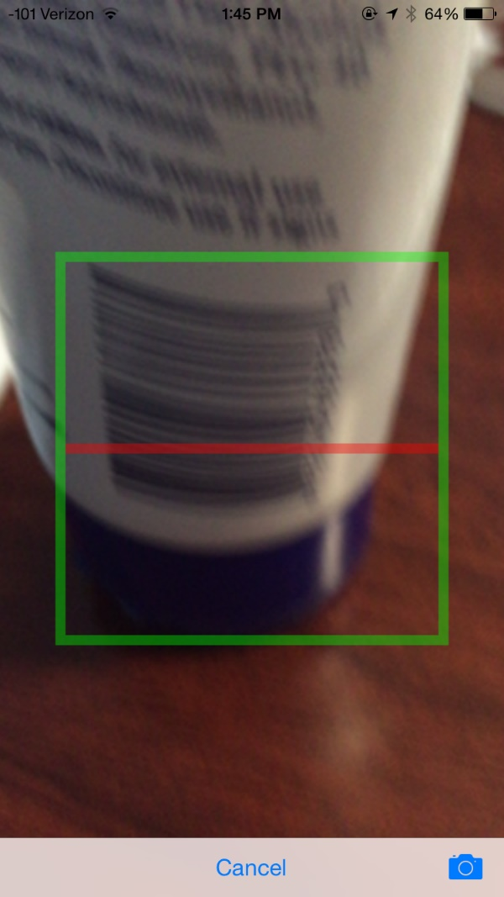A normal camera to scan barcode

Tap to the barcode to focus and camera will show a rectangle to locate barcode

1. **Reside menu**

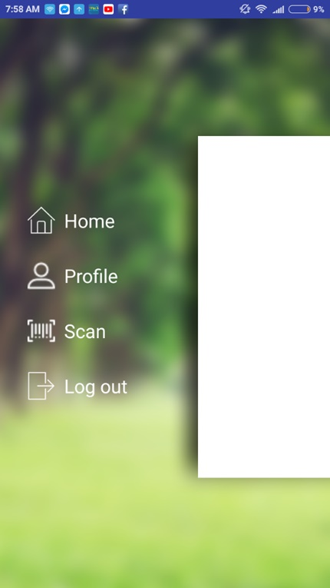

After login, there is a reside menu. This has 4 icons:

* Home
* Profile
* Scan
* Logout

This menu is mainly used to change between activities. Each icon represents an activates. User swipes to the left to open menu.

1. **Product Detail**

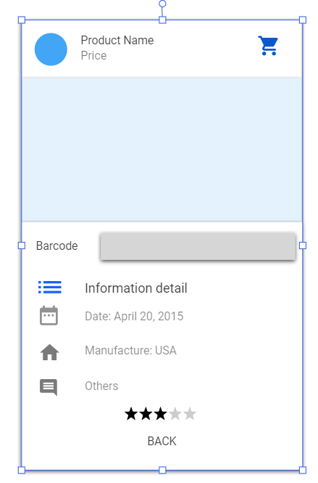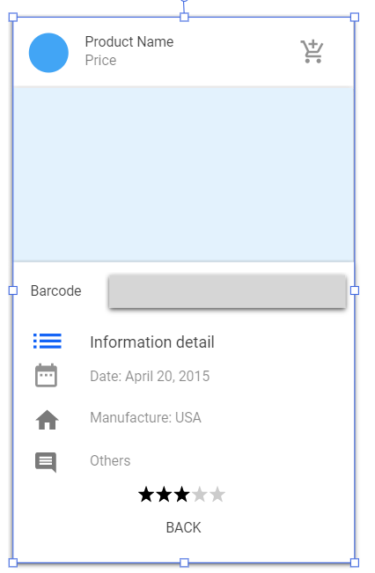

For the detail information of product from the top to bottom

Text view: Show the name and price

Icon in cart: Click to add product to the cart. After clicked, it changes to the blue one like in the right picture

Image view: Hold the image of product

Text view with image: Show information of product such as: date, manufacture, …

Rating: Average star for all users when they rate the product

Back button: Return to menu

1. **In cart**

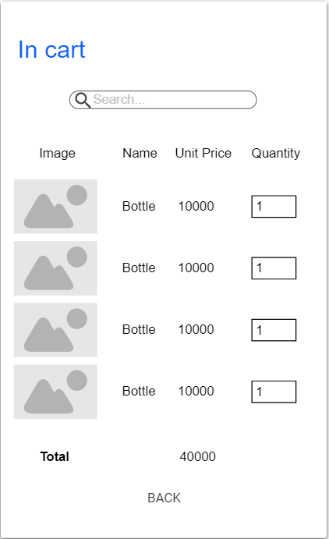

In-cart layout shows list of products that user added.

Search bar to have a quick search of product.

There are 4 categories that shown:

* Image (Text View)
* Name (Text View)
* Unit Price (Text View)
* Quantity (Edit Text)

Total price (Text View): show total price of all products

Back button to go back