COOKIT

The goal of the project is to develop a web application for managing culinary recipes, which creates a convenient environment for storing your own recipes, publishing them, and interacting with users.

Roles:
Role | Description
Guest | Unauthorized user. Can view the list of recipes and detailed information about recipes. Can use search and filtering features (by rating, category, etc.). Can view public user profiles (basic information). Can register a new account and log into the system. Cannot create, edit, or delete recipes. Cannot leave comments, rate recipes, subscribe to users, create lists, send reports, or receive notifications.
User | Authorized user. Can register, log in, and log out of the system. Can create, edit, and delete their own recipes. Can view all public recipes and user profiles. Can leave comments and rate recipes created by other users. Can add recipes to favorites or personal lists. Can create and manage shared recipe lists. Can subscribe/unsubscribe to other users. Can add users to a personal blacklist (restricting interaction). Can receive notifications (e.g., new comments, new followers, updates in shared lists). Can send reports about inappropriate recipes or comments to the administrator. Cannot edit or delete recipes or comments created by other users (except their own).
Admin | Administrator with extended system management permissions. Has all permissions of a regular User. Additionally: can edit and delete any recipe regardless of the author. Can delete or moderate any comment. Can manage reported content (view reports, review them, take action). Can block or delete user accounts in case of rule violations. Can manage categories and system-level data (create, edit, delete categories). Can monitor user activity when necessary for moderation purposes. Can resolve conflicts related to shared lists or inappropriate behavior. Responsible for maintaining system integrity, enforcing platform rules, and ensuring appropriate content moderation.

User Management System
№ | Role | Use Case | Description
1 | Guest | Sign Up | Create a new account in the system
2 |  | Log In | Authenticate and access the system using credentials
3 | User | Manage Profile | Manage personal data
4 |  | Log Out | Terminate the current authorized session
5 | Admin | View User Accounts | View a list of all registered users in the system
6 |  | Delete Any User | Remove any user from the system

Recipe Management System
№ | Role | Use Case | Description
1 | Guest | View Recipes | View the list of all available recipes and their details
2 |  | Search and Filter | Search for recipes by name, rating, or category
3 | User | View Recipes | View the list of all available recipes and their details
4 |  | Create Recipe | Add a new recipe to the system
5 |  | Edit Own Recipe | Modify the content of a recipe created by the user
6 |  | Delete Own Recipe | Remove a recipe created by the user from the system
7 |  | Search and Filter | Search for recipes by name, rating, or category
8 |  | Manage Shared Lists | Create and collaborate on shared recipe lists with other users
9 |  | View Following Feed | View a dedicated feed of recipes from users that the current user follows
10 |  | View User Account | View another user account
11 | Admin | Edit Any Recipe | Modify any recipe in the system regardless of the author
12 |  | Delete Any Recipe | Remove any recipe from the system to maintain content quality
13 |  | Manage Categories | Create, edit, or delete recipe categories

Interaction and Favorites System
№ | Role | Use Case | Description
1 | User | Comment on Recipes | Leave feedback or text comments on other users' recipes
2 |  | Rate Recipes | Provide a star rating for recipes
3 |  | Add to Favorites | Save a recipe to a personal list of favorites
4 |  | Social Interaction | Follow/unfollow authors or manage a black list of users
5 | Admin | Manage Comments | View or delete any comments to ensure moderation

Moderation and Administration System
№ | Role | Use Case | Description
1 | User | Submit a Report | Report inappropriate content or users to the administrator
2 | Admin | Content Moderation | Review and remove bad comments, recipes, or users
3 |  | System Integrity | Maintain the overall correctness and integrity of system data

Use case diagrams
Guest role use case diagram:
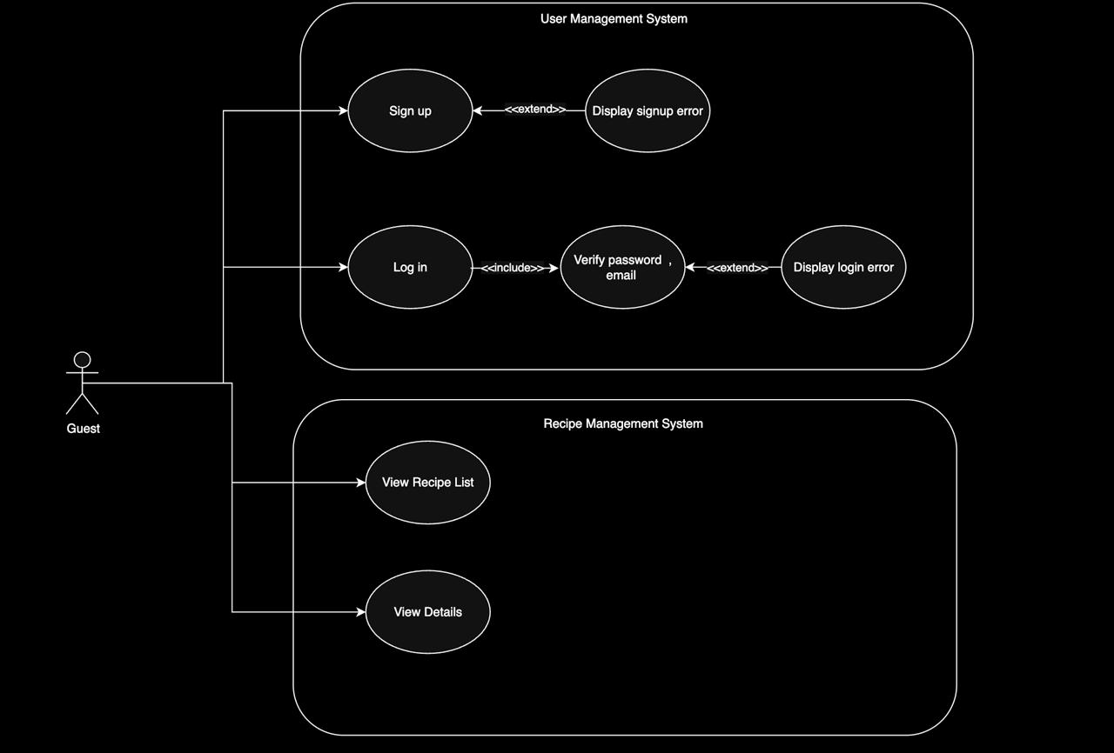

User role use case diagram:
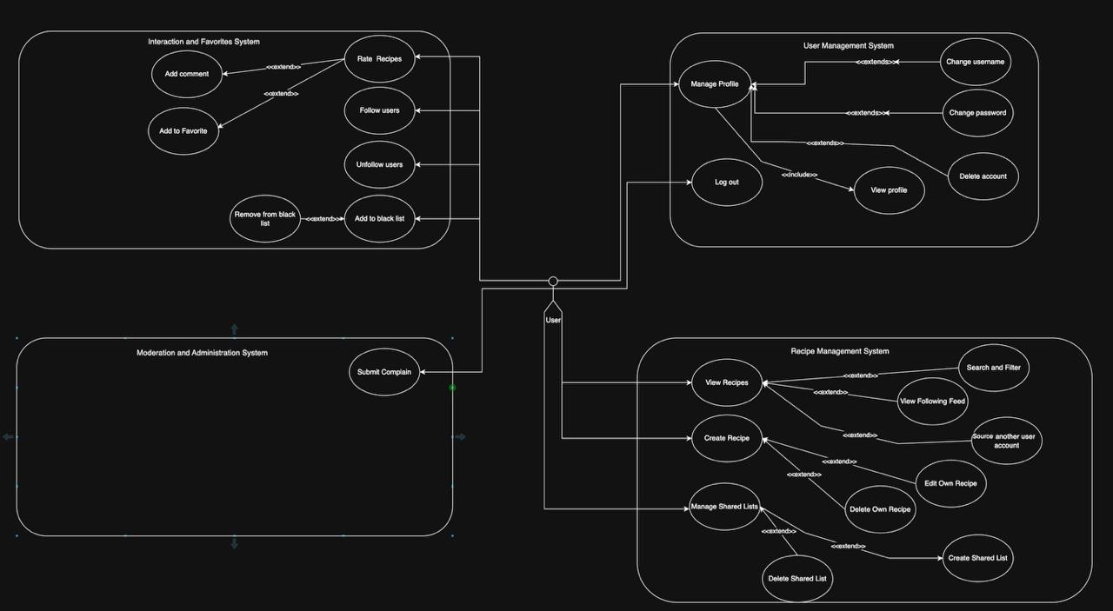

Admin role use case diagram:
