Hoàng Văn Quân
Bài 1:
<!DOCTYPE html>
<html lang="en">
<head>
<style>
body {
text-align: center;
}
h1 {
color: red;
background-color: gray;
}
h2 {
color: red;
}
</style>
</head>
<body>
<h1>Test CSS Style Sheet</h1>
<h2>This is heading level 2</h2>
<p>Thos sampe HTML page about CSS style sheet. you can use <span style="background-color: yellow;">id, class
selectors, and font, color
properties.</span>It is
<span style="color:aqua;
background-color: lightyellow;">very important skill </span>in web design
</p>
</body></html>
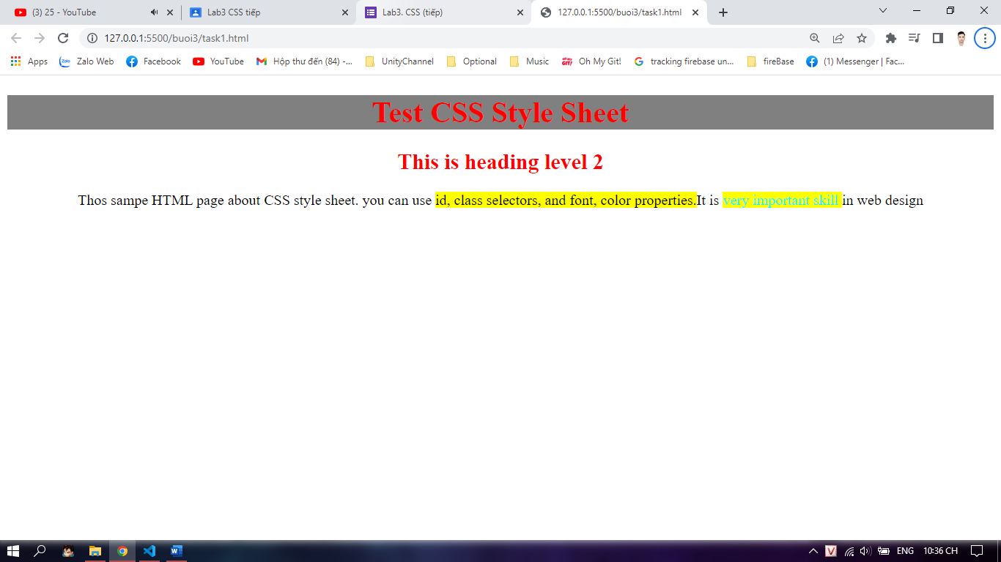
Bài 2:
<!DOCTYPE html>
<html lang="en">

<head>
<style>
div{
width: 250px;
margin: 25px 25px 25px;
padding: 25px 25px 25px;
border-style: solid;
background-color: rgb(197, 190, 190);
border-color: dodgerblue;
border-width: 25px;
text-align: left;

}
</style>
</head>

<body>
<div>
<p >This text is the actual content of the box. We have added a 25px padding, 25px margin and a 25px dodgerblue
border. Ut enim ad minim veniam, quis nostrud exercitatioin ullamco laboris nisi ut aliuip ex ea commodo
consequat. Duis aute irure dolor in reprehenderit in voluptate velit esse cillum colore eu fugiat nulla
pariatur. Excepteur sint occaecat cupidatat non proident, sunt in culpa qui officia deserunt mollit anim id est
laborum.</p>
</div>
</body>

</html>

Bài 3:
<!DOCTYPE html>
<html lang="en">
<head>
<style>
li{
list-style-image:url('Untitled-1.gif');
list-style-type: lower-alpha;

}
</style>
</head>
<body>
<h2>Default list</h2>
<ul class="li">

<li> <a href ="bai1.html">Home </a></li>
<li><a href ="bai1.html">products</a></li>
<li><a href ="bai1.html">contact</a></li>
</ul>
</body>
</html>

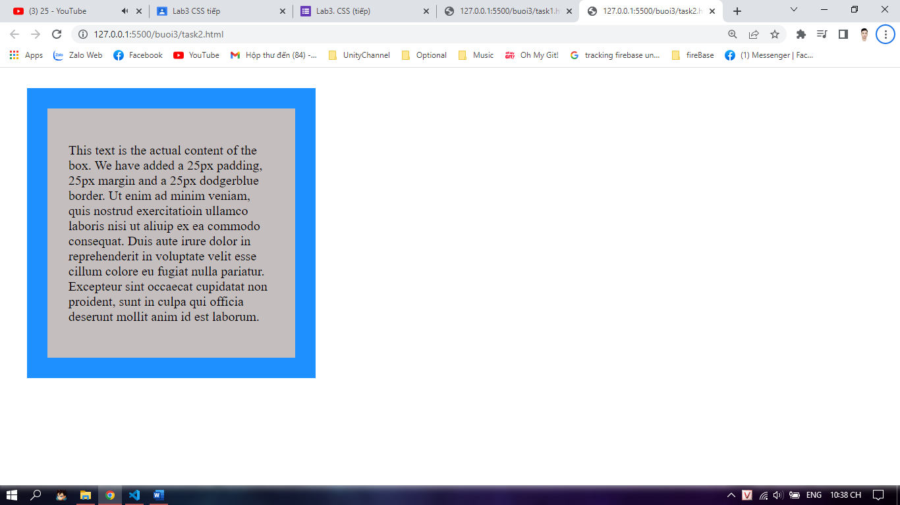
Bài 4:
<!DOCTYPE html>
<html lang="en">
<head>
<meta charset="UTF-8">
<meta http-equiv="X-UA-Compatible" content="IE=edge">
<meta name="viewport" content="width=device-width, initial-scale=1.0">
<title>Document</title>
<style>
li{
border-left: 1px groove rgb(160, 44, 238);
border-right: 1px groove rgb(160, 44, 238);
list-style: none;
}
li.top{
border-top: 1px groove rgb(160, 44, 238);
border-bottom: 1px groove rgb(160, 44, 238);
}
li.bot{
border-top: 1px groove rgb(160, 44, 238);
border-bottom: 1px groove rgb(160, 44, 238);
}
</style>
</head>

<body>
<ul>
<li class="top">coffee</li>
<li>Tea</li>
<li class="bot">coca cola</li>
</ul>
</body>
</html>

