COVER PAGE
INTRODUCTION TO DATA MANAGMENT PROJECT REPORT
(Project Semester August-December 2020)

SUICIDES OVERVIEW FROM 1985 TO 2016

Submitted by
K HARSHAVARDHAN REDDY
Registration No: 11806793

Programme and Section: KMO7O
Course Code: INT217

Under the Guidance of
VASUDHA MAM (23636)

Discipline of CSE/IT
Lovely School of Computer Science and Engineering
Lovely Professional University, Phagwara



DECLARATION

I, K HARSHAVARDHAN REDDY, student of INT217 under CSE/IT Discipline at, Lovely Professional University, Punjab, hereby declare that all the information furnished in this project report is based on my own intensive work and is genuine.

Date: 30-11-2020 Signature
Registration No. 11806793 HARSHAVARDHAN

Acknowledgement
It is great Pleasure for me to undertake this project. I feel highly doing the project entitled- “SUICIDES OVERVIEW FROM 1985 TO 2016”.
I am grateful to my project guide VASUDHA MAM Faculty Member of INT217 Course.
This Project would not have completed without her enormous help and worthy experience. Whenever I was in need, she was there behind me.
Although, this report has been prepared with utmost care and deep routed interest. Even then I accept respondent and imperfection.
K HARSHAVARDHAN REDDY
Student at Lovely Professional University.

Table of Contents
COVER PAGE 1
DECLARATION 2
Acknowledgement 3
Table of Contents 4
Introduction: 5
Key facts 6
Prevention 8
Objectives or Scope of Analysis: 8
Source of the Data Set: 9
ETL PROCESS(Extract Transform Load): 9
Analysis on Data Set: 14
Introduction: 14
General Description: 14
Specific Requirements, Functions and Formulas: 14
Analysis Results: 20
Visualization: 25
List of Analysis with results: 26
FUTURESCOPE 26
References: 27
Bibliography: 27

Introduction:
Most of us can hardly imagine the suffering that precedes suicide and the pain left in its wake. When the person who dies is young, the devastation is even more profound. The public, however—including most parents—remains disturbingly unaware of the prevalence of suicide among young people. This is in part because, until recently, there was virtually no public health policy on the subject; in part because society is reluctant to discuss both suicide and the mental illnesses most directly responsible for it; and in part because there is a pervasive belief that suicide is highly idiosyncratic in nature and therefore neither predictable nor preventable. Unlike oncologists and cardiologists, who know that certain types of Tumors or heart disease radically increase the likelihood of death, psychiatrists and psychologists tend not to think of mortality rates in the context of psychiatric illnesses. This has led to considerable confusion, as well as to an under emphasis on how much is actually known about suicide from a clinical and scientiﬁc point of view. In fact, we know a great deal.
We know, ﬁrst, that suicide is a terrible killer of the young. In the United States, suicide is the third major cause of death in 15-to-19-year-olds and the second leading cause of death in college-age students. In 1996, more teenagers and young adults died from suicide than from cancer, heart disease, AIDS, stroke, and lung disease combined. Suicide kills the young dreadfully and disproportionately. And, across the world, in those between the ages of 15 and 44, suicide is the second leading killer of women and the fourth of men. Nearly one million people die by suicide each year, 30,000 of them in the United States.
In addition, studies conducted by the centers for Disease Control and Prevention ﬁnd that one in ten college students, and one in ﬁve high school students, acknowledge having seriously considered committing suicide in the preceding year. Nearly one high school student in ten admits to having actually attempted it. Each year in the United States, more than 500,000 suicide attempts are made that are serious enough to warrant medical attention in an emergency room.
We understand—up to a point—the mental states of those who kill themselves: the despair, depression, irritability, agitation, and sheer hopelessness. We have learned a great deal about the suicidal experience from the victims’ legacies—notes, diaries, psychological autopsies, and clinical interviews with people who have survived severe suicide attempts. We have compelling evidence from a large number of studies that the single most important factor in suicide is psychopathology: More than 90 percent of all people who kill themselves suffered from a major psychiatric or addictive illness (depression, manic-depression, schizophrenia, or alcohol and drug abuse), a severe anxiety disorder, or borderline or antisocial personality disorder. Those who are victims of both depression and alcohol or drug abuse are especially at risk. Most people who were depressed will not kill themselves. But of those who do, the majority were profoundly depressed.

Key facts
- Close to 800 000 people die due to suicide every year.
- For every suicide there are many more people who attempt suicide every year. A prior suicide attempt is the single most important risk factor for suicide in the general population.
- Suicide is the third leading cause of death in 15-19-year-olds.
- 79% of global suicides occur in low- and middle-income countries.
- Ingestion of pesticide, hanging and firearms are among the most common methods of suicide globally
- 47,173 Americans died of suicide in 2017, making it the 10th leading cause of death in the US
- There were twice as many suicides as there were homicides in the US in 2017.
- Suicide was the second leading cause of death for people ages 10-34 in the US in 2017.
- On average, 1 person dies by suicide every 11 minutes in the US.]
- About 50% of people in the US know someone who has died by suicide in their lifetime.
- 10.5% of adults in the US 18-25 years old had serious suicidal thoughts in 2017.
- Lesbian, gay, bisexual, and questioning youth are almost 5 times more likely to attempt suicide.
- In a national study, 40% of transgender adults reported having made a suicide attempt. 92% of these individuals reported having attempted suicide before the age of 25.
- Women are 3 times more likely than men to attempt suicide, and men are 3.5 times more likely to have a fatal outcome when attempting suicide.
- 79% of global suicides occur in low- and middle-income countries.
- Firearms accounted for 23,854 suicides in the US in 2017 -- that’s about half of all suicide deaths.
- .
Key things to know
In 2010, over 38,000 Americans committed suicide, making it the tenth leading cause of death. Depression is the major underlying cause of suicide. Understanding and recognizing the warning signs of depression and suicidal behaviour are helpful in preventing suicide.
The following answers to important questions can help you understand suicide and take steps to stop it.

The reasons
Q: Why do people commit suicide?
A: A suicide attempt is an indication something is gravely wrong in a person’s life. Suicide is a desperate attempt to escape unbearable suffering.

Talking about it
Q: Can talking about suicide make a person who’s distressed more likely to try it?
A: The opposite is true—ignoring the problem in hopes it will go away can make the person feel even more isolated and misunderstood.

At risk
Q: Who’s at risk for suicide?
A: Suicide can result from mental illness. Other risk factors include the recent loss of a loved one or a job, divorce, a dire medical condition, and a lack of social support.
Certain groups are at higher risk of taking their lives:
- Older adults. People ages 65 and older have the highest suicide rates of any age group. Contributing factors are untreated depression, death of loved ones, chronic illness, and loneliness.
- Persons age 15 to 24. Suicide is the third-leading cause of death in this age group and accounts for about 20% of all deaths annually. Suicide risk factors for teenagers include depression, alcohol or drug abuse, a recent traumatic event, availability of a gun, and exposure to other teens who have committed suicide.
- Males. Of those who attempt suicide, the completion rate for men is 4 times higher than for women. However, women attempt suicide about 2 to 3 times as often as men. Men who are 85 years and older have the highest rate of suicide.

Medications
Q: Do antidepressants raise or lower the risk?
A: Antidepressant medications are effective in treating depression, thus reducing the overall risk of suicide. However, sometimes a person will need to try different types of antidepressants, or use a combination of medications, before an effective result is achieved. Different age and ethnic groups process these medications at a different rate of metabolism. Therefore, close supervision for anyone taking these medications is important. Antidepressants can take weeks to several months before the beneficial effects of the medications are noticed, and cannot be used as a quick fix for suicidal thoughts.

Signs to watch for
Q: What are the signs someone might be suicidal?
A: Most suicidal people give some sign of their intentions. These symptoms may indicate a person is at risk for suicide:
- Verbal suicide threats, such as “You’d be better off without me.”
- Lack of interest in future plans.
- References to “unbearable” feelings and hopelessness.
- Saying good-bye to family and friends.
- Giving away prized possessions.
- Increasing withdrawal and isolation from family and friends.

Prevention
Q: Can suicide be prevented?
A: The best prevention is to treat the underlying causes. If a person is depressed, or is a substance abuser, for example, treating the disorder helps to prevent the disease from progressing to the point of suicidal thinking. Medication along with counselling have been shown to be the best methods of treatment. Recognizing the warning signs and seeking help are the best methods of prevention.
If you think a person is suicidal:
- Determine if the person has a specific plan to carry out the suicide.
- Don’t leave the person alone.
Whenever anyone verbalizes or acts as though he or she will harm himself or herself, this person should be taken seriously. Contact a local crisis center or the National Suicide Prevention Hotline at 800-273-TALK (8255). You can also contact 911 for help, or take the person to the nearest emergency room. It is difficult to try and help the suicidal person by yourself. Contact or get the person to a qualified mental health professional as soon as possible.
Social media and suicides risk
An immense quantity of information on the topic of suicide is available on the Internet and via social media. Biddle et al.10 conducted a systematic Web search of 12 suicide-associated terms (e.g., suicide, suicide methods, how to kill yourself, and best suicide methods) to simulate the results of a typical search conducted by a person seeking information on suicide methods. They analysed the first 10 sites listed for each search, for a total of 240 different sites. Approximately half were pro suicide Web sites and sites that provided factual information about suicide. Pro suicide sites and chat rooms that discussed general issues associated with suicide most often occurred within the first few hits of a search. We should note that this study primarily focused on pro suicide search terms and thus likely excluded many suicide prevention and support resource sites. They also conducted a study that examined suicide-related sites that can be found using Internet search engines. Of 373 Web site hits, 31% were suicide neutral, 29% were anti suicide, and 11% were pro suicide. The remaining sites either did not load or included “suicide” in the title but were not suicide sites (e.g., sites for movies and novels with “suicide” in their title or music bands whose names included “suicide”). Together, these studies have shown that obtaining pro suicide information on the Internet, including detailed information on suicide methods, is very easy.

.

Objectives or Scope of Analysis:
The main Objectives of the Project are:
- Country wise suicides
- Year wise suicides
- Sex wise suicides per 100k population.
- Generation wise GDP per capita
- Generation wise suicides
- Age wise suicides

Source of the Data Set:
The main Source of the Data Set is Kaggle. From the following link I have downloaded the Dataset
https://www.kaggle.com/russellyates88/suicide-rates-overview-1985-to-2016

ETL PROCESS(Extract Transform Load):
Extraction: Extraction Process I have done from Source (Kaggle) using above link. Which was in Excel.csv file.
Data set Before ETL Process
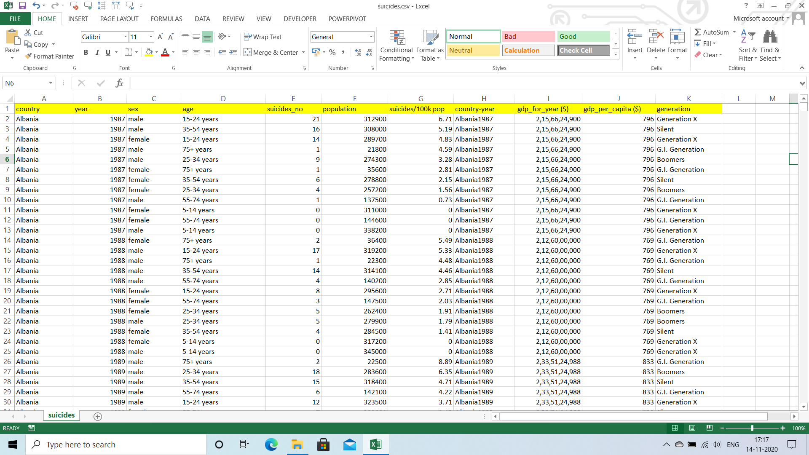

Transformation: Transform Process I have done Using Tableau Prep. In Tableau Prep I have done Cleaning Process. When I have taken the data set from Kaggle.com it was about 2800 rows. It consists of duplicate columns I have cleaned the data set in Tableau Prep. Actually we can do So many operations like clean step, Remove Null Values, Remove Duplicate Values etc. I have done cleaning without affecting the original dataset for remaining rows. Now it is 2800 rows after Cleaning Process is done, as there is only duplicate column. The following Picture will Clearly show what I have done
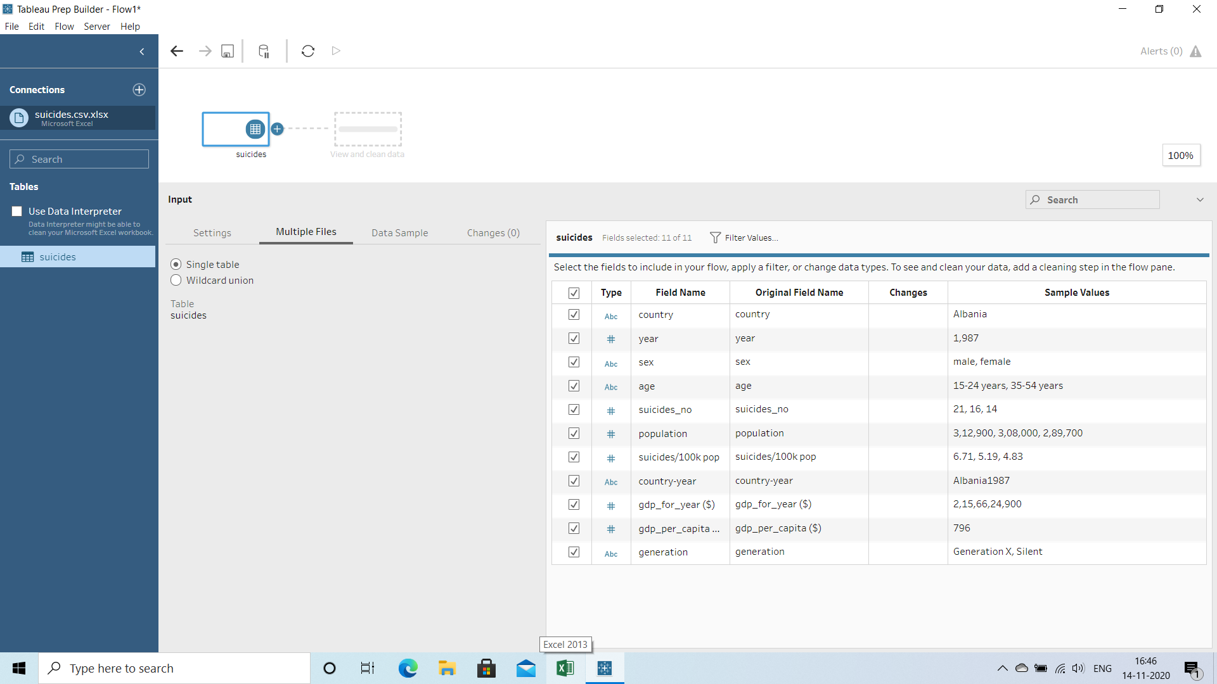
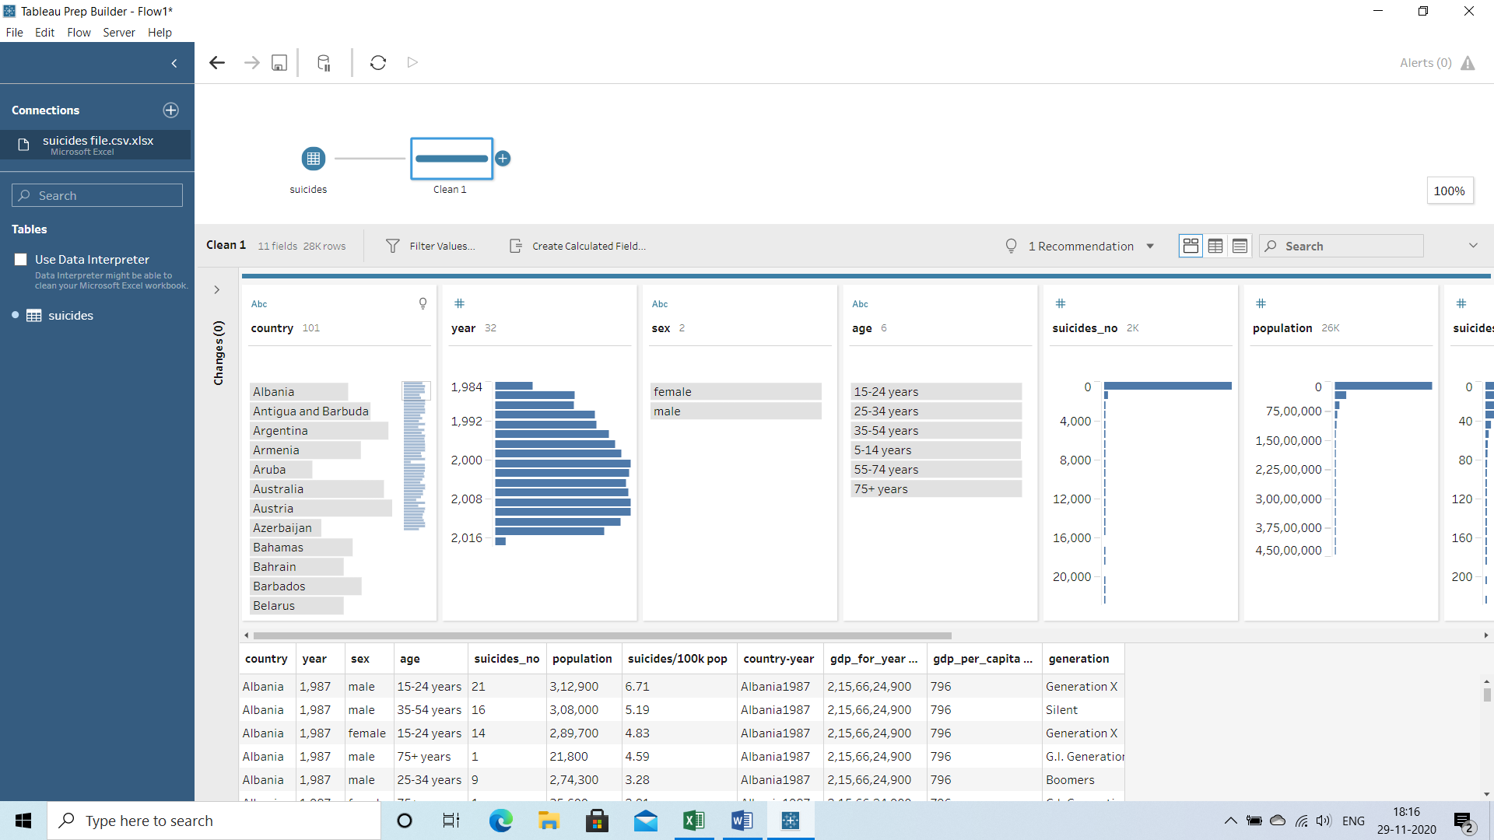
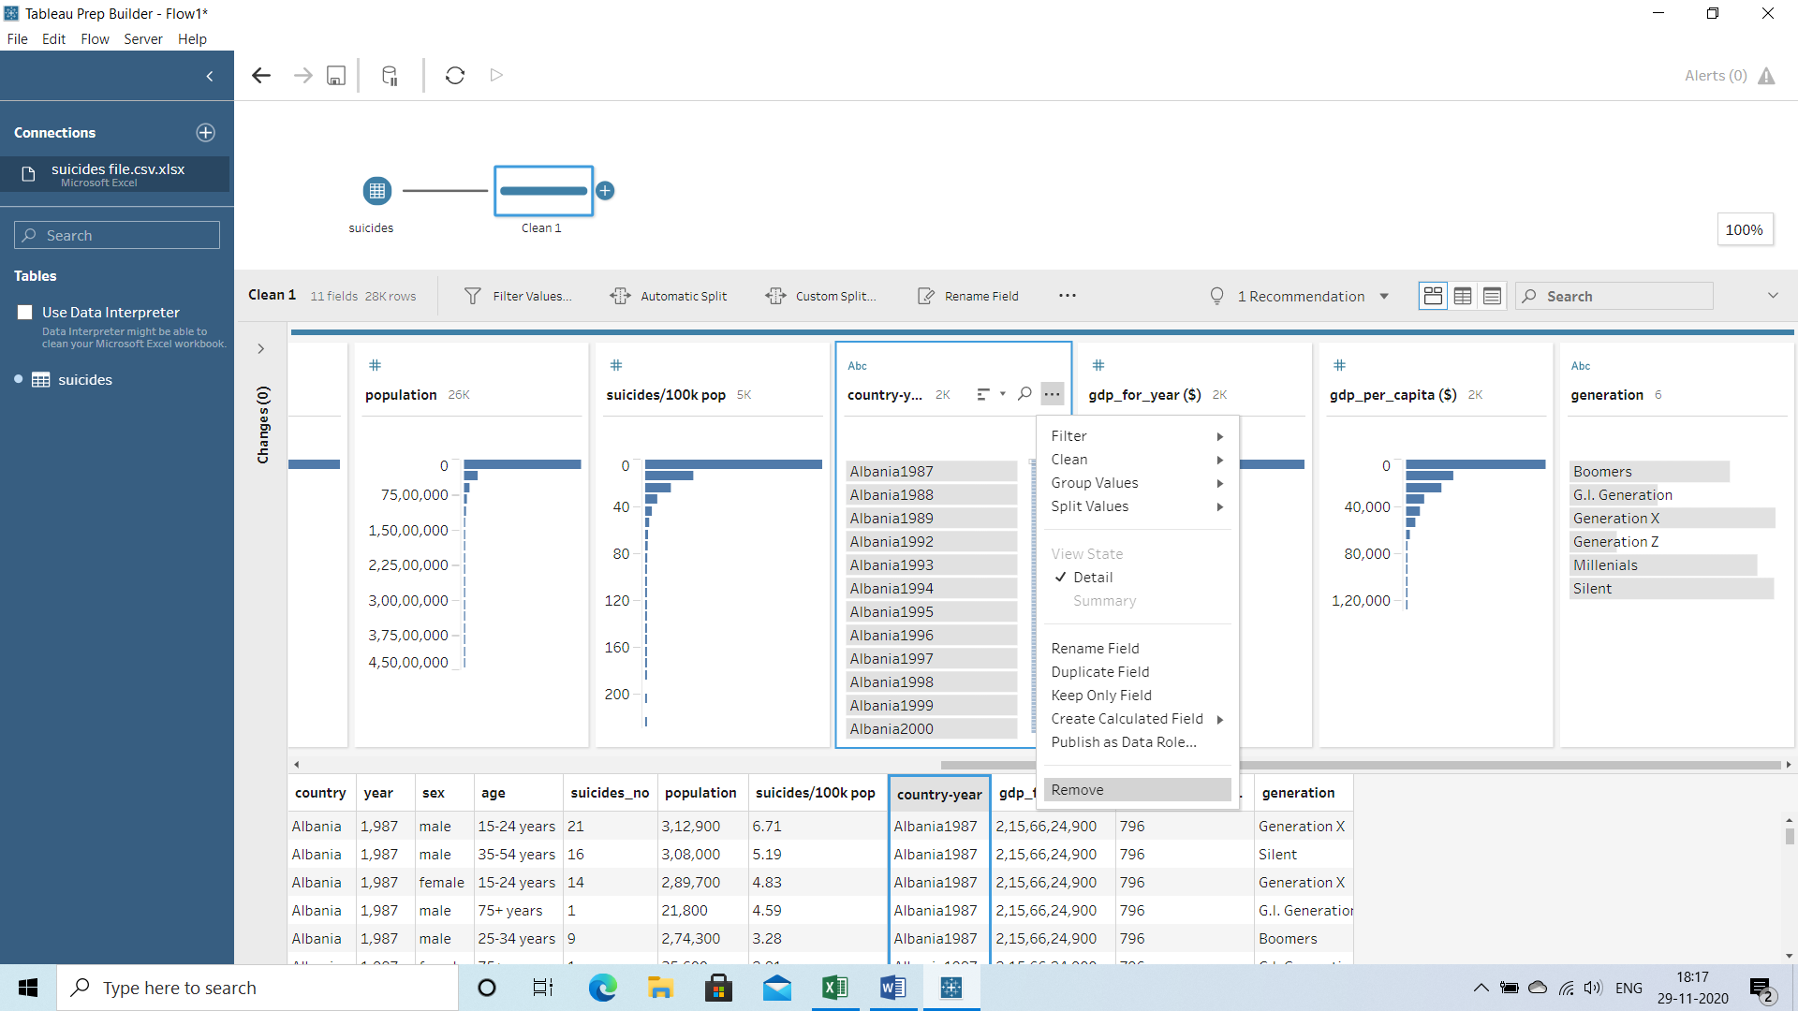

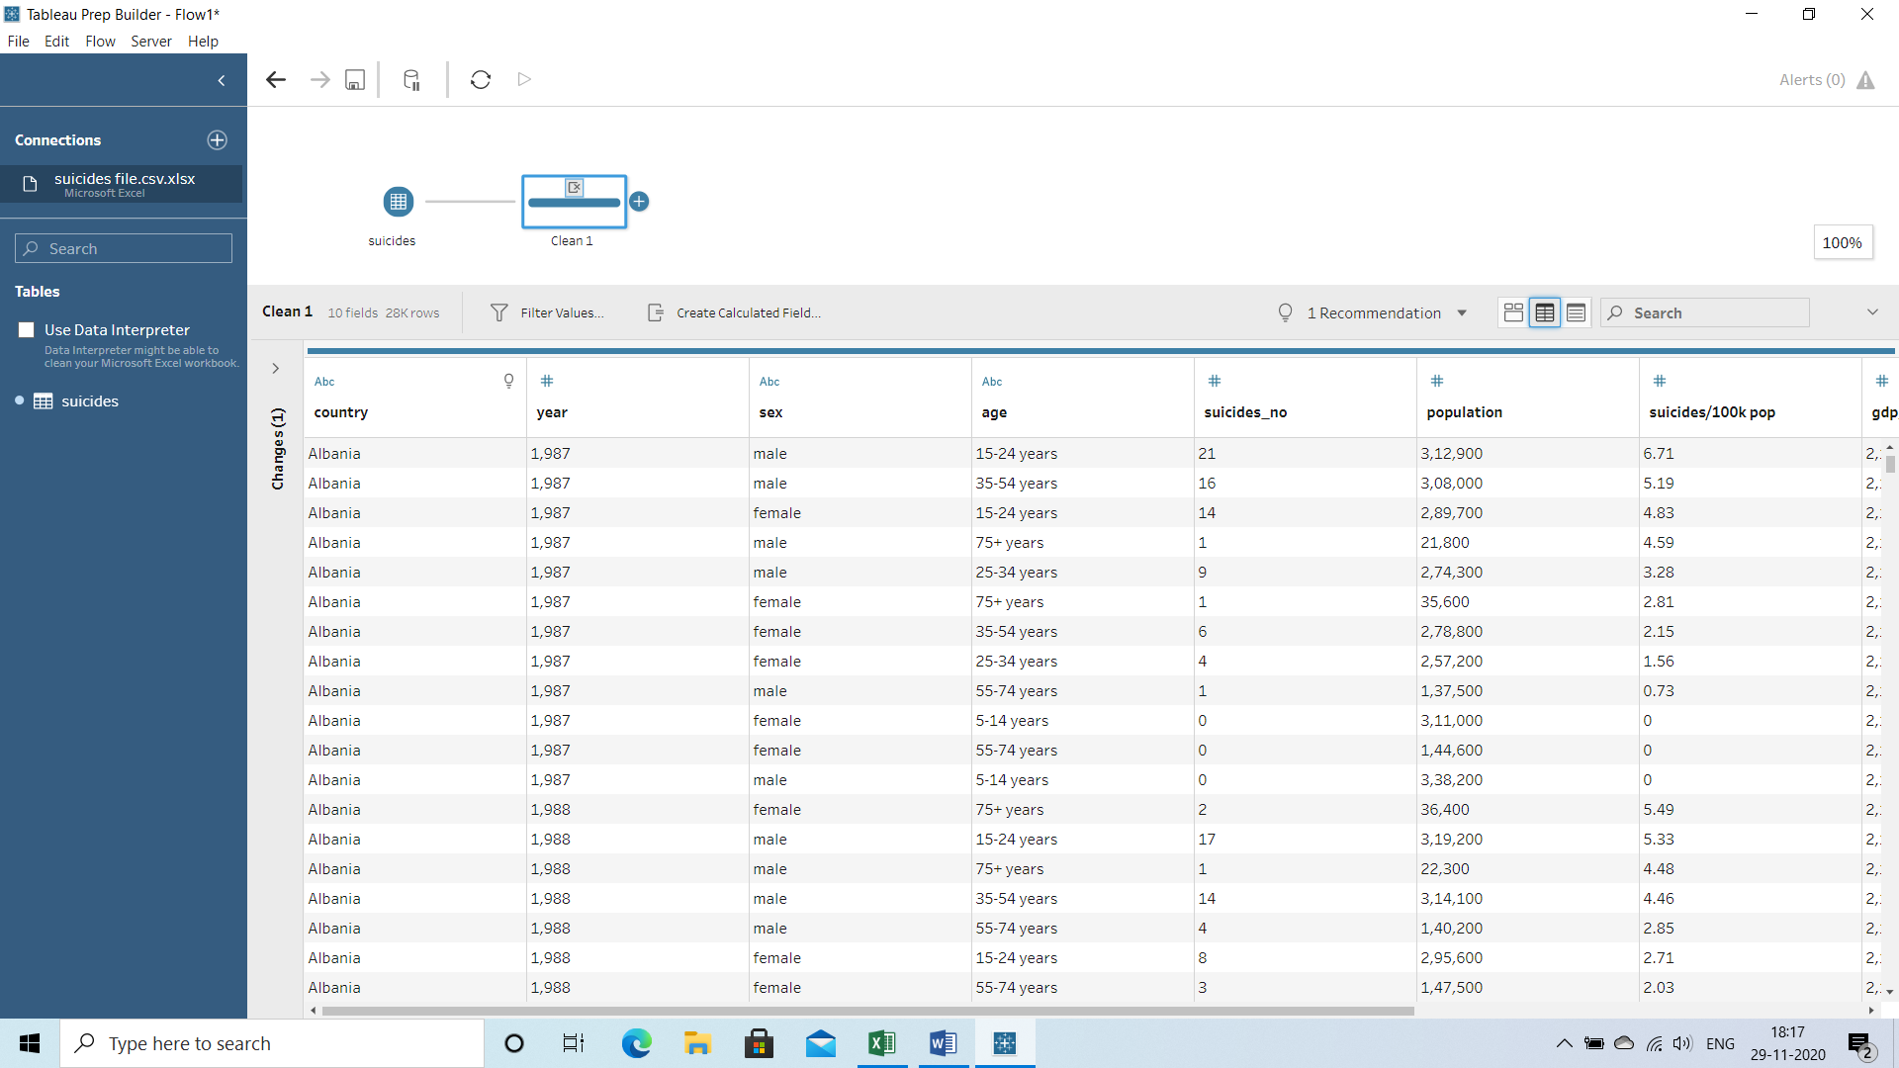
Dataset after ETL Process
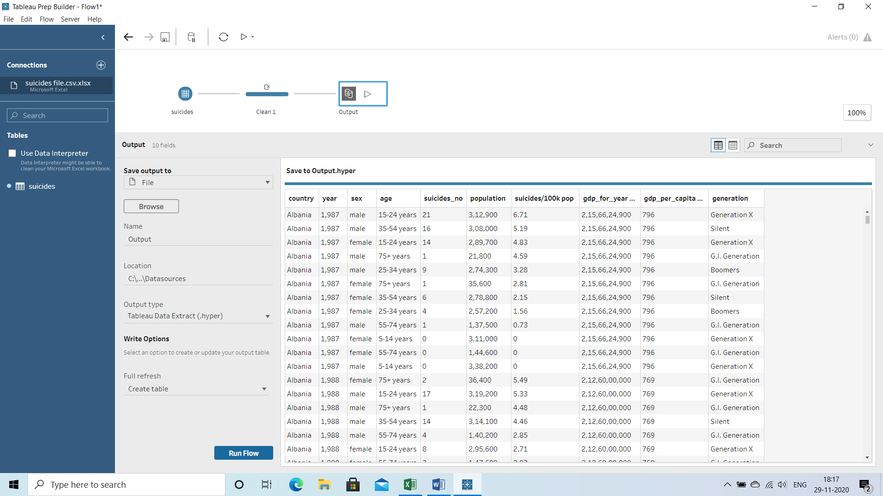

Loading Process:
- You have to load the data i.e, generate output and store in desktop and check once the data s cleaned or not
- You will find the data is cleaned
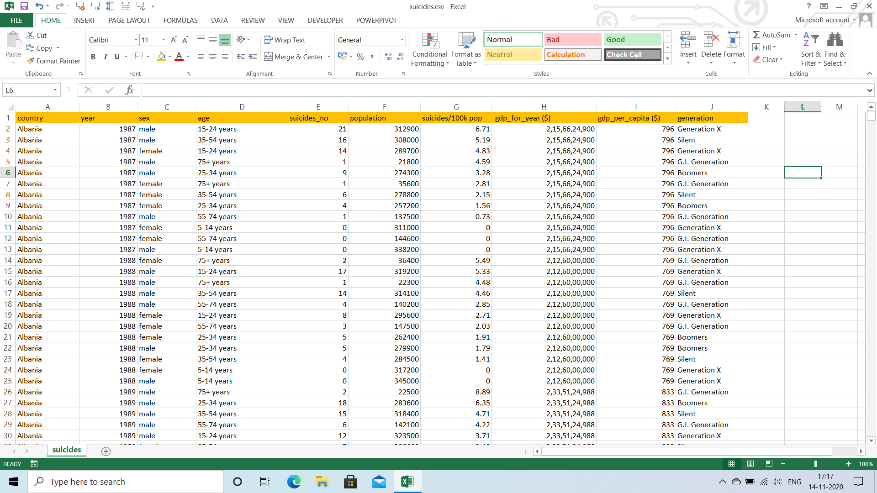

And finally, I have created the dashboard in Excel.

Analysis on Data Set:

Introduction:
The data set is all about the suicides overview from 1985 to 2016. While many public datasets (on Kaggle and the like) provide crime in india, there are not many counterpart datasets available for suicides anywhere on the web. On digging deeper, I found out that suicides overview from 1987 to 2010 deploys a nicely indexed appendix-like structure to allow for simple and easy web scraping. On the other hand, suicides overview from 1985 to 2016 uses sophisticated modern-day techniques (like dynamic page load) using JQuery making scraping more challenging.

General Description:
The specific aspects I have used to create dashboard using Excel file is Tableau Prep for cleaning Purpose and the important Elements in Excel which I have used to do in this dashboard is Pivot Tables, Slicers etc.,

Specific Requirements, Functions and Formulas:
The data set consists of 10 columns and 2800 rows. The 10 columns are country, year, sex, age, suicides number, population, suicides per 100k, GDP per capita, GDP per year, Generation. The Main Tool I have used to Create Dashboard is Pivot Tables in the following Picture it was Clear why and how I have used pivot tables:

1st Pivot Table
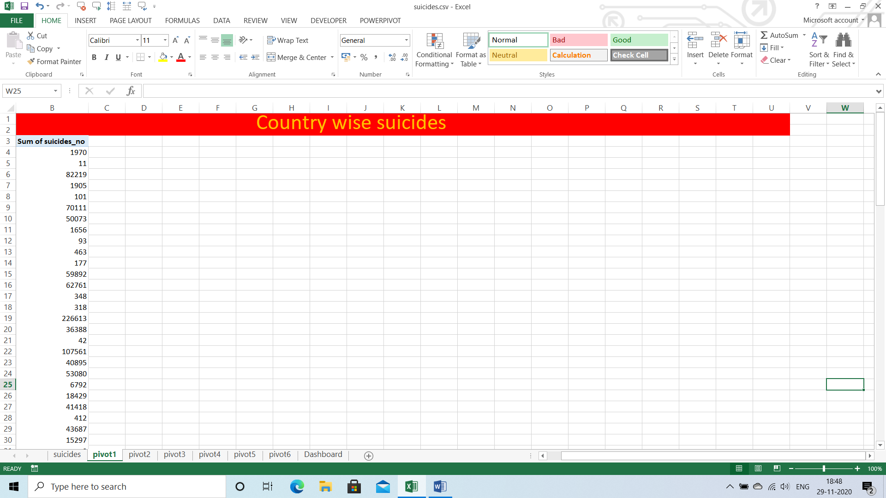
2nd Pivot Table
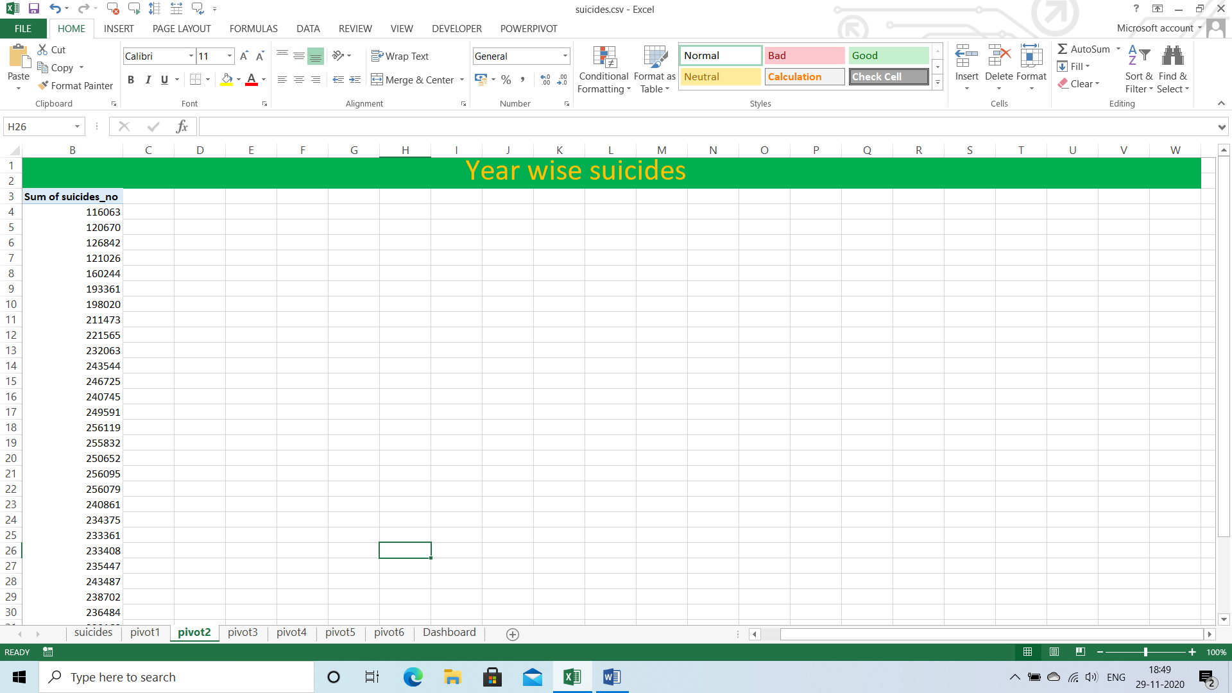

3rd Pivot Table:
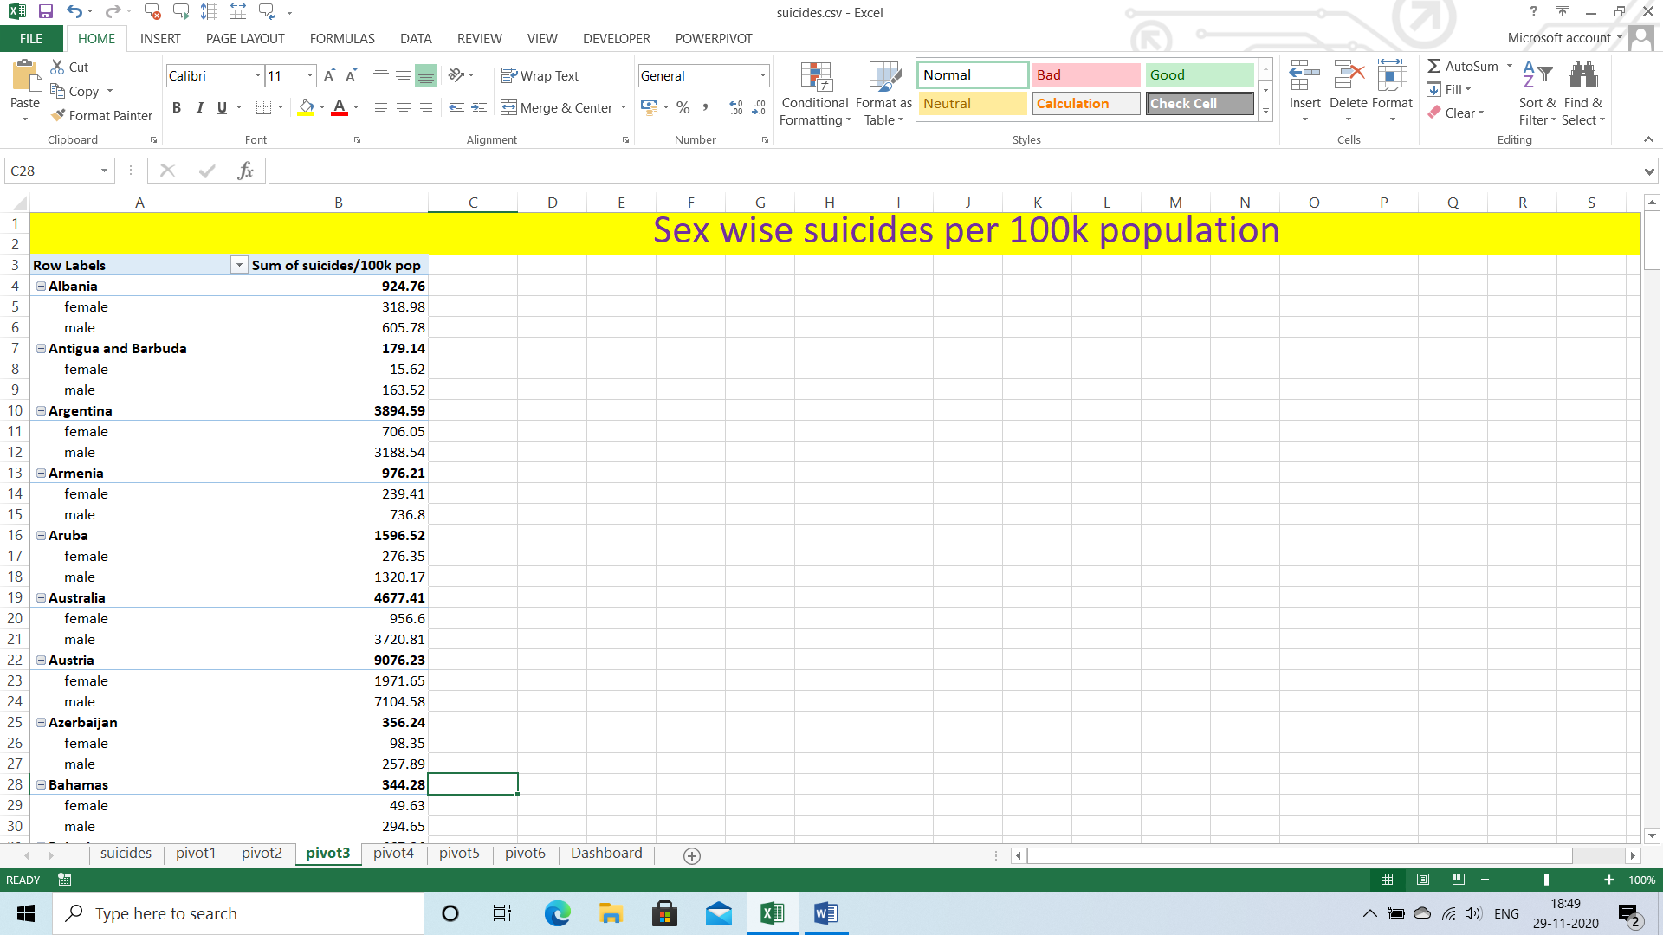

4th Pivot Table:
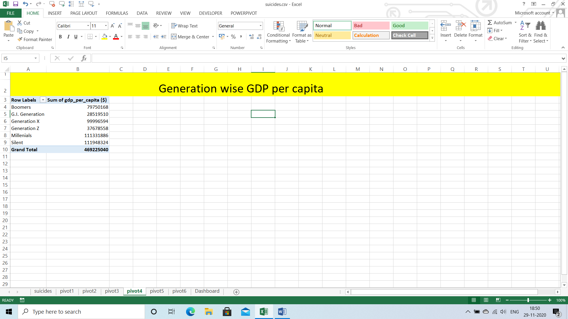

5th Pivot Table:
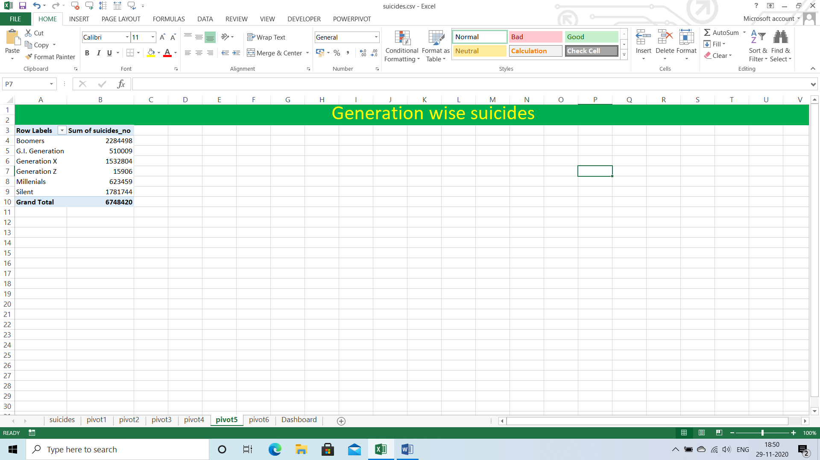

6th Pivot Table:
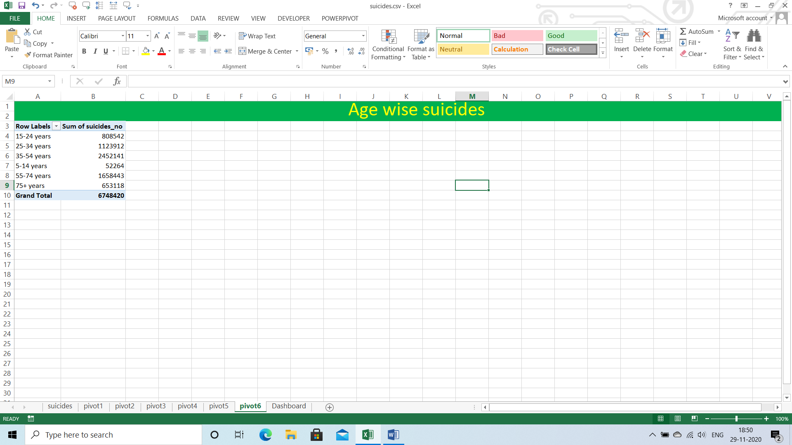

And all the functions Formulas I used in tableau Prep when I have cleaned the Data.

Analysis Results:

The Result of 1st Pivot Chart as Graph:
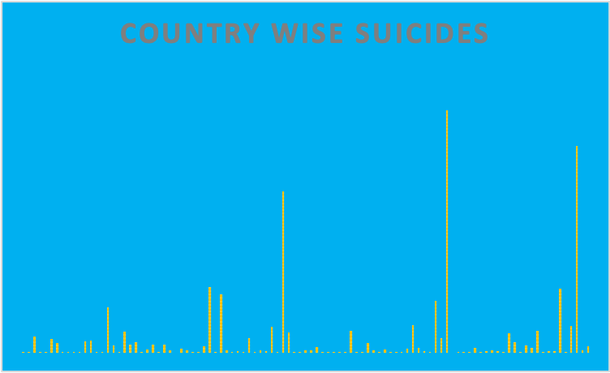

The Result of 2nd Pivot Chart as Graph:
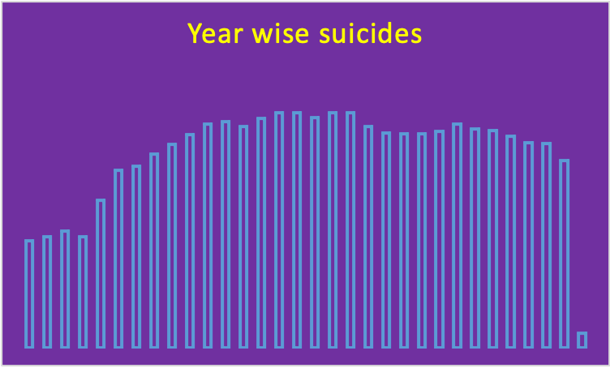

The Result of 3rd Pivot Chart as Graph:
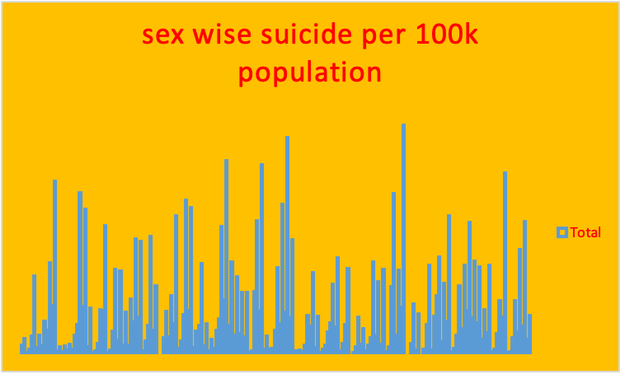

The Result of 4th Pivot Chart as Graph:
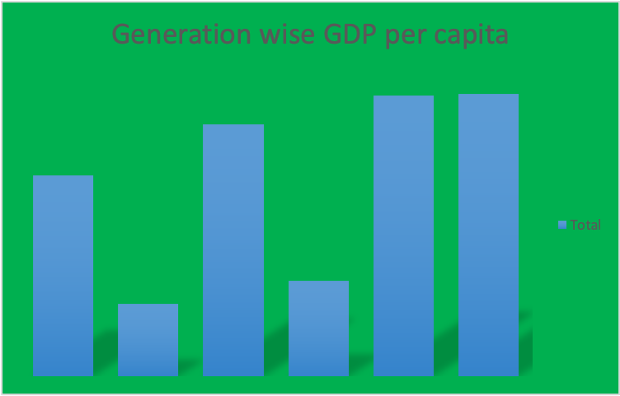

The Result of 5th Pivot Chart as Graph:
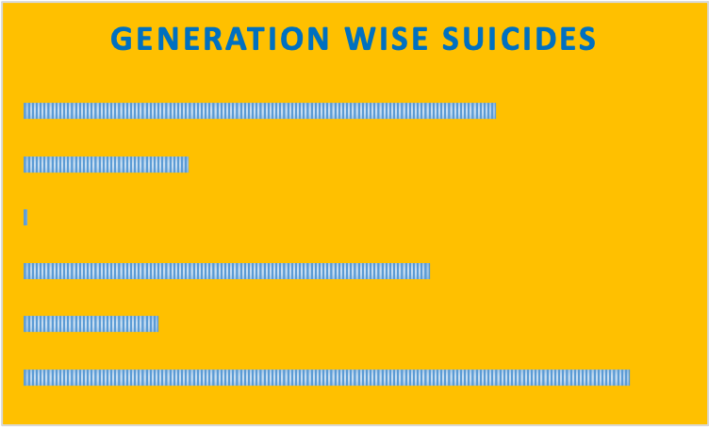

The Result of 6th Pivot Chart as Graph:
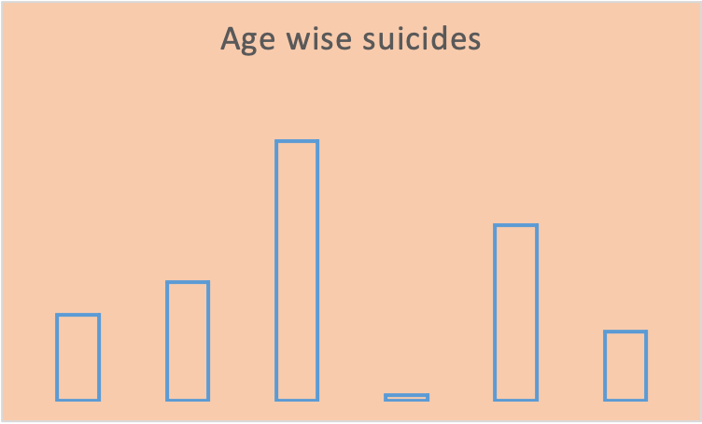

- I have used Slicers for some columns to make Dashboard Interactive and easy to understand the Dataset
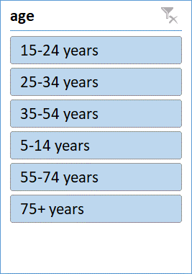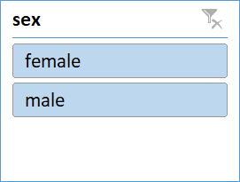
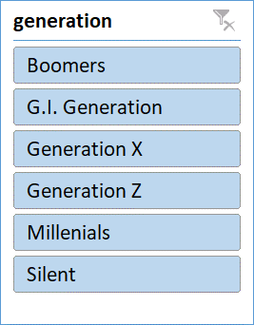
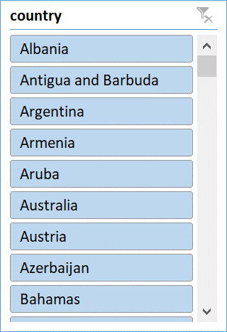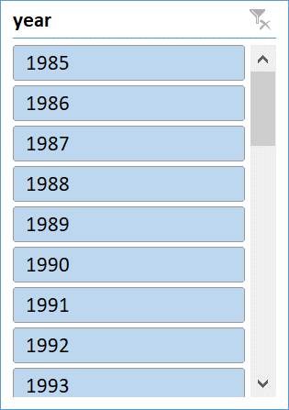

Visualization:
The Dashboard Visualization

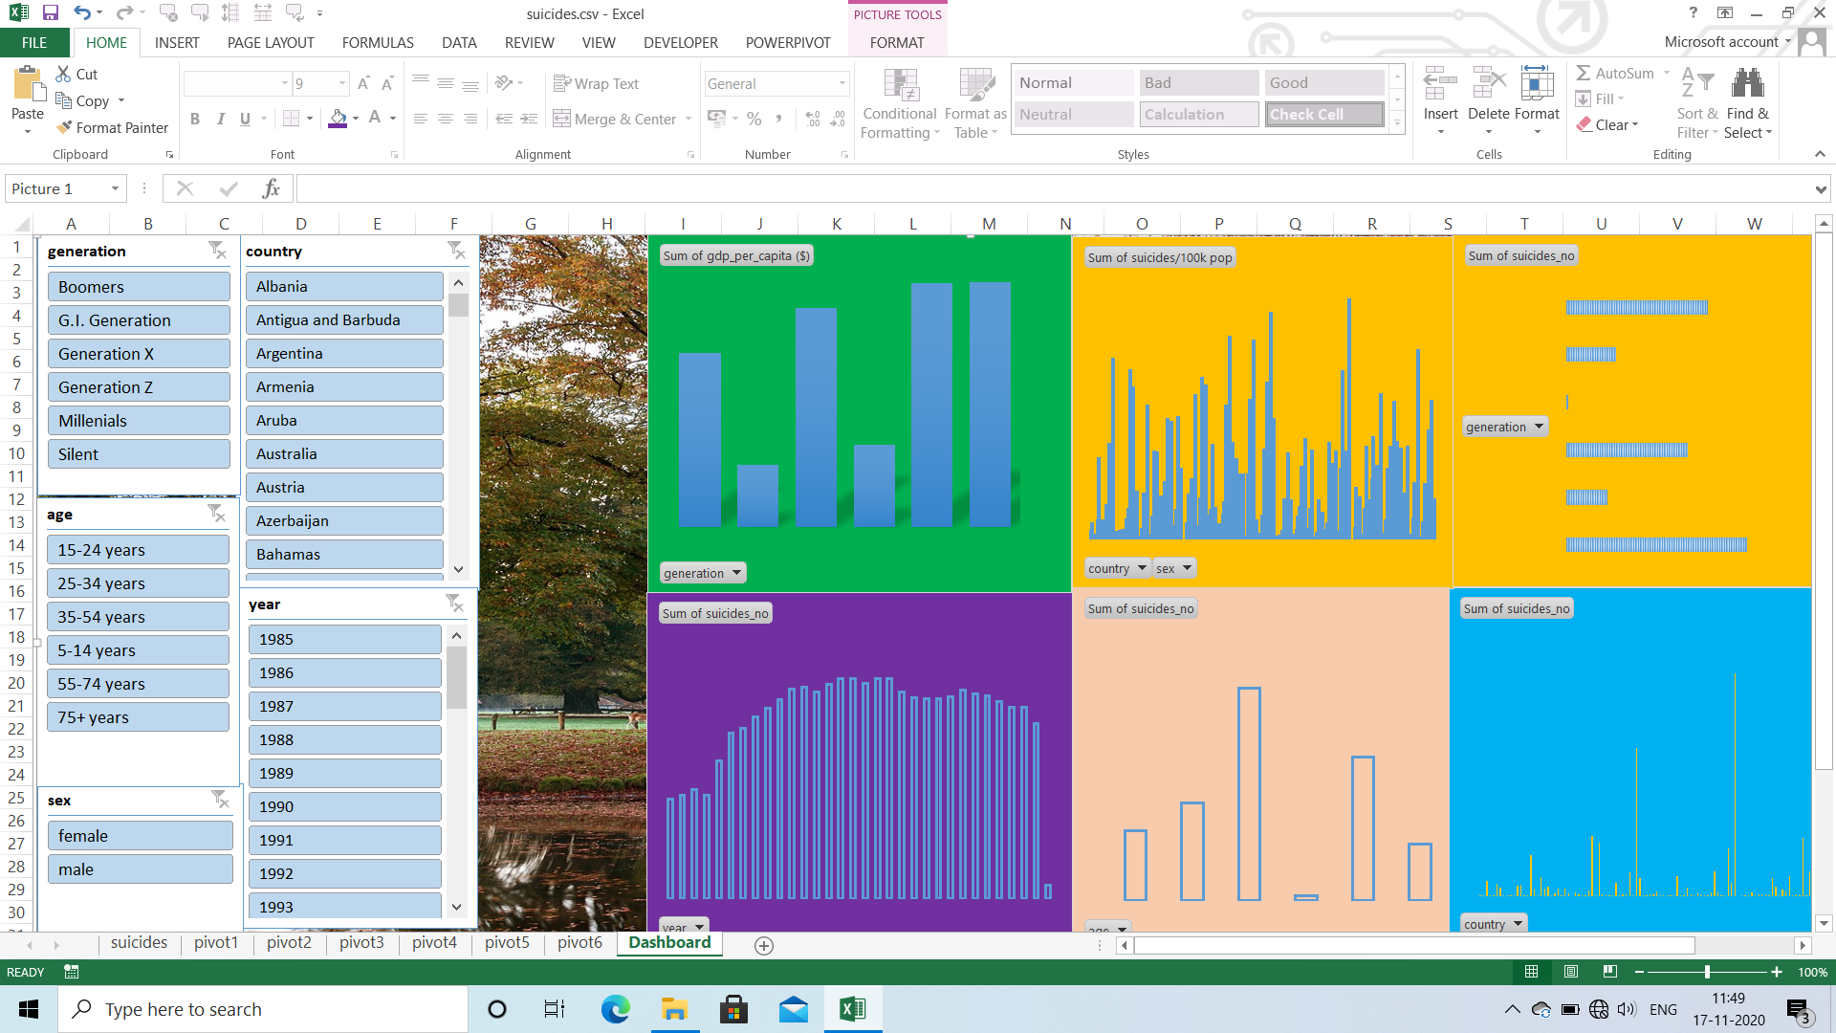

List of Analysis with results:
As I have shown results for Pivot tables and graphs above in Analysis Results and the list of analysis are:
- I have analyzed how to create pivot tables according to column categories
- I have created pivot charts according to the data category.
- I have analyzed the data properly accordingly I have created dashboard interactively.

FUTURESCOPE
Data analytics is a process through which data is cleaned, analyzed and modelled using tools. This data is then used to derive insights. The insights are then used for business related decision-making purposes. There are many techniques that data analysts use in different fields of work. In the world of business, Data analytics is used for making strategies to get the desired business results. Today, data analytics has become a big career option in India. As a result, big data analytics courses are in huge demand.
Businesses have realized the importance of utilizing big data analytics to maximize their profits. They know that it is vital for their growth and for the future health of their business. Today, major business decisions are taken by utilizing the insights derived from data related to the organization or industry related data. As competition increases and customers are flooded with choices, it has become important to move faster in the market and that too with accuracy.

References:
For Reference the websites are Kaggle.com, https://www.kaggle.com/russellyates88/suicide-rates-overview-1985-to-2016
https://www.dana.org/article/suicide-in-the-young-an-essay/
https://www.who.int/news-room/fact-sheets/detail/suicide
https://www.stanfordchildrens.org/en/topic/default?id=what-you-must-know-about-suicide-1-4134
https://www.ncbi.nlm.nih.gov/pmc/articles/PMC3477910/

Bibliography:
https://www.dana.org/article/suicide-in-the-young-an-essay/
https://www.who.int/news-room/fact-sheets/detail/suicide
https://www.stanfordchildrens.org/en/topic/default?id=what-you-must-know-about-suicide-1-4134
https://www.ncbi.nlm.nih.gov/pmc/articles/PMC3477910/
CERTIFICATE

This is to certify that K HARSHAVARDHAN REDDY bearing Registration no. 11806793 has completed INT 217 titled, “SUICIDES OVERVIEW FROM 1985 TO 2016” under my guidance and supervision. To the best of my knowledge, the present work is the result of his/her original development, effort and study.

Signature and Name of the Supervisor
Designation of the Supervisor
School of Computer Science Engineering
Lovely Professional University
Phagwara, Punjab.

Date: 30-11-2020

