### Final Project

#### Problem Definition:

Suicide is an issue that affects every country in the world. Whether the country is wealthy or poor, no country is exempt. Nowadays where suicide has become ever more prevalent in the media spotlight, we are able to discover a multitude of factors that leads to it. Iin my project, I would like to look at the GDP per capita of countries across the different regions of the world and try to analyse whether or not this independent variable has any effect on the suicide rate per 100,000 people in these countries. The purpose of this project will be to test that as GDP per capita increases, whether the suicide rate per 100,000 people decrease. The analysis will hope to answer the question: as the the economy grows, wages increase, living standards improve whether people be less likely to commit suicide. In today’s society, people study hard to get into good universities, get a high GPA and get a high paying job because subconsciously, many of us believe that the more money we have, the better life we will live. In such a society, will increased income alone make the general population less suicidal?

#### Analysis:

The method of anlaysis will be to examine the data set that looks at suicide rate in 48 countries across the globe at a country level from 1985 - 2015 and combine this data with the GDP per capita data of these countries between those years and compare the two varaiables to analyse whether or not an increase in GDP per capita will lead to a decrease in suicide rate per 100,000 of the population.

Year on year vs suicde rate was not analysed because as years went by, GDP per capita tends to increase leading to the results of year vs suicide rate data to be identical to that of GDP per capita vs suicide rate.

The initial data set is presented in the following format for 48 countries with an additional column for GDP per capita:

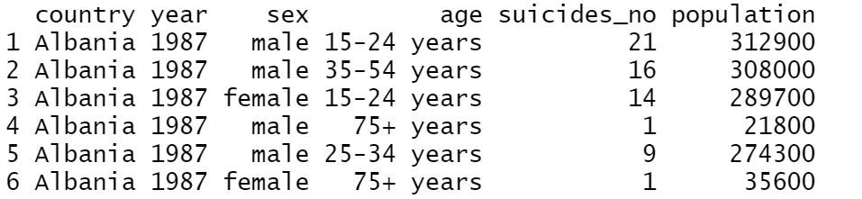

Table 1: Example of the data set that is being analysed

Creating a scatter plot to Initial visual analysis into the data set of the world seems to show that as GDP per capita increases, sucide rate drops accordingly.

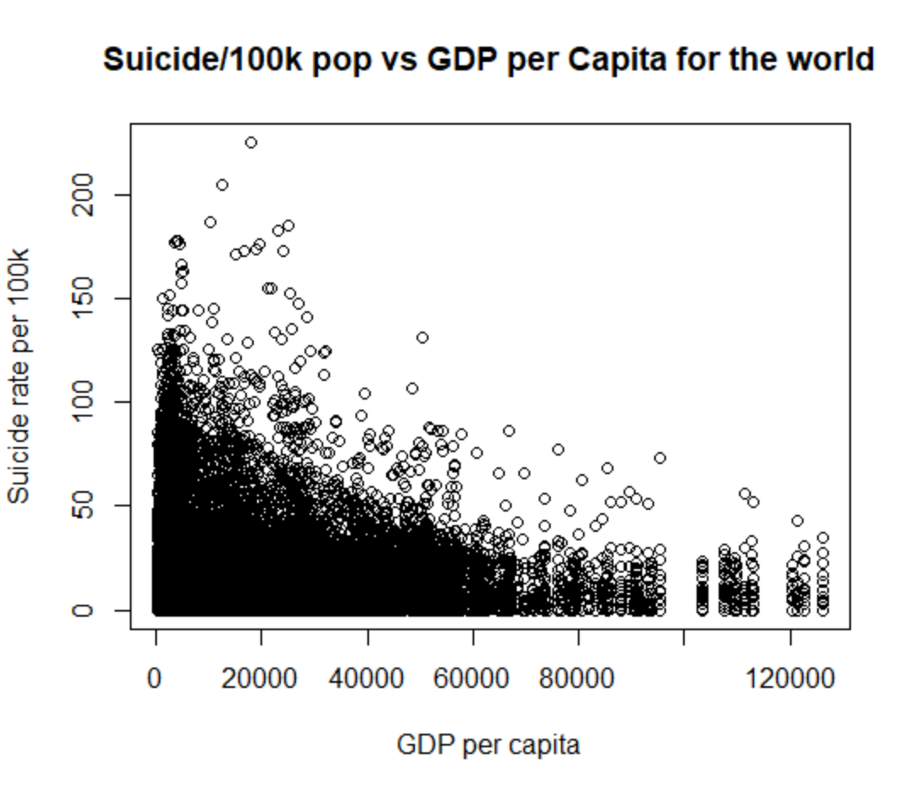

Figure 1: Initial analysis of suicide rate vs GDP per capita across 48 countries from 1985 - 2015

#### The data is obviously quite messy so it was necessary to use the filter and aggregate function to clean up the data and obtain the following results:

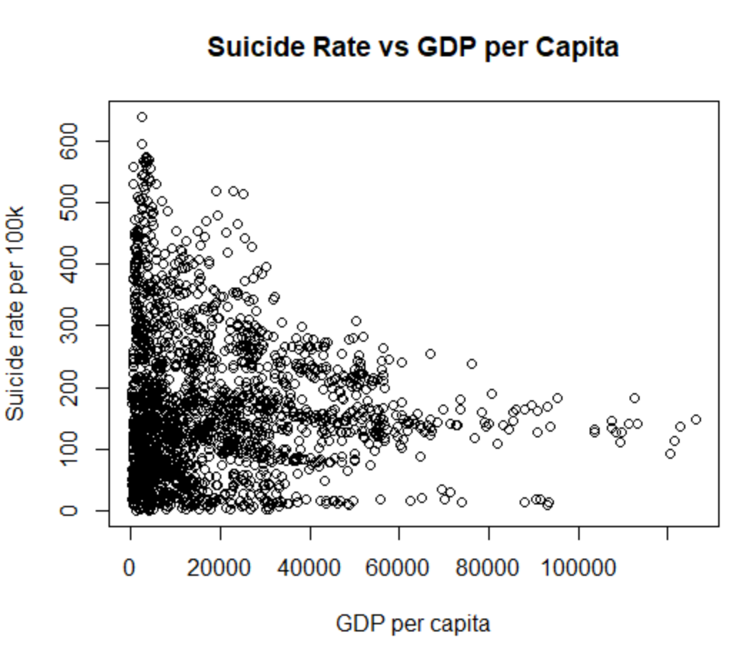

#### Figure 2: Suicide rate vs GDP per capita after cleaning the data

#### The data was cleaned up by removing rows where there is no recorded suicide rates and combining the duplicated observation by summing the suicde/100k pop of that year across the different gender and age group.



Running a regression on this data set shows that for every 1 increase in GDP per capita, there is a 0.00009 decrease in suicide rate. Which indicates that as GDP increases, suicide rate will indeed fall. However, examining the 0.468 p value, there is little indication of a relationship between gdp per capita and suicide rates. Using the correlation coefficient function on this data set returns a value of -0.0153. Again, this shows that the relationship between gdp per capita and suicide rate is insignificant.

Using the correlation function returns 0.03, a weak positive correlation between GDP per capita and suicide rates.

The correlation is also not obvious when observing the data through box plots.

|  |  |
| --- | --- |

Figure 3: Comparison of suicide rate to real GDP per capita from 1985 - 2015

Although GDP per capita fluctuated between 1985 - 2002, the 25th - 75th percentile had increased relatively steadily from 2003- 2008, then 2009 - 2012 and finally 2013 - 2015. When it is compared with suicide rates, there seems to be very little correlation as the 25th-75th continues to fluctuate between the years 2003 - 2015.

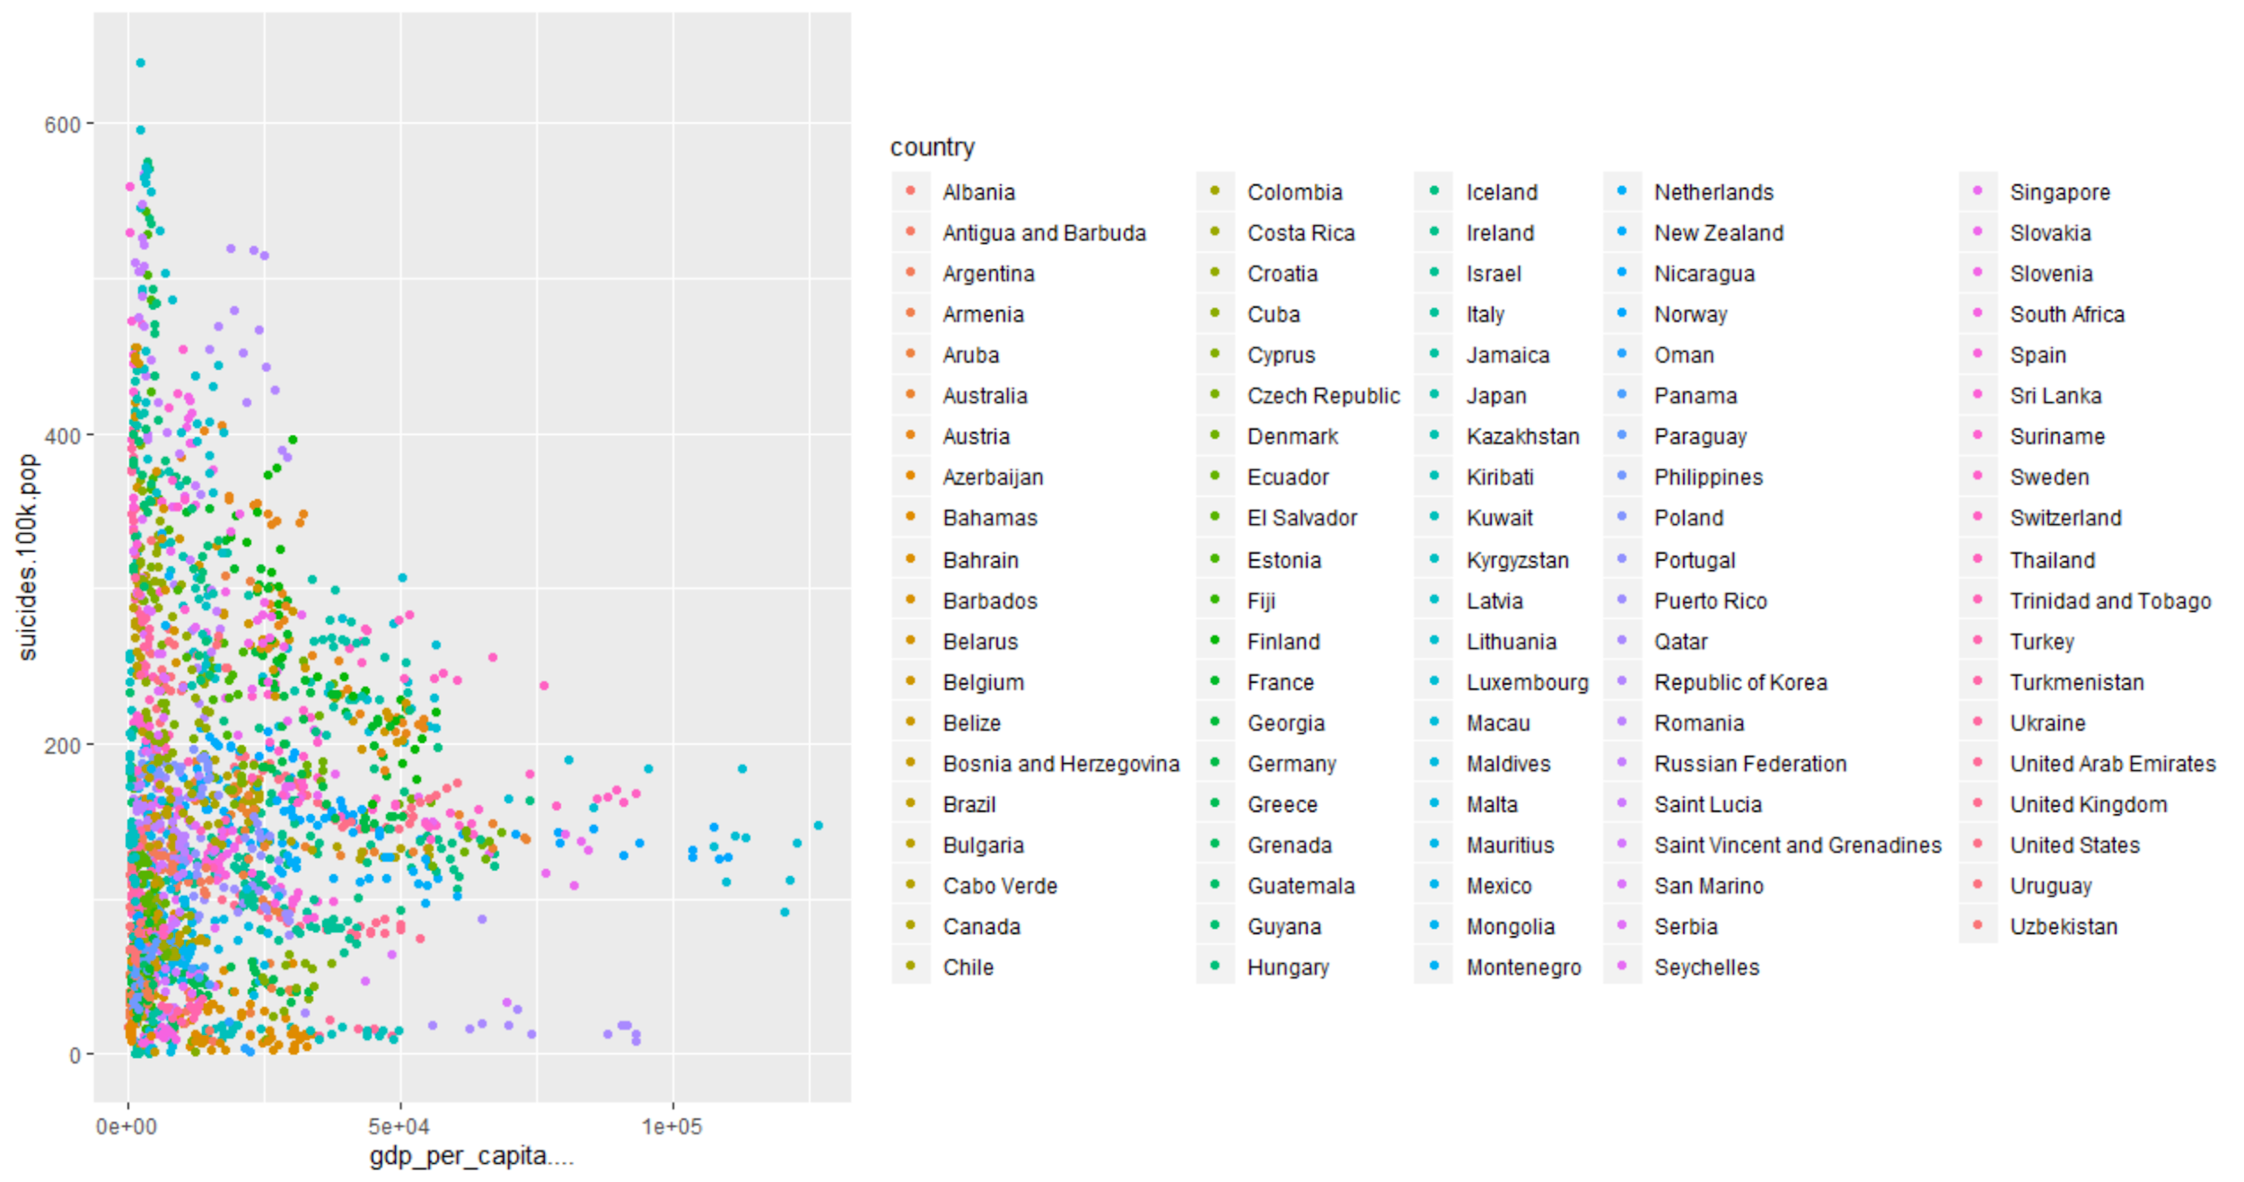

Figure 4: Suicide rate vs real GDP per capita identified by country

Assessing this data currently presented and summarised across 48 countries over the years 1985 - 2015, a further breakdown by country was necessary to better understand the conflicting observations and to determine whether or not real GDP per capita and suicide rates relate.

#### 4 countries were selected from the data set for further analysis: The United States, the United Kingdom, Japan and Russia.

The consumer price index data was found online at [Federal Reserve Bank of St Louis](https://fred.stlouisfed.org/) and the data across the years was applied to the GDP of these 4 countries where 2015 = 100 through the formula:

(Nominal GDP/(CPI/100)) = Real GDP

The real GDP was then divided by the population to find the real GDP per capita.

The reason behind these 4 countries is that the United States and United Kingdom are developing democratic western countries with comparable human development indexes across the years that share similar political systems and cultures.

Japan was selected due to its high level of development but drastically different culture and values and how that will compare to Western countries.

Russia was examined because although it states that it is a democracy, it is run as an oligarchy. It does not reflect similar culture or values as any of the countries above and is less developed in comparison.

| **Country** | **Human Development Index** |
| --- | --- |
| United States | 1995: 0.876  2014: 0.915 |
| United Kingdom | 1995: 0.837  2014: 0.907 |
| Japan | 1995: 0.838  2014: 0.891 |
| Russia | 1995: 0.700  2014: 0.813 |

Table 2: HDI for US, UK, Japan and Russia

Source : <http://www.hdr.undp.org/en/countries>

**United States**



|  |  |
| --- | --- |

Figure 5: Regression of US suicide rate vs real gdp per capita

Examining the data for the United States, we can see that as GDP per capita increases, suicide rate reduces by 0.0023. This is much higher when compared to the rest of the world which seems to show that GDP per capita or income is more correlated with sucide for people in the US. The low P value also seems to show that the data is statistically significant.

Visually, the real GDP per capita change from $43392.76 to $49757.61 (1985 - 1996) shows an overall reduction of suicides rate per 100k. During this time, real GDP per capita increased on average of 1.228% per annum while suicides rates per 100k showed a change of -0.980% per annum. However, when analysing data from 1996 onwards, we see a 0.999% increase per annum in real GDP per capita corresponding with a 0.245% increase per annum in suicide rates per 100k.

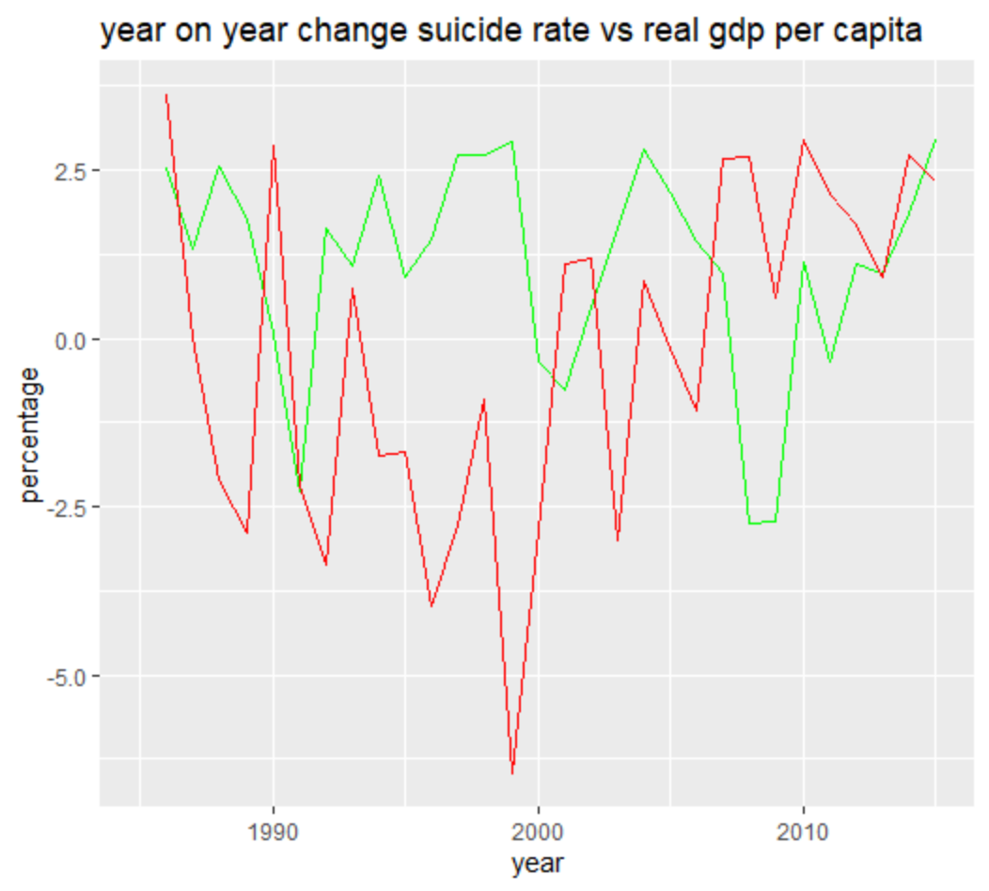

Figure 6: Year on year change of GDP per capita (*Green*) compared to suicide rate (*Red*) in the US

By calculating the year on year change of suicide rate compared to GDP per capita, we are able to see some consistent correlation between increased real GDP per capita growth rate when compared to suicide rates grwoth rate. Furthermore, the data does also seem to show consistent correlation with macro economic factors. During the dotcom bust of 2000, a dip in real GDP per capita change can be observed, at the same time suicide rate growth rose sharply.

However there are certain cases where this does not apply, such as 2010 where GDP per capita increased by 3.874% but the suicide rate also increased by 2.342%.

Running the correlation function in R on real GDP per capita and Suicide rates, it is observed that the correlation coefficient is -0.76, showing a strong negative correlation between real GDP per capita and suicide rates. However, there is still inconsistency of data and correlation across the years, which perhaps could be explained if other factors such as access to psychiatrists, mental health were also analysed.

**United Kingdom:**



|  |  |
| --- | --- |

Figure 7: Regression of UK suicide rate vs real gdp per capita

Examining the data of the United Kingdom, for every 1 increase in real GDP per capita, suicide rate reduces by 0.0008. The P value in this instant is also low, which seemingly indicates that the data is also statistically significant.

On average during this period, the real GDP per capita increased by 0.734% in comparison to suicide rate per 100k that changed by -1.098%.

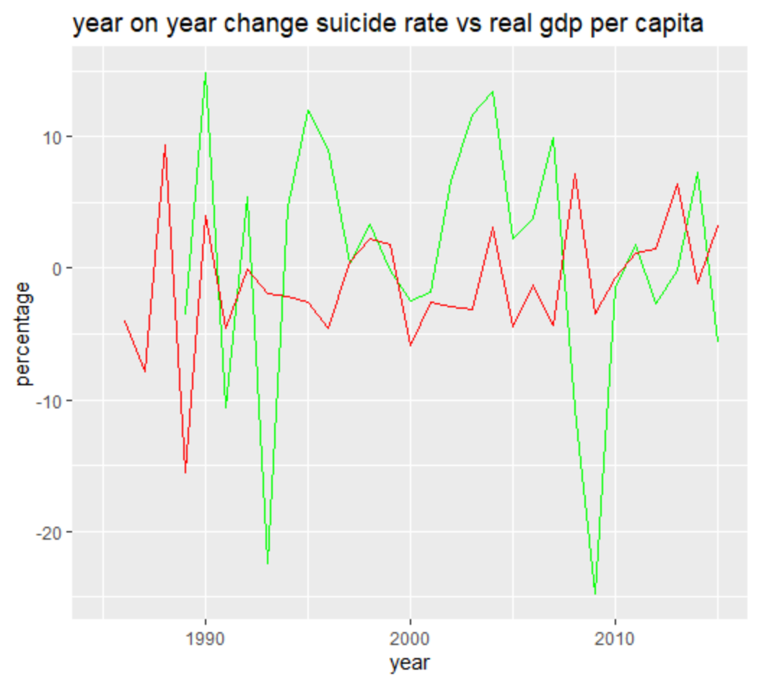

Figure 8: Year on year change of GDP per capita (*Green*) compared to suicide rate (*Red*) in the UK

Looking at the correlation between change in GDP per capita vs change in suicide rates, we see trends that are different from the one seen in the US data. There are many data points such as the ones in 1990, 2000 and 2004 where as the GDP growth rate increas corresponded to an increase in suicide growth rates. The data is also not consistent with macro economic factor seen by the reduction in GDP growth rate and suicide growth rate during the dotcom burst and 2008 financial crisis.

There is a -0.776 correlation between real GDP per capita and suicide rates in the United Kingdom, showing a strong negative correlation despite some inconsisten trends in the data.

**Japan:**

|  |  |
| --- | --- |



Figure 9: Regression of Japan suicide rate vs real gdp per capita

Examining the data of Japan, for every 1 increase in real GDP per capita, suicide rate reduces by 0.0018. The P value in this instant is also low, which seemingly indicates that the data is also statistically significant. In comparison to data in the US and UK, this data set is less statistically significant. The corresponding change in suicide rate with change in real GDP per capita is 2.25 times higher in Japan compared to the UK, but is lower compared to the United States.

During this period, the real GDP per capita increased by 2.384% on averaged correlating to a suicide rate per 100k that changed by -1.465% per annum.

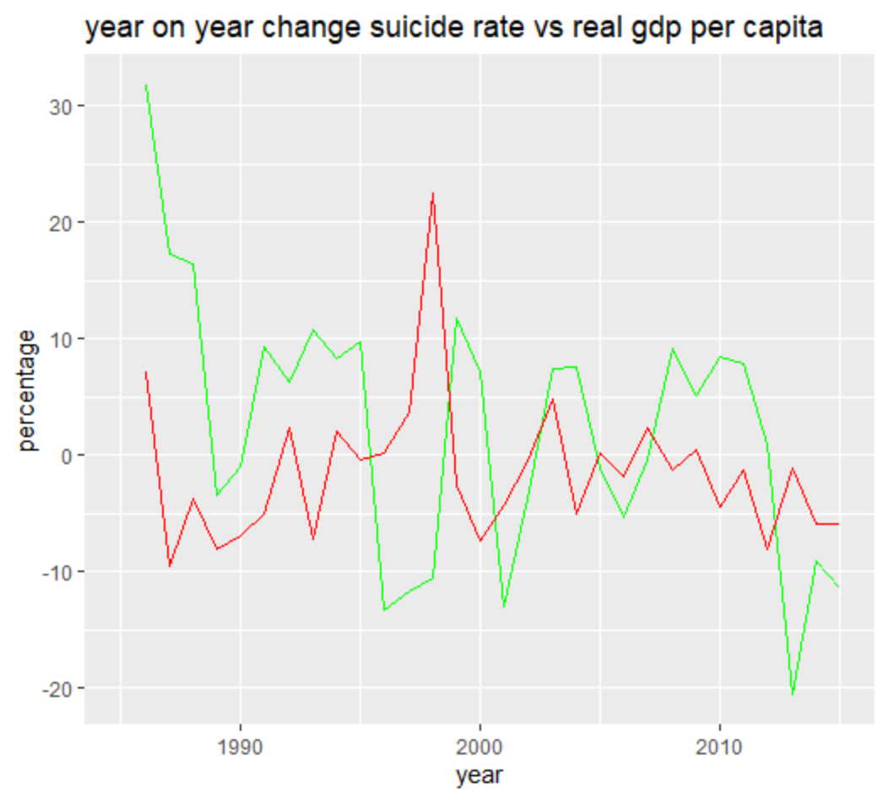

Figure 10: Year on year change of GDP per capita (*Green*) compared to suicide rate (*Red*) in Japan

Assessing year on year data, it can be observed that in year 1998 where real GDP per capita increased from previous year by 1.108%, suicide rate change from previous year increased by over 18%. In the year 2013, while the real GDP per capita from previous year reduced by 20%, the suicide rate from previous year also reduced by 1%. This indicates that there can be many other underlying factors that correlate to suicide rates aside from GDP per capita.

There is a correlation of -0.523 meaning there is a -0.5 correlation between real GDP per capita and suicide rates in Japan. Compared to the US and the UK, the real GDP per capita seems to contribute much less to suicide rates. In turn, Japan’s high suicide rate could be due to cultural factors such as culture and high unemployment rate amongst young people which is not correctly reflected through GDP per capita according to [BBC news](https://www.bbc.com/news/world-33362387).

**Russia:**

|  |  |
| --- | --- |



Figure 11: Regression of Russia suicide rate vs real gdp per capita

The data of the Russian Federation shows for every 1 increase in real GDP per capita there is a corresponding 0.00204 increase in suicide rate. This is unique to the data of UK, US and Japan considering that there is a low positive correlation of 0.3 which shows that there is no reason to show that a decrease in GDP per capita will increase suicide rate.

During this period, Russia’s real GDP per capita on average fell by 16.632% per annum while the suicide rate per 100,000 fell by 4.336% per annum.

The difference in analysis in Russian data stems from the irregularity of real GDP per capita numbers in comparison to US, UK and Japan. While the GDP for those three countries showed a consistent upwards trend over the years, Russia’s economy was much more turbulent due to the fall of the Soviet Union in the early 1990’s. More recently, during the invasion of Crimea, the country was also subjected to international sanctions.

#### Conclusion

Based on the analysis conducted in this project, the correlation between suicide rate and GDP per capita observed across the world is low, and therefore it would be unreasonable to assume that increase in GDP per capita will reduce suicie rates and an increase in GDP per capit to increase suicide rates.

When conducting further analysis into the data of the US, the UK, Japan and the Russian Federation, we see that for the US, UK and Japan there is a more of a trend and correlation when Consumer Price Index is applied to the GDP. Despite, the inconsistencies in regards to positive changes in GDP per capita will not always correspond to a negative change in suicide rates per 100k in the analysis, the data still shows moderate to high correlation in those three countries. Although real GDP per capita does contribute to suicide rates to a certain degree, there are many other factors that must also be taken into account when examining suicide rates.

#### Limitations

Initial analysis of the data and observations did not take into consideration inflation rate, which led to analysis that was heavily incluenced by suicide rate. Once the comment had been received in regards to suicide rate, the approach was changed to include inflation rate into the data set. However, it was difficult to find the exact method to adjust GDP per capita to inflation rate for the 48 countries across 30 years even with extensive online research. An attempt was made using the real GDP formula: nominal GDP / deflator rate / population. However it is unclear to me whether my calculations are precise. Through trial and error, the analysis arrived at two sets of varying results. The results below were eliminated from analysis.

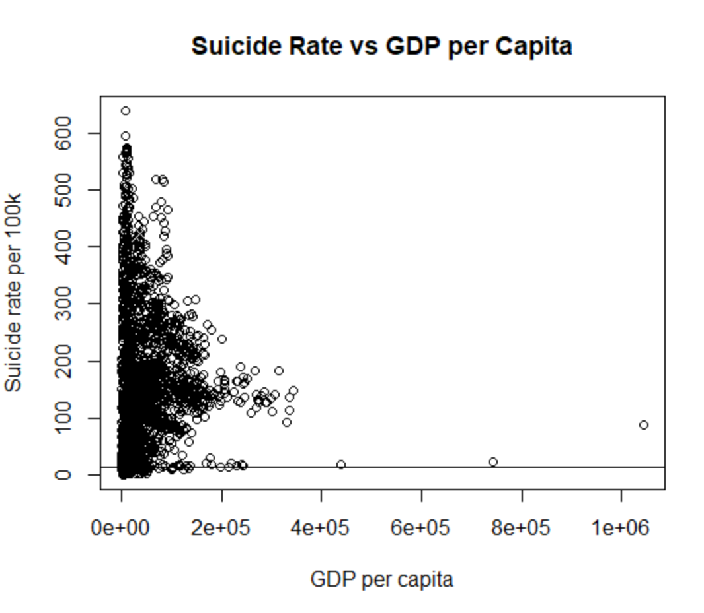

There was uncertainty in terms of which deflator rate was required in order to calculate the correct Real GDP per capita which led to the assumption that this analysis was not accurate. An attempt was made to use this new real GDP per capita value to examine it by country, the trend returned were similar to that of the data that had not been adjusted to inflation.

|  |  |
| --- | --- |

Although the initial data set looked promising, and interesting analysis was produced, it was soon apparent after the comments about inflation rates that it would be much more difficult to process, calculate and analyse the data set that takes inflation into account. Majority of previously established observations became obsolete with the newly manipulated set of data.

The previous analysis provided data that were seemingly much more obvious in terms of correlation, however it is for the benefit of the project that the suggestion of the instructor is taken into consideration in order to conduct correct analysis.

**Previous data with no consideration of inflation rate:**

|  |  |  |
| --- | --- | --- |

**If given more time**, it would have been important to be able to apply CPI rates consistently to every single country within the data set to be able to observe the change over time. It would have also been beneficial to have a deeper understanding of the oddity of Russian GDP data in comparison to other countries. There was much trial and error during this project in terms of calculating the GDP that was correctly adjusted to inflation, which resulted in a rushed re-analysis of the entire data set in the end.

It would also be insightfull to look into other factors that may correlate with suicide rate such as stress, happiness indicator, access to psychologist etc. Conduct regression analysis on these factors and compare them with the results of the analysis done on GDP per capita to determine what factors have a bigger impact on suicide rate. The current analysis is too linear as it was determined early that GDP per capita showed low correlation with suicide rate.