

**CSE101: Computer Programming**

**Project Title: Book Donation System**

**Submitted By:  
Pareedula H V Sai Krishna**

**Reg No: 12219635**

**Section: KOCMP**

**Roll No:58**

**Submitted to:**

**Radhika Nambiar**

**Introduction:**

The Book Donation System is a software application designed to assist organizations in managing their book donation process. The system allows the user to add, update, delete, search and display the book records stored in a file. This project was implemented using C programming language and leveraged the capabilities of file handling in C to store and manipulate the data.

The purpose of this report is to present the details of the Book Donation System and its functionalities. The report provides an overview of the project, its objectives, requirements and design. It also includes a detailed explanation of the different modules of the program, their functionality and working.

This report is structured as follows: Section 2 describes the objectives and requirements of the project. Section 3 presents the design and architecture of the system. Section 4 outlines the implementation details of the different modules of the program. Section 5 provides a testing methodology and results. Finally, Section 6 concludes the report and discusses future scope of the project.

Overall, the Book Donation System provides a simple and efficient solution for managing book donations for non-profit organizations. It streamlines the donation process and makes it easier to manage book records. The system can be easily extended to include additional features and integrate with other systems.

**Modules:**

1. **void Display():** This function reads all the book records from the file and displays them to the user. It first opens the file in read mode and reads the records one by one using a while loop. For each record, it prints out the values of all its attributes like the book ID, year of publication, title of the book, author's name, donor's name and receiver's name on the screen. Once all the records have been read and printed, the function closes the file.
2. **void Add():** This function adds a new book record to the file based on inputs entered by the user. It first opens the file in append mode, which means that any new records will be added at the end of the file. Then it takes user input for all the attributes of the record like the book ID, year of publication, title of the book, author's name, donor's name and receiver's name. The function then writes this record to the end of the file and closes the file.
3. **void Delete():** This function deletes a book record from the file based on the book ID entered by the user. It first checks if the record with the given book ID exists in the file or not by calling the helper function Check(int id). If the record exists, it opens the file in read mode and another temporary file in write mode. It then reads all the records from the original file one by one, except for the record with the given book ID. It writes these records one by one to the temporary file. Once all the records have been copied to the temporary file, the original file is closed, the temporary file is renamed as the original file and closed.
4. **void Update():** This function updates an existing book record in the file based on the book ID entered by the user. It first checks if the record with the given book ID exists in the file or not by calling the helper function Check(int id). If the record exists, it opens the file in read/write mode and another temporary file in write mode. It then reads all the records from the original file one by one. If the current record has the same book ID as entered by the user, it prompts the user to enter new values for any or all of the record attributes like the book ID, year of publication, title of the book, author's name, donor's name and receiver's name. Once the updated record has been created, it writes it to the temporary file. Once all the records have been read and updated, the original file is closed, the temporary file is renamed as the original file and closed.
5. **void Search():** This function searches for a book record in the file based on the book ID entered by the user. It first opens the file in read mode and reads all the records from the file one by one. If the current record has the same book ID as entered by the user, it prints out the details of that record like the book ID, year of publication, title of the book, author's name, donor's name and receiver's name on the screen. Once the search is complete or all records have been searched, the function closes the file.
6. **main():** This function is the entry point of the program and drives its flow. It first displays a menu of options like Add, Update, Delete, Display, Search and Exit to the user. It takes user input for the choice and invokes the corresponding function based on the choice. The loop continues until the user chooses to exit the program by entering 6.

**Pseudo Code:**

1. Declare a struct to hold book records with fields for book ID, year of publication, title, author, donor and receiver.
2. Define five functions: Display(), Add(), Update(), Delete(), and Search().
3. In the main() function, create a loop that displays a menu of options until the user chooses to exit the program.
4. In the Add() function, prompt the user for information about a new book and write it to a file.
5. In the Delete() function, prompt the user for the book ID of the record they want to delete, check if it exists in the file, remove it from the file and write the updated file to disk.
6. In the Update() function, prompt the user for the book ID of the record they want to update, allow them to choose which field(s) to update, and write the updated record to a temporary file. When all records have been processed, replace the original file with the temporary file.
7. In the Display() function, prompt the user to display all records or a specific record by book ID. Read the data from the file and print the appropriate records.
8. In the Search() function, prompt the user for a search query and search the file for matching records based on either title or author.

**Source Code**

#include <stdio.h>

#include <stdlib.h>

#include <string.h>

struct Books_Record

{

    int Book_id;

    int Year;

    char Title[500];

    char Author[500];

    char Donor[500];

    char Reciver[500];

} b1;

void Display();

void Add();

void Delete();

void Update();

void Search();

int Check(int id);

FILE *Record;

int main()

{

    int choice_1;

    do

    {

        printf("\n----------BOOK DONATION SYSTEM----------\n");

        printf("1.Add Record\n2.Update Record\n3.Delete Record\n4.Display\n5.Search\n6.Exit\n");

        printf("Enter Your Choice: ");

        scanf("%d", &choice_1);

        switch (choice_1)

        {

        case 1:

            Add();

            break;

        case 2:

            Update();

            break;

        case 3:

            Delete();

            break;

        case 4:

            Display();

            break;

        case 5:

            Search();

            break;

        case 6:

            printf("Thanks for using the Program");

            break;

        default:

            printf("The Choice you entered is Wrong");

        }

    } while (choice_1 != 6);

    return 0;

}

void Add()

{

    Record = fopen("MasterRecord.txt", "a+");

    printf("Loading Add Record Module....\n");

    printf("Enter the Title of the Book: ");

    fflush(stdin);

    scanf("%[^\n]", b1.Title); // using a scanset to read input

    printf("Enter the Book ID: ");

    scanf("%d", &b1.Book_id);

    printf("Enter the Year of Publishing: ");

    scanf("%d", &b1.Year);

    fflush(stdin);

    printf("Enter the Author of The Book: ");

    scanf("%[^\n]", b1.Author); // using a scanset to read input

    fflush(stdin);

    printf("Enter the Name of Donor: ");

    scanf("%[^\n]", b1.Donor); // using a scanset to read input

    fflush(stdin);

    printf("Enter The name of the Receiver: ");

    scanf("%[^\n]", b1.Reciver); // using a scanset to read input

    fflush(stdin);

    fwrite(&b1, sizeof(b1), 1, Record);

    fclose(Record);

    printf("Book Record Added Sucessfully\n");

}

int Check(int id)

{

    Record = fopen("MasterRecord.txt", "r");

    while (fread(&b1, sizeof(b1), 1, Record))

    {

        if (id == b1.Book_id)

        {

            return 1;

        }

    }

    return 0;

}

void Update()

{

    FILE *temp;

    int id;

    printf("Loading Update Module....\n");

    printf("Enter the Book ID of the record you want to update: ");

    scanf("%d", &id);

    Record = fopen("MasterRecord.txt", "r");

    temp = fopen("TempRecord.txt", "w");

    int flag = 0;

    while (fread(&b1, sizeof(b1), 1, Record))

    {

        if (id == b1.Book_id)

        {

            flag = 1;

            printf("1.Update Title\n2.Update Book ID\n3.Update Year\n4.Update Author\n5.Update Donors Name\n6.Update Receivers Name\n7.Update All\n");

            int choice;

            printf("Enter Your Choice: ");

            scanf("%d", &choice);

            switch (choice)

            {

            case 1:

                printf("Enter the Title of the Book: ");

                scanf(" %[^\n]", b1.Title); // using a scanset to read input

                break;

            case 2:

                printf("Enter the new Book ID");

                scanf("%d", &b1.Book_id);

                break;

            case 3:

                printf("Enter the Year of Publication ");

                scanf("%d", &b1.Year);

                break;

            case 4:

                printf("Enter the Author's Name: ");

                scanf(" %[^\n]", b1.Author); // using a scanset to read input

                break;

            case 5:

                printf("Enter the Donors name: ");

                scanf(" %[^\n]", b1.Donor); // using a scanset to read input

                break;

            case 6:

                printf("Enter the Receivers name: ");

                scanf(" %[^\n]", b1.Reciver); // using a scanset to read input

                break;

            case 7:

                printf("Enter the Title of the Book: ");

                scanf(" %[^\n]", b1.Title); // using a scanset to read input

                printf("Enter the Book ID: ");

                scanf("%d", &b1.Book_id);

                printf("Enter the Year of Publishing: ");

                scanf("%d", &b1.Year);

                printf("Enter the Author of The Book: ");

                scanf(" %[^\n]", b1.Author); // using a scanset to read input

                printf("Enter the Name of Donor: ");

                scanf(" %[^\n]", b1.Donor); // using a scanset to read input

                printf("Enter The name of the Receiver: ");

                scanf(" %[^\n]", b1.Reciver); // using a scanset to read input

                break;

            default:

                printf("Wrong Choice\n");

            }

            fwrite(&b1, sizeof(b1), 1, temp);

            printf("After Updation: \n");

            printf("The Book ID is : %d\n", b1.Book_id);

            printf("The Book Title is : %s\n", b1.Title);

            printf("The Author of the book is : %s\n", b1.Author);

            printf("The Year of Publication of the book is: %d\n", b1.Year);

            printf("The book was donated by : %s\n", b1.Donor);

            printf("The book was recived by: %s\n", b1.Reciver);

        }

        else

        {

            fwrite(&b1, sizeof(b1), 1, temp);

        }

    }

    if (flag == 1)

    {

        fclose(Record);

        fclose(temp);

        temp = fopen("TempRecord.txt", "r");

        Record = fopen("MasterRecord.txt", "w");

        while (fread(&b1, sizeof(b1), 1, temp))

        {

            fwrite(&b1, sizeof(b1), 1, Record);

        }

        fclose(Record);

        fclose(temp);

    }

    else

    {

        printf("Book With ID not found in Records.\n");

    }

}

void Delete()

{

    printf("Loading Delete Module....\n");

    Record = fopen("MasterRecord.txt", "r");

    FILE *temp;

    temp = fopen("TempRecord.txt", "w");

    int id;

    printf("Enter the ID of the book you want to delete: ");

    scanf("%d", &id);

    int record_deleted = 0; // flag variable

    while (fread(&b1, sizeof(b1), 1, Record))

    {

        if (id == b1.Book_id)

        {

            printf("Deleting Record\n");

            record_deleted = 1;

        }

        else

        {

            fwrite(&b1, sizeof(b1), 1, temp);

        }

    }

    fclose(Record);

    fclose(temp);

    if (record_deleted)

    {

        printf("Record Successfully Deleted.\n");

        Record = fopen("MasterRecord.txt", "w");

        temp = fopen("TempRecord.txt", "r");

        while (fread(&b1, sizeof(b1), 1, temp))

        {

            fwrite(&b1, sizeof(b1), 1, Record);

        }

        fclose(Record);

        fclose(temp);

    }

    else

    {

        printf("Book with ID %d not found in the records.\n", id);

    }

}

void Display()

{

    printf("Loading Display Module....\n");

    int choice;

    printf("Enter 1 to display all records or 2 to display a specific record: ");

    scanf("%d", &choice);

    int bookId;

    Record = fopen("MasterRecord.txt", "r");

    switch (choice)

    {

    case 1:

        printf("Displaying All Records: \n\n");

        while (fread(&b1, sizeof(b1), 1, Record))

        {

            printf("The Book ID is : %d\n", b1.Book_id);

            printf("The Book Title is : %s\n", b1.Title);

            printf("The Author of the book is : %s\n", b1.Author);

            printf("The Year of Publication of the book is: %d\n", b1.Year);

            printf("The book was donated by : %s\n", b1.Donor);

            printf("The book was received by: %s\n\n", b1.Reciver);

        }

        break;

    case 2:

        printf("Enter the Book ID to display its details: ");

        scanf("%d", &bookId);

        printf("Searching Book with bookid %d", bookId);

        while (fread(&b1, sizeof(b1), 1, Record))

        {

            if (b1.Book_id == bookId)

            {

                printf("The Book ID is : %d\n", b1.Book_id);

                printf("The Book Title is : %s\n", b1.Title);

                printf("The Author of the book is : %s\n", b1.Author);

                printf("The Year of Publication of the book is: %d\n", b1.Year);

                printf("The book was donated by : %s\n", b1.Donor);

                printf("The book was received by: %s\n\n", b1.Reciver);

                break;

            }

        }

        if (feof(Record))

        {

            printf("Book with ID %d not found in the records.\n", bookId);

        }

        break;

    default:

        printf("Invalid choice.\n");

        break;

    }

    fclose(Record);

}

void Search()

{

    Record = fopen("MasterRecord.txt", "r");

    printf("Loading Search Module....\n");

    int choice;

    char query[500];

    printf("1.Search by Title\n2.Search by Author\n");

    printf("Enter your choice: ");

    scanf("%d", &choice);

    switch (choice)

    {

    case 1:

        printf("Enter the Title: ");

        fflush(stdin);

        scanf("%[^\n]", query);

        while (fread(&b1, sizeof(b1), 1, Record))

        {

            if (strcmp(query, b1.Title) == 0)

            {

                printf("\nBook Found Scucessfully.....\n\n");

                printf("The Book ID is : %d\n", b1.Book_id);

                printf("The Book Title is : %s\n", b1.Title);

                printf("The Author of the book is : %s\n", b1.Author);

                printf("The Year of Publication of the book is: %d\n", b1.Year);

                printf("The book was donated by : %s\n", b1.Donor);

                printf("The book was received by: %s\n", b1.Reciver);

                break;

            }

        }

        if (feof(Record))

        {

            printf("Book with Title %s not found in the records.\n", query);

        }

        break;

    case 2:

        printf("Enter the Author: ");

        fflush(stdin);

        scanf("%[^\n]", query);

        while (fread(&b1, sizeof(b1), 1, Record))

        {

            if (strcmp(query, b1.Author) == 0)

            {

                printf("\nBook Found Scucessfully.....\n\n");

                printf("The Book ID is : %d\n", b1.Book_id);

                printf("The Book Title is : %s\n", b1.Title);

                printf("The Author of the book is : %s\n", b1.Author);

                printf("The Year of Publication of the book is: %d\n", b1.Year);

                printf("The book was donated by : %s\n", b1.Donor);

                printf("The book was received by: %s\n", b1.Reciver);

                break;

            }

        }

        if (feof(Record))

        {

            printf("Book with Author %s not found in the records.\n", query);

        }

        break;

    default:

        printf("Wrong Choice!\n");

        break;

    }

    fclose(Record);

}

**Output**

**Initial Output Screen:**

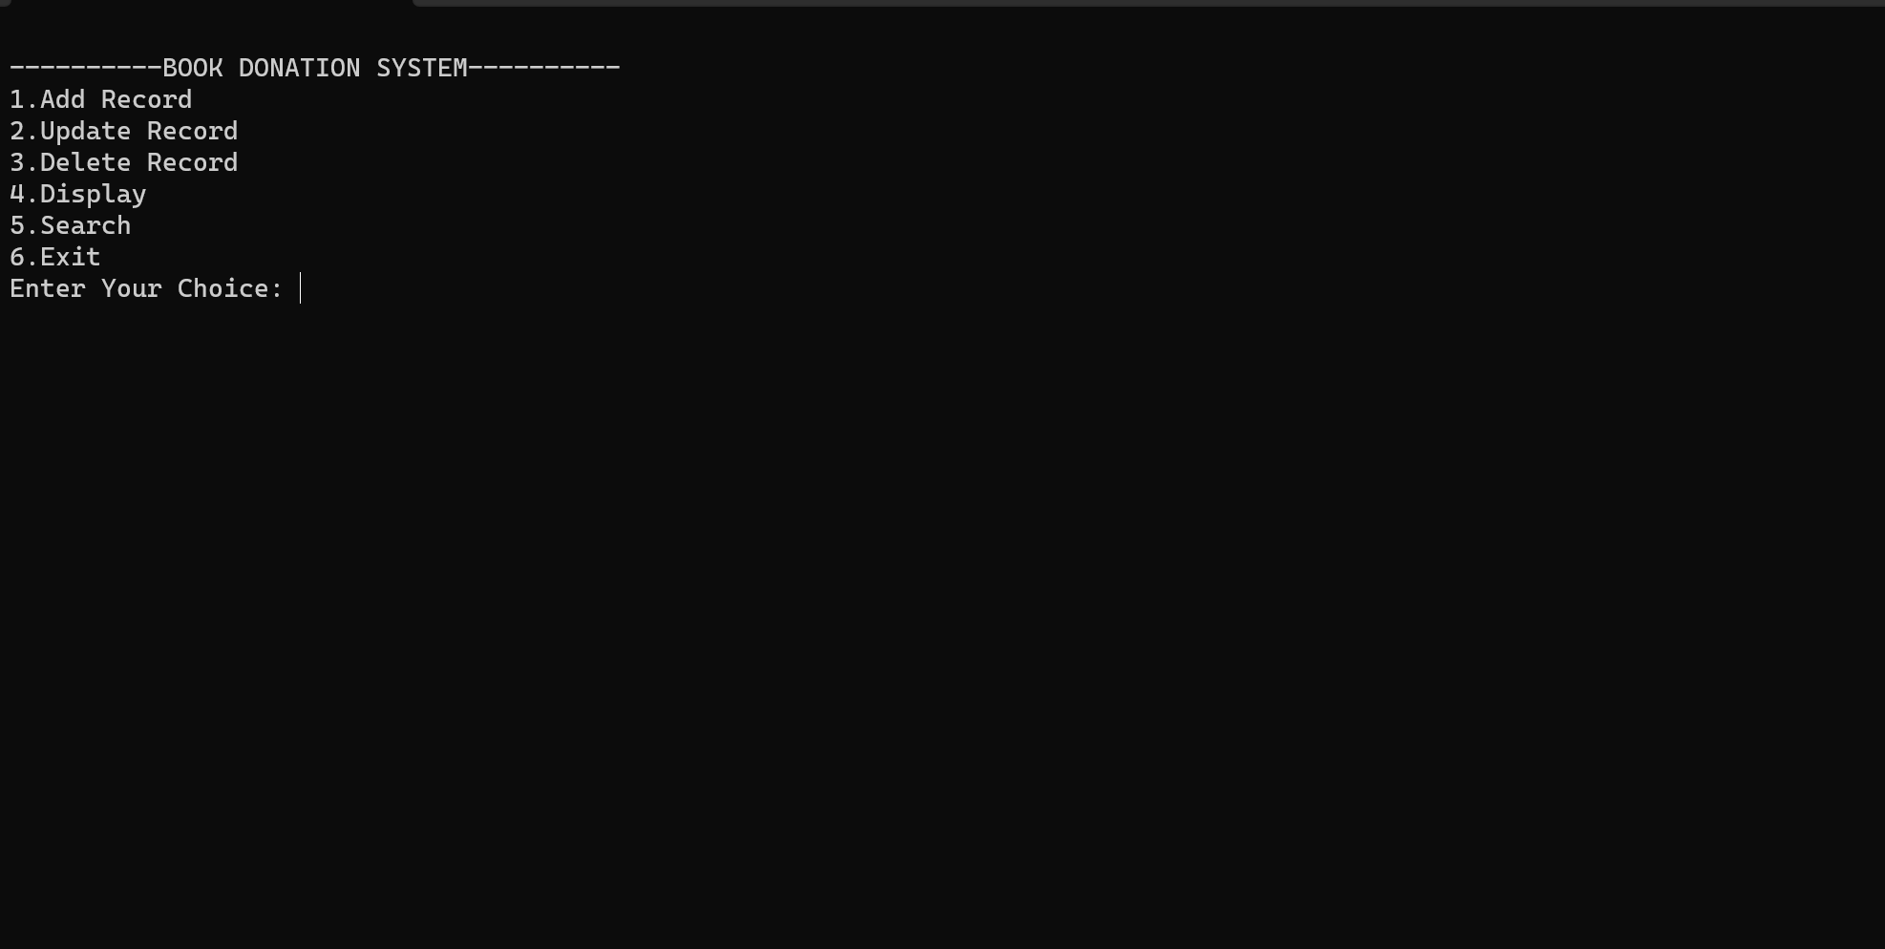

**Module 1: Add Record**

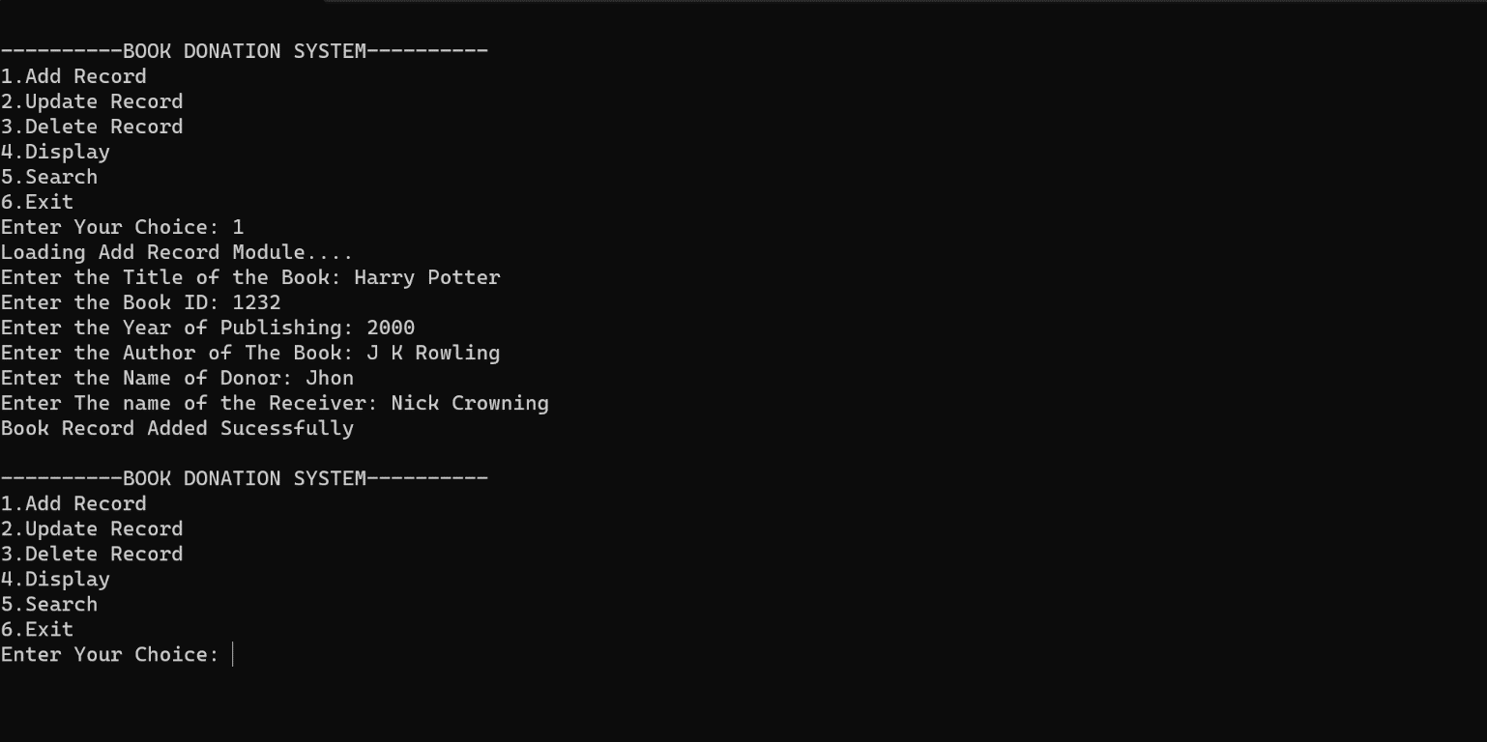

**Module 2 : Update Record**

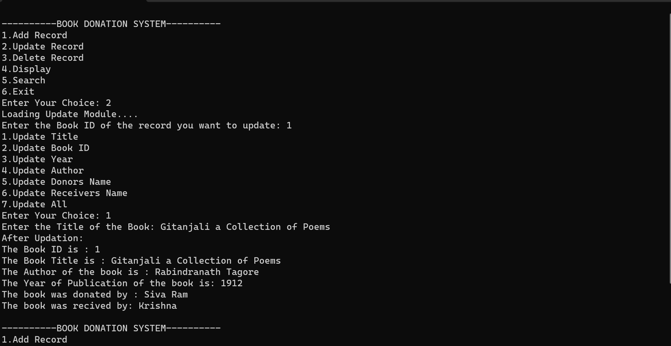

**Module 3: Delete Record**

**Module 4 : Display Module**

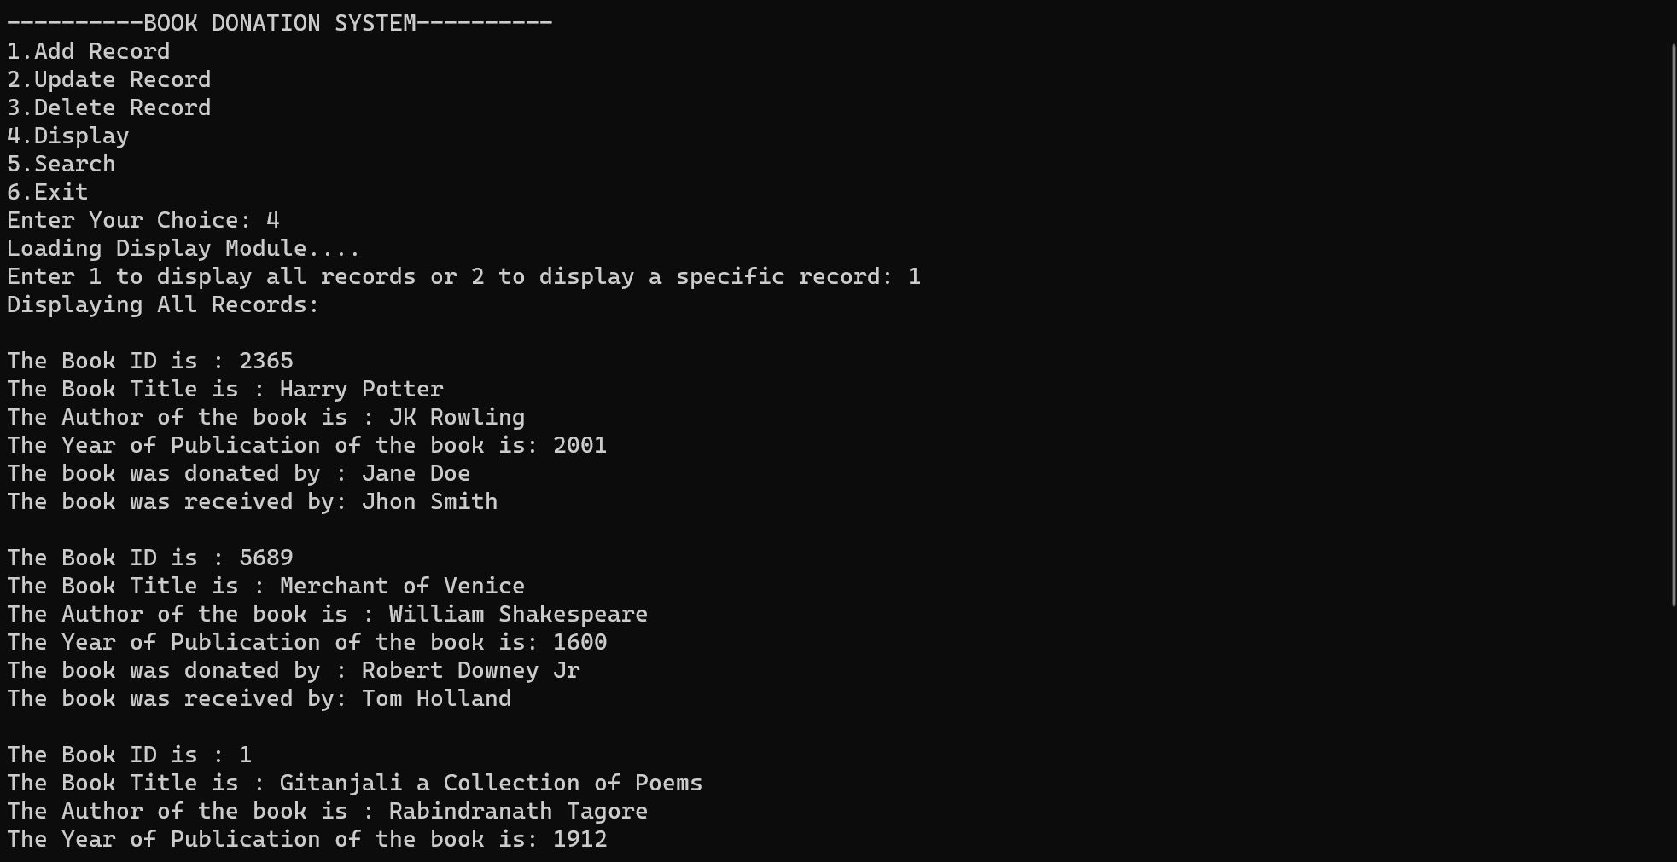

**Module 5: Search**

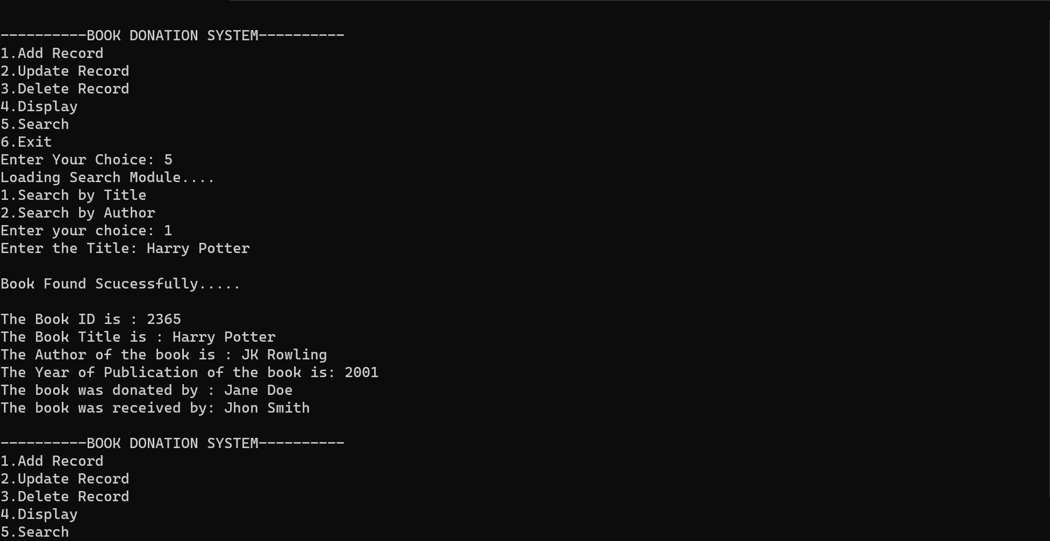

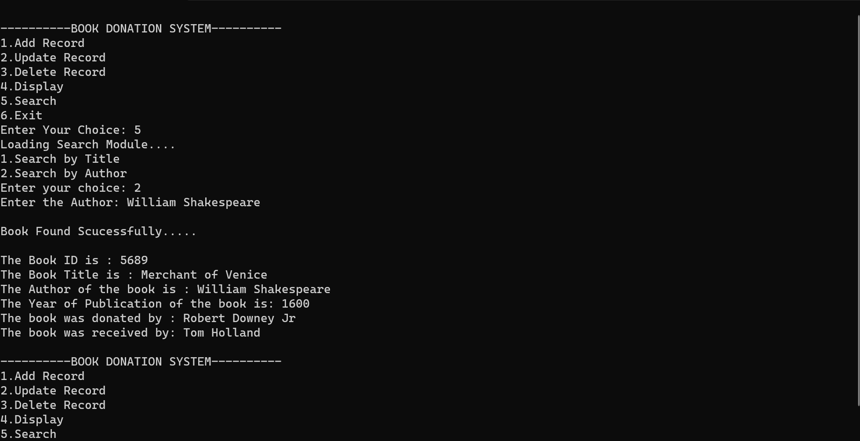

**Exit Screen:**

