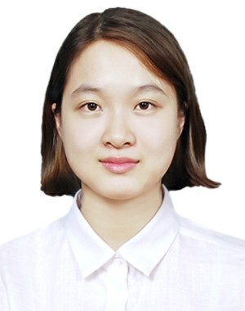DUONG THI LY

**Date of birth** Dec 11, 1995

**Gender** Female

**Phone** 0973839454

**Email** [lyduong1112@gmail.com](mailto:lyduong1112@gmail.com)

**Address** Xom Day-Dai Yen-Chuong My-Ha Noi

**Website** https://[www.facebook.com/lyduong1112](http://www.facebook.com/lyduong1112)

# OBJECTIVE

* Accumulate, improve skills and experiences to improve myself.
* Find a stable job that can stick to the long run.
* Become responsible, professional, always try to complete the work.
* Bring a lot value to the company. From that, I will contribute to development of company as well as find opportunities for promotion in the workplace.

# EDUCATION

Sep 2013 - Jun 2017 **Ha Noi University Of Science**

Major: Chemical Engineering GPA: 3.21/4.0

# WORK EXPERIENCE

## 2017 - 2018 VIAGS TAN SON NHAT - Vietnam Airport Ground Services Company Limited TSN

Service Staff

* + Guide and support passengers when checking at the airport.
  + Help the elderly, children, people with disabilities ...
  + Work in checkin counter and departure gate.

2019 - Present **Samsung Electronics Vietnam Thai Nguyen Co.,Ltd**

HR Staff

* + Make MBO Evaluation for Operator and Technician
  + Manage working time, overtime; checking the attendance data for employees...
  + Training policies, benifits, regulation company for employees
  + Make other reports as required by management...

# ACTIVITIES

## 11/2013 "NHỮNG BÀI CA ĐI CÙNG NĂM THÁNG" PROGRAM

Member of the Organizing Committee

* + Organizing music programs for pupils and students.
  + Prepare music questions for the program.
  + Support students to participate in the contest.

## 11/2016 CELEBRATE THE 60TH ANNIVERSARY OF THE FACULTY OFCHEMISTRY

Member

* + Join reception group to welcome guests.
  + Join sports, music, camping for students

10/2013 - 06/2014 **CHEMICAL CLUB**

Member

* + Organizing programs, meetings in the club.
  + Find chemical questions and perform experiments for the Olympia program.

06/2014 - 01/2015 **" TỰ NGUYỆN" CLUB**

Member

* + Participate in the activities of the club
  + Participate in volunteer activities in Lung Ca, Thai Nguyen.
  + Help children with autism in Sao Mai center.

03/2014 **" NIỀM TIN ÁNH SÁNG-ULIS " CLUB**

Volunteer

* + Participate in volunteer activities in Chiem Hoa, Tuyen Quang.
  + Join the show program of the club and the local.

# HONORS & AWARDS

2013-2017 - Member of the Organizing Committee of the program " Những bài ca đi cùng năm tháng " of the Faculty of Chemistry.

* + Join the 60th anniversary of the establishment of the Faculty of Chemistry.
  + Achieve excellence in the academic year 2013-2017.

# INTERESTS

Traveling, music, badminton,...

# ADDITIONAL INFORMATION

* Knowledge of chemistry, work and research in the lab.
* Friendly, sociable.
* Hardworking
* Withstand the pressure of work.
* Good communication and problem solving skills.
* Good healthy.

© topcv.vn