Project Documentation (TROUBLESHOOTING)
- UA="(itmo-444-544 weather lab, you@example.com)"
  - FORECAST_URL=$(curl -s -H "User-Agent: $UA" "https://api.weather.gov/points/41.8458,-87.6272" \ | python3 -c "import sys,json; print(json.load(sys.stdin)['properties']['forecast'])") curl -s -H "User-Agent: $UA" "$FORECAST_URL" | python3 -m json.tool | head -40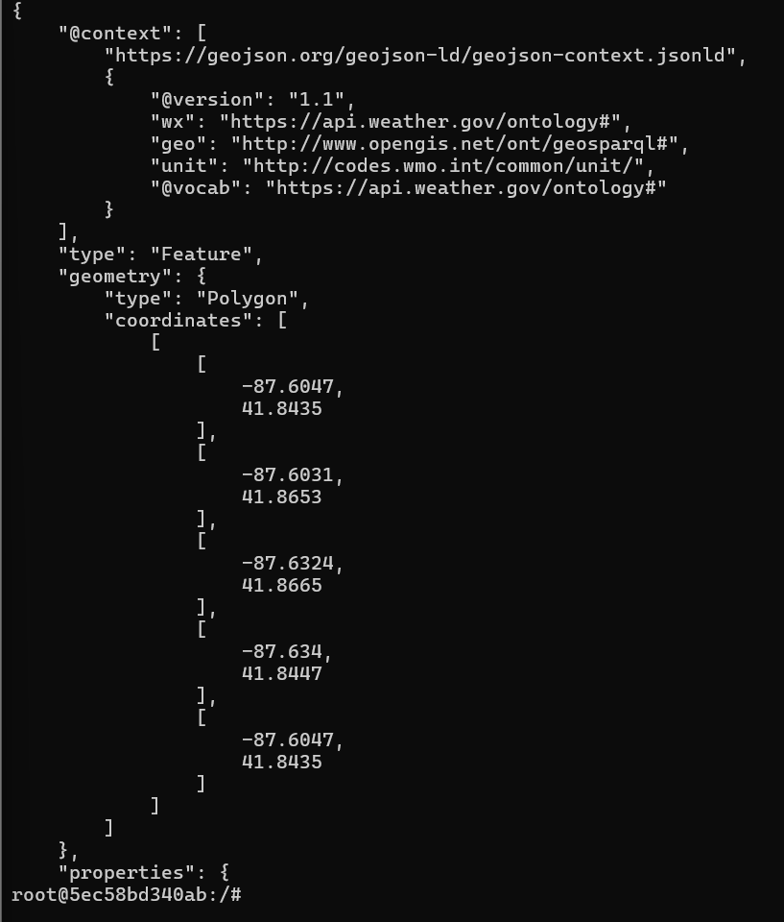
- Note: API key does not start with Aiza anymore; rather, it starts with AQ.
- Lab instructions does not mention which Gemini model to choose. I chose gemini-3.5-flash-lite for cost effectiveness. Set it with export GEMINI_MODEL="gemini-3.5-flash-lite".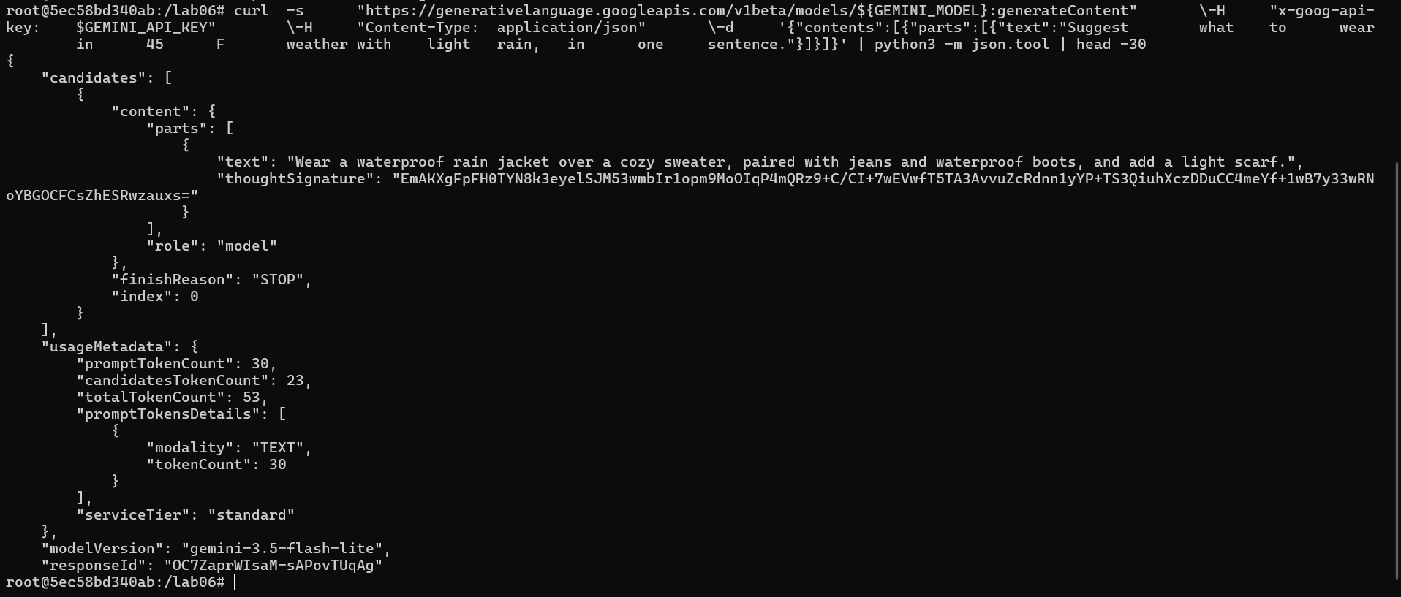
- Troubleshoot the aws ssm command not working [PERMISSION NOT EXISTS]; create an inline policy with this template on lab account:
{
"Version": "2012-10-17",
"Statement": [
{
"Effect": "Allow",
"Action": [
"ssm:PutParameter",
"ssm:GetParameter",
"ssm:DeleteParameter",
"ssm:AddTagsToResource"
],
"Resource": "arn:aws:ssm:us-east-2:XXXXXXXXXXXX:parameter/itmo-444-544/gemini-api-key"
},
{
"Effect": "Allow",
"Action": "ssm:DescribeParameters",
"Resource": "*"
}
]
}

- 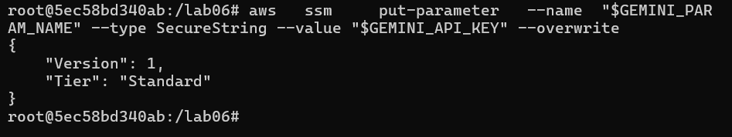
- Another permissions error: 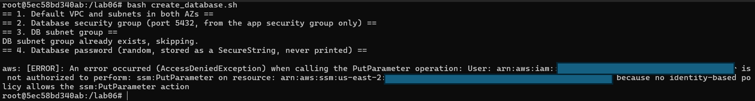
  - Add AWS managed permissions to save on customer inline policy limit (max of 2048 bytes): add DynamoDB, EC2FullAccess, RDSFullAccess, SSMFullAccess, AutoScalingFullAccess, IAMFullAccess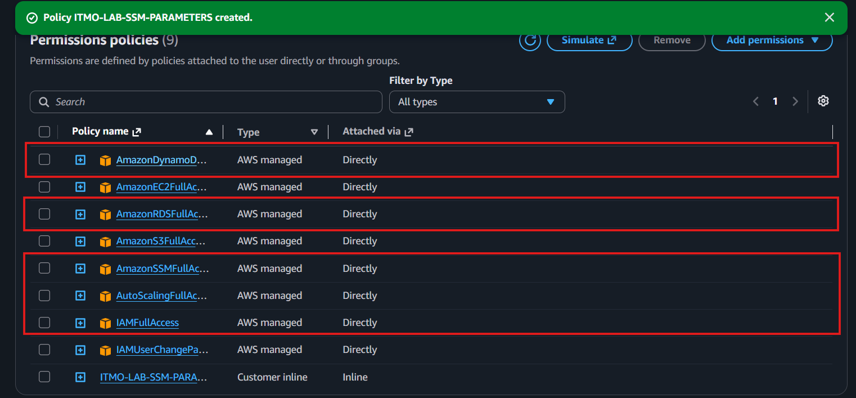
- Python3 app_smoke_test.py fails: 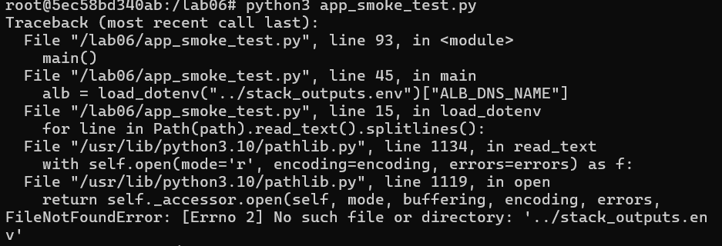
  - Solution: move the python file into /lab06/testing/ and run from inside the /testing/ directory, since ../stack_outputs.env is within the /lab06/ directory and not within the root (/) directory.
- Permission denied when attempting to access weather journal. 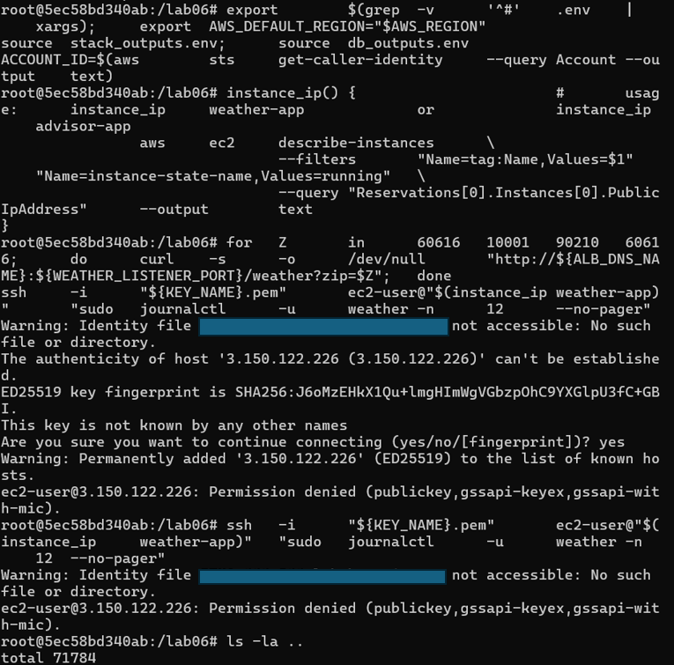
  - Solution, add .pem keypair to the repository, but ensure that .gitignore has *.pem included so the keypair is not visible in the repo. Remove the keypair.pem file from the repo before committing as a safeguard.

THIS PAGE HAS BEEN LEFT BLANK INTENTIONALLY
LAB REPORT QUESTIONS
- Part 0: Output of ls -R lab06 | head -40, showing the layout.
  - 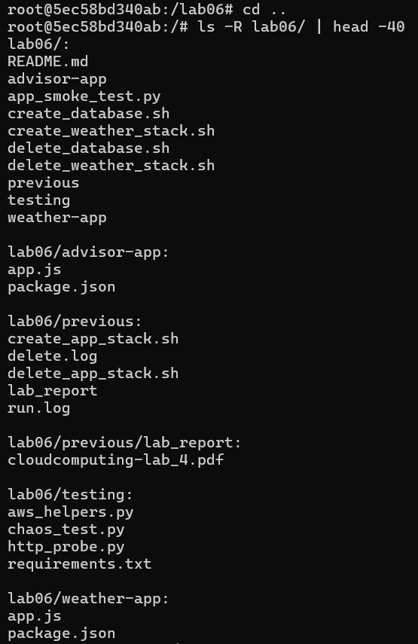
- Part A: Output of the NWS calls, and one sentence on why two upstream calls are needed.
  - The National Weather Service API works only through latitude and longitude coordinates, but we only have ZIP codes; so, to satisfy NWS’ required input, we convert our human-friendly ZIP code to machine-friendly global positioning system coordinates. 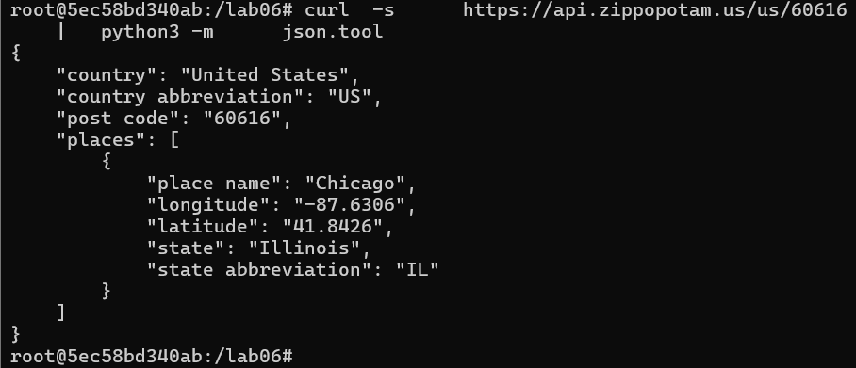
  - 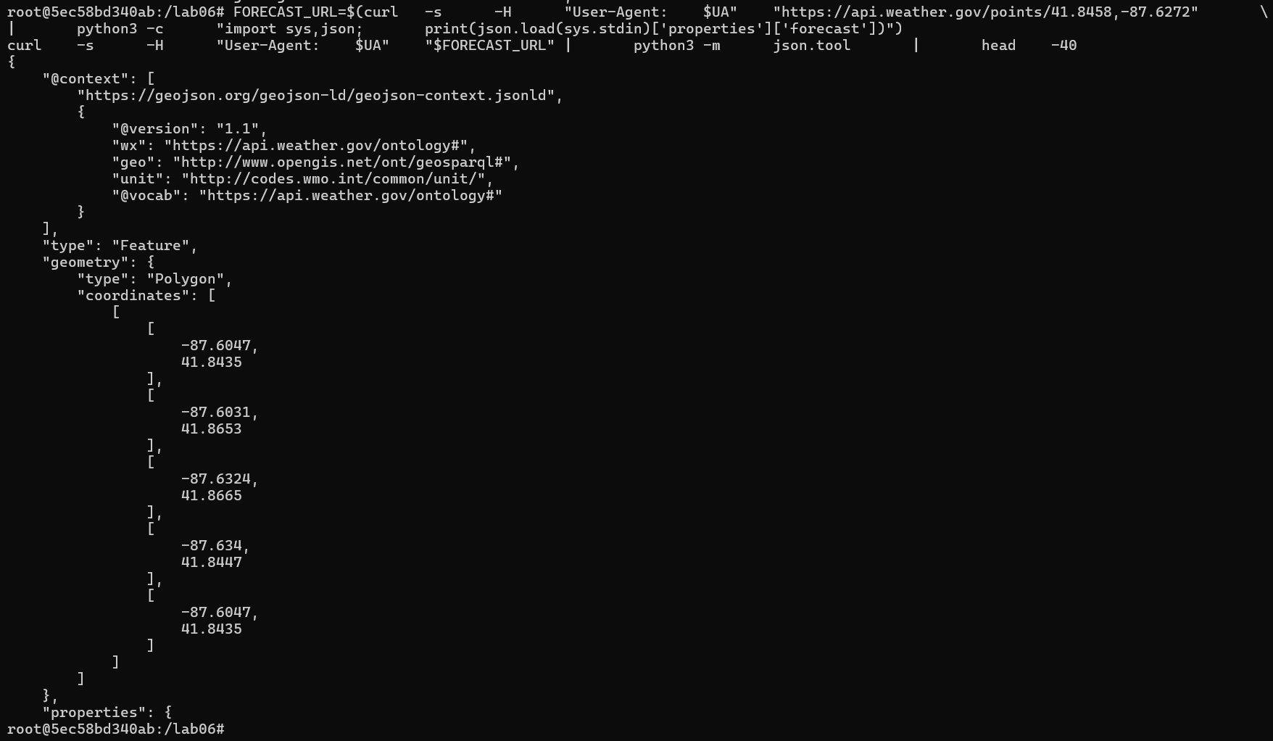
- Output of create_database.sh.
  - 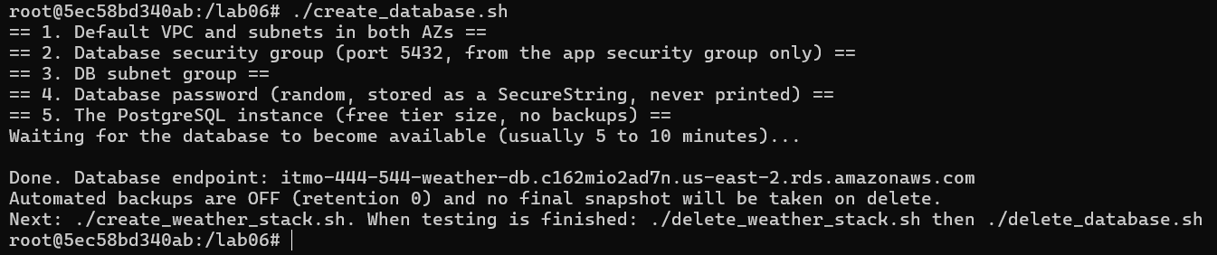
- Step 4: Output showing retention 0, not public, single-AZ, and empty snapshot and automated backup lists.
  - 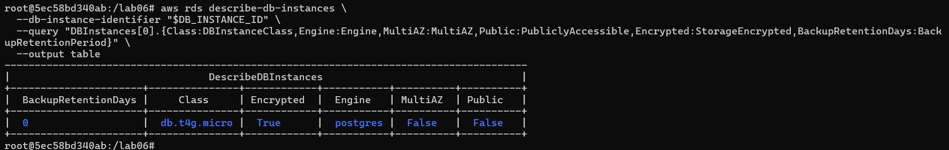
  - 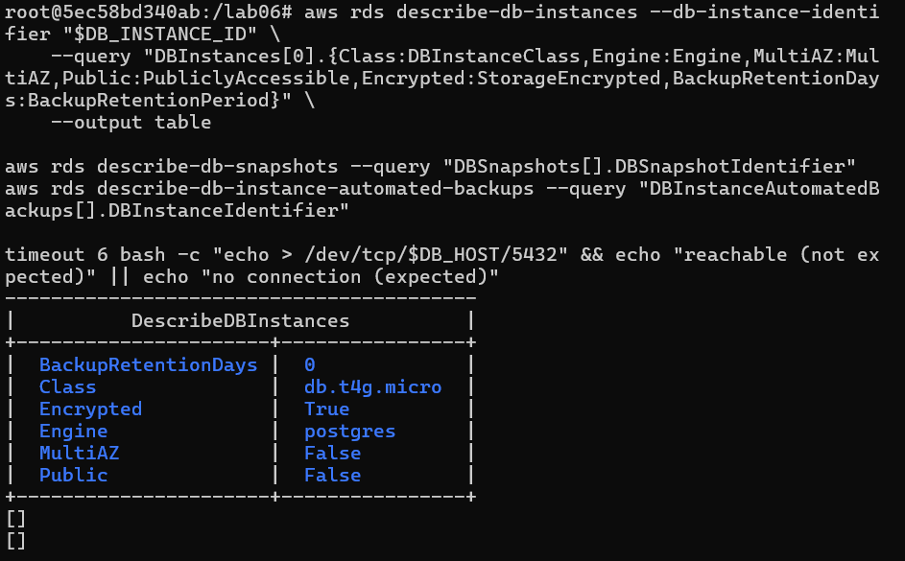
  - 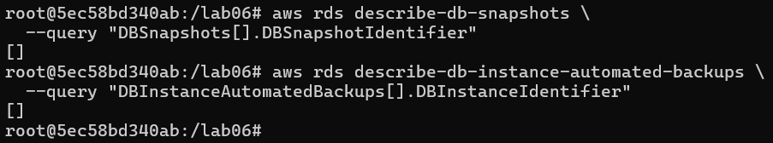
  - 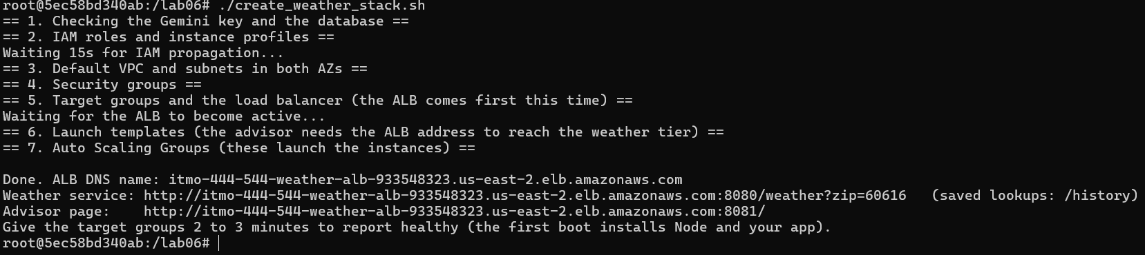
- Screenshot of the advisor page showing a suggestion for a zip code, and the JSON from /advice?zip=... for the same zip.
  - 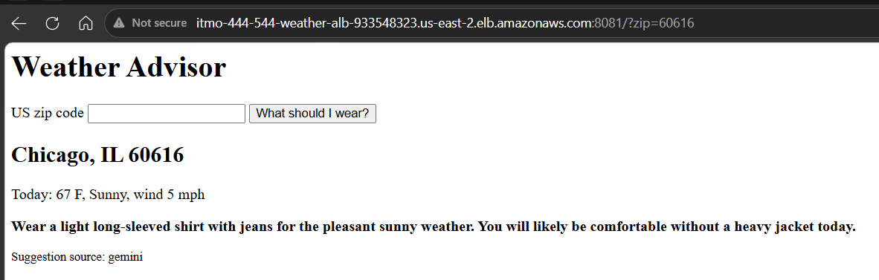
  - 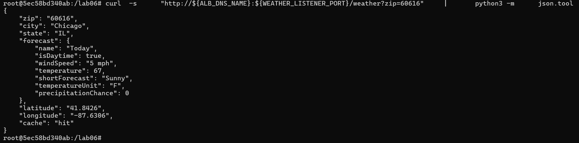
  - 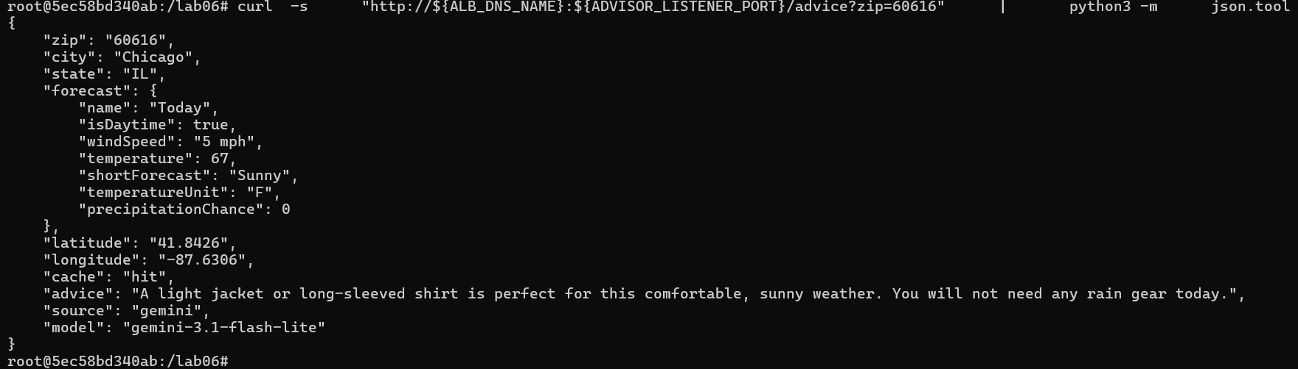
- Output of app_smoke_test.py with all nine checks passing.
  - 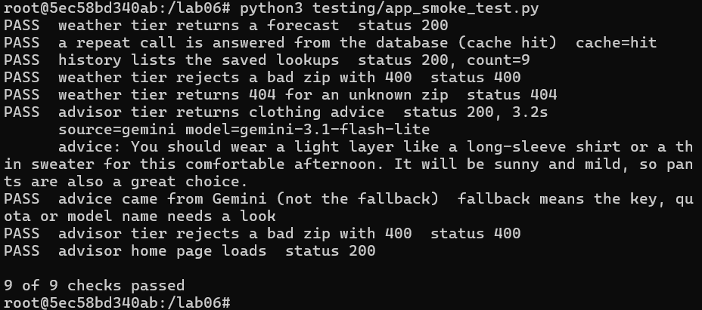
- Step 1: A few lines of the weather journal, with a sentence explaining one weather success line.
  - The first entry shows that on October 23rd, 2026, at 17:42:23, an event request from 172.31.16.42 (node 3491, part of us-east-2, internal computing resource) was made to query the weather at zip code 60616, which returned success and had a delay of 2 milliseconds. 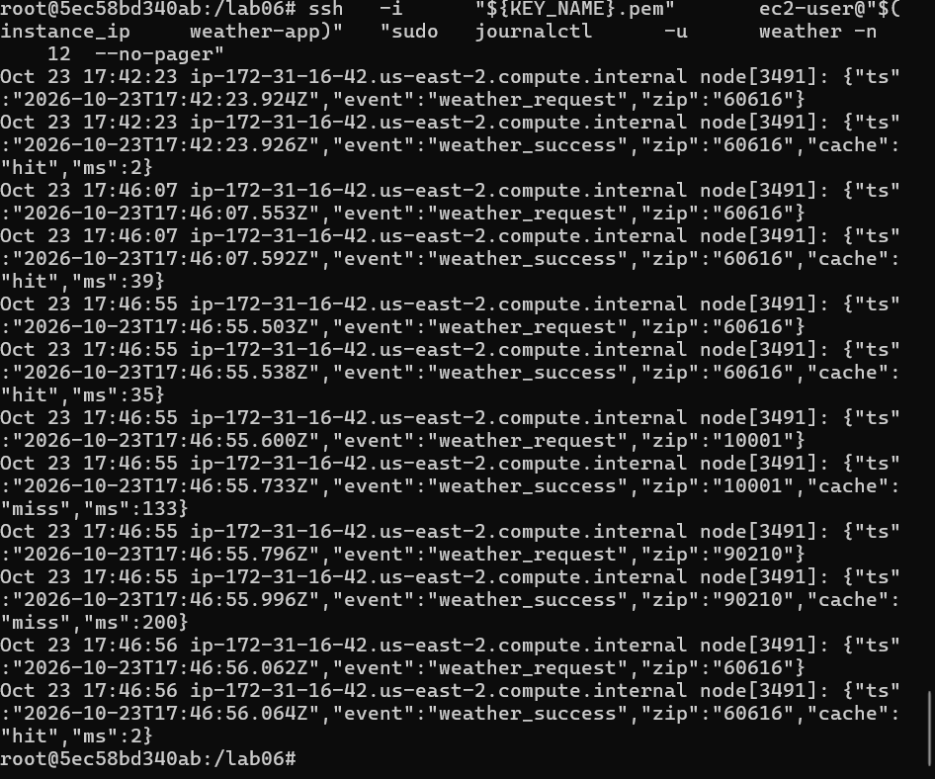
- Step 2: The /history output and the psql query output.
  - 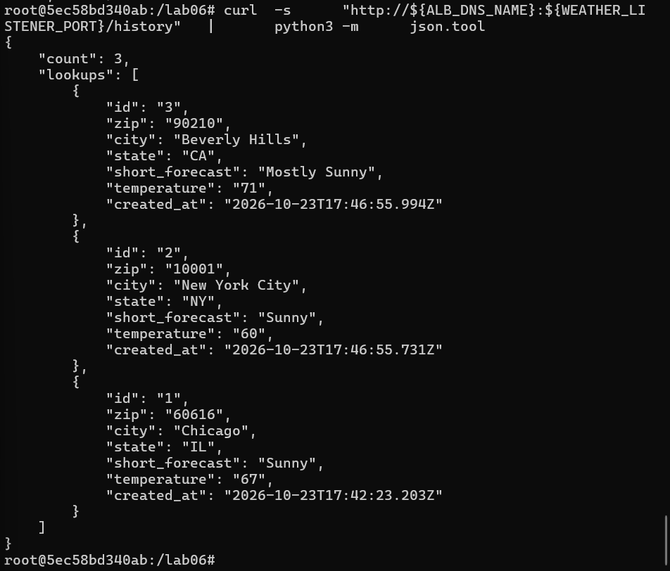
  - 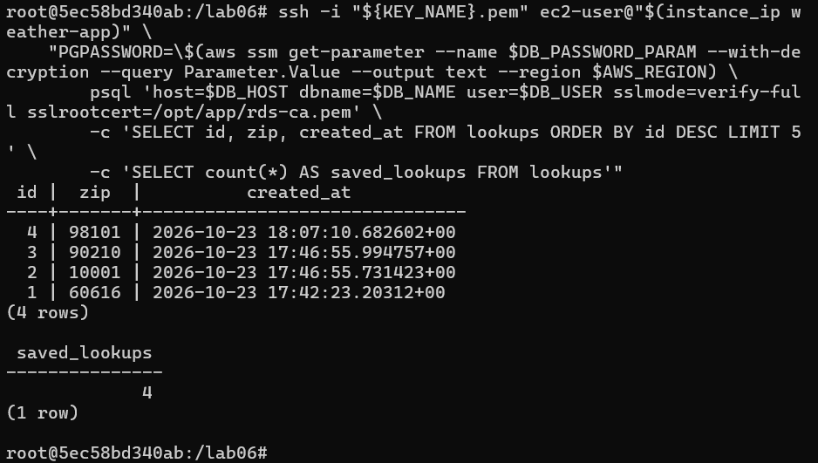
- Step 3: The miss and hit timings, and your two sentences.
  - A hit only took 2 milliseconds because it drew from the cache, while a miss varied from 61 milliseconds to 268 milliseconds.
  - 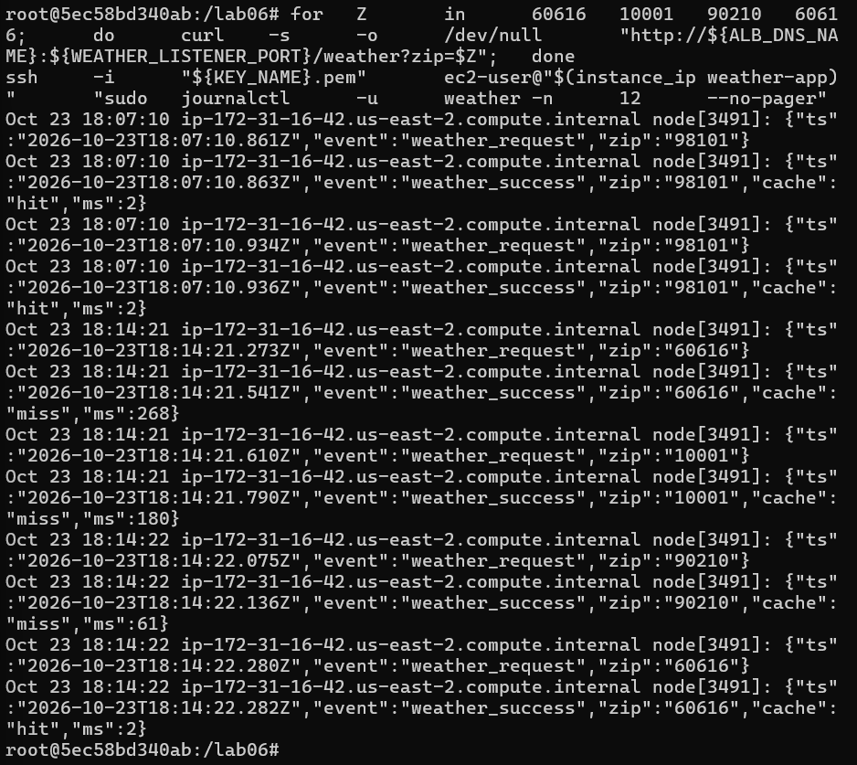
  - Having a short cache means faster response times when a service is rate-limited (cannot easily accommodate incoming requests in real-time, so resource efficiency dictates saving commonly queried requests). Usually, when customers/users query the weather, the expectation is a quick response to inform appropriate dress code and future event preparations.
- Step 5: The IAM simulator results for both roles and both secrets, and your sentence about the advisor tier.
  - 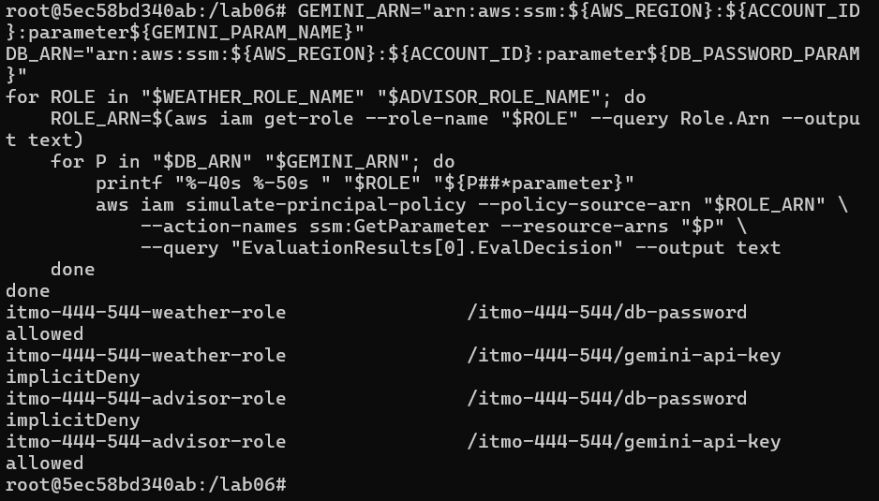
  - A bad actor who infiltrates the advisor role will only get the gemini api key, but not the weather role’s database password.
- Step 6: The direct and through-the-ALB results, and your sentence about security group sources.
  - 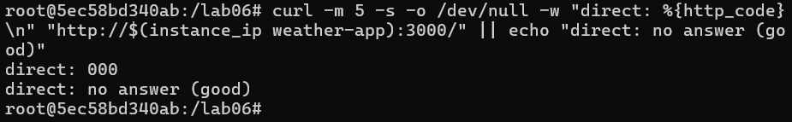
  - The security group rule referencing another security group is more secure than allowing a CIDR range because only specific IP addresses that are added to the second security group are allowed to access the resource as opposed to a range of unverified IPs (least privilege).
- Step 7: The output while the database was cut off, the db_error log line, and your sentence about the 30 second pause.
  - 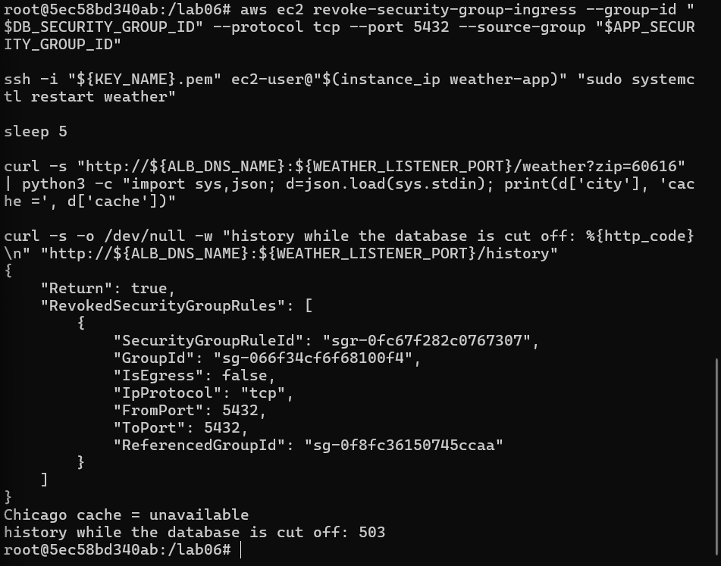
  - 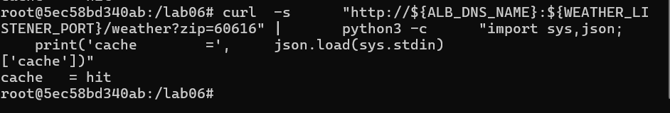
  - The 30 second pause allows for AWS to propagate the new security group rules; without it, users would continuously query an outdated API that reports “down” even though the service is “up” again.
- Step 8: The fallback answers, the gemini_error journal lines, and your sentence about the weakness of silent fallback.
  - 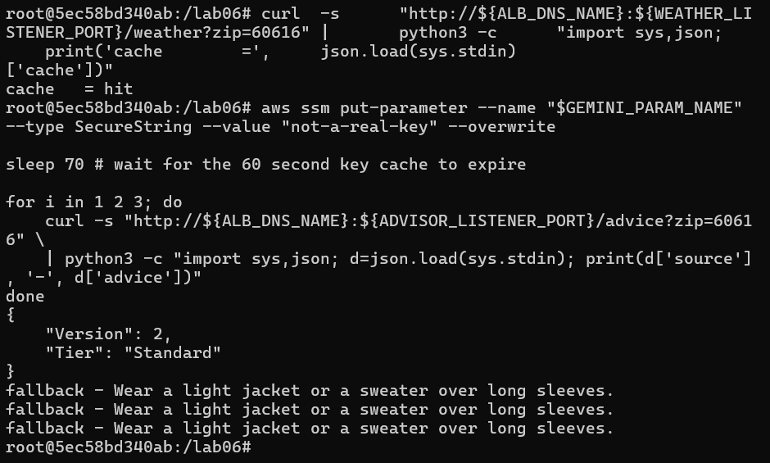
  - 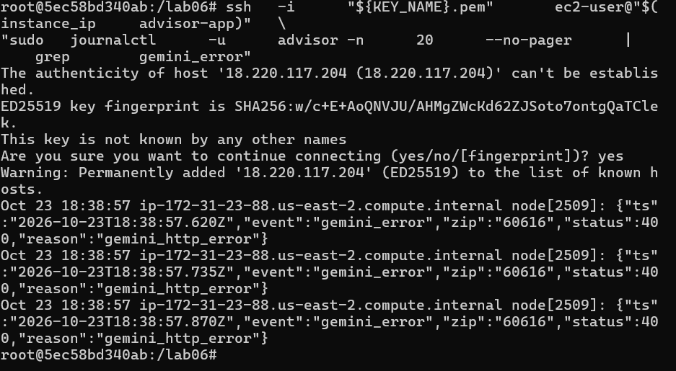
  - Users may take the fallback answer at face value, which is not applicable for all weather scenarios—you could not comfortably wear a sweater with long sleeves during the hot summer—and a silent redirect to a log could imply that the gemini calls are working when in fact it is rejecting a malformed key.
- Step 9: The recovery time you measured, what the advisor returned during the outage, and your sentence about where state should live.
  - 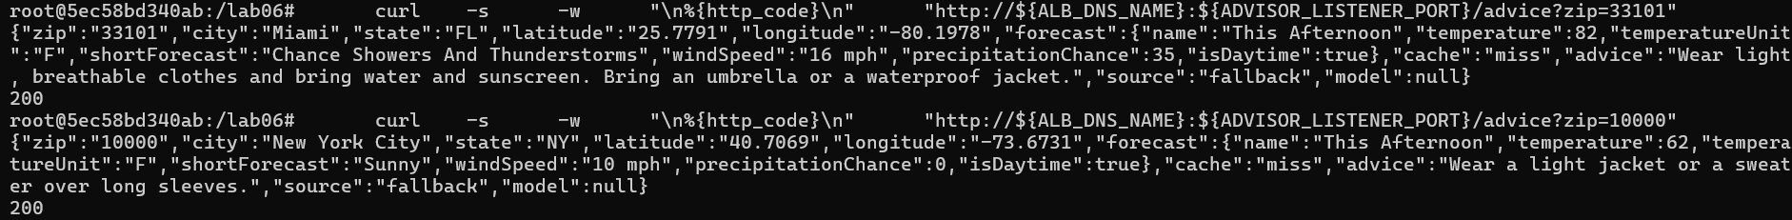
  - The cache reports miss despite follow up check reporting hit, I assume this is because the cache check happens too quickly before the status update can confirm that cache is reachable.
- One paragraph on why the secrets are in SSM and each is read by one role, instead of in .env or the user-data.
  - The environment variables file .env could be accidentally revealed in a github repository, thus revealing sensitive, costly secrets like the Gemini API key. SSM in this example will store the key as an encrypted string within the AWS environment so that the advisor role can still work with the key but it is not available anywhere in plaintext for discovery. Note that only the advisor role can read the API key, a security implementation that limits how damaging exposure can be if one of the roles were compromised.
- One paragraph on turning backups off: what it saved, what it cost you, and when you would never do it.
  - Hot backups are costly to maintain in AWS, even in cold storage it will incur a passive cost charged hourly. For databases that do not need to be maintained after execution (persistence not necessary), turning off backups can save on any retention costs. Removing backups also allows the security groups, roles, any attached load balancers, and autoscaling groups to be removed. Otherwise, AWS will not allow databases with redundancy and backups to be deleted (both manually and through scripts).
- One paragraph on what data you sent to Gemini and why the free tier makes that matter.
  - The data I sent to Gemini is the weather conditions. This includes daytime indicator, temperature, wind speed, and rain chance. For the free tier, prioritizing a simple query whilst also providing ample information maximizes the number of queries I can make with my API key. If I wanted Gemini to provide an advanced output (i.e., make me a seven-day forecast table with suggested dress code for each day), the free tier would prove inadequate or inaccurate on scale.
- Answers to the Section 15.1 review questions. (EXTRA CREDIT)

- Step 10: Output of the verification commands showing no database instance, snapshot, automated backup, load balancer or lab role remains.
  - 
   