1. Open the tool Form 1

You then choose the folder where your CSV file Student.ID is located

Just click on ‘Set url of your csv file’ button

Example: Here I want the file CSV is shown on my Desktop

1. Next, you click on ‘open your marking folder’ to open the folder where your marking files is located. After that just click OK.

1. Then you can click ‘Export to CSV’ button to extract all the StudentIDs from the folder name to the CSV file StudentID.CSV

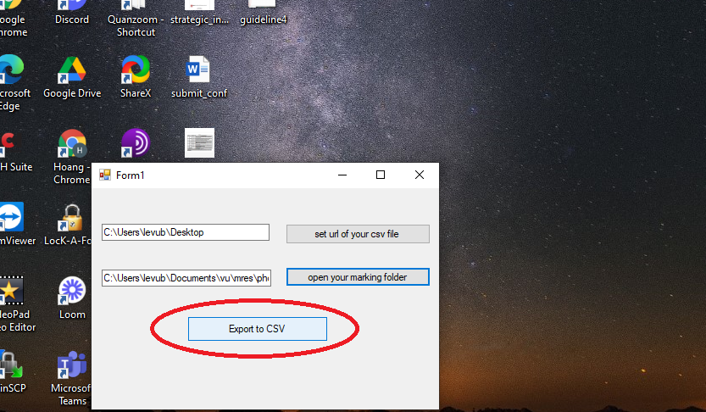

1. That’s done. Now simply open your StudentID.CSV file on Desktop and you can see you have got all the studentID number

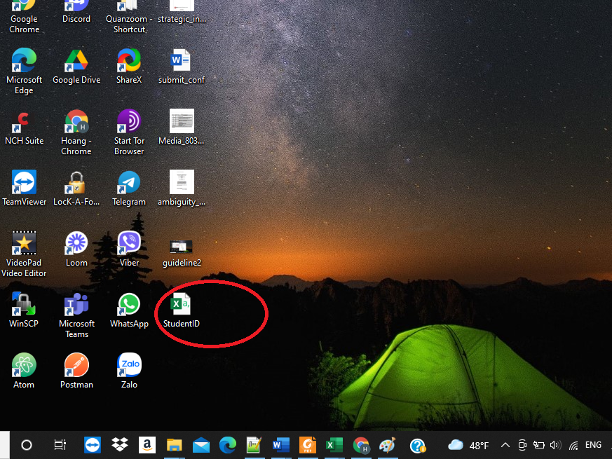

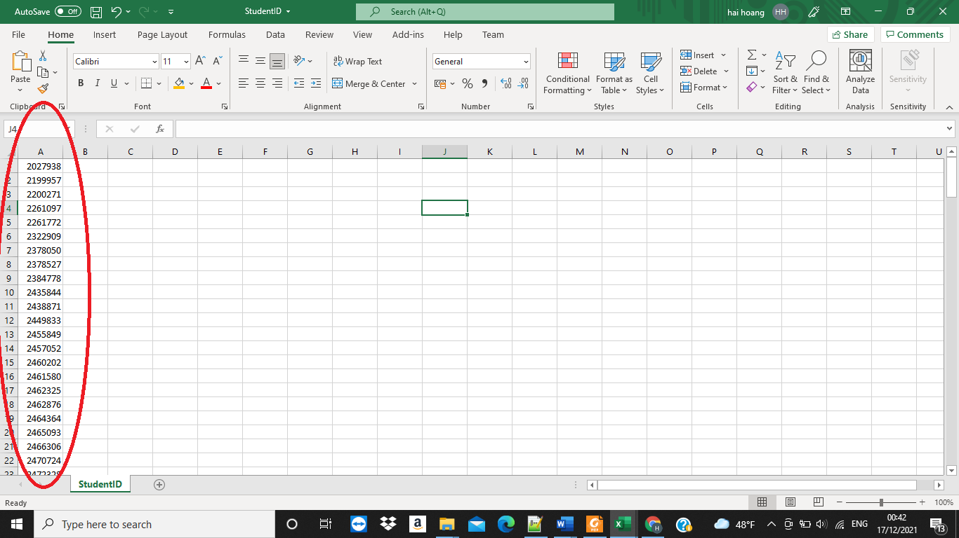

Thank you for reading to this line !