# **Title Page**

COS30045: Data Visualisation

**Visualizing the Impact of Rising Costs on the Cost of Living**

Huy Vu Tran - 104177995

02/18/2024

Word count: 1862

# **Executive Summary**

The report delves into the profound impacts of rising living costs, with a specific focus on the United Kingdom amidst global challenges. Through insightful visualizations, it unveils the intricate interplay between increasing prices and the cost of living, catering to economists, decision-makers, and affected individuals.

The CPI inflation rate graph depicts a persistent trend of inflation exceeding targets, indicating a continuous rise in living expenses. Additional insights into this trend can be found in Jacobs, Perera, and Williams (2014). Moreover, housing and transportation costs emerge as significant contributors to inflation, with Yu and Huang's study (2016) shedding light on the interaction between housing prices and inflation. Similarly, soaring energy prices, depicted through a bar graph, pose challenges to household budgets. Radulescu et al.'s research (2022) offers valuable insights into the broader implications of rising energy prices on inflation and economic activity.

For a more nuanced understanding of each visualization and its implications, readers are encouraged to explore the referenced studies. These studies provide valuable context and analysis to enrich comprehension of the economic landscape and the strategies necessary to navigate the complexities of rising living costs effectively.

**Table of Contents**

**Title Page** 1

**Executive Summary** 2

**Table of Contents** 3

**1.** **Introduction** 4

**2.** **Body** 5

Inflation Rate Analysis 5

Housing and Transportation Costs 7

Soaring Energy Prices 9

**3.** **Conclusion** 11

**4.** **References** 12

1. **Introduction**

In the face of global concerns such as climate change, political instability and financial, rising living costs have emerged as a major concern throughout the world. With a focus on the United Kingdom specifically, this paper aims to do an extensive analysis of the effect of increasing prices on the cost of living. Economists, decision-makers, and people who are influenced by the factors affecting the cost of living in the UK are among the many people for whom this document is meant.

This article uses visualisations that capture key aspects of the topic to help readers understand the complex interactions between different variables. An extensive examination of the inflation rate and how it affects living expenses is the goal of the first graphic. Then, the next chart that follows addresses how housing and transportation expenses have affected the rate of inflation overall by examining the link between housing, transportation costs, and inflation. The third and final visualisation examine the influence of energy costs on the cost of living, concentrating on how have energy prices impacted the overall cost of living.

1. **Body**

## **Inflation Rate Analysis: Understanding the Impact of Increasing Prices on the Cost of Living**

In the first visualization of this report, the inflation rate of the UK's Consumer Price Index (CPI) is efficiently displayed using a line graph. With the x-axis tracking time and the y-axis indicating the inflation rate, it clearly illustrates the pattern of inflation over time. The actual rate of inflation and the Bank of England target rate are distinguished by different colors. There are, nonetheless, a few little issues that need to be fixed. Uneven gridlines may impede accurate data interpretation, and the y-axis's non-zero start point may make it less natural to compare the inflation rate to the target.

**Figure 1: UK Inflation**

Although the first graph shows the trend clearly and compares it to the goal rate, it is devoid of some information, like monthly inflation rates and possible inflation causes. While the data's overall accuracy is adequate, the problem with the gridlines has to be fixed. It's crucial to remember that, in order to have a more comprehensive understanding, this chart should be examined in conjunction with other economic aspects. Though it follows several design guidelines, it may be clearer if the y-axis was started at zero and the gridline spacing was maintained.

To fully leverage the insights from this visualization, I propose incorporating several improvements. Starting the y-axis at zero would provide a better basis for comparing the inflation rate to the target. Consistent gridlines would enhance the precision of the data. Additionally, including monthly rates in addition to the annual trend would offer a more granular view and enrich the analysis. Briefly discussing potential inflation drivers such as global events or supply chain disruptions would strengthen the arguments and demonstrate a well-rounded understanding.

Nonetheless, the graph still points out that, while inflation has fluctuated, the overall trend has been higher since early 2021. Despite a minor decline from the previous month, the most recent data point is still far higher than the goal rate. This suggests that the cost of living will continue to rise, although a little more slowly. UK households' buying power has decreased as a result of inflation exceeding the target rate. According to the 2014 analysis by Jacobs, Perera, and Williams, people must make more money in order to retain the same level of life. Since low-income households already have limited discretionary money, this effect is probably going to be more severe for them.

## **Housing and Transportation Costs: Examining the Role of Rising Expenses in Driving Inflation**

A line graph below is utilized to effectively show how housing and transportation costs are pushing inflation up in the second chart. It can be easily seen that this visualisation presents both categorical and numerical data. It uses lines to represent categories like housing, transportation, and food. The length of each line corresponds to its percentage contribution to inflation.

**Figure 2: Rising housing and transport costs are pushing inflation up**

While the graph effectively highlights housing and transportation as the main inflation drivers, its effectiveness is hampered by two limitations. Firstly, uneven bar spacing makes comparing values between categories challenging. While generally readable, the missing label hinders the ability to extract precise data. Another potential issue lies in the use of color coding. With categories already labeled, color becomes redundant and could even be confusing for some viewers. Additionally, the visualization only addresses which factors contribute to inflation, neglecting the question of how much inflation has actually increased.

To improve the visualization's accessibility, information, and message communication, ensuring consistent spacing between bars will further facilitate accurate comparisons between categories. Removing the color coding, given the presence of clear labels, would focus on clarity and avoid unnecessary complexity.

Analyzing the second chart reveals a potential link between rising housing and transport costs and increasing inflation. Notably, the contribution of housing to inflation grew from 0% in January 2021 to over 2% in January 2022, while transport's contribution similarly went from 0% to more than 1% during the same period. The pattern suggests strong potential for rising housing and transport costs being significant contributors to the current inflationary trend. This could be illustrated in the study made by Yu and Huang (2016), they demonstrated how variations in housing and transporting costs may impact a society's overall supply and demand, which in turn can impact inflation. This means people will likely prioritize them even when prices rise, potentially prompting businesses to increase their own prices to cover their costs.

## **Soaring Energy Prices: Exploring the Influence of Energy Costs on the Cost of Living**

The third and final visualisation is a bar graph that makes use of numerical data; in this case, the average energy cost for each billing period from 2018 to 2023 in the UK. Bars that are varied in height are used to encode the data. Each bar's height corresponds to the typical energy cost for that particular billing period.

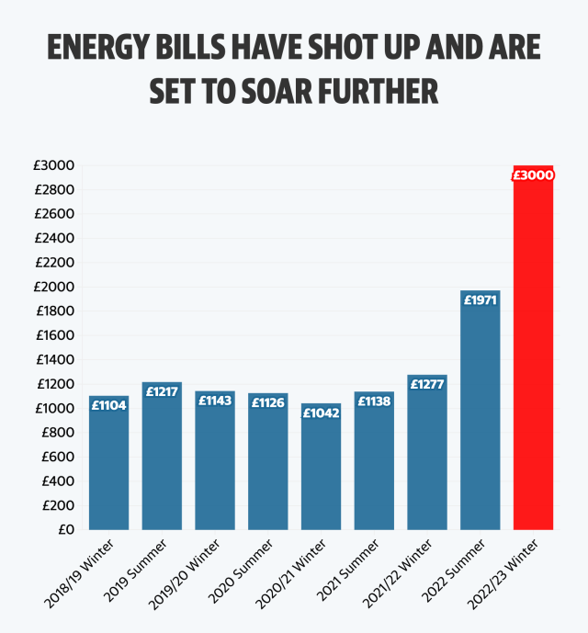

**Figure 2: Energy bills have shot up and are set to soar further**

The aforementioned visualization suggests that energy prices are on the rise in the UK, but it has a number of drawbacks that make it less useful. Let's investigate these problems and look at possible fixes. The readability of this representation presents the main obstacle. The lack of gridlines and narrow bars make it challenging to determine the precise average energy bill for each time. Instead of providing viewers with a clear idea, this opacity keeps them guessing.

Although the chart has labels and a clear title, it might still benefit from more adherence to good design standards. By making the following adjustments, this graphic can become a more powerful tool. Gridlines will enable viewers to correctly interpret and compare the average energy bill amounts for each period by offering useful points of reference. Not to mention that larger font sizes for labels guarantee improved legibility for all readers, including those with vision difficulties.

Adding to what we've already seen, the graph shows that energy costs have been steadily rising since 2018, with the average household in the UK spending £235 more in 2022–2023 than it did only four years earlier. Household budgets are being severely strained as a result, making it harder for some people to pay for needs like heating and electricity for appliances, and even placing them in financial distress. However, the effects don't end there. The economy as a whole is impacted by rising energy costs, which have an impact on the cost of products and services. According to Radulescu et al.'s research (2022), businesses are compelled to raise their pricing due to rising energy input costs, which ultimately results in higher consumer expenses. As a result, this creates a complex web of challenges, impacting individuals, businesses, and the overall economy.

1. **Conclusion**

To sum up, this research has offered a thorough examination of how rising costs affect living expenses in the UK in light of international issues including climate change, unstable political systems, and unstable financial markets.

The report's visualizations highlight important facets of the subject. The Consumer Price Index, also known as the CPI, inflation rate for the UK is shown in the first visualization throughout time, showing a consistent pattern of inflation exceeding the Bank of England's target rate. Although there are some limitations on how the data is presented, the research points to a steady increase in the living expense, which might have an impact on family spending power. The second graphic emphasizes how important housing and transportation expenses are to the present inflationary trend and raises the possibility of a link between growing housing and transportation costs and rising inflation. The third and final graphic shows the continuous rise in energy costs, which puts strain on household budgets and forces companies to modify their pricing policies.

Overall, these visualizations provide insightful information on the difficulties in controlling inflation and reducing its negative social impacts, highlighting the need for more study and legislative initiatives to solve the problems brought on by the growing expense of living.

1. **References**

Jacobs, D., Perera, D. and Williams, T. (2014). Inflation and the Cost of Living . [online] Reserve Bank of Australia. Available at: <https://www.rba.gov.au/publications/bulletin/2014/mar/4.html>.

Radulescu, C.V., Gole, I., Troaca, V.A. and Gombos, C.C. (2022). Rising Energy Prices: The Impact on Inflation, Economic Activity and the Results of the Fight Against Global Warming. New Trends in Sustainable Business and Consumption. [online] doi:<https://doi.org/10.24818/basiq/2022/08/006>.

Yu, H. and Huang, Y. (2016). Regional heterogeneity and the trans-regional interaction of housing prices and inflation: Evidence from China’s 35 major cities. Urban Studies, 53(16), pp.3472–3492. doi:<https://doi.org/10.1177/0042098015617882>.