# Testing the Hololens: the Report

Here we are going to report on what we have done and our findings throughout the process of setting up vuforia on the Hololens.

## Set-up

Initially we started with the goal to take the basic vuforia tutorial and get it running on the Hololens. We followed the guide1 to get an image tracker in unity. After that was working via the laptop camera we tried to export it to the Hololens, to little success. We swapped to the Hololens specific tutorial2 which we later found out is horribly out dated.

After many hours of trying these two we decided to take what we know and build the project from scratch. This was a far better solution as we were able to get the Program running near effortlessly. To do this we created a free dev key and created a database via the Vuforia developer engine.

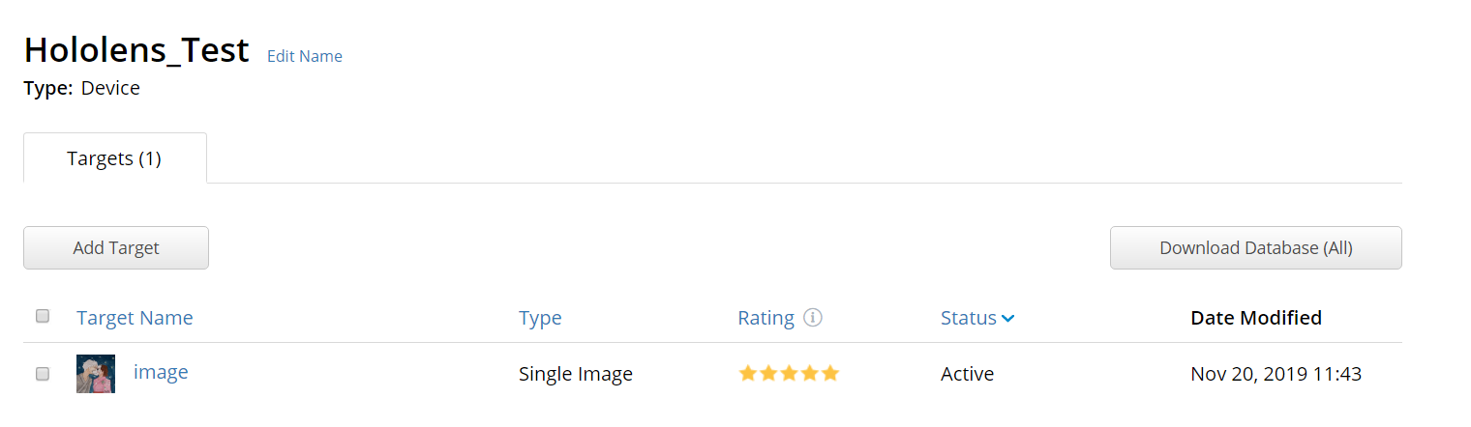

The Hololens was able to detect the image, apply the object – in this case a cube – and track it throughout rotating around the object. We saw that it was not as robust at keeping the image in a set place however, as once the image was not being registered it kept the cube static on the screen

## Improvements