Pipeline level1:
[process]:
1.add DFFs before result mux whose output will be written to RegFile
2.add DFF before control signal INmux[1:0]
3.add DFF before DR[2:0], which make the output of mux and DR synchronous.
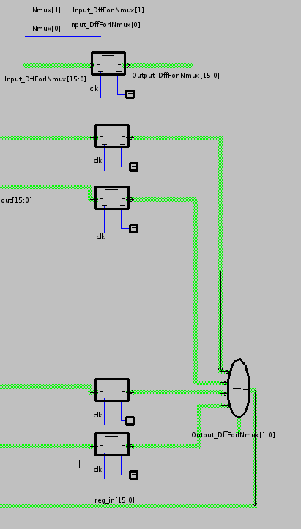

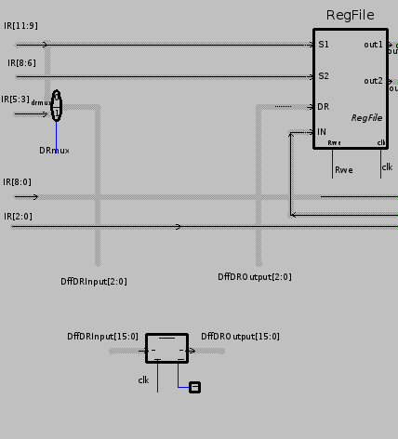

[result]:
pipeline: level1:

=======================(1500)===========

R0[0000] R1[0000] R2[0000] R3[0000] R4[0000] R5[0000] R6[0000] R7[0000]

---- Memory ----
addr ---- content---- translation
---- ---------------- ----------------
01fc: 1111111111111111 unknown instruction
01fd: 1111111111111111 unknown instruction
01fe: 1111111111111111 unknown instruction
01ff: 1111111111111111 unknown instruction
PC==> 0200: 0001111101011110 <== LIM DR7 15e
0201: 0000111111001000 ALU SR7 SR7 DR1 ADD
0202: 0000000001010100 ALU SR0 SR1 DR2 SUB
0203: 0100011000000000 LEA DR3
0204: 0001100000000110 LIM DR4 006
0205: 0010101011000000 LDR DR5 AR3
----------------
============================================

=======================(3500)===========

R0[0000] R1[0000] R2[0000] R3[0000] R4[0000] R5[0000] R6[0000] R7[0000]

---- Memory ----
addr ---- content---- translation
---- ---------------- ----------------
01fd: 1111111111111111 unknown instruction
01fe: 1111111111111111 unknown instruction
01ff: 1111111111111111 unknown instruction
0200: 0001111101011110 LIM DR7 15e
PC==> 0201: 0000111111001000 <== ALU SR7 SR7 DR1 ADD
0202: 0000000001010100 ALU SR0 SR1 DR2 SUB
0203: 0100011000000000 LEA DR3
0204: 0001100000000110 LIM DR4 006
0205: 0010101011000000 LDR DR5 AR3
0206: 0011000011000000 STR SR0 AR3
----------------
============================================

=======================(5500)===========

R0[0000] R1[0000] R2[0000] R3[0000] R4[0000] R5[0000] R6[0000] R7[ff5e]

---- Memory ----
addr ---- content---- translation
---- ---------------- ----------------
01fe: 1111111111111111 unknown instruction
01ff: 1111111111111111 unknown instruction
0200: 0001111101011110 LIM DR7 15e
0201: 0000111111001000 ALU SR7 SR7 DR1 ADD
PC==> 0202: 0000000001010100 <== ALU SR0 SR1 DR2 SUB
0203: 0100011000000000 LEA DR3
0204: 0001100000000110 LIM DR4 006
0205: 0010101011000000 LDR DR5 AR3
0206: 0011000011000000 STR SR0 AR3
0207: 0000011100110000 ALU SR3 SR4 DR6 ADD
----------------
============================================

[analysis]
after two clock cycles, ff5e is written to R7 register successfully.

