**Solid Mechanics Coursework**

Wang Hanhong

02 November, 2022

**Experiment (Three-Point Bending/ Flexural Test)**

**Section A：**

1. **Experimental data functions**

The image of the function produced from the experimental data is shown

Figure 1

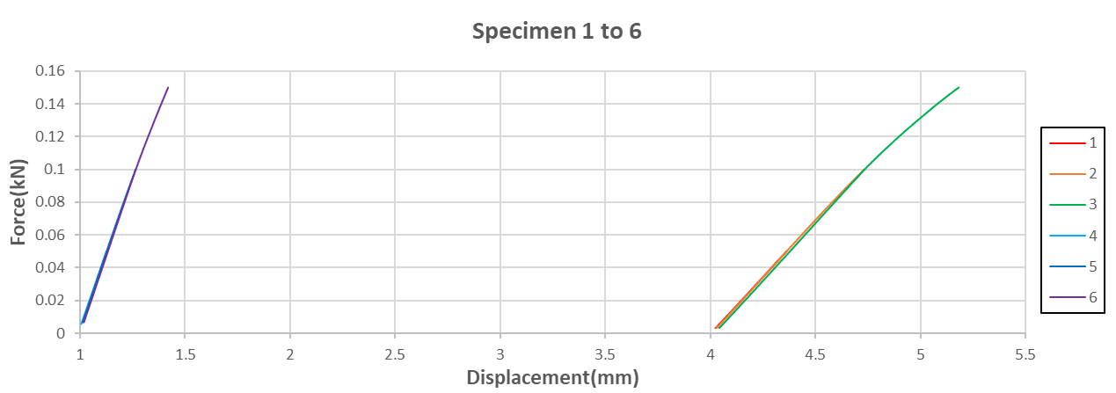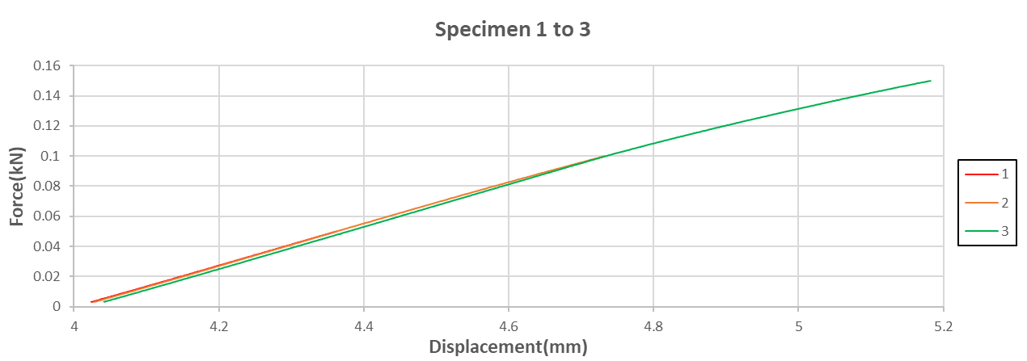in Figure 2. The specific images of the two different materials are shown in Figures 3 and 4.

Figure 2

Figure 3

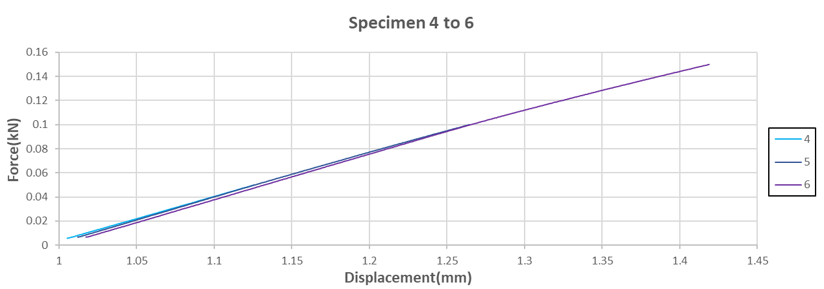

Figure 4

Figure 2

1. **Analysis**

The value of the rotational inertia I is obtained by substituting the width b and thickness h of the sample and using the following equation.

（1）

The inertia of rotation is calculated as $I=4.5×{10}^{-11}$

The regression equations for the six functions are established in Figures 1-3 and used to find the zeros and obtain the actual displacement distances.

Substitute the various known data and use the following formula (2) to find the values of $E1, E2, E3$ and $Eexp$ and fill in Table 1 for the different materials and forces.

Figure 5

A sketch of the bending test is shown in Figure 5 .

63.3GPA

170.1GPA

167.7GPA

64.4GPA

64.2GPA

61.2GPA

（2）

Table 1

172.1GPA

170.4GPA

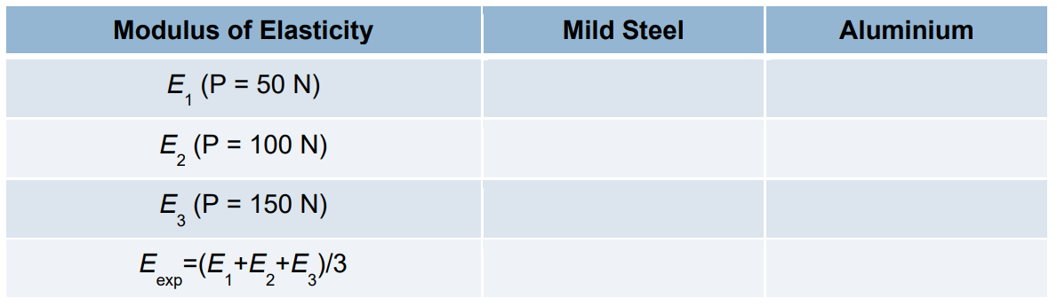

1. **Summary**

The various experimental data obtained from the calculations in Table 1 show that the modulus of elasticity of Mild steel is much greater than that of Aluminium. The analysis shows that the deflection of mild steel is less than that of aluminium under the same load.

The two $E3$ values in Table 1 are clearly different from $E1$ and $E2$. Analysis of the experimental data reveals that the two materials are slowly rising to 150N with equal force, and the deformation displacements of 50N and 100N are approximate, but the deformation displacement of 150N is large, which may be the reason for the small 150N figure. To reduce the possible error, we should do more experiments to take the average value.

**Section B：**

1. **Analysis**

Based on the results obtained in Section A, equation (2) is invoked to calculate each of the six values of δ From these, maximum deflections were obtained for Aluminium and Mild steel specimens at three loads ($P=50N/ 100N/ 150N$).

All results are presented in Table 2.

Table 2

0.408mm

0.136mm

0.272mm

1.097mm

0.731mm

0.366mm

1. **Summary**

The average modulus of elasticity($Eexp$) obtained by substituting the six experimental data into equation (2), gives more accurate displacements occurring under different loads for the two samples after reducing the experimental error

**Section C：**

1. **ANSYS(FEA)**

The displacement versus position curves for the relevant materials were produced by using ANSYS as shown in Table 3.

**M**

|  |  |  |
| --- | --- | --- |
| **F** | Mild Steel | Aluminium |
| 50  N |  |  |
| 100N |  |  |
| 150N |  |  |

Table 3

1. **Analysis**

Six deflections can be derived from the results of the six FEA images in Table 3 and the results are shown in Table 4.

0.97099mm

0.64733mm

0.32366mm

0.34511mm

0.23077mm

0.11504mm

Table 4

1. **Summary**

Six FEA plots of displacement and position analysis functions were obtained by modelling and simulating using ANSYS (Table 3), these six plots show the distribution of deflection between the two materials under different load forces.

**Section D：**

1. **Comparison of results**

Using Table 2 of the experimental results in Section B and Table 4 of the FEA analysis results in Section C, it is found that the maximum deflection of the experiments is greater than the maximum deflection of the FEA results. However, relatively speaking, the difference is not as great in aluminium as in mild steel.

**2. Error analysis**

There are several possible errors that could cause a large difference between the two results:

1. The density of the parts used in the experiments was not uniform and the machining accuracy was too high to ensure that the centre of mass coincided exactly with the geometric centre.
2. The slope of the displacement as a function of force curve obtained from the experimental data is not accurate enough, which may be due to the fact that the parts were not placed in the exact position. Of course, this does not exclude the possibility that the machine calibration is wrong.
3. **Experimental improvements**

The analysis in Part 2 leads to a number of recommendations to reduce experimental error:

1. Experiments are carried out using parts that are machined to a higher degree of accuracy, which reduces experimental errors due to uneven density.
2. Improve the equipment and calibrate it several times. This allows the parts to be placed more accurately in the right position, which allows the experimental data to be generated with a more accurate slope of displacement and force, reducing experimental errors.