人工智慧

40611016E 張清華

1. 應用目的 :
   1. 看是否能預測病人是否有心臟疾病(target)
2. 使用資料集及資料集的資料欄位說明

<https://www.kaggle.com/ronitf/heart-disease-uci>

* 1. 1. age
  2. 2. sex
  3. 3. chest pain type (4 values)
  4. 4. resting blood pressure
  5. 5. serum cholestoral in mg/dl
  6. 6. fasting blood sugar > 120 mg/dl
  7. 7. resting electrocardiographic results (values 0,1,2)
  8. 8. maximum heart rate achieved
  9. 9. exercise induced angina
  10. 10. oldpeak = ST depression induced by exercise relative to rest
  11. 11. the slope of the peak exercise ST segment
  12. 12. number of major vessels (0-3) colored by flourosopy
  13. 13. thal: 3 = normal; 6 = fixed defect; 7 = reversable defect

1. 程式碼與準確度

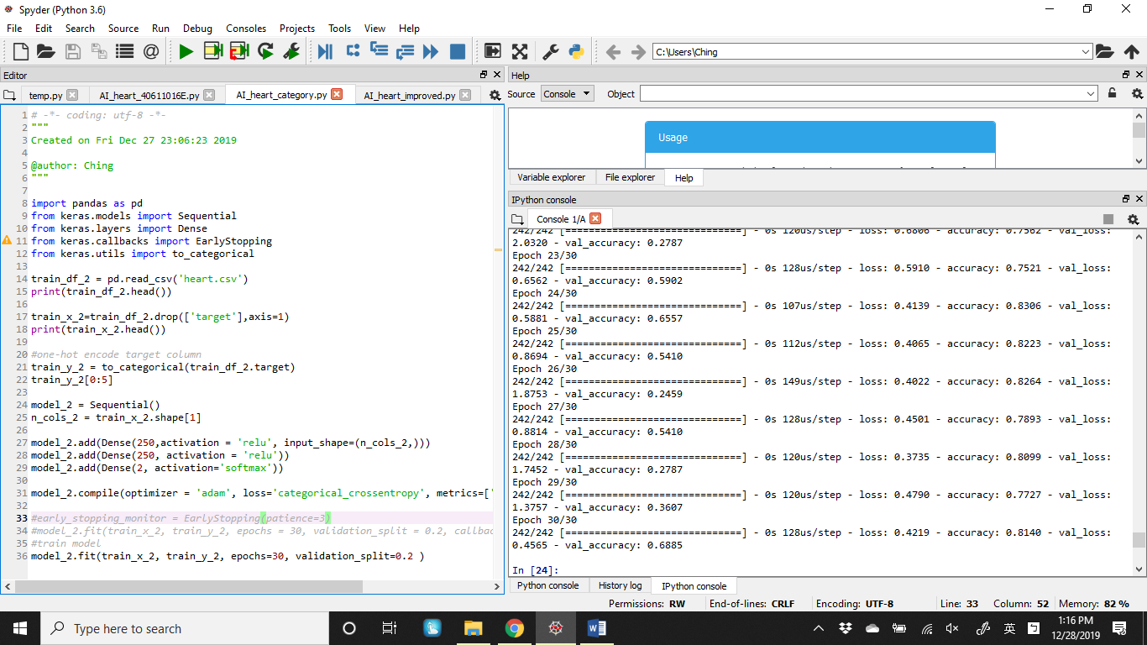

14-22 將要分類的目標(target)移除要分析的x_train_2，以及目標放入train_y_2

27-29 則是加入Dense

36 則是預測得到心臟病

loss: 0.4219 - accuracy: 0.8140 - val_loss: 0.4565 - val_accuracy: 0.6885