Candidate & Voter Agents in 3D Political Spectrum Space

Harold Walbert, Christopher Nguyen, Namloc Nguyen, Jessie Park

December 8, 2016

## Abstract

In this paper we seek to model an electoral process where voters choose candidates based on the voter's self-interest. We construct an agent-based model using three dimensions of empirical distributions of ideology. Over the course of a campaign, voters update their preference for a candidate based on their unique position in their social network and their unique position in 3D political ideology space. Voters can influence other voters perceptions of the likelihood that their preferred candidate will win. In addition candidates are able to respond to the the "polls" they take of voters and are able to make known updated policy positions in an effort to find more voters.

## Introduction

In an electoral process, voters choose candidates based on the voter's self-interest and candidates want to receive votes from voters. We construct an agent-based model under the assumption that electoral preferences of induvial voters change over the course of a campaign due to social interactions and the influence of local and global information. In these networks, voters can influence other voters (and vice-versa) in how they ultimately vote.

The main objectives of this paper are to further the conversation about party competition from both the voter and candidate perspectives as well as understand distributions of voter preferences that may follow different distributions and may be clustered over a wide variety of political dimensions. Additionally this paper will allow for the political spectrum to be more complex than the usual one or two-dimensional spectrums that are common in the literature. Agents follow a variation of the median voter theorem. While there are amy examples and discussions of the median voter theorem little has been done to apply the Hotelling model to different dimensions. The current research has targeted two-dimensional applications of the Hotelling model to determine optimal locations and prices, and analyzing the effects of this two-dimensional competitive model. (Larralde, Jensen, & Edwards, 2006; Veendorp & Majeed, 1995) Brierly (2008) married the Hotelling model and the Salop model and took it to the nth dimension to formulate a generalization that can be applied location theories and the median voter theorem. By using empirical data and agent-based modelling, we identify three axis on the political spectrum which will give voters the environment to chose their preferred candidate and that will give candidates the space in which to operate in order to try to capture the votes of the median voter.

This paper will proceed as follows:

1. A literature review of the literature as it progresses through the economic foundations necessary for our experiment, a relevant literature review of research on the politial spectrum, political ideology, measurent, and visualization (ex. Nolan chart). The logic of the basic mathematical model behind downs paradox will be covered as well.
2. An examination of the Data, Methods & Analysis that make up this paper. This will include cleaning and analysis of the empirical data, model specification, etc.
3. Results and Findings
4. Discussion

## Literature Review

Harold Hotelling (1929) in "Stability in Competition" hints at, what Duncan Black later formalized as, the median voter theorem which states that to capture the majority, the outcome must be preferred by the median voter. Hotelling first makes the argument using the location of businesses on a straight path - both of whom will alter not only their prices but their location along the path to attract more customers. The businesses will lower their prices and begin to converge on the one-dimensional plane in an effort to seem more appealing to customers. (Hotelling, 1929) The classic example of two ice cream vendors on a beach boardwalk lends a hand in explaining the behaviour that Hotelling noticed. [Insert ice cream story here] While the application was to analyze behaviour of the firm in capturing the market, Hotelling does recognize the shift in political stances between the Democratic Party and the Republican Party.

Almost 20 years later, Black (1948) in "On the Rationale of Group Decision-making" refines and formalizes the behaviour Hotelling noted in political stances and majority voting into the median voter theorem. Granted two constraints, the position of the median voter is a Nash equilibrium - at that point, nothing is gained by moving away from that position. The two constraints are assumptions that preferences are single-peaked and assumptions that preferences are only considered over a single dimension. (Black, 1948) For our experiment, we assume that the preferences of the voters are single-peaked in that they will gain the most utility by voting for their candidate. Where this experiment strays is with the second constraint. The median voter theorem is restricted to a single dimension since an equilibrium cannot be reached in situations considering multiple dimensions. However, following in the footsteps of Brierly (2008), without marrying the Hotelling model to the Salop model, we pivot and turn our focal points to the Hotelling model and Downs paradox to conduct spatial analysis voter behaviour. [Alright, something doesn't sit right with me here]

Downs paradox, also referred to as the paradox of not voting, states that a rational, self-interested voter will not vote if the cost of voting is greater than the expected benefit of voting. Since the probability that the voter gets into a car crash on the way to the voting poll is higher than the probability that the voter will cast the deciding vote, the voter will most likely not vote since the cost of voting will be greater than benefit. (Downs, 1957a; Downs, 1957b; Feddersen, 2004) However, that is not the behaviour that is exhibited. Voters will go through inclement weather, overcome the distance to the voting poll, wait in long lines, spend time pondering about who to vote - all of which are factors of cost in voting - to go vote. "This finding suggests that voters participate because they hope to influence the ultimate outcome of the election." (Feddersen, 2004) The in-depth analysis of the mathematical equation behind downs paradox will be covered in the next section. [I might add more to downs paradox with the cost of information (?)]

The main equation that is used to determine if an agent votes or not in any election is given by: P×B+D>C Where P is the subjective probability that one's vote will make a difference in the outcome, B is the difference between the distance between the agent that is not my candidate and the agent that is my candidate, D is the private benefits from the act of voting, and C is the cost of voting. P itself is mathematically defined as: $P=3e^{(-2(N-1)(F-0.5)^{2})}/2\sqrt{2π(N-1)}$ where F = avg (B) of links and represents the agents individual belief that their preferred candidate will win. N is the number of voters participating in an election. As N increases the law of large numbers tends to apply, and we will see P approach one half. The law of large numbers necessitates such an outcome should occur assuming an underlying Gaussian distribution. B is the overall gain from the differences in ideological positioning in terms of utility. In graphical terms, it is the difference in displacement of the preferred candidate to the voter subtracted from the displacement of the non-preferred candidate to the voter. The difference is the utility gained from voting. D is the private benefit of the actual act of voting, which could be defined as a subsidy, favorable legislation, pride in fulfilling civic duties, and other private benefits.etc. The act of voting may result in a positive value D, which is not necessarily tied to any legislation that gets passed (it just has to be perceived as beneficial), or it may help avoid a negative value D, which may be the feeling of guilt if one does not vote. Lastly, C is defined as the costs of voting. Costs could include anything from typical travel costs accrued in travelling to a voting booth to opportunity costs incurred due to loss of the chance to partake in all other substitute options. When the probability of the preferred candidate winning by the utility a voter gains in picking a candidate is greater than the costs of voting less his personal gains from voting, the agent votes. If this does not hold, our agent should not rationally vote. This is the Rational Voter Hypothesis termed by Downs.

The Nolan chart was created by David Nolan, a political scientist of the Libertarian party. He realized that having a spectrum of just two extremes was just inadequate to describe anything. People are not completely defined as liberals or completely as conservatives in all political views. David Nolan instead reoriented the graph into a two-dimensional chart that measures personal freedoms on the vertical axis and economic freedoms on the horizontal axis. The chart is a visual representation of people's alignment on not just liberal versus conservative, but also statist versus libertarian ideologies. Libertarianism generally "supports the smallest possible government, supports individual liberty in all ways, prefers to only defend our borders and not interfere in other countries' affairs." Statist, on the other hand, hold a view that is close to "the marriage of liberal and conservative aspects of big government. Supports both the conservative 'family' agenda and the liberal 'social' agenda. Supports both major diplomatic and military involvement abroad." Conservative views "tends to give a nod and a wink to liberty while placing emphasis on government control of "family" issues (gay marriage, abortion, borders, etc.) while pushing for major military involvement worldwide by America, in the hopes of creating a faith-based, 'conservative' world." Liberals "ends to give a nod and a wink to liberty while placing emphasis on government control of 'social issues' (social safety net, minority rights, etc.) while pushing for major diplomatic involvement worldwide by America backed by somewhat lesser military involvement, in the hopes of creating an inclusive, 'liberal' world." Lastly, Nolan makes room for a "moderate" middle ground called Centrist, which is an area in the middle of his chart. (Q8, 2016) All five parts when viewed together give a more robust answer to what people generally ascribe to in political opinion. Having low levels of social freedom while having low levels of economic freedom no longer count as the normal liberal or normal conservative; they are part of the statists. This holds true for high levels of both; the libertarian view would be ascribed to them.

Johnston and Feldman believe that there is an inability for a heterogeneous man to be categorized merely using a single unidimensional spectrum." The multidimensionality of preferences implies that self-placement along a single dimension is insufficient to account for the variety of ideological perspectives in the public." The two of them also show that there is a myriad of determinants that factors into a person's ideological grouping when there are multiple dimensions. "We have shown that modeling the predictors of ideology yields substantially different conclusions in a two-dimensional model than the one-dimensional model." (Feldman, 2013) This is because certain variables only affect a single movement of travel, but others move across multiple dimensions. Castle and Mair noticed that "there are many parties whose primary goals cross-cut the Left-Right ideological dimension and whose names may reveal little concerning their ideological position." They come up with three strategies to identify location-scale: first is to read closely what is put out by the country's leading "experts" (media, academics.); second is adding "ad hoc decision rules," to the first, that specifies party location; lastly they say to use surveying techniques to poll people in order to gauge their political ideologies. (Castle, 1984) This is not enough to explain ideology and at the same time it is too much. A poll can created and whichever way a person votes on each issue could be a spectrum in of itself, creating a possibly infinite-dimension. The problem is that, while this is very specific, it is not particularly useful in trying to generalize ideology. Instead of adding a multitude, one could possibly claim that there are only three dimensions that truly matter when trying to describe the typical rational voter. Using just three for a model limits what needs to be accounted for, while still maintaining a higher level of truth.

Agent based modeling has been used by Laver and Sergenti to understand Political Agents...more to come.

## Method of Analysis

We begin by asking the question: "Can we model voting agents where these agents may take into account up to 3 dimensions of political ideology? Furthermore, can we give these agents an empirical basis for the distributions they take?" An agent-based model is ideal for looking at questions where the interactions of individual, unique decision makers effect the macro level emergent outcome. It allows simulations of interactions of autonomous individuals (the voters) in an environment, in order to determine the overall effect of the outcome. This paper does this by using data comparing political parties (Swank, 2013). Data includes Country and Year level detail with information on the whether it was an election year along with variables for political classifications (Castles & Mair, 1984). There are 28 variables giving vote/seat/cabinet portfolio percentages for the following political classifications: Left, Right, Christian Democratic, Centrist Christian Democratic, Center Party, Right Wing Populist, and Left Libertarian. There are 1,226 observations over the years 1950 - 2011 for 21 countries.

Table of Countries and frequency of observation

##   
## Australia Austria Belgium Canada Denmark   
## 62 62 62 62 62   
## Finland France Greece Ireland Italy   
## 62 62 38 62 62   
## Japan Netherlands New Zealand Norway Portugal   
## 62 62 62 62 37   
## Spain Sweden Switzerland United Kingdom United States   
## 35 62 62 62 62   
## West Germany   
## 62

Table of Years observed and the frequency of the observation

##   
## 1950 1951 1952 1953 1954 1955 1956 1957 1958 1959 1960 1961 1962 1963 1964   
## 18 18 18 18 18 18 18 18 18 18 18 18 18 18 18   
## 1965 1966 1967 1968 1969 1970 1971 1972 1973 1974 1975 1976 1977 1978 1979   
## 18 18 18 18 18 18 18 18 18 19 20 20 21 21 21   
## 1980 1981 1982 1983 1984 1985 1986 1987 1988 1989 1990 1991 1992 1993 1994   
## 21 21 21 21 21 21 21 21 21 21 21 21 21 21 21   
## 1995 1996 1997 1998 1999 2000 2001 2002 2003 2004 2005 2006 2007 2008 2009   
## 21 21 21 21 21 21 21 21 21 21 21 21 21 21 21   
## 2010 2011   
## 21 21

After cleaning and preparing the data Principal Components Analysis (PCA) is used to reduce the dimensionality of the original dataset. The first three components of the PCA explain approximately 80% of the variance. Adding two more components only gets us up to 90%.

## PC1 PC2 PC3 PC4 PC5  
## Standard deviation 24.160347 15.681036 12.237869 9.041559 7.167424  
## Proportion of Variance 0.476120 0.200570 0.122160 0.066680 0.041900  
## Cumulative Proportion 0.476120 0.676690 0.798840 0.865520 0.907430

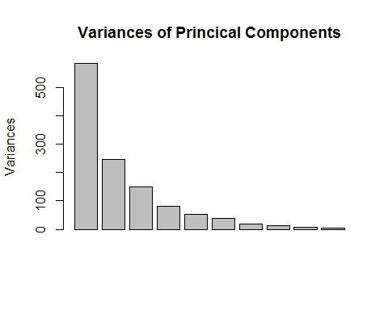

We can think about these three prinical components as three dimensions of political ideology that each person, country, agent has. Understanding the distributions of political ideology could shed light on how voting and elections work. We want to take a look at these first three dimensions. But before we work on all three dimensions lets take a look at the first two. 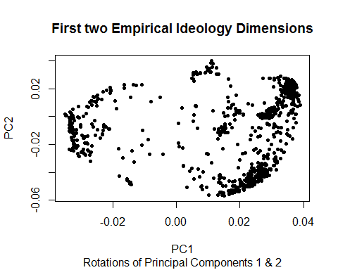

Different dimensions of political ideology are important for understanding how voters behave. Here is a look at the distributions of all three dimensions along with their correlations. 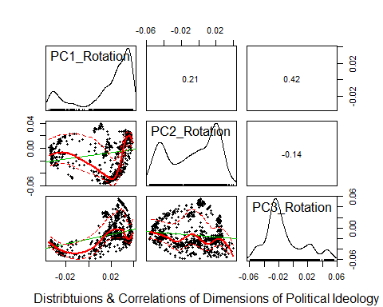

We can see that the distributions are sometimes bi-modal and do not appear to follow a normal distribution. How does this distribution change if we start to look to include the third dimension? Could we understand more about political ideology space if we took this into account? The plot below shows all three dimensions in one graph. 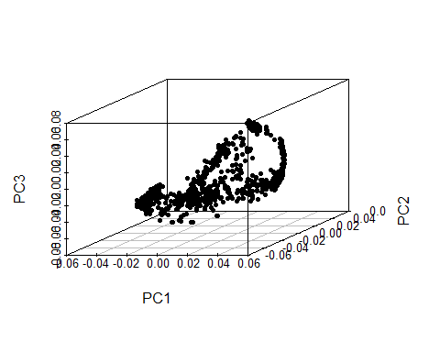

Now lets lookat the same information but colored by Country 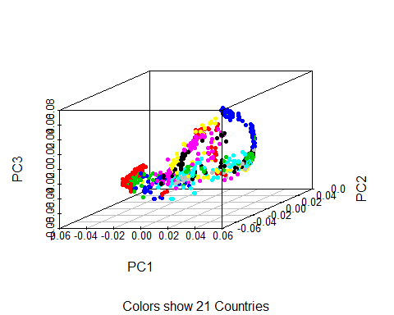

Although political ideology is a continuous spectrum, political parties exists in a much more binary space. They describe themselves as "left" vs. "right", "authoritatian" vs. "libertarian", "conservative" vs "liberal". I use kmeans clustering analysis to understand the different groups or communities (i.e. political parties) that the data suggests might exist. The graph below shows all three dimensions of political ideology and colors each observation according to the cluster to which it belongs. Examples are shown for 2 & 3 clusters

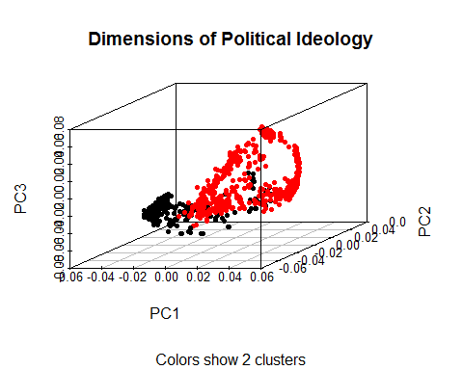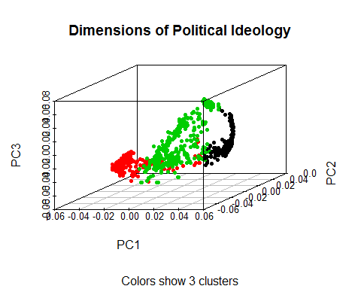

## 

## Bibliography

Black, D. (1948). On the Rationale of Group Decision-making. Journal Of Political Economy, 56(1), 23-34. <http://dx.doi.org/10.1086/256633>

Brierly, A. B. , 2008-04-03 "A Generalization of the Hotelling-Salop Model to M-Dimensions" Paper presented at the annual meeting of the MPSA Annual National Conference, Palmer House Hotel, Hilton, Chicago, IL Online <APPLICATION/PDF>. 2013-12-14 from<http://citation.allacademic.com/meta/p265616_index.html>

CASTLES, F. & MAIR, P. (1984). Left-Right Political Scales: Some 'Expert' Judgments. European Journal Of Political Research, 12(1), 73-88. <http://dx.doi.org/10.1111/j.1475-6765.1984.tb00080.x>

Downs, A. (1957a). *An Economics Theory of Democracy*.

Downs, A. (1957b). An Economic Theory of Political Action in a Democracy. Journal Of Political Economy, 65(2), 135-150. <http://dx.doi.org/10.1086/257897>

Feddersen, T. (2004). Rational Choice Theory and the Paradox of Not Voting. Journal Of Economic Perspectives, 18(1), 99-112. <http://dx.doi.org/10.1257/089533004773563458>

Feldman, S. & Huddy, L. (2014). Not so simple: The multidimensional nature and diverse origins of political ideology. Behavioral And Brain Sciences, 37(03), 312-313. <http://dx.doi.org/10.1017/s0140525x13002562>

Hernán Larralde, Pablo Jensen, Margaret Edwards. Two dimensional Hotelling model : analytical results and numerical simulations. 2006. <hal-00114288>

Hotelling, H. (1929). Stability in Competition. The Economic Journal, 39(153), 41-57. <http://dx.doi.org/10.2307/2224214>

Swank, D. (2013). Comparative Political Parties Dataset: Electoral, Legislative, and Government Strength of Political Parties by Ideological Group in 21 Capitalist Democracies, 1950-2011. Electronic Database, Department of Political Science, Marquette University, <http://www.marquette.edu/polisci/faculty_swank.shtml>

Veendorp, E. & Majeed, A. (1995). Differentiation in a two-dimensional market. Regional Science And Urban Economics, 25(1), 75-83. <http://dx.doi.org/10.1016/0166-0462(94)02075-r>