Predicting phage-host relationships using network fusion

Hielke Walinga (4373561)  
hielkewalinga@gmail

# Introduction

Here we propose methods for predicting phage-host relationships using network fusion techniques and so combining different sources of information. Network fusion is generally only applied to similarity matrices. Here we propose extensions to the existing network fusion algorithm so that it can be used with bipartite graphs as well.

## Motivation

Bacteria are under constant attack of phages that act as viruses and integrate their DNA into the bacteria so that the phages can multiply themselves. This is a parasitic relation where the bacteria act as host to carry out the multiplication of the phage DNA .

The bacterial communities are very diverse and almost all suffer from attacks by phages. Because of the need of phages to be reproduced by the bacteria, you can find glues about what phages attack what bacteria by looking into DNA of both the phages and the bacteria. This gives interesting ways to indirectly infer what phages attack bacteria. It is therefore an interesting subject to learn more about ecological networks on the micro scale.

In addition, there has been increased interest in the use of phages against bacterial infection. This is caused by an increasing number of antibiotic resistant bacteria resistant bacteria. Using phages to kill bacteria can help to better combat bacterial infection .

## Representing the phage-host relationships in a bipartite graph

We will model the phage-host relations as a bipartite graph. We model the bacteria and the phages as nodes in the graph. So, in the resulting graph we will have two kinds of nodes. One group of nodes that each represent a kind of bacteria and another that represent a kind of phage.

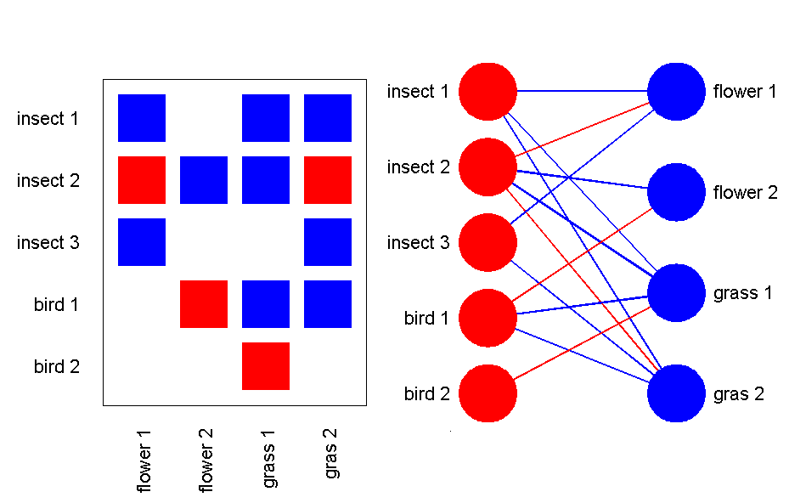

Another example of a bipartite network in ecology. What animals eat what plants. Source:

We will divide the information of the graph in three matrices. There are two matrices that represents the similarity between respectively the phages or the bacteria, and there is a third matrix that represents the relation between the phages and the bacteria. Usually a bipartite graph is only represented using this third matrix, and when refered to the bipartite graph we usually mean only this matrix. However we will also make use of the information of the similarity matrices between phages and between bacteria.

In the relation matrix, or interconnection matrix, an edge represents the possibility for a phage to be able to infect the bacterium. We will refer to this matrix as $C$. The dimensions of this matrix are $f×b$, where $f$ indicates the amount of phages and $b$ indicates the amount of bacteria. Now, each entry of the matrix represents a relation with one particular phage and one particular bacteria.

The matrix that represents the phage similarity we call $F$ and has dimensions $f×f$, where $f$ indicates the amount of phages. The other matrix indicates the similarity of the bacteria with the other bacteria. This matrix we call $B$ and has dimensions $b×b$. Unlike the relation matrix $C$, the similarity matrices are symmetrical.

## Modularity and nestedness

Phage-host relationship graphs are often non-random. They have certain characteristics that are called modularity and nestedness.

Modularity in a bipartite graph means that we can define certain groups that mostly have connections with other nodes in that group, but have less connections with nodes outside the group. Biologically, this probably indicates that these bacteria and phages are living together and therefore the phages have mostly evolved to target those specific group of bacteria and cannot infect other bacteria that are not found in nature with those other phages.

Nestedness in a bipartite graph means that we can order the graph in such a way that there is a hierarchy between phages that target a lot of bacteria and phages that only target a few bacteria. For this graph, there are general phages, that can target a lot of bacteria and specialized phages, that only target a few. Biologically these patterns are likely caused by the fact that some phages have evolved better attack mechanisms against multiple bacteria and some are lacking behind. Just as some bacteria have evolved better defense mechanisms than those infected by a lot of phages.

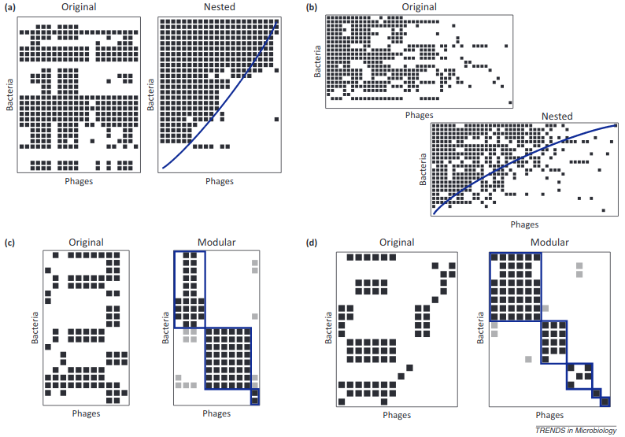

Nestedness vs. modular infection matrices. Source:

When investigating published relation matrices of phage-host relationships based on empirical data, it is found that these matrices are mostly nested. However, it is also noted that this observation might be biased by the environments that have been analyzed in those experiments. Environments like low resource environments, for example, might eliminate the general phages. Another interesting bias that is discovered, is that network analysis of microbial communities in food production is often more modular. These communities are most likely selected by those food producers as modular communities are more robust against phage attacks .

## What data is available

The proposed method tries to use information that is available for as well phage-host relationships as well as phage-phage and bacterium-bacterium relationships / similarities. Sometimes information that is used in the similarity calculation can also be used to predict an infection relationship. Most of these relationships are based on the fact that because phages insert themselves in the DNA of the bacterium, they will likely have similar DNA, or a bacterium might even have traces of the phage found in the bacterium. Here summarized what these kinds of sources of information are, found in .

### Data sources for phage-host relationships

**Co-abundance in metagenomics** Metagenomic samples are samples from nature including multiple organisms. Whenever you find a phage and a bacterium together in the same metagenomic dataset, they live together and makes it also likely that the phage infects the bacterium.

**Genetic homology** Since phages integrate their DNA into the bacteria, over time some left-overs of genes might still be found in the bacteria. Comparing genes in phages and bacteria might give glues about the relationships the bacteria and phages have.

**Oligonucleotide profiles** In addition to the genetic homology, you can also look on the base pair level itself for relations between different genomes. In this case, you can look at small pieces of DNA (oligonucleotides or k-mers) and match them between organisms.

**Codon usage** Instead of taking arbitrary k-mers, you can also look at the codons and see how much similarity you can find there. In this case you look at the in frame 3-mers. Codon usage might be important as a phage needs to make use of the tRNA as the bacterium when infecting.

**GC content** The least specific way of looking for homology on the basepair level is to look at the percentage of GC content in the genomes.

**Exact matches** Since the phages insert themselves in the bacteria, it is possible to find complete phages in the bacterium’s genome, and thus confirming a relationship between the found phage and the bacterium.

**CRISPR** To defend themselves against phages, bacteria have acquired an immune system that saves the intruders information in CRISPR arrays. Extracting the CRISPR arrays and matching them with phages might give glues about what phages the bacteria faces.

### Data sources for phage-phage relationships

The metrics uses to match phages and bacteria, can also be used to generate the similarity between phages (except CRISPR, and searching for exact matches). In addition you can make use of phylogentic distances between phages, or look at the phylogentic distances of the genes that are used for infiltrating in the bacteria.

### Data sources for bacterium-bacterium relationships

Just as for phages, the already mentioned metrics can also be used to find relationships between bacteria. Even though a CRISPR spacer might not hit in a phage, using it for bacterium-bacterium similarity can still be helpful as it still indicates that they (used to) have the same phages as attackers. Here we can also focus in on the phylogeny of the proteins of the defense mechanisms of the bacteria.

## Network fusion

When creating a network from biological data, a common challenge involves being able to combine multiple sources of information. This problem is known as network fusion.

There are multiple different strategies to solve the network fusion problem. Here we propose to make use of an existing method called similarity network fusion (SNF)  with more details here .

For a full explanation of the algorithm, consult the papers, but in short, you have to create a similarity network for each source of information and then combine the networks using the following algorithm:

First generate a similarity matrix $W$ for each of your information sources, then normalize this matrix to create the status matrix. Take the self-similarity as $\frac{1}{2}$. Then create a kernel matrix $P$ by normalizing using the k-nearest neighbours $N_{i}$ which results in a sparse matrix $P^{*}$. We will keep using the $*$ to indicate sparseness by nearest neighbour selection.

$$P(i, j) =
\begin{cases}
\cfrac{W(i, j)}{2 \sum_{k \neq i}W(i, k)} & j \neq i \\
\hfil \frac{1}{2} & j = i
\end{cases}$$

$$P^*(i, j) =
\begin{cases}
\cfrac{W(i, j)}{\sum_{i \in N_j}W(i, j)} & i \in N_j \\
\hfil 0 & else
\end{cases}$$

Here are the update formulas to fuse the different status matrices $P_{v}$ and $P_{w}$ that represent two different information sources. Repeat the formulas till convergence.

$$\begin{matrix}\begin{matrix}P_{v,t+1}=P_{w,t}^{*}×P_{v,t}×P_{w,t}^{*,T} \\ P_{w,t+1}=P_{v,t}^{*}×P_{w,t}×P_{v,t}^{*,T}\end{matrix}\end{matrix}$$

This can be extended to account for more than 2 information sources.

# Related work

As far as I can find, the only computational work done on phage-host relationships involves a single metric which is used to measure the possibility of a phage-host relationship . I could not find references to an attempt to combine these results or to combine it with phage-phage or bacterium-bacterium similarity. There is however a paper that reports using “iterative weighted distributed averaging” to apply network fusion on bipartite graphs .

# Proposed method

The challenge here is that in essence we have different sources of information, but we also have two different kinds of similarity matrices, one for bacteria and one for phages, and we have different sources of information for the third matrix, the relation matrix.

The challenge here is that we have three kinds of matrices that all have different sources of information. We want to combine all this information and create a single relation matrix. This proposal shows how all these sources can be combined to get this relation matrix and using all the different sources of information. We dot his by proposing modifications of the SNF algorithm useful for bipartite networks.

The assumption we make here, is that related phages target the same bacteria, and that related bacteria are target by the same phages. This is most likely to work best when the bipartite network is also mostly modular, but it will work as well if the bipartite network is very nested although it could be that the general phages will diffuse too much or too little to the other phages.

## Combining different information

First, the different sources of information for both the phages as the bacteria networks are combined to present a similarity graph for both the phages and the bacteria. For this the standard SNF method can be used.

## Diffusion of the phage-host relationship

Now we have a similarity network for both the phages as the bacteria. The next step will be to ‘diffuse’ the information that exist for phage-host relationships (the connection graph) to other phage-host connection that don’t have this information available. We diffuse the weights to other connections that have the most similar phages or the bacteria.

To do this we first pick what network to use (either the phage-phage $F$, or the bacterium-bacterium $B$). (It is probably best to make use of the sparse similarity matrix here, $F^{*}$ and $B^{*}$.). Then multiply this with the connection matrix ($C$). This will then move the weights over the strongest connection for each phage or bacterium.

When working out the math it will become clear that the steps for the phage similarity matrix and the bacteria similarity matrix can be combined into a single step that has much resemblance to the previous discussed SNF algorithm.

Here we find the update rule to move from $C_{t−1}$ to $C_{t}$ to $C_{t+1}$ in one step. These steps can be repeated $n$ times.

$$\begin{aligned}
\begin{split}
C_{t+1} &= F^* \times C_t \\
C_{t} &= (B^* \times C_{t - 1}^{T})^{T} \\
&= C_{t - 1} \times B^{*,T} \\
\hfil Combined: \\
C_{t+1} &= F^* \times C_{t - 1} \times B^{*,T}
\end{split}\end{aligned}$$

### Alteration to ensure convergence

Since we are alternating between two different similarity matrices, I don’t think it will converge. To make sure the algorithm converges, I propose to alter the similarity matrices every iteration by gradually reducing the percentage of weight that gets moved around until it reaches zero percent.

This can be mathematically be accomplished by changing the normalization function so the self-similarity start at some point ($a(0)=\frac{1}{2}$) and let it gradually grow to one. When it reaches one, the normilization transforms the similarity matrix into an identity matrix. Now all similarity is self-similarity and no weight is shifted anymore.

$$\begin{gathered}
P^*(i, j) =
\begin{cases}
(1 - a(t)) \times \cfrac{W(i, j)}{\sum_{i \in N_j}W(i, j)} & i \in N_j \\
\hfil a(t) & i = j \\
\hfil 0 & else
\end{cases} \\
a(0) = \frac{1}{2} \\
a(T) = 1
\end{gathered}$$

What’s more, this adjustment can help to prevent weights drift to far away and can thereby preserve some nestedness. It is probably also best that this function that is responsible for reducing the amount of shifted weight is convex so that most of the change happens in the first iteration. I believe this will be best to prevent disrupting the nestedness too much, but it can be experimented with what would be best.

### Performing network fusion on the connection matrix

Now we only are left with multiple connection matrices for each source of information on the phage-host relationships. We can however transform the connection matrix in a square matrix ($M$) by adding the missing edges between bacteria and phages as an edge with zero. So, in essence we stack the connection matrix with the similarity matrix of the phages and the bacteria. The resulting matrices can then be fused using the aforementioned SNF fusion algorithm. This can in fact be simplified by applying similar to the SNF fusion algorithm to the connection matrix directly.

Here we merge connection matrix $C_{w}$ with $C_{v}$. In the derivation $0_{x}$ indicates a square with all zeros with size x by x.

$$\begin{matrix}\text{Full matrix from connection matrix:} \\ M=\left[\begin{matrix}0 & C^{T} \\ C & 0\end{matrix}\right]\end{matrix}$$

$$\begin{matrix}\text{Update rules:} \\ M_{v,t+1}=M_{w,t}^{*}×M_{v,t}×M_{w,t}^{*,T} \\ M_{w,t+1}=M_{v,t}^{*}×M_{w,t}×M_{v,t}^{*,T}\end{matrix}$$

$$\begin{matrix}M_{v,t+1} & =M_{w,t}^{*}×M_{v,t}×M_{w,t}^{*,T} \\ & =\left[\begin{matrix}0_{b} & C_{w}^{*,T} \\ C_{w}^{*} & 0_{f}\end{matrix}\right]×\left[\begin{matrix}0_{b} & C_{v}^{T} \\ C_{v} & 0_{f}\end{matrix}\right]×\left[\begin{matrix}0_{b} & C_{w}^{*,T} \\ C_{w}^{*} & 0_{f}\end{matrix}\right] \\ & =\left[\begin{matrix}0_{b} & C_{w}^{*,T}C_{v}C_{w}^{*,T} \\ C_{w}^{*}C_{v}^{T}C_{w}^{*} & 0_{f}\end{matrix}\right] \\ C_{v},t+1 & =C_{w}^{*,T}C_{v}C_{w}^{*,T}\end{matrix}$$

### Discussion: A note on the order and combination of steps

As can be seen, there are a few different ways to combine all the information. You can for example also apply the network fusion on the connection matrix first and then diffuse it using the similarity matrices. This is also faster because then the diffusion is only applied to one connection matrix and not multiple. I think this might be a worthwhile alternative to investigate.

On the other hand, you can even apply the diffusion using the different sources of the similarity matrices. I, however, don’t think that is the best way as it then will start to mix different kinds of information too much too early. Although, you can also argue that information might be lost too soon, so this is probably is something that needs to be experimented with a bit.

Finally, you can also create the full square matrix from the connection matrix by including the similarity weights already instead of setting those edges to zero. I also think that such an approach tries to combine too much information too early. However, it might still be interesting to investigate the affect between forcefully setting the similarities between bacteria and phages to zero or to let them grow as well, or even initialize them to some value (fixed or otherwise). Setting those to the identity matrix of a fraction of that is also another option.

### A note on computational complexity

To reduce the computational I propose to make the similarity matrices sparse by only looking at the k-nearest neighbours for each similarity neighbour. This is also done in the SNF algorithm and can also trivially be applied to the aforementioned formulas, and have been indicated using $*$.

### Notes on modular versus nestedness

The approach relies on the assumption that phage-host networks are modular. I assume it would work best in situations where one wants to place unknown bacteria or phages in a spot with already fairly known relationship.

However, it should also work for relative nested networks, but only if it is true that generalized phages and general bacteria are relatively very similar to a lot of other respectively phages and the specialized phages / less targeted bacteria are more unique.

# Summary

The discussed method can be summarized in four steps (not necessarily in this order):

* Find similarity matrices for phage-phage and bacterium-bacterium using network fusion.
* Find connection matrix for phage-host.
* Diffuse the phage-host matrix using the phage-phage and bacterium-bacterium matrix.
* Apply network fusion to the resulting diffused phage-host relationships.

# Further ideas

## Maximizing modularity

Although modularity is not an end in itself, a good modular network is something what can be expected. That’s why it might be worth looking into methods that focus on maximizing the weights on the different information sources, instead of applying the network fusion algorithm. This can be done on the connection matrix alone (and so still have the ability to perform network fusion and diffusion first), but can also be done on the combined matrix with all the phage-phage and bacterium-bacterium information already included. This might however, force the modular network a bit too much.

Additionally, it might be that certain changes to some update formulas can force a certain degree of modularity. One can see if this is possible and improves the results.

## Using experimentally proven phage-host relationships

There is various experimentally proven phage-host relationships available. These experimental data can be used to enhance the network fusion or to validate our method.

Still, it is important to note that those experimentally reported phage-host relationships might be biased and using it needs caution.

### Enhancing the proposal with some semi-supervised method

It might be possible to use this as an alternative information source that can make certain relationships more important than others because of it being experimentally proven, or can be used in some semi-supervised learning way.

### Validation

This source of information can however also be used a way to validate our method.

It is perhaps also a good idea to see if certain assumptions we make in this proposal or true for the real world. Especially the idea that phages that infect the same bacteria are more similar to each other and bacteria with the same phages as viruses are more similar to each other.