**Your First Vue.js App**

* Vue can be added by

<script src="https://cdn.jsdelivr.net/npm/vue/dist/vue.js" defer></script>

* **Or**
  + Yarn install vite
    - Lets us use vue.js with hot reload
  + **Create two files**
    - **Index.js and index.html**
  + **Initalize template with “app” id**
    - **This is were vue renders**

**Running Vue application (development environment)**

* Yarn vite

**Using Vue.js (hello world)**

**Adding a template Property**

**Separating js from index.html**

Template box (like angular)



* **Left:** index.html
* **Right:** index.js

**Using Interaction with methods**

* Options API

Data Option

Template option



* + Is a classic way of building vue component
  + Methods layer is where we define how Vue interacts with data

Method Option



* Composition API

**Control flow with v-if and v-else**

1. Using logic in template
   * Add condition to `**v-if**`

1. Using logic in method
   * Add method to `**v-if**`

**Loops with v-for**

* Loop is done using **v-for**
* **V-show** renders components but puts it to **display: none**
  + **V-show is useful when using animation**
* **v-if** doesn’t render the component
  + **This is used in general**

**Computed Properties**

* Allows to modify array list properties before being used
  + Useful when creating subset list of list
  + This is cooler than AngularJS

Computed properties

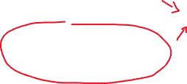

**Class bindings**

* **V-bind:attr_name**
  + Short form 🡪 :attr_name
* Is a way of telling to not use string literal but javascript expression

Binding



* **V-on** short handed form 🡪 @



**Input Validation**

* Use **v-bind:attr_name=”vue_data”** or **:attr_name=”vue_data”** to pick up value of data
* **Use v-on:input=”vue_function” or @input=”vue_function”** to register value of data

**v**

Registers value



**Amazing v-model**

* Is equivalent to 2-way binding in angular.js
  + Combines both v-bind:input and v-bind:attr_name

The same



* Can be used with checkbox

v-model with checkbox

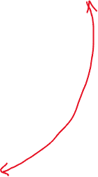

* Can accept array of values for checkbox
  + When uses the same **v-model**



**Your First Component**

* Component imported inside `component` section
* Variable 🡪 always strats with uppercase
* Component 🡪 always starts with lowercase



Component used here



Component imported here



Created component

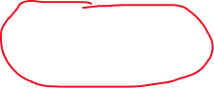

**Component Props**

* Component imported inside `component` section
  + Is passed using **v-bind**
  + must be declared which props are coming in before user
* Variable 🡪 always strats with uppercase
* Component 🡪 always starts with lowercase

Property used here



Custom component declared here



List of incoming props



Example

Reducing unnecessary tags

* Done by injecting v-for directory to component

**Child-Parent Communication with Events**

* is done by calling this.$emit(emit_name, val) in child component

**Example**

Emit called here



Called here



Called function

Emitted value (from child component)

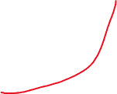

**Form Validation**