Chapter 1
Research Description
1.1 Background of the Study
The word ‘vibes’ refers to a person's emotional state or the atmosphere of a place as communicated to and felt by others. The proponents chose to name the system as MyVibes since users share music lists in a typical atmosphere where one’s preferences can influence another.
Music/MP3 ranking is largely common both online and in music applications. Ranked songs are usually based on the number of plays and their current popularity. Music applications such Last.fm, uses plug-ins to extract music data from playlists and create ranking of the songs for the users. The Google PageRank algorithm created by Larry Page and Sergey Brin is a good method to use for ranking. The Google PageRank is primarily used on Google’s search engine to rank pages so that users are given the best search results as possible. The pages are ranked according to the number of hyperlinks pointing to it from other web pages, putting the most important web pages at the top of the list. Using the underlying principle of the algorithm, the PageRank can be applied to rank other objects, such as music.
Recommendation systems can be seen in the web a lot, such as product and movie recommendation engines. There are two recommendation methods that are usually used by websites to generate recommendations for users; namely, the Item-Based approach and the User-Based Approach. Item-based recommendation is popular for use in the products, but it is a good idea to use the User-Based approach when applied to music. This idea is applied in the sense that we ask our friends for music recommendations if we know that we share the same preferences of music as them.
Collaborative Filtering techniques cluster users with the same preferences for easier recommendation. Based from a cluster with similar preferences, patterns and predictions can be generated. Overall, this will give it a feel of having personalized recommendations.
All these ideas mentioned namely music/mp3 ranking, collaborative filtering techniques and the PagePank algorithm lead to the realization of our research. There are still relatively few applications of this research, particularly the use of these techniques together in ranking music.
1.2 Statement of the Problem
A lot of objects in the Internet (such as movies, songs and websites) use the item-based method of recommendation. That is, the objects are ranked based on the attributes of the object (ex. ratings and genre of a movie) as opposed to user-based recommendation that relies on the groups of users with similar preferences. Exchanging music preferences is an interesting topic in which recommendation techniques can be used. But there are only few of these applications that exist in the web. User-based recommendation is another method to use for music rather than item-based recommendations. Good recommendation techniques that are used for recommendation systems other than music can be applied to the music field itself. Also, due to the heterogeneous nature of objects being ranked in the internet (such as movies, music and websites), representing and querying of music data is a challenge. There is much to be explored in creating music recommender systems for users to truly utilize this tool.
1.3 Research Objectives
1.3.1 General Objectives
The general objective of this research is to develop and implement a music recommender application that will generate music recommendations for a user based from the users who share the same music preferences. It will also generate a list of ranked songs according to the data extracted from the music players of the users involved. The application is meant to be an online community for users and their chosen circle of friends to exchange music lists by computer-generated recommendations.
1.3.2 Specific Objectives
The following are specific objectives of the research:
1.3.2.1 Design the client-server architecture of the MyVibes Music Recommender System.
1.3.2.2 To implement a method of transferring data from the media player to the application.
1.3.2.3 To implement the PageRank algorithm that ranks songs for recommendation to other users.
1.3.2.4 To implement collaborative filtering techniques in extracting specific and significant data from a user’s music player, making it a user-oriented method of ranking.
1.3.2.5 To implement solutions for representing, querying and handling heterogeneous music data of different users.
1.4 Scope and Limitations of the Research
The project was intended to create a client-server online community that focuses on the exchange of computer-generated music rankings between the users involved. It creates music rankings that will only include the generalized, user-to-user and user point of view. Furthermore, the online community environment was designed to have simple and minimal features for its simple purpose.
This research was not meant to function as a fully functional online social networking application. In addition, this research was limited to defining its music data input solely from the information gathered from the user’s music player. Hand-picked music selections from the user are not included. Also, automatic data extraction from media players occurs if the user is online.

1.5 Significance of the Research
The research implemented a more intelligent and user-oriented method of recommending music among a group of users. The method of music ranking in this research helped users in gaining better access to music that they would actually like, given that the recommendation come from their circle of friends. This research also encouraged the use of collaborative filtering, not only in music, but also in other fields as well. Collaborative filtering has a lot more potential uses with its method of extracting data from a user’s interaction with an object (like movies, websites and music) for better recommender systems.
1.6 Methodology
This research was conducted to create a music recommender application where users can share music lists that are automatically generated by the application based on the information collected from their playlists. Few recommender systems have been established for music preferences, but because music is so popular, there might just be more of these that will be developed. This chapter discusses the specific methods involved in the process of data gathering, analyzing data, implementing and using collaborative filtering methods and PageRank algorithm in creating the system.
Reviewing and studying related papers and researches is the first step undertaken to formulate solutions. Data gathering happens all throughout the research. Along with studying past researches, music data was also gathered then filtered from the users' music players and a survey was conducted at the end to test the correctness of the generated playlist versus actual user preferences. Analysis and design, implementation and testing happened in between music data filtering and conducting the survey.

1.6.1 Literature Review and Data Gathering
Studying related papers, studies and researches is the first step to formulate solutions. Each method described in the researches were studied and evaluated for its effectiveness. Better solution methods can be proposed to address problems based on our evaluation.
1.6.2 Analysis and Design
This research implemented an application for a community of users. Therefore, several diagrams were developed to describe the application and guide the user through it. An Activity Diagram was made to serve as a walkthrough of the application. The Use Case Diagram described how users can interact with the application, and what functions they can do. UML Model that include a Sequence Diagram were also developed.
1.6.3 Implementation
This part describes algorithms and concepts involved in a step-by-step process in attaining the solution.
1.6.4 Testing
To test the effectiveness and usability of the application, several users were asked to use the application so a stream of data can be generated for evaluation. The testing period took about two months so that relevant observations can be made when users frequently update and change their music of choice, and how this affects current music rankings. Users were also asked to take a short survey on how satisfied they were with the music lists that the application generated. They were asked to evaluate their application-generated user rankings (based on their accuracy versus their preference) and the list that they were recommended (based on how they will like the songs on the list).

Chapter 2
Review of Related Literature
This chapter presents the significant terms and definitions relating to the application of PageRank and collaborative filtering technique in creating a system for music recommendation. Moreover, a discussion of existing PageRank and collaborative filtering technique systems and a relative ground of these systems are included.
2.1 Recommender Systems
Recommender systems or recommendation systems (sometimes replacing "system" with a synonym such as platform or engine) are a subclass of information filtering system that seek to predict the 'rating' or 'preference' that a user would give to an item (such as music, books, or movies) or social element (e.g. people or groups) they had not yet considered, using a model built from the characteristics of an item (content-based approaches) or the user's social environment (collaborative filtering approaches). Popular recommender systems found in the web include Amazon and IMDB(Internet Movie Database). Both make use of item-based recommendation, wherein relationships between items and current users are analyzed.
2.2 PageRank
PageRank was named after Larry Page and it was used by Google Internet search engine which assigns a numerical weighting to each element of a hyperlinked set of documents, such as World Wide Web, by means of “measuring” its relative importance within the set.
Google figures that when one page links to another page, it is effectively casting a vote for the other page. PageRank is Google's trademark and it is its way of deciding a page's importance. The more votes that are cast for a page, the more important the page must be. Google calculates the importance of a page from the votes. Also, the importance of each vote is taken into account for the calculation of PageRank because it is one of the important factors that determine the rank of the page in the search results. The PageRank of a page is defined recursively and depends on the number and PageRank metric of all pages that link to it (incoming links). A page that is linked to by many pages with high PageRank receives a high rank itself. If there are no links to a web page there is no support for that page. The Google PageRank looks like this:
PR(A) = (1-d) + d*(PR*(T1)/C*(T1) +…+ PR*(Tn)/C(Tn))
where PR(A) is the PageRank of a page A; PR(T1) is the PageRank of a page T1; C(T1) is the number of outgoing links from the page T1; d is a damping factor in the range 0 < d < 1, usually set to 0.85. Disregarding the damping formula(d), the simplified version looks like this:
PR(A) = PR*(T1)/C*(T1) +…+ PR*(Tn)/C*(Tn)
The algorithm may be applied to any collection of entities with reciprocal quotations and references. The numerical weight that it assigns to any given element E is referred to as the PageRank of E and denoted by PR(E).
Numerous academic papers concerning PageRank have been published since Page and Brin's original paper. In practice, the PageRank concept has proven to be vulnerable to manipulation, and extensive research has been devoted to identifying falsely inflated PageRank and ways to ignore links from documents with falsely inflated PageRank.

2.2.1 PageRank : Standing on the Shoulders of the Giant
The Web is viewed as a directed graph of pages connected by hyperlinks. A random surfer starts from an arbitrary page and simply keeps clicking on successive links at random, bouncing from page to page. The PageRank value of a page corresponds to the relative frequency that the random surfer visits that page, assuming that the surfer goes on infinitely. The more time spent by the random surfer on a page, the higher the PageRank importance of the page. But Castagna (April 2009) said on his paper, “Having Fun with PageRank and Map Reduce “, a random surfer just follows links at random indefinitely that causes the rank of a page sink and cycles.
On the paper “PageRank : Standing on the Shoulders of the Giant” , the author, Franceschet (2010), concludes that PageRank introduced an original notion of quality of information found on the Web: the collective intelligence of the Web, that is formed by the opinions of the millions of people that populate the universe, is exploited to determine the importance, and ultimately the quality of that information.

2.3 Collaborative Filtering
Collaborative Filtering (Shardanand & Maes, 1995; Konstan, et. al., 1997) is one of the most popular and successful ﬁltering techniques that have been used to date. It is applied in a setting where users have a choice between a numbers of items (i.e. all books in a book store) and provide votes to items that they know about. Collaborative Filtering helps users to make choices based on the opinions of similar users in a system and ﬁnd relevant items that they may not have explored so far. The basic idea employed is that users who agree with each other on some items based on their ratings are likely to agree or disagree on future items. To make predictions for a given user, collaborative ﬁltering algorithms typically ﬁnd similar users in a system, and assign weights to the level of similarity. The preferences of this set of similar users is combined and weighted with the assigned weights. This technique has its basis in every-day life where people consider the opinions of similar minded people in order to decide what they want to buy next (e.g. a music CD).
Collaborative ﬁltering is therefore an algorithmic form of word-of-mouth process. Collaborative ﬁltering algorithms are now widely used in Internet applications, with considerable success. For example, Amazon.com and CDNow.com, the largest online book and music stores respectively on the web, use collaborative ﬁltering to provide personalized information ﬁltering for users. Many other recommender systems have been developed using this technology, such as MovieFinder.com, Belcore Video Recommender (movie recommendation sites), Levis Style Finder (www.levis.com, a clothing recommender system), and lately, NetFlix, an online DVD rental store. Figure 2.2 on page 12 shows a systematic example of collaborative filtering data with the task of predicting values for the user U_{a}.

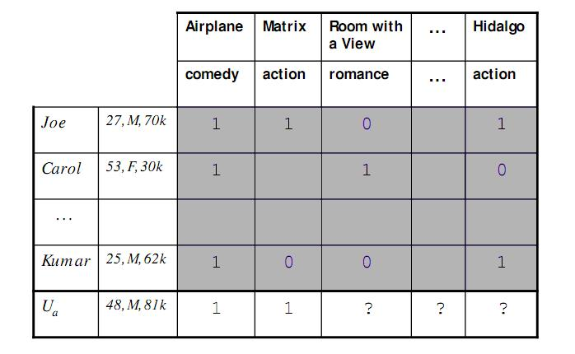
Figure 2.2 An example of a Collaborative filtering data.

2.3.1 Clustering based Recommendation System
In the context of item recommendation systems, clustering algorithms are generally used to identify groups of similar users who has the same preferences. Most of the clustering methods have been integrated in several collaborative filtering-based recommendation systems in order to alleviate sparsity (small in numbers and scattered over a large area) and scalability problems.
Lack of scalability is one of the shortcomings of user-based approaches. Because user profiles change rapidly as users interact with the system, the neighbourhood construction phase must be an on line process. Therefore, for very large data sets, the latency for computing the recommendation can be unacceptable.
According to Xue et al. (2005), to overcome the problem in sparsity, use a collaborative filtering system based on a K-means clustering in order to smooth the unrated item/data for individual users according to the group. While according to Yashar Moshefeghi, Deepak Agarwal, Benjamin Piwowarski and Jeason Jose (date here) on their paper “Movie Recommender: Semantically Enriched Unified Relevance Model for Rating Prediction in Collaborative Filtering”, they said that item-based collaborative filtering, which is similar to user-based when the role of the item and user is swapped, was a solution to the scalability problem.
On the same context, Jiang et al. (2006) suggests using a cluster-based collaborative filtering based on an iterative clustering method that exploits the interrelationship between the users and items.
To overcome the problem in scalability, George & Merugu (2005) used a collaborative filtering approach based on that weighted co-clustering algorithm that will include simultaneous clustering of video of users and items.
According to the paper of Ilham Esslimani, Armelle Brun & Anne Boyer, the “A Collaborative Filtering Approach Combining Clustering and Navigational Base Correlations”, they used a collaborative filtering model which exploits the groups of users based on a similarity matrix of the users that allows the reduction in dimensionality and used navigational patterns to refine the results of clustering and produce recommendations.
2.3.1.1 Data Mining
Data mining is part of the Knowledge Discovery in Databases(KDD) process, and is understood to be the non-trivial extraction of previously unknown and potentially useful, valid and comprehensible information from a large volume of data. Data mining makes use of data analysis tools to discover previously unknown, valid patterns and relationships in large data sets, leading to knowledge discovery. Data mining tools can range from statistical models, mathematical and machine learning algorithms and methods. Data mining involves six common classes of tasks. Namely: Anomaly detection, Association Rule Learning, Clustering, Classification, Regression and Summarization.
2.3.1.2 Machine Learning
Machine learning is a system capable of acquiring and integrating knowledge automatically by learning through a series of experience, training, analytical observation. This results in a continuously self-improving system. A big focus of machine learning is to automatically produce models of patterns, plans, representations and description to show how a particular system or concept works. For example, it can come up with rules to perform an operation or produce certain results, functions and patterns based on all that it has learned from the data input.
2.3.2 Rating Prediction
Collaborative filtering approaches are often classified as memory-based or model-based. In the memory-based approach, all rating examples are stored as-is into memory (in contrast to learning an abstraction). In the prediction phase, similar users or items are sorted based on the memorized ratings. To predict the rating of an item i for a user u, this method simply averages the ratings r_{i,u’} (same item, different user) weighting them by the similarity between u and u’ (user-based method). Based on the ratings of these similar users or items, a recommendation for the test user can be generated. Examples of memory-based collaborative filtering include user-based methods and item-based methods. The advantage of the memory-based methods over their model-based alternatives is that less parameter have to be tuned; however, the data sparsity problem is not handled in a principled manner.
In the model-based approach, training examples are used to generate a model that is able to predict the ratings for items that a test user has not rated before. Examples include decision trees, aspect models and latent factor models. The resulting ‘compact’ models solve the data sparsity problem to a certain extent. However, the need to tune an often significant number of parameters has prevented these methods from practical usage. Lately, researchers have introduced dimensionality reduction techniques to address data sparsity. However, as pointed out in, some useful information may be discarded during the reduction.
2.4 Related Applications
2.4.1 Last.fm
Lorenzi(2005) extracted user data from Audioscrobbler to analyse song-similarities. Audioscrobbler is the data back-end of the popular social music network Last.fm, where listening statistics on song, artist and user level can be retrieved. Using the community data, he basically counted the number of co-occurrences of any pair of songs in all of the user’s 50 most played tracks list and derived song similarity (or song distance) out of them. If two songs co-occurred in more track lists, those two songs were determined to be more basically similar. To comprise all song dependencies, the songs were embedded in a 10-dimensional Euclidean space, using the song distances determined in the track list analysis. Thus, each song was assigned a 10-dimensional coordinate, whereby each song can be identified using the embedding metrics. Clearly, a great basis for item-to-item collaborative filtering was established.
2.4.2 iTunes
In triumph of the Nerds, Robert Cringely (1996) TV documentary series about the rise of the personal computer industry, Steve Jobs (2002) was asked what made Apple such an unusual company. 'It comes down,' he said, 'to trying to expose yourself to the best things that humans have done and then try to bring those things into what you're doing. Picasso (1881) had a saying, "good artists copy, great artists steal", and we have always been shameless about stealing great ideas.'
Before we get too sanctimonious about this, it's worth remembering that Jobs's adoption of Picasso's mantra is what has made Apple such an innovative force in the computer business. Its unique selling proposition is that it takes good ideas and turns them into products that ordinary human beings can use. The graphical user interface of all modern computers, for example, was not invented by Apple but by researchers at Xerox's Palo Alto lab in 1970-73.
Xerox, conversely, proved incapable of exploiting the then-revolutionary technology, thereby providing a classic case study in fumbling the future. Jobs recognized the potential of the Xerox interface and made it available to the world in 1984 in a consumer product called Macintosh.
Similarly, the MP3 format for compressing audio files was patented in 1987, and music in MP3 format was widely circulating on the net from the mid-1990s. But it took Apple to turn compressed music files into a consumer product by launching the iPod and iTunes software in 2001.
It's the same story with Wi-Fi. The technology was around from 1990, but in order to create a wireless network at home for most of that decade you needed to be two-thirds geek and one-third lunatic. In 1999, Apple turned Wi-Fi into a plug-and-play consumer product under the Airport brand name, and wireless networking has become ubiquitous since then.
Spool forward 12 years to last week, when the version 8 update of iTunes was released. Having duly downloaded and installed it, users were confronted with a new feature - the 'genius button'. Pausing only to spit at the implicit hubris, your columnist duly agreed to the terms and conditions (which basically involve agreeing to let Apple analyze your music library) and sat back.
It works like this: click on a track in your iTunes music library and a sidebar pops up with a list of other tracks which are, somehow, 'like' the one you've chosen. By a happy coincidence, all are available for purchase from the iTunes store. So Van Morrison's 'Days like This' triggers associations with (among others) 'End of the Line' by the Traveling Wilburys, 'World Spins Madly' by the Weepies and - more intriguingly - 'Waiting on a Friend' by the Rolling Stones and several songs by Paul Simon.
But click on anything by the Beatles and the genius button turns moronic. 'Genius sidebar,' it complains, 'could not find matches for your specific selection, but here are the top songs and albums from the iTunes store.'
This rather gives the game away. The 'genius' of iTunes is really a crippled implementation of collaborative filtering, one of the oldest - and most useful - technologies to have emerged from the web. It's based on algorithms that filter information based on a collection of profiles of other users, working on the assumption that people with similar profiles may share similar interests. It is what enables Amazon, for example, to suggest books, records and videos that you might like, based on your record of purchases and the information the site holds on millions of other customers. The difference is that the range of choice and suppliers is much greater on Amazon than it is on the iTunes store.
The introduction of the genius button suggests Apple is sticking close to Jobs's philosophy about the shameless appropriation of great ideas. But the new iTunes feature is a pretty feeble appropriation. It is also a lost opportunity. Collaborative filtering improves dramatically the more people are involved.
2.4.3 A Collaborative Filtering Method Based on the Forgetting Curve
Collaborative filtering (CF) is one of the most successful approaches for making personalized recommendations. The paper of Hong Yu Zhuanyun Li(2010) aim that the issue of tracking the drifting of the user's interests, and proposes a novel collaborative filtering recommendation method based on Ebbinghaus Forgetting Curve. The new method learns and tracks the user's interests by defining the user's interests as the short-term interest and the long-term interest, and by defining the weight function based on the time-window as well. In order to produce high quality recommendations, both the data weight based on the time-window and the data weight based on the item-similarity are used. Furthermore, the paper finds a special power function curve is much more fit to the forgetting curve through a mathematical analysis tool. Comparative experiments with the standard data show that the proposed method providing dramatically better quality recommendations.
2.4.4 From Community Detection to Mentor Selection in Rating-Free Collaborative Filtering
The number of items that users can now access when navigating on the Web is so huge that these might feel lost. Recommender systems are a way to cope with this profusion of data by suggesting items that fit the users’ needs. One of the most popular techniques for recommender systems is the collaborative filtering approach that relies on the preferences of items expressed by users, usually under the form of ratings. In the absence of ratings, classical collaborative filtering techniques cannot be applied. Fortunately, the behavior of users, such as their consultations, can be collected. In this paper, we present a new approach to perform collaborative filtering when no rating is available but when user consultations are known. We propose to take inspiration from local community detection algorithms to form communities of users and deduce the set of mentors of a given user. We adapt one state-of-the-art algorithm so as to fit the characteristics of collaborative filtering. Experiments conducted show that the precision achieved is higher than the baseline that does not perform any mentor selection. In addition, our model almost offsets the absence of ratings by exploiting a reduced set of mentors.
Chapter 3
3.1 Architectural Structure
The theoretical framework diagram below presents a general view of the extraction, processing and ranking with the theories involved.
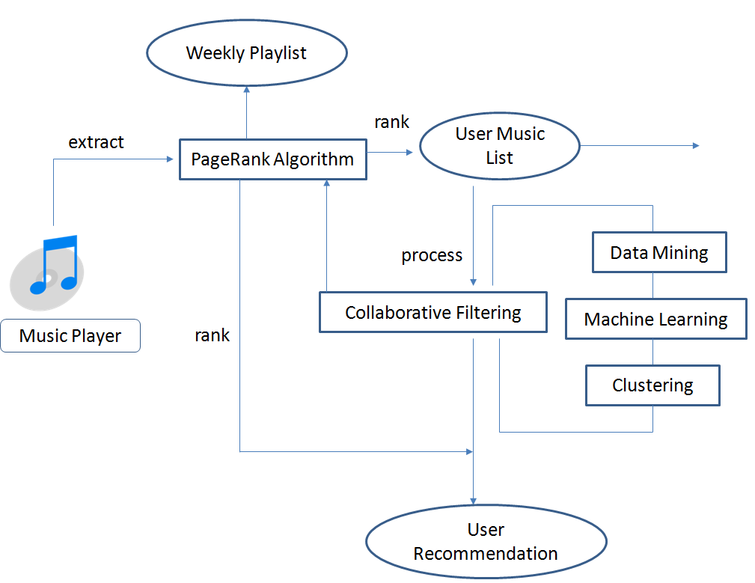
Figure 3.1 Theoretical Framework
The flow of the proposed system will start by extracting the necessary information from the user’s choice of music player(i.e., Winamp). A plug-in will be used as the device that will extract the information and transfer it to the main program. As the music player updates itself with the songs being played overtime, so will the plug-in extract the information and update the information in the main program.
The first playlist built is the personal playlist of the each user, according to the songs in their music player. After the information is extracted, the songs are ranked using the PageRank algorithm. The user’s personal ranked playlist is the foundation for recommending songs to other users.
As each user has a playlist, all these data will be gathered together to find users with similar preferences by using Collaborative Filtering Techniques. In a closer look, data mining and machine learning algorithms are used to discover patterns among the users and songs. Data mining extracts specific information to use them in identifying recurring patterns or trends among the songs of the users. Machine learning is more concerned in the prediction of songs. It will recommend songs using the results from the data mining.
Clustering techniques grouped together users who share the same preferences, and then recommendation or ‘predictions’ are given to users. These recommendations are again ranked using the PageRank algorithm so that the user can see the recommended songs that are closest or most similar to the song the user rates or likes.
The weekly playlist is the list of songs that were the popular during that week. It makes use of all the data for a particular week. It still undergoes collaborative filtering and ranked using the PageRank algorithm to create the weekly playlist.
3.2 Client-Server Technology
Since the application was used online and involved a lot of users over the web, a Client-Server Network Technology was used to cater to all to the users. Figure 3.2 below shows a diagram. All user requests and interactions were sent and monitored by the server and then the results are sent back to the user. The application takes inspiration from the Skype application in using Client-Server technology as well as the interface.
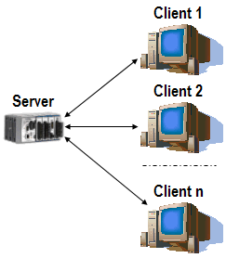
Figure 3.2 A Client-Server Diagram
3.3 PageRank Algorithm
The application began with extracting music data from the music player used by a particular user. The music player was synced to the application. The PageRank algorithm created the playlist of a particular user using the data collected from the user’s music player.
PageRank determined the weight of a song. That is, every song was evaluated to see how well the user likes it, based on the number of plays, how recent it was played and other factors that help determine its rank. The end result is a playlist of ranked songs for the particular user based from all the data collected.
3.4 Collaborative Filtering Technique
The Collaborative Filtering technique was used to (1) collect preferences, rating patterns and taste information from users in a system then (2) generate predictions(music lists) for a particular user using the collected data from other users who are found to share similar preferences with the particular user.
3.4.1 Model-Based Approach
The model-based type of Collaborative Filtering developed a model of user ratings. This process is performed by using data mining and machine learning algorithms to find patterns in training data. Clustering models are commonly used under the model-based approach. Clustering models handled data sparsity of all the users involved (due to the big amount of data that will be collected), managing data every time a user changes his preferences. This will also generate better prediction performance.
3.5 Clustering based Recommendation System
The clustering method grouped together users who have similar preferences. Due to data ambiguity and sparsity, this method makes recommendations within small clusters rather than using the whole data to achieve better scalability.
3.5.1 Data Mining and Machine Learning
Data mining was the process used to extract knowledge from a large data set that discovered new patterns or knowledge in groups of data records (cluster analysis). Machine learning was focused for prediction, using known properties from data gathered.
Chapter 4
MyVibes Subsystem
This chapter describes the MyVibes subsystem.
4.1 System Overview
MyVibes, stands for a name of a music recommender system that the proponents have composed. This is a PC-based, client server recommender system – a collaborative Computer Science – Information Technology undergraduate thesis project.
MyVibes subsystem is composed of two main parts, the plug-in which acts as a collector of the data and the main site where the online community appears. The user must create an account first before he/she can download and install the plug-in. As long as the user finished installing the plug-in, the data collector is activated immediately. This data collector fits any kind of music player, and this is the one who collects the data from the music player and stores it on its database if the user is offline. If the user is online, the data collected will be sent directly to the client server and make its ranking and recommendations. The main site is like a social networking site where the user will be able to add their friends. The recommendation given by the server is based on the choice of songs of the user and the user’s lists of friends. The data collected from the user’s playlist and from the user’s friends playlist will be ranked and filtered before the recommendations will be given.

4.2 System Objectives
The system has the following objectives.
- MyVibes must successfully let the user create or use his/her profile when opening the main site.
- MyVibes must successfully let the user install the plug-in to their PC after creating an account.
- The collector must be able to collect data and store to its database when the user is offline.
- The collector must be able to extract the data to the server when the user is online.
- The PageRank algorithm must be able to successfully rank the data extracted.
- Collaborative techniques must be able to give a recommendation based on the data given.
4.3 System Scope and Limitations
- The Music Recommender plug-in only works on music players compatible with the Windows operating system.
- The plug-in and website run on Windows XP operating system or higher, with PostgreSQL version 8.3 or higher installed.
- For any music player used, the data to be extracted remains the same, namely: song, artist, album, play count and genre.
- The plug-in was written in Visual C and uses PostgreSQL for its offline and online database backend.

4.4 Architectural Design
This part of the chapter presents an overview of the system and its individual components. Figure 4.1 illustrates in a general view how the MyVibes recommendation system works.
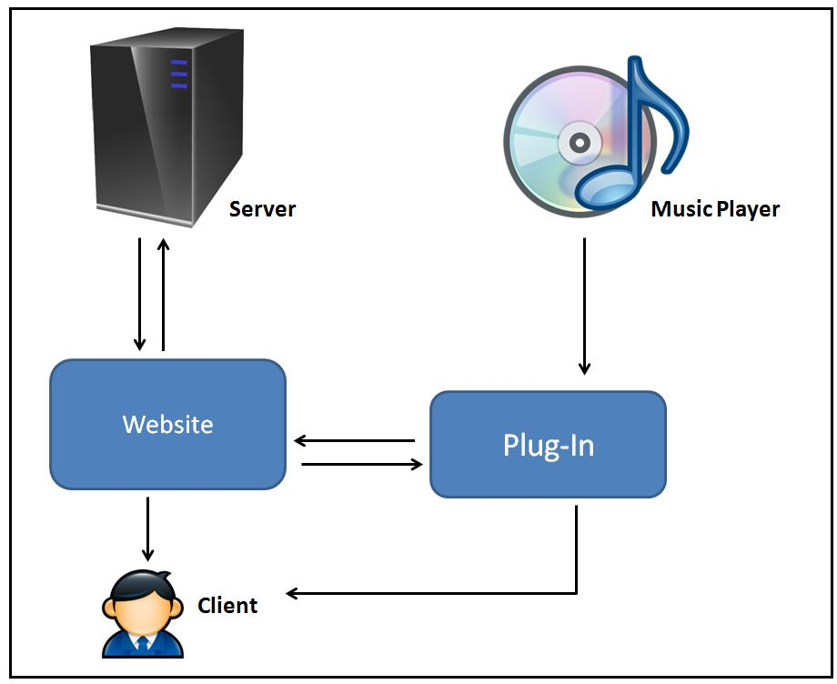
Figure 4.1 The MyVibes Music Recommender System

The MyVibes recommendation system starts with music player. The necessary data is extracted from the music player by the plug-in. The information gathered by the plug-in is sent to the website. The user’s profile is updated using the information sent by the plug-in. The user’s profile is updated every time information from the music player changes. The plug-in responds to change in the music player, and updates information to the website automatically.
In the websites, all requests from the clients are handled by the server. Once the request is accommodated, the result is sent back to the client. The plug-in is considered as a mini-desktop application, and it displays what music the user is currently playing. In an online setup where the user is online and is logged in to the website, the plug-in displays recommendation for each song that is played. Figure 4.2 illustrates how the plug-in works in offline setup. Likewise, Figure 4.3 illustrates the plug-in in an online setup. Further details about the two setups will be discussed in these sections.
The two main components of the MyVibes recommender system is the website and the plug-in.

4.4.1 Website
The website acts like a social networking site where a user can add friends and interact with them. Most importantly, exchange music lists with them. The website handles requests from users using a server.

4.4.2 Plug-In
The plug-in can be downloaded and installed only when the users have an account at the websites. The plug-in connects with the music player to be able to collect information of songs from the music player. The plug-in displays the current song playing in the music player and gives recommendations when the user is active in the website. This means that the pre-requisite for generating recommendation is for a user to be online in the website, so that data can be gathered from other users.
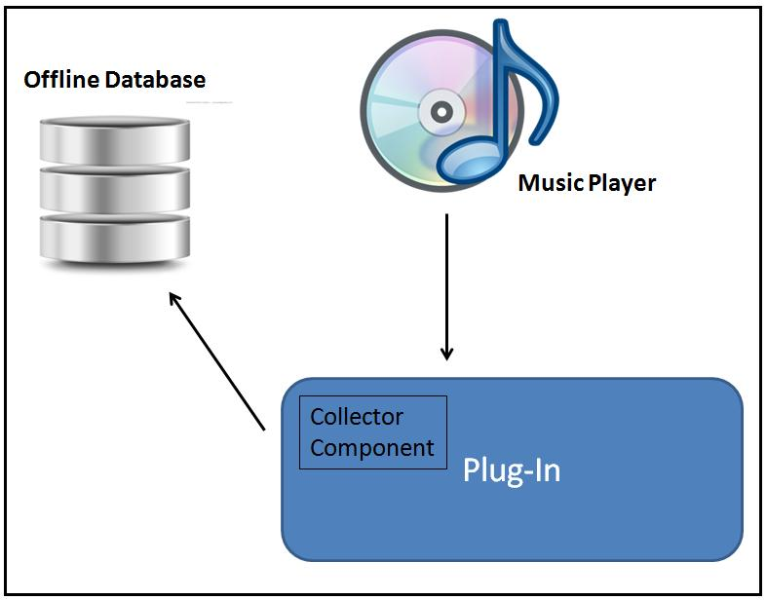
Figure 4.2 The Plug-In in an offline setup
In a closer look at the plug-in, there is the collector component. The collector component is the part of the plug-in that accumulates data from the music player when the user is offline. In an offline setup, the collector components stores the data from the music player in an offline database. The plug-in continues to extract data from any changes made in the music player. However, it doesn’t generate recommendations because it cannot connect with the other users in the website. Once the user becomes online the website, the data from the offline database is compared to the online database. The online database is updated and the two databases must contain the same music data.
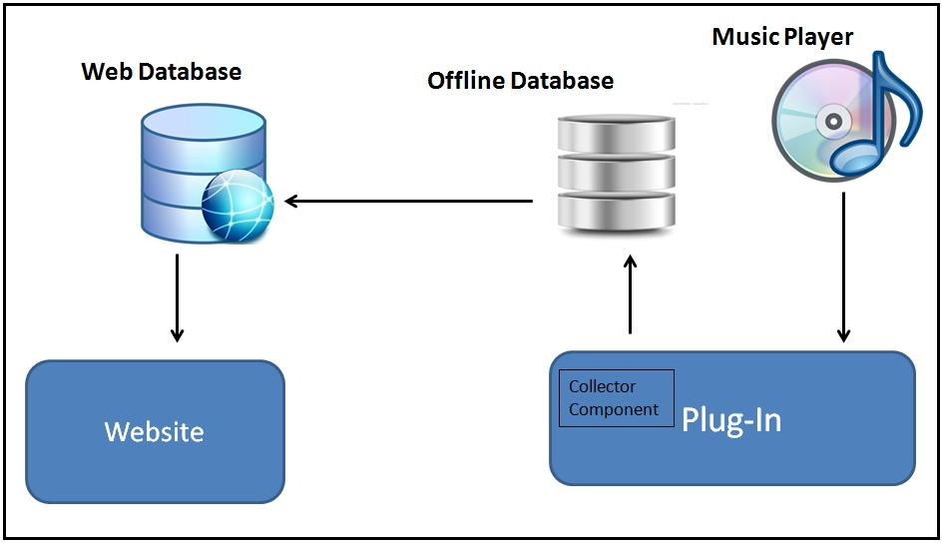
Figure 4.3 The Plug-In in an online setup
Once the user becomes online in the website, the collector component is in-charge of updating the web database from the data accumulated in the offline database. When the web database is updated, the website is also updated. The plug-in can then generate recommendations each time a song is played.
4.4.3 PostgreSQL Database
The PostgreSQL was used to build the database. The web database basically contains the following data:
- User profiles
- Basic information about each user, such as name, address, age, likes, etc.
- Music Information
- This is the information extracted from the music player. Song name, artist, play count, time, genre and album.
- Song ratings
- Ratings of users for each song.
4.5 System Capabilities
The MyVibes recommender system has the following capabilities:
- Create a profile
- This involves the processes in creating and maintaining an individual profile. Such as the following:
- Sign Up
- Log In
- Edit Profile
- Upload Picture
- Add Friends
- Delete Friends
- Rank
- This enables the user to rank a specific song based on how a user likes it. The rating is done on a scale of 1-10.
- Play Music
- When a user clicks on a song he/she is interested in, the websites can play the song so then the user can rate it.
4.6 Technical Requirements
The application runs with the following minimum requirements:
- Windows XP or higher
- at least 1GB Ram
- PostgreSQL version 8.3 or higher
4.7 Activity Diagram
4.8 Sequence Diagram
4.9 Use Case Diagram
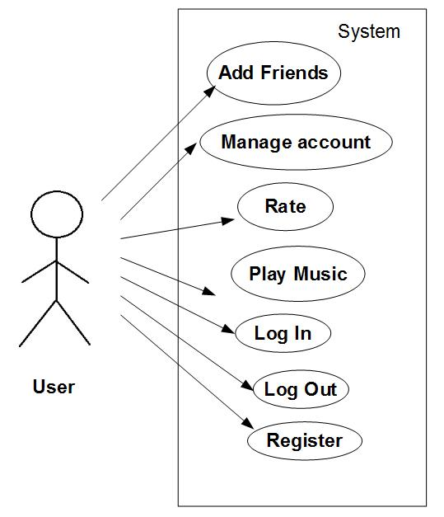
Figure 4.6 below shows the use case diagram to describe what functions a user can do. Use case scenarios are written below the diagram.
Figure 4.6 Use Case Diagram

4.10 Entity-Relationship Diagram
Figure 4.7 describes the entities, attributes and the relationships among tables.
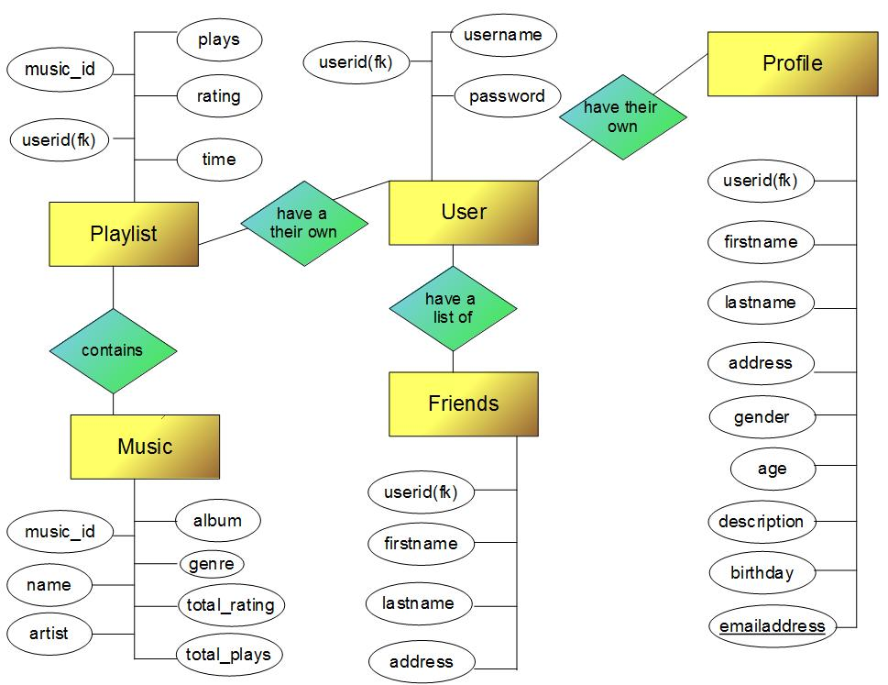
Figure 4.7 Entity-Relationship Diagram
4.11 Database Schema
The database schema presented in Figure 4.8 below presents the general view of the database design.
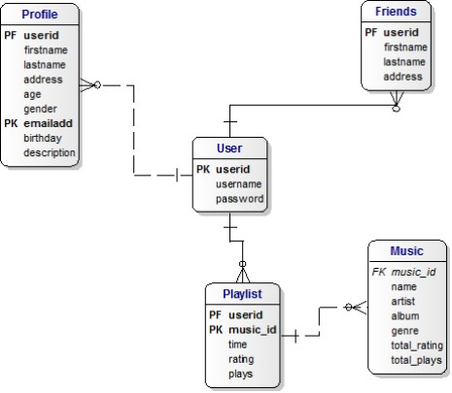
Figure 4.8 Database Schema

Gant Chart

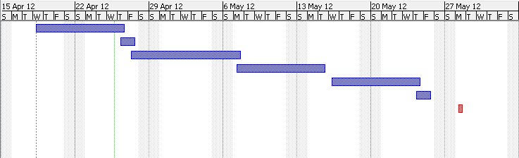

References:

Boyer, A., Brun, A., Esslimani I. (2009). A collaborative filtering approach combining clustering and navigational based correlations.
Lemire, D., Maclachlan, A. (2005). Slope one predictors for online rating-based collaborative filtering.
Castagna, P., (2009). Having fun with PageRank and map reduce.United Kingdom: Handoop User Group (HUG).
Franceschet, M. (2010). PageRank: standing on the shoulder of giants.
Goos, G., Hartmanis, J., Van Leeuwen, J. (1973) Lecture notes in computer science.
D. Goldberg, D. Nichols, B. Oki, and D. Terry, “Using collaborative filtering to weave an information tapestry, “Communication of the ACM, vol.35, no.12, pp. 61-70, 1992.
Brun, A., Castagnos, S., Boyer, A., (2011, Jan 10). From community detection to Mentor Selection in rating-free collaborative filtering. Advances in Multimedia. 2011 (2011), 19, Retrieve from http://www.hindawi.com/journals/am/2011/852518/
Fayyad, U., Piatetsky-Shapiro, G., Smyth, P., (1996). "From Data Mining to Knowledge Discovery in Databases". Retrieved 2008-12-17.
Chakrabarti, S., Ester, M., Fayyad, U., Gehrke, J., et.al, (2006) "Data Mining Curriculum". ACM SIGKDD. 2006-04-30. Retrieved 2011-10-28.
Kotsiantis, S.B., (2007). Supervised Machine Learning: A Review of Classification Techniques. ‘Vibes’. (google definition).

