Classification Model for Stock Crash Risk of Individual Stocks in the Korean Stock Market

Abstract
Many researchers have tried to predict future stock prices, and predicting the risk of stock price crashes is one of them. If we can reduce the losses caused by stock price crashes, investment performance can be improved dramatically. This study explores how to predict the plunge risk of individual stocks in the Korean stock market from 2015 to 2024 using various machine learning models. Based on data including stock prices, financial indicators, and market volatility index (VKOSPI), various machine learning models were explored using the evaluation metric ROC-AUC. The results showed that decision tree-based ensemble models such as LightGBM performed better than deep learning-based models, and that wavelet transform, volatility index, and seasonality of daily time series data were effective. This study has significance in terms of variable selection, feature engineering, and various model exploration as one of the methods to predict the risk of sudden drops in individual stocks.

- Introduction
Stock price crashes of individual firms can be triggered by a variety of causes, including declines due to market-wide systematic risk, as well as unexpected negative information disclosures within the firm or information opacity (Hutton et al., 2009), agency problems(Kim et al., 2011) and supply and demand imbalances (Hong & Stein, 2003), sharp selling by certain investment entities. Such stock price crashes cause a sharp decline in the value of investment portfolios. Therefore, predicting and managing the risk of stock price crashes in advance is crucial for investment performance and risk management, and has long been a central topic in banking and finance research (Chen et al., 2001).
However, Efficient Market Hypothesis (Fama, 1970) states that investors can not predict future market prices using publicly available information, as market prices already reflect all known data. However, many researchers suggest that the market is not always efficient but it works on average (Grossman & Stiglitz, 1980). Markets can experience periods of excessive exuberance, exceeding expectations. Conversely, markets can also suffer from undue pessimism and sharp downturns (De Bondt & Thaler, 1985). If investors can use these inefficiency, predicting the market can be meaningful (Shleifer & Summers, 1990).
Stock price forecasting has long relied on statistical techniques to explore the possibilities, one of which is the use of regression analysis to signs of financial market (Campbell et al., 2008). However assumption of linear relationship is a limitation of statistical techniques. Financial market data often exhibits complex, nonlinear patterns and interactions that linear models struggle to capture effectively (Hsieh, 1991).
Also researchers have also used time series models such as Generalized Autoregressive Conditional Heteroskedasticity (GARCH) (Andersen et al., 2003). By focusing on the idiosyncratic clustering or asymmetry that stock price volatility sometimes exhibits, the idea was to try to capture market crashes, or severe negative returns. However, these statistical approaches are limited by the assumption that variables follow a certain probability distribution (Eom et al., 2019).
Machine learning techniques also have been actively applied to the study of stock price prediction. Various machine learning models, such as Support Vector Machines (SVMs), Random Forests, Gradient Boosting Decision Tree algorithms like XGBoost, LightGBM have the advantage of being able to effectively learn complex and non-linear data patterns (Ballings et al., 2015).
Recently, deep learning models have also gained traction. Variants of Recurrent Neural Network (RNN), such as Long Short-Term Memory (LSTM), Gated Recurrent Unit (GRU) are gaining traction in the field of stock price forecasting due to their ability to capture the long-term dependence of time series data or local patterns in the data (Gu et al., 2020). Convolutional Neural Network (CNN) models, originally lauded for their prowess in image recognition, are also being increasingly applied to financial time series, leveraging their capacity to identify intricate local patterns and features within the data, which can be crucial for market prediction.
This study aims to make a academic contribution in the following key aspects. First, this study explores methods for predicting the crash risk of individual stocks by leveraging various models, including logistic regression, random forest, XGBoost, LightGBM, catboost and deep learning models such as CNN, LSTM, GRU, and Transformer. Moreover, Unlike many existing studies that primarily focus on forecasting stock price direction or general price movements, our research is significant because it investigates techniques to predict sharp decline risks for individual stocks in the Korean market . Furthermore, it re-evaluates the efficacy of tree-based machine learning models, rather than solely concentrating on recent deep learning modeling trends.
Second, many studies tend to focus on either market data or financial data in isolation. But this research overcomes such limitations by integrally utilizing both long-term daily stock price data and quarterly financial statement data for publicly traded Korean companies , thereby enhancing predictive power. A crucial differentiator of this study is its endeavor to find effective methodologies for compressing and integrating daily stock price data with quarterly financial data.
Third, by considering the complex characteristics of financial time-series data , we aim to focus on meaningful predictive features, such as seasonality and option volatility, to our models. Our approach goes beyond simply applying diverse models. it is an attempt to maximize predictive accuracy by fully utilizing the inherent potential of the data itself.
- Literature Review
Attempts to apply machine learning techniques to stock price prediction have been around for a long time. Machine learning techniques such as logistic regression (LR), decision trees (DT), and random forests (RF) have been widely used. Chen (2011) utilized decision trees and logistic regression to predict the likelihood of financial failure of a firm. Ballings et al. (2015) compared logistic regression, SVM, KNN, random forests, and AdaBoost and found that ensemble models such as Random Forests performed the best in predicting stock price direction. This is confirmed by subsequent studies such as Ciner (2019), Yin et al. (2023) , who demonstrate that tree-based ensemble models can outperform single models. Ciner (2019) found that industry returns can significantly predict market returns using random forests. Yin et al. (2023) proposed an optimization technique to improve the performance of random forests and demonstrated its effectiveness in mid- to long-term stock price prediction.
Gradient boosting decision tree is a powerful ensemble technique that sequentially combines multiple decision trees to progressively reduce prediction errors (Friedman, 2001). Gradient boosting can achieve high prediction accuracy on many types of data (Chen & Guestrin, 2016). and recent implementations, in particular, improve the efficiency of handling categorical variables and provide competitive learning speeds even on large datasets(Ke et al., 2017; Prokhorenkova et al., 2018). Decision Tree based ensemble approach typically has a low overfitting tendency and provides interpretation of the results in terms of variable importance.
Deep learning-based models are also gaining traction as a stock price prediction methodology. Nelson et al. (2017) applied LSTM (Long Short-Term Memory) to stock price prediction, and Ding and Qin (2020) and Wang et al. (2021) reviewed the performance of LSTM, CNN, and GRU (a family of RNNs). Naik and Mohan (2021) showed that a hybrid model combining XGBoost and deep learning can effectively predict the risk of stock price plunge in the Indian stock market. Wang et al. (2022) showed that a transformer-based structure is effective for stock price prediction. Li and Qian (2022) showed that a neural network structure combining GRU and Transformer can be applied to improve stock price prediction performance
Table 1 Models for stock price direction used in literature.
 | Machine Learning Models |  |  |  |  |  | Deep Learning Models |  |  |  | Features
 | LR | DT | RF | XGB | LGBM | Cat  Boost | LSTM | CNN | GRU | Trans former | stock | option | financial
Chen (2011) | ✓
C. Ciner (2019) |  | ✓ |  |  |  |  |  |  |  |  | ✓
L. Yin (2023) |  | ✓ | ✓ |  |  |  |  |  |  |  | ✓
N. Naik (2021) |  |  |  | ✓ |  |  |  |  |  |  | ✓
X. Zhao (2023) |  |  |  | ✓ | ✓ |  |  |  |  |  | ✓
H. Li (2023) |  |  |  |  | ✓ |  |  |  |  |  |  | ✓ | ✓
S.Ding (2020) |  |  |  |  |  |  | ✓ |  | ✓ |  | ✓
T.Wang (2021) |  |  |  |  |  |  |  | ✓ | ✓
F. Wang (2022) |  |  |  |  |  |  | ✓ | ✓ | ✓ | ✓
L. Li (2022) |  |  |  |  |  |  | ✓ |  | ✓ | ✓
This paper | ✓ | ✓ | ✓ | ✓ | ✓ | ✓ | ✓ | ✓ | ✓ | ✓ | ✓ | ✓ | ✓

However, recent research has also pointed out the limitations of deep learning models, including their complexity, lack of interpretability, susceptibility to overfitting, and need for large amounts of data and tuning. Salman and Liu (2019) theoretically explained the mechanism of overfitting in deep learning, and Shwartz-Ziv and Armon (2022) emphasized that deep learning is not necessarily the best choice for tabular data, and that tree-like models can perform more robustly on structured data.
In this study, we conducted performance analysis on various models based on the cumulative results of previous studies. This study applied a stock price plunge risk classification model that combines financial statements and price indicators as training data, as well as volatility (VKOSPI) and seasonality information. By integrating time series and other financial factors, this study aims to proactively predict the risk of stock price plunge of individual stocks in the Korean stock market, which can be used as a practical decision support tool for investment strategy and risk management efficiency.
3. Methodology
3.1. Data and Preprocessing
3.1.1. Data Scope
The data used in this analysis are daily stock market data, quarterly financial statement data for 2,812 stocks listed on the Korean stock market and index option market volatility (VKOSPI) from year 2015 to 2024.
3.1.2. Data partitioning for cross-validation
In this study, we performed cross-validation using the walk-forward method (Tashman, 2000) to evaluate the generalization performance of the model to reflect the characteristics of time series data. The partitioning was done by applying a sliding window method, and each fold was organized to contain temporally contiguous data. We constructed a total of five folds by moving a sliding window sequentially forward in time, and verified the stability of the model's performance by iteratively training and evaluating each fold.
Walk-forward validation and sliding window techniques are useful in situations where the order of the data is important, such as in financial time series analysis, and where past data is used to predict the future. These approaches avoid information leakage (look-ahead bias) that can occur when evaluating time series forecasting models and better reflect the true predictive power of the model for future data (Cerqueira et al., 2020).
3.2. Target Variable Definition
Target Variable of this study is a binary variable. It is defined to take the value of 1 if there is an event that causes the stock price of a given stock to decline by more than 40% within the next 60 trading days at a given point in time, and 0 otherwise. In other words, a value of 1 indicates that the risk of a significant stock price decline has been realized in the short term. These target variables focus on identifying and predicting the risk of a sharp decline, or “tail risk,” that could result in a substantial loss of asset value for investors (Magdon-Ismail & Atiya, 2004)
$MDD=\max_{t≤τ≤w≤t+60}\left(\frac{P_{τ}-P_{ω}}{P_{τ}}\right)$
where MDD denote the Maximum Drawdown over the 60 trading days, t denotes the given point in time for the observation, τ and ω are time indices within the 60-trading-day window starting from t, $P_{τ}$ and $P_{ω}$ denote stock price at time τ, ω, where ω≥τ.
3.3. Feature Set
Stock price plunge prediction models utilize different kinds of characteristics to comprehensively reflect a company's intrinsic value and short-term market trends.
3.3.1. wavelet Transform
While indicators of a company's financial condition are released quarterly, stock prices fluctuate daily. To overcome this data frequency gap and to incorporate the dynamic nature of recent stock price movements into the model, we apply the Wavelet Transform(Ramsey, 1999; Verma et al., 2023) to the daily stock price sequence of the last 60 days. The wavelet transform decomposes the stock price time series data into different frequency bands, which can capture complex patterns such as short-term volatility and long-term trends.
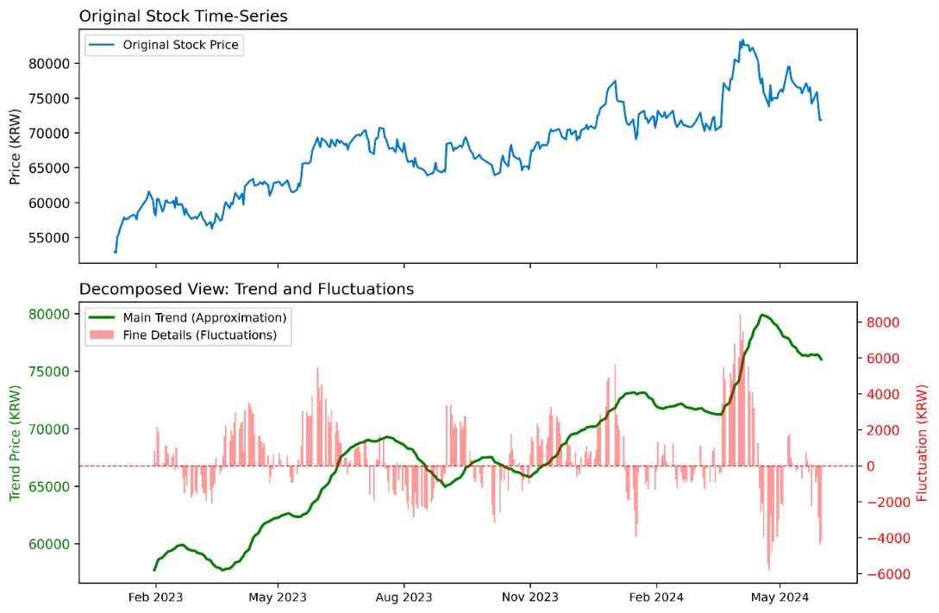
Pig. 1 Wavelet Decomposition : Samsung Electronics Stock
By calculating the statistical characteristics (energy, standard deviation, skewness, kurtosis) of the wavelet coefficients obtained through this transformation, we extracted the key dynamic features of daily stock price information in a compressed form.
$$cA_{j+1}[k]=\sum_{n}{h\left[n-2k\right]cA_{j}\left[n\right] }(Approximation Coefficients)$$
$$cD_{j+1}\left[k\right]=\sum{g\left[n-2k\right]cA_{j}\left[n\right]}(Detail Coefficients)$$
where h[] denote a low-pass filter, g[] denotes a high-pass filter, both determined by the chosen mother wavelet, j denotes the level of decomposition, while n and k are indices for the coefficient position, $cA_{j}\left[n\right]$ represents the approximation coefficients at decomposition level j. For the initial level (j=0), this corresponds to the original stock price time series. $cD_{j+1}\left[k\right]$ are the detail coefficients at the next level, capturing the high-frequency components of the signal, $cA_{j+1}\left[k\right]$ are the approximation coefficients at the next level, representing the low-frequency, smoothed components of the signal.
In this study, we used Daubechies 4 wavelets to perform the decomposition up to the J=3 level, resulting in a set of wavelet coefficients {$cA_{3}$,$cD_{3}$,$cD_{2}$,$cD_{1}$} was obtained. For each wavelet coefficient array C={$c_{k}$∣k=1,2,...,M} (where C represents one of $cA_{3}$,$cD_{3}$,$cD_{2}$,$cD_{1}$ and M is the number of coefficients in that array), we compute the following statistical properties Define the mean of the corresponding array C as $μ_{C}= \frac{1}{M}\sum_{k=1}^{M}{c_{k}}$
.
- Energy ($E_{C}$​): the signal’s overall strength in the specified frequency band.
$$E_{C}=\sum_{k=1}^{M}{c_{k}^{2}}$$
where $c_{k}$ is the k-th coefficient, and M is the total number of coefficients
- Standard Deviation ($σ_{C}$​): reflects how widely the coefficients in that band fluctuate.
$σ_{C}$ $= \sqrt{\frac{1}{M}\sum_{k=1}^{M}{{(c_{k}-μ_{C})}^{2}}}$
where $μ_{C}$ is the mean of the coefficients
- Skewness ($S_{C}$​): any asymmetry in the coefficient distribution.
$S_{C}=$ $\frac{\frac{1}{M}\sum_{k=1}^{M}{{(c_{k}-μ_{C})}^{3}}}{σ_{C}^{3}}$
where $σ_{C} is$Standard Deviation
- Excess Kurtosis ($K_{C}$​): gauges how peaked the distribution is and how heavy its tails are compared with a normal distribution.
$K_{C}=$ $\frac{\frac{1}{M}\sum_{k=1}^{M}{{(c_{k}-μ_{C})}^{4}}}{σ_{C}^{4}}$-3
3.3.2. Volatility Index
To embed options-market information that can sway individual share prices, we add the Korean volatility gauge VKOSPI to the feature set (Lee & Ryu, 2014)
$$σ^{2}=\frac{2}{T}\sum_{i}{\frac{ΔK_{i}}{K_{i}^{2}}e^{rT}Q\left(K_{i}\right)}-\frac{1}{T}{\left(\frac{F}{K_{0}}- 1\right)}^{2}$$
$$VKOSPI_{30}= 100 \sqrt{\left(\frac{T_{1}σ_{1}^{2}\left(N_{2}- 30\right)}{N_{2}- N_{1}}+\frac{T_{2}σ_{2}^{2}\left(30 - N_{1}\right)}{N_{2}- N_{1}}\right)*\frac{365}{30}}$$
Where T is the time to expiration in years, r is the continuously compounded risk-free interest rate, F is the no-arbitrage forward price for the expiration, $K_{i}$​ is the i-th strike price, Q($K_{i}$​) is the price of the out-of-the-money (OTM) option for the strike price $K_{i}$​, $σ_{1}^{2}$, $σ_{2}^{2}$​ are the variances for the near-month and next-month expirations, calculated using the first equation, $N_{1}$ and $N_{2}$​ are the calendar days to expiration for the near-month and next-month options, respectively.
3.3.3. Feature Set
The resulting stock price-based dynamic characteristics and market volatility indices were combined with static and quasi-static characteristics such as a company's basic financial health (profitability, debt structure, valuation metrics, etc.), supply and demand factors, and industry classification as inputs to the final model. The final list of selected characteristics and their descriptions is shown in below.
Table 2. Features
Category | Variable Name | Description
Stock Market Data | STCK_PRPR | Standard deviation of 60-day price data.
 | PRICE_TO_52W_HIGH | Ratio of current price to its 52-week high.
 | PRICE_TO_52W_LOW | Ratio of current price to its 52-week low.
 | ORGN_NTBY_QTY | Net buy quantity from institutional investors.
 | SCRT_GRP_CLS_CODE | Encoded industry sector code(KRX)
 | FN_ACML_TR_PBMN | Accumulated trading value.
 | Wavelet Features  (8-features) | Statistical features (energy, std) from wavelet coefficients of 60-day price data.
Option Market Data | VKOSPI | Korea's Volatility Index (V-KOSPI).
Financial & Valuation | ROE | Return on Equity.
 | ROE_INC | Change in Return on Equity from the previous period.
 | PER | Earnings Yield (Net Income / Market Cap).
 | PSR | Sales Yield (Sales per Share / Price).
 | DR | Debt Ratio.
 | DEBT_DEPENDENCY | Debt Dependency Ratio.
 | NET_DEBT_RATIO | Net Debt to Market Cap ratio.
 | DEBT_COST_RATIO | Debt Cost to Market Cap ratio.
 | ICR | Interest Coverage Ratio.
 | CSGR | Capital Stock Growth Rate
 | TEGR | Total Equity Growth Rate
 | MONTH | Calendar month of observation (1-12) for seasonality.

3.2. Modelling
3.2.1. Model
To identify classifiers that mesh well with the quirks of financial time-series, we reviewed several machine-learning families.
(a) Regression-based Models
We begin with the canonical regression classifier—logistic regression (LR). The model forms a linear combination of the explanatory variables and then maps that score through a logistic link, yielding the estimated probability that the target event occurs.(Cox, 1958)
$$P\left(Y=1 | X\right)=\frac{1}{1+e^{-\left(β_{0}+ β_{1}X_{1}+ …+ β_{p}X_{p}\right)}}$$
where X denotes the vector of explanatory variables (X1​,…,Xp​), $β_{0}$ ​is the intercept (or bias) term of the model, $β_{0}$​,…$β_{p}$​ denote the regression coefficients (or weights) corresponding to each explanatory variable.
(b) Tree-based Models
Random Forest (RF), an ensemble model drawing from Decision Trees (DT) (Loh, 2011) improves prediction accuracy by using the bagging method on multiple trees (Breiman, 2001). Models like XGBoost (Chen & Guestrin, 2016), and LightGBM (Ke et al., 2017) are types of Gradient Boosting Decision Trees (GBDT)(Friedman, 2001). GBDT approach train multiple trees in a sequence, where each new tree tries to correct the error of the one before it, gradually reducing the overall error. CatBoost(Prokhorenkova et al., 2018) presents a variation of the GBDT algorithm. It uses a method called 'Ordered Boosting' which helps to prevent overfitting and enhances the model's generalization performance.
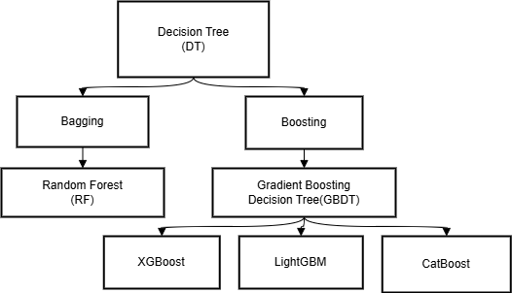
Pig. 2 Taxonomy of Tree-Based Machine Learning Models
(c) RNN(Recurrent Neural Networks) based Model
The Recurrent Neural Network (RNN) model, introduced by Elman (1990) , is a deep learning framework designed to address the sequential characteristics inherent in time-series data. An RNN effectively integrates information from the prior hidden state with the current input. Essentially, this is modeled using a recursive formula: hₜ = f(Wxₜ + Uhₜ₋₁ + b). Among RNN architectures, Long Short-Term Memory (LSTM), developed by Hochreiter and Schmidhuber (1997) stands out. It incorporates input, output, and forget gates within its cell structure. This design allows the network to selectively retain crucial information while discarding what's not essential. Another notable variant is the Gated Recurrent Unit (GRU) (Cho et al., 2014). The GRU presents a more streamlined architecture yet delivers comparable performance to LSTM.
(d) CNN -based models (Convolutional Neural Networks)
CNN-based models (Convolutional Neural Networks) Meanwhile, convolutional neural networks (CNN) (LeCun et al., 1998) are models that have been developed mainly in the field of image recognition. Recently, attempts have been made to utilize CNN for time series modeling by converting time series data into image form or directly applying one-dimensional convolutions (Wang et al., 2017)
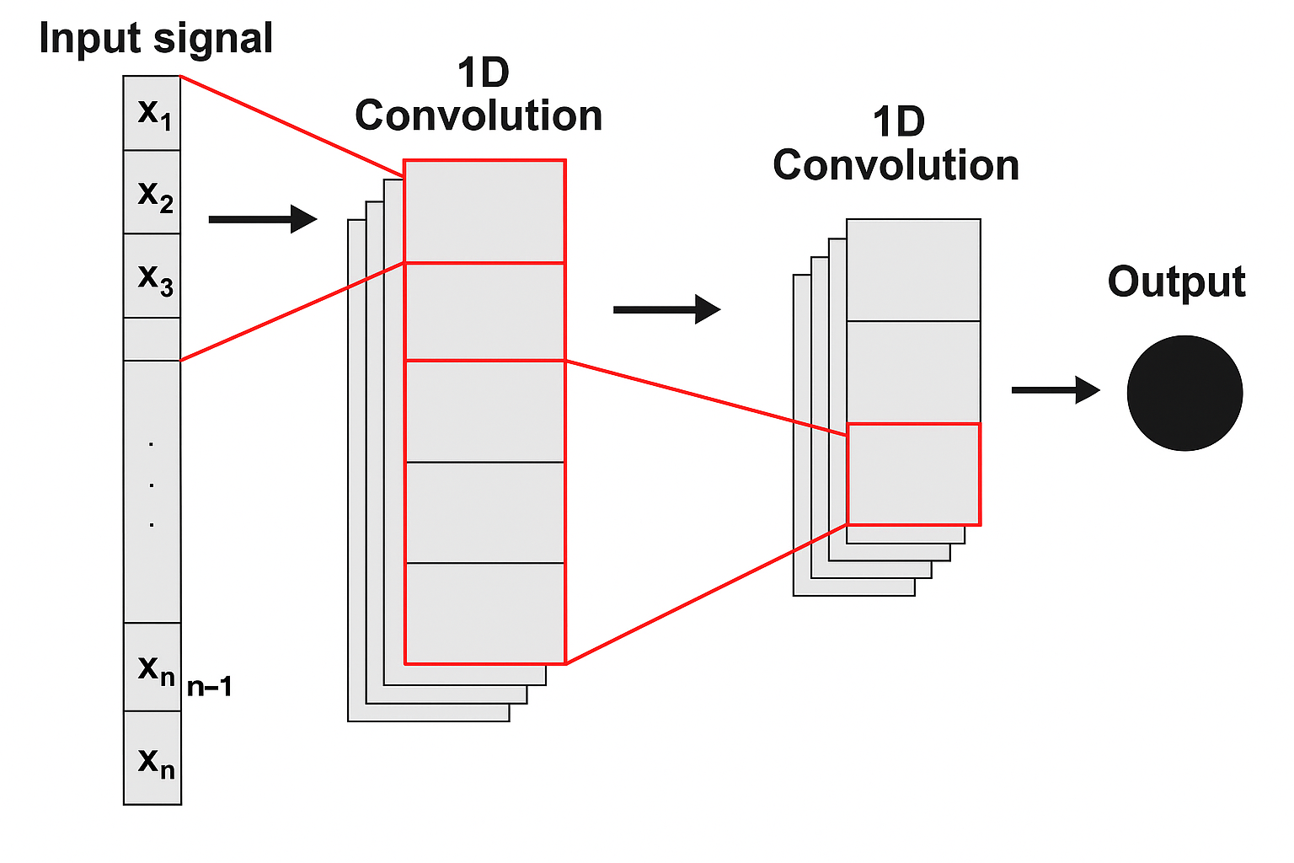
Pig. 3 One-Dimension Convolution Neural Network Model
(e) Transformer Model
Researchers are now applying Transformers to time-series forecasting as well (Lim et al., 2021; Zhou et al., 2021). Unlike RNNs, a Transformer looks at every element in the sequence at once through self-attention rather than stepping through items one by one (Vaswani et al., 2017). Attention scores are computed with Attention(Q, K, V) = softmax(QKᵀ / √d_k) · V, where Q, K, and V are the query, key, and value matrices, and d_k is the scaling factor for the dot product. This architecture learns long-range patterns even in very long series and makes good use of parallel hardware. The downside is its size: a Transformer reaches peak accuracy only when plenty of training data and computing power are available.
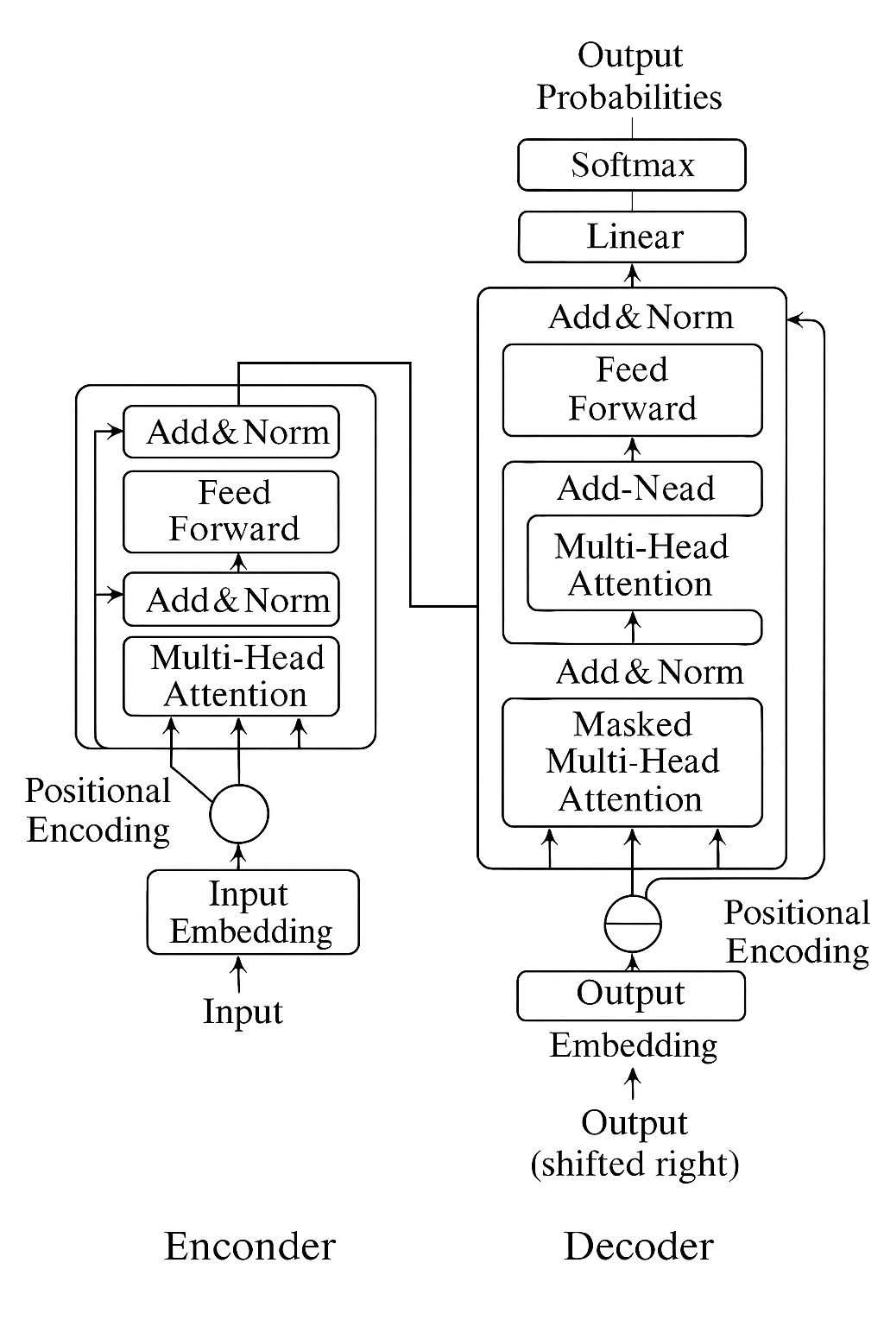
Pig. 4 Transformer Model Architecture
3.2-2. Strategy for Handling Class Imbalance
The target variable in the training dataset indicates whether the price will fall by more than 40% within the next 60 business days. The distribution of the variable was 17,432 samples in the ‘windowdrop=0’ (no sharp decline) class and 910 samples in the ‘windowdrop=1’ (sharp decline occurred) class. The ratio of samples between the two classes was approximately 19.16 to 1. This distribution indicates that the target variable class is in a state of severe imbalance.
To curb that bias, we applied oversampling during training. By increasing the presence of the minority class, the learner is guided to treat mistakes on crash days as carrying a heavier penalty, which in turn improves its ability to spot rare but costly downturns (He & Garcia, 2009).
3.2-3. Evaluation Metrics
(a) AUC(Area Under the Receiver Operating Characteristic Curve)
AUC(Area Under the Receiver Operating Characteristic Curve) score (Bradley, 1997; Huang & Ling, 2005) ranges from 0.5 for random guessing to 1.0 for perfect separation. Because it is threshold-free, AUC remains a stable yard-stick even when the data are unbalanced, making it a sound choice for our setting.
$$AUC = \frac{1}{N_{+}N_{-}}\sum_{i=1}^{N_{+}}{\sum_{j=1}^{N_{-}}{I\left( s_{i}> s_{j}\right)}}$$
Where $N_{+}$​ is the number of positive (label = 1) instances in the evaluation set, $N_{-}$​ is the number of negative (label = 0) instances in the evaluation set, $s_{i}$ denotes the prediction score assigned to the i-th positive instance, $s_{j}$ denotes the prediction score assigned to the j-th negative instance, $I\left( s_{i}> s_{j}\right)$is the indicator function that equals 1 when the score of the positive instance exceeds that of the negative instance $\left( s_{i}> s_{j}\right)$ and 0 otherwise.
The ROC curve itself plots the True Positive Rate against the False Positive Rate across every cutoff and helps reveal the trade-off between catching crashes and raising false alarms. (Fawcett, 2006)
(b) Brier Score
To judge the accuracy of predicted probabilities, we also report the Brier Score(Brier, 1950). It is the mean squared gap between the forecast probability and the actual outcome; smaller values indicate sharper and better-calibrated forecasts.
$$Brier Score=\frac{ 1}{N}\sum_{i=1}^{N}{{\left(f_{i}- o_{i}\right)}^{2}}$$
where $f_{i}$ is the predicted probability for instance i, $o_{i}$​ is the actual outcome (0 or 1), N is the total number of instances.
(c) Kolmogorov-Smirnov statistic
Finally, the KS statistic measures how far apart the cumulative score distributions of the two classes spread (Massey Jr, 1951). Values range from 0 to 1, with larger numbers signaling clearer separation. The statistic is widely used in finance, especially in credit-scoring tasks, and serves here as another lens on the model’s discriminating power.
$$D = \sup_{x}\left| F_{1\left(x\right)}- F_{2\left(x\right)}\right|$$
where $F_{1\left(x\right)}$ and $F_{2\left(x\right)}$ are the cumulative distributions of the predicted scores for the positive and negative classes.
3.2-4. Statistical Significance Testing
This study gauges whether the observed performance gaps among various machine-learning models are meaningful by applying the Friedman test. The test orders each algorithm’s average score and evaluates the null hypothesis that all models share the same average performance (Friedman, 1937; Friedman, 1940).
When the Friedman statistic rejects null hypothesis, we turn to a post-hoc analysis to learn which pairs of models truly different. We employ the Nemenyi procedure, a multiple-comparison test that contrasts every classifier with the others. if the gap between two models’ averagee ranks exceeds the critical difference (CD), their performances are deemed significantly different (Demšar, 2006). Through these statistical tests, the aim is to secure statistical confidence in the observed rank in model performance.
- Result
To evaluate the predictive performance of the proposed models, we compared and analyzed the results of various machine learning algorithms using AUC, brier score and the Kolmogorov–Smirnov statistic. Both metrics were computed on the training folds and again on the held-out test set to gauge generalization.
Table 3. Model Evaluation(5-fold Average)
Model | train_auc | test_auc | train_ks | test_ks | train_brier | test_brier
LGBM | 0.959058 | 0.836673 | 0.792081 | 0.549618 | 0.069202 | 0.058123
CatBoost | 0.959125 | 0.827207 | 0.794469 | 0.532548 | 0.065023 | 0.050499
RF | 0.974173 | 0.816270 | 0.854758 | 0.516476 | 0.063713 | 0.063346
XGB | 0.916915 | 0.787128 | 0.699349 | 0.474586 | 0.113998 | 0.087831
Transformer | 0.784800 | 0.772797 | 0.448608 | 0.446332 | 0.171756 | 0.146820
CNN | 0.771006 | 0.759543 | 0.431569 | 0.443341 | 0.168483 | 0.135919
LSTM | 0.892252 | 0.740050 | 0.654370 | 0.395708 | 0.118562 | 0.091985
GRU | 0.879406 | 0.735026 | 0.649703 | 0.388473 | 0.158354 | 0.155752
LR | 0.775885 | 0.708831 | 0.448445 | 0.368118 | 0.184706 | 0.163708

On the test data, LightGBM(AUC 0.8366 and KS 0.5496) posted the strongest numbers, clearly edging out every other contender. CatBoost (AUC 0.8272) and Random Forest (0.8163) turned in solid showings as well, yet neither matched LightGBM’s overall discriminative power.
Deep learning models, including the Transformer, CNN, LSTM, and GRU, demonstrated relatively lower performance than tree-based model. Additionally, The significant gap between training and test performance for models like Random Forest ( train AUC of 0.974 vs. test AUC of 0.816 ) and LSTM ( train AUC of 0.892 vs. test AUC of 0.740 ) indicates overfitting. Overfitting occurs when a model learns the training data so thoroughly that it sacrifices its ability to generalize to new, unseen data. In contrast , the Transformer model exhibited a much smaller performance gap, suggesting better generalization, though its overall predictive power was weaker. As anticipated, the baseline logistic regression model yielded the poorest results, which confirms the non-linear nature of the prediction problem.
- Discussion
To decide whether such gaps are more than chance, we ran a Friedman test on the five cross-validation folds, ranking each model by its test-set AUC (Friedman, 1937; Friedman, 1940). . The result (p = 0.006) overturned the null hypothesis that all algorithms perform alike, signalling a statistically meaningful spread in performance.
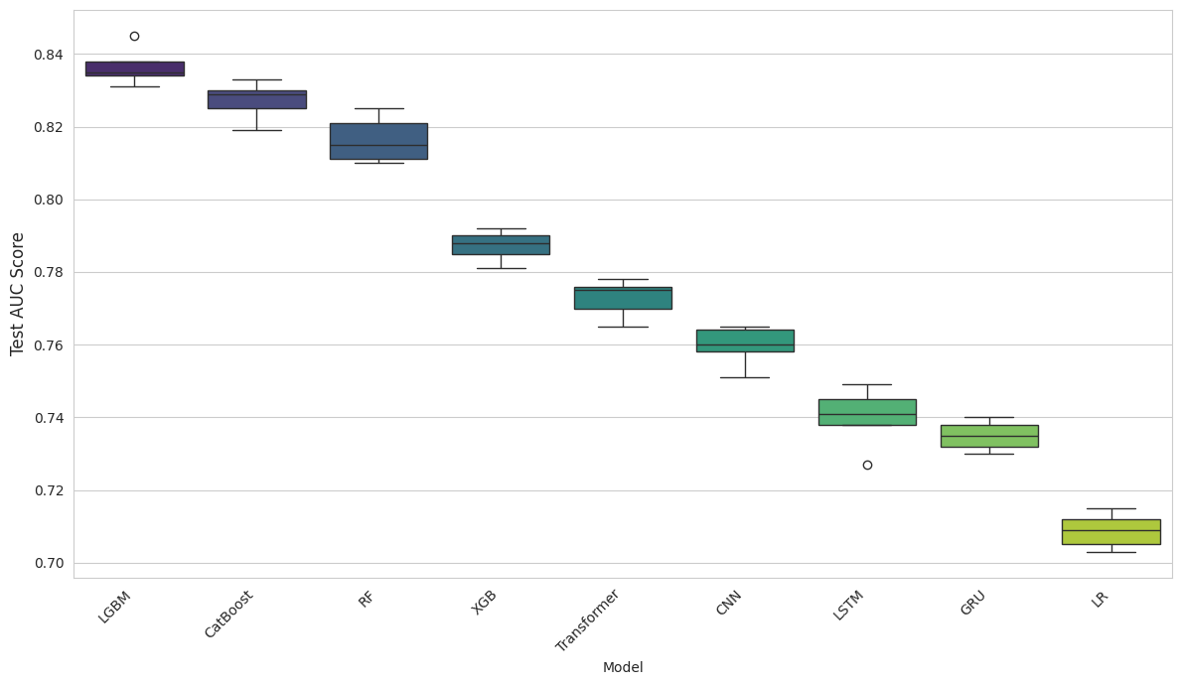
Pig. 5 Model Performance Comparison on Test AUC (5-Fold Cross-Validation)
At a Nemenyi post-hoc test at the 0.05 level, the analysis confirmed that LightGBM surpasses the deep-learning trio, Transformer, CNN and GRU, by a significant margin. Among the five top scorers (LightGBM, CatBoost, XGBoost, Random Forest and LSTM), however, none of the pairwise differences cleared the critical distance, suggesting their peak predictive power lies in the same statistical band.
We inspected each variable’s contribution to the prediction by using LightGBM as a benchmark. Volatility Index(VKOSPI) and seasonality rose to the top, while price-based gauges such as 52 week low price divided by price also carried substantial weight. These results show that the model has tapped into signals and patterns that genuinely foreshadow a crash, underscoring its promise for real-world early-warning systems.
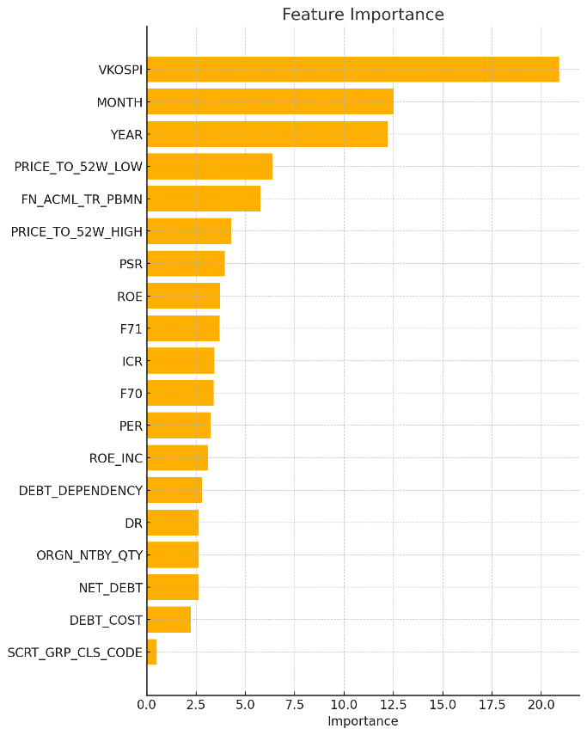
- Contribution
  - theoretical contribution
A key contribution of this work is its focus on forecasting this specific tail risk .Unlike other studies that primarily focus on predicting the direction or level of stock prices, this research focus on crash risk, the probability of an individual stock dropping by 40 % or more within the next 60 trading days. Furthermore , the study explores the most suitable models for this task . It finds that for structured financial data , a model like LightGBM can achieve better predictive performance than more complex deep learning architectures. What truly sets this work apart is its dataset. These findings are drawn from a comprehensive dataset from the Korean stock market, which integrates a wide variety of information, including stock prices, corporate financial data, and option market volatility ( VKOSPI ).
  - practical contribution
The crash risk prediction model developed in this study offers several contribution in investment practice. First, the model can serve as an investment and risk management tool. It provides a quantitative score for the crash probability of each stock. This allows investors to improve their portfolio by proactively adjusting their exposure to high-risk assets or by building hedging strategies. Second, our research presents an effective method for integrating data of different frequencies. The process of combining quarterly financial data with daily stock price and market volatility data , using techniques such as wavelet transforms, significantly enhances predictive power of model. This approach provides a useful framework for developing other financial analysis models that rely on diverse data sources .
- Conclusion and Future Work
Drawing on Korean equity data from 2015 to 2024, we compared several classifiers that flag stocks likely to plunge within 60 trading days. In a walk-forward cross-validation, LightGBM led the field (AUC 0.84; KS 0.55). For structured financial tables, light-weight tree ensembles outperformed heavier neural nets such as CNNs, GRUs, and Transformers. The VKOSPI index, calendar dummies, and the price-to-52-week-low ratio emerged as the strongest crash indicators. Together, these findings offer practical evidence for investors and risk officers who wish to build a timely alert system. Future studies could enrich the feature set with deep time-series encoders and autoencoders, move toward hybrid models that blend trees with neural networks, and test signal-driven, risk-adjusted portfolios in a full back-test to see how the strategy fares in live markets.

Reference
Andersen, T. G., Bollerslev, T., Diebold, F. X., & Labys, P. (2003). Modeling and forecasting realized volatility. Econometrica, 71(2), 579-625.
Ballings, M., Van den Poel, D., Hespeels, N., & Gryp, R. (2015). Evaluating multiple classifiers for stock price direction prediction. Expert systems with Applications, 42(20), 7046-7056.
Bradley, A. P. (1997). The use of the area under the ROC curve in the evaluation of machine learning algorithms. Pattern recognition, 30(7), 1145-1159.
Breiman, L. (2001). Random forests. Machine learning, 45, 5-32.
Brier, G. W. (1950). Verification of forecasts expressed in terms of probability. Monthly weather review, 78(1), 1-3.
Campbell, J. Y., Hilscher, J., & Szilagyi, J. (2008). In search of distress risk. The Journal of finance, 63(6), 2899-2939.
Cerqueira, V., Torgo, L., & Mozetič, I. (2020). Evaluating time series forecasting models: An empirical study on performance estimation methods. Machine learning, 109(11), 1997-2028.
Chen, J., Hong, H., & Stein, J. C. (2001). Forecasting crashes: Trading volume, past returns, and conditional skewness in stock prices. Journal of Financial Economics, 61(3), 345-381.
Chen, M.-Y. (2011). Predicting corporate financial distress based on integration of decision tree classification and logistic regression. Expert systems with Applications, 38(9), 11261-11272.
Chen, T., & Guestrin, C. (2016). Xgboost: A scalable tree boosting system. Proceedings of the 22nd acm sigkdd international conference on knowledge discovery and data mining,
Cho, K., Van Merriënboer, B., Gulcehre, C., Bahdanau, D., Bougares, F., Schwenk, H., & Bengio, Y. (2014). Learning phrase representations using RNN encoder-decoder for statistical machine translation. arXiv preprint arXiv:1406.1078.
Ciner, C. (2019). Do industry returns predict the stock market? A reprise using the random forest. The Quarterly Review of Economics and Finance, 72, 152-158.
Cox, D. R. (1958). The regression analysis of binary sequences. Journal of the Royal Statistical Society Series B: Statistical Methodology, 20(2), 215-232.
De Bondt, W. F., & Thaler, R. (1985). Does the stock market overreact? The Journal of finance, 40(3), 793-805.
Demšar, J. (2006). Statistical comparisons of classifiers over multiple data sets. Journal of Machine learning research, 7(Jan), 1-30.
Ding, G., & Qin, L. (2020). Study on the prediction of stock price based on the associated network model of LSTM. International Journal of Machine Learning and Cybernetics, 11(6), 1307-1317.
Elman, J. L. (1990). Finding structure in time. Cognitive science, 14(2), 179-211.
Eom, C., Kaizoji, T., & Scalas, E. (2019). Fat tails in financial return distributions revisited: Evidence from the Korean stock market. Physica A: Statistical Mechanics and its Applications, 526, 121055.
Fama, E. F. (1970). Efficient capital markets. Journal of finance, 25(2), 383-417.
Fawcett, T. (2006). An introduction to ROC analysis. Pattern recognition letters, 27(8), 861-874.
Friedman, J. H. (2001). Greedy function approximation: a gradient boosting machine. Annals of statistics, 1189-1232.
Grossman, S. J., & Stiglitz, J. E. (1980). On the impossibility of informationally efficient markets. The American economic review, 70(3), 393-408.
Gu, S., Kelly, B., & Xiu, D. (2020). Empirical asset pricing via machine learning. The Review of Financial Studies, 33(5), 2223-2273.
He, H., & Garcia, E. A. (2009). Learning from imbalanced data. IEEE Transactions on knowledge and Data Engineering, 21(9), 1263-1284.
Hochreiter, S., & Schmidhuber, J. (1997). Long short-term memory. Neural computation, 9(8), 1735-1780.
Hong, H., & Stein, J. C. (2003). Differences of opinion, short-sales constraints, and market crashes. The Review of Financial Studies, 16(2), 487-525.
Hsieh, D. A. (1991). Chaos and nonlinear dynamics: application to financial markets. The Journal of finance, 46(5), 1839-1877.
Huang, J., & Ling, C. X. (2005). Using AUC and accuracy in evaluating learning algorithms. IEEE Transactions on knowledge and Data Engineering, 17(3), 299-310.
Hutton, A. P., Marcus, A. J., & Tehranian, H. (2009). Opaque financial reports, R2, and crash risk. Journal of Financial Economics, 94(1), 67-86.
Ke, G., Meng, Q., Finley, T., Wang, T., Chen, W., Ma, W., Ye, Q., & Liu, T.-Y. (2017). Lightgbm: A highly efficient gradient boosting decision tree. Advances in neural information processing systems, 30.
Kim, J.-B., Li, Y., & Zhang, L. (2011). Corporate tax avoidance and stock price crash risk: Firm-level analysis. Journal of Financial Economics, 100(3), 639-662.
LeCun, Y., Bottou, L., Bengio, Y., & Haffner, P. (1998). Gradient-based learning applied to document recognition. Proceedings of the IEEE, 86(11), 2278-2324.
Lee, C., & Ryu, D. (2014). The volatility index and style rotation: Evidence from the Korean stock market and VKOSPI. Investment Analysts Journal, 43(79), 29-39.
Li, C., & Qian, G. (2022). Stock price prediction using a frequency decomposition based GRU transformer neural network. Applied Sciences, 13(1), 222.
Lim, B., Arık, S. Ö., Loeff, N., & Pfister, T. (2021). Temporal fusion transformers for interpretable multi-horizon time series forecasting. International Journal of Forecasting, 37(4), 1748-1764.
Loh, W. Y. (2011). Classification and regression trees. Wiley interdisciplinary reviews: data mining and knowledge discovery, 1(1), 14-23.
Magdon-Ismail, M., & Atiya, A. F. (2004). Maximum drawdown. Risk Magazine, 17(10), 99-102.
Massey Jr, F. J. (1951). The Kolmogorov-Smirnov test for goodness of fit. Journal of the American statistical Association, 46(253), 68-78.
Naik, N., & Mohan, B. R. (2021). Novel stock crisis prediction technique—a study on indian stock market. IEEE access, 9, 86230-86242.
Nelson, D. M., Pereira, A. C., & De Oliveira, R. A. (2017). Stock market's price movement prediction with LSTM neural networks. 2017 International joint conference on neural networks (IJCNN),
Prokhorenkova, L., Gusev, G., Vorobev, A., Dorogush, A. V., & Gulin, A. (2018). CatBoost: unbiased boosting with categorical features. Advances in neural information processing systems, 31.
Ramsey, J. B. (1999). The contribution of wavelets to the analysis of economic and financial data. Philosophical Transactions of the Royal Society of London. Series A: Mathematical, Physical and Engineering Sciences, 357(1760), 2593-2606.
Salman, S., & Liu, X. (2019). Overfitting mechanism and avoidance in deep neural networks. arXiv preprint arXiv:1901.06566.
Shleifer, A., & Summers, L. H. (1990). The noise trader approach to finance. Journal of Economic perspectives, 4(2), 19-33.
Shwartz-Ziv, R., & Armon, A. (2022). Tabular data: Deep learning is not all you need. Information Fusion, 81, 84-90.
Tashman, L. J. (2000). Out-of-sample tests of forecasting accuracy: an analysis and review. International Journal of Forecasting, 16(4), 437-450.
Vaswani, A., Shazeer, N., Parmar, N., Uszkoreit, J., Jones, L., Gomez, A. N., Kaiser, Ł., & Polosukhin, I. (2017). Attention is all you need. Advances in neural information processing systems, 30.
Verma, S., Sahu, S. P., & Sahu, T. P. (2023). Discrete wavelet transform-based feature engineering for stock market prediction. International Journal of Information Technology, 15(2), 1179-1188.
Wang, C., Chen, Y., Zhang, S., & Zhang, Q. (2022). Stock market index prediction using deep Transformer model. Expert systems with Applications, 208, 118128.
Wang, H., Wang, J., Cao, L., Li, Y., Sun, Q., & Wang, J. (2021). A stock closing price prediction model based on CNN‐BiSLSTM. Complexity, 2021(1), 5360828.
Wang, Z., Yan, W., & Oates, T. (2017). Time series classification from scratch with deep neural networks: A strong baseline. 2017 International joint conference on neural networks (IJCNN),
Yin, L., Li, B., Li, P., & Zhang, R. (2023). Research on stock trend prediction method based on optimized random forest. CAAI Transactions on Intelligence Technology, 8(1), 274-284.
Zhou, H., Zhang, S., Peng, J., Zhang, S., Li, J., Xiong, H., & Zhang, W. (2021). Informer: Beyond efficient transformer for long sequence time-series forecasting. Proceedings of the AAAI conference on artificial intelligence,

