**데이터베이스시스템 프로젝트2**

20171273 심현우

1. 다음 데이터를 입력하시오.
2. Books

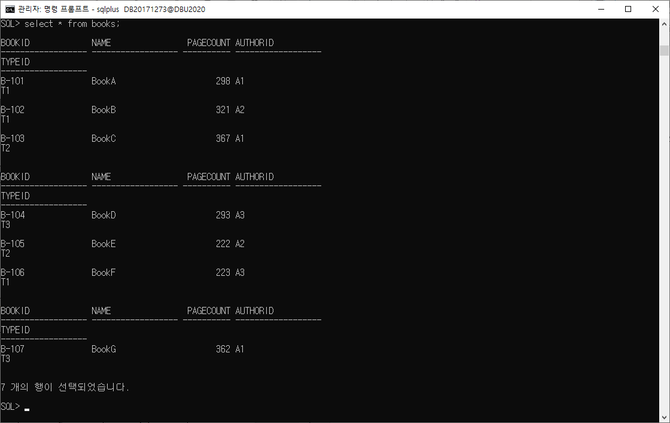

질의문 :

insert into books (bookid, name, pagecount, authorid, typeid) values ('B-101', 'BookA', 298, 'A1', 'T1');

insert into books (bookid, name, pagecount, authorid, typeid) values ('B-102', 'BookB', 321, 'A2', 'T1');

insert into books (bookid, name, pagecount, authorid, typeid) values ('B-103', 'BookC', 367, 'A1', 'T2');

insert into books (bookid, name, pagecount, authorid, typeid) values ('B-104', 'BookD', 293, 'A3', 'T3');

insert into books (bookid, name, pagecount, authorid, typeid) values ('B-105', 'BookE', 222, 'A2', 'T2');

insert into books (bookid, name, pagecount, authorid, typeid) values ('B-106', 'BookF', 223, 'A3', 'T1');

insert into books (bookid, name, pagecount, authorid, typeid) values ('B-107', 'BookG', 362, 'A1', 'T3');

select * from books;

1. students

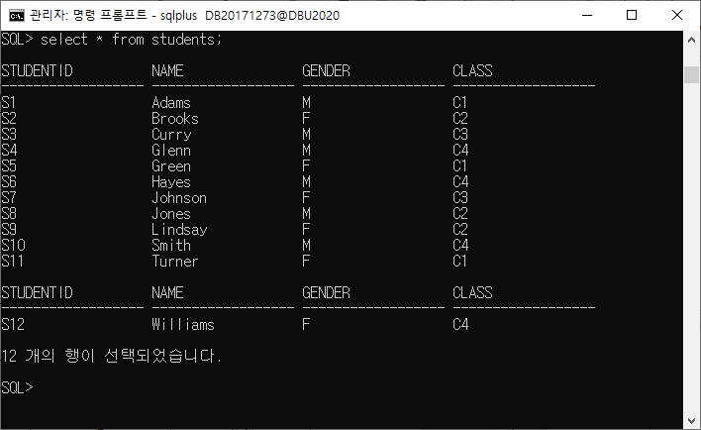

질의문 :

insert into students (studentid, name, gender, class) values ('S1', 'Adams', 'M', 'C1');

insert into students (studentid, name, gender, class) values ('S2', 'Brooks', 'F', 'C2');

insert into students (studentid, name, gender, class) values ('S3', 'Curry', 'M', 'C3');

insert into students (studentid, name, gender, class) values ('S4', 'Glenn', 'M', 'C4');

insert into students (studentid, name, gender, class) values ('S5', 'Green', 'F', 'C1');

insert into students (studentid, name, gender, class) values ('S6', 'Hayes', 'M', 'C4');

insert into students (studentid, name, gender, class) values ('S7', 'Johnson', 'F', 'C3');

insert into students (studentid, name, gender, class) values ('S8', 'Jones', 'M', 'C2');

insert into students (studentid, name, gender, class) values ('S9', 'Lindsay', 'F', 'C2');

insert into students (studentid, name, gender, class) values ('S10', 'Smith', 'M', 'C4');

insert into students (studentid, name, gender, class) values ('S11', 'Turner', 'F', 'C1');

insert into students (studentid, name, gender, class) values ('S12', 'Williams', 'F', 'C4');

select * from students;

1. borrows

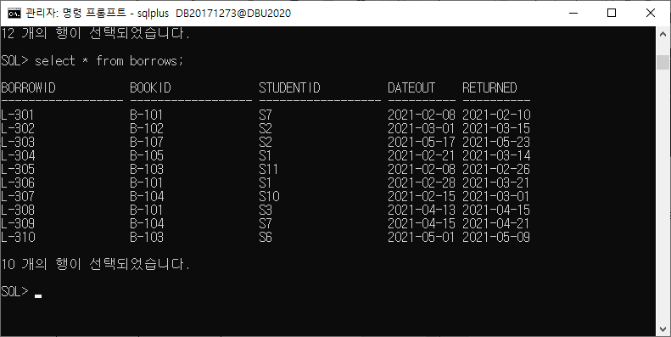

질의문 :

insert into borrows (borrowid, bookid, studentid, dateOut, returned) values ('L-301', 'B-101', 'S7', '2021/02/08', '2021/02/10');

insert into borrows (borrowid, bookid, studentid, dateOut, returned) values ('L-302', 'B-102', 'S2', '2021/03/01', '2021/03/15');

insert into borrows (borrowid, bookid, studentid, dateOut, returned) values ('L-303', 'B-107', 'S2', '2021/05/17', '2021/05/23');

insert into borrows (borrowid, bookid, studentid, dateOut, returned) values ('L-304', 'B-105', 'S1', '2021/02/21', '2021/03/14');

insert into borrows (borrowid, bookid, studentid, dateOut, returned) values ('L-305', 'B-103', 'S11', '2021/02/08', '2021/02/26');

insert into borrows (borrowid, bookid, studentid, dateOut, returned) values ('L-306', 'B-101', 'S1', '2021/02/28', '2021/03/21');

insert into borrows (borrowid, bookid, studentid, dateOut, returned) values ('L-307', 'B-104', 'S10', '2021/02/15', '2021/03/01');

insert into borrows (borrowid, bookid, studentid, dateOut, returned) values ('L-308', 'B-101', 'S3', '2021/04/13', '2021/04/15');

insert into borrows (borrowid, bookid, studentid, dateOut, returned) values ('L-309', 'B-104', 'S7', '2021/04/15', '2021/04/21');

insert into borrows (borrowid, bookid, studentid, dateOut, returned) values ('L-310', 'B-103', 'S6', '2021/05/01', '2021/05/09');

select * from borrows;

1. types

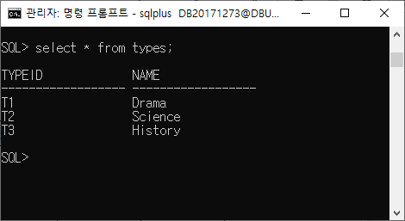

질의문 :

insert into types (typeid, name) values ('T1', 'Drama');

insert into types (typeid, name) values ('T2', 'Science');

insert into types (typeid, name) values ('T3', 'History');

select * from types;

1. authors

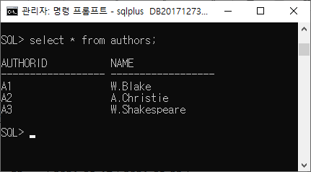

질의문 :

insert into authors (authorid, name) values ('A1', 'W.Blake');

insert into authors (authorid, name) values ('A2', 'A.christie');

insert into authors (authorid, name) values ('A3', 'W.Shakespeare');

select * from authors;

1. 페이지 수(pagecount)가 300 이상인 모든 책의 이름을 나열하라.

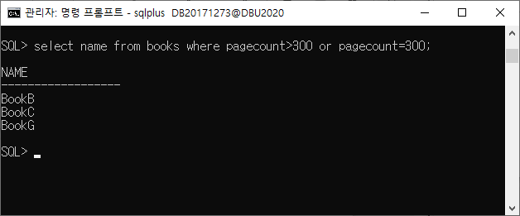

질의문 : select name from books where pagecount>300 or pagecount=300;

1. 페이지 수(pagecount)가 200이상 250 미만인 모든 책의 이름을 나열하라.

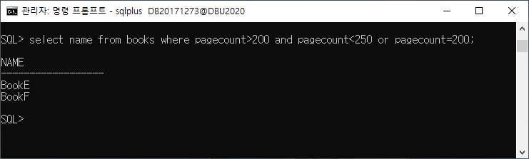

질의문 : select name from books where pagecount>200 and pagecount<250 or pagecount=200;

1. 반(class)이 C1반이거나 C2반인 모든 여학생의 이름을 나열하라.

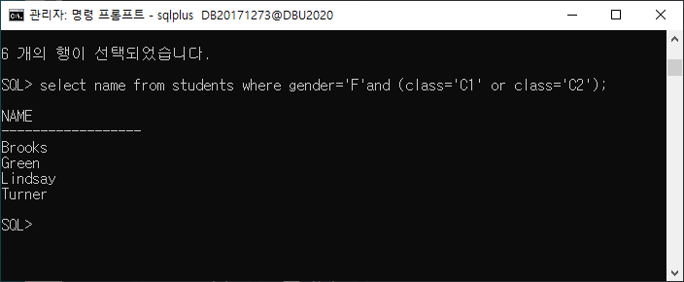

질의문 : select name from students where gender=’F’ and (class=’C1’ or class=’C2’);

1. 페이지 수(pagecount)가 가장 큰 책의 이름을 찾아라.

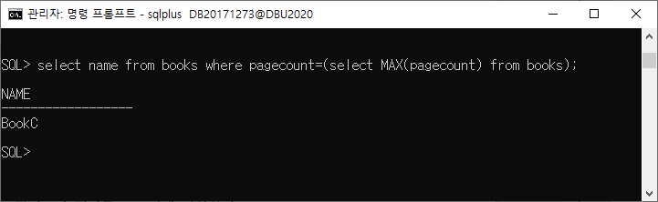

질의문 : select name from books where pagecount=(select MAX(pagecount) from books);

1. 페이지 수(pagecount)의 내림차순으로 책의 이름을 나열하라.(책 이름, pagecount 쌍으로 나타낼 것)

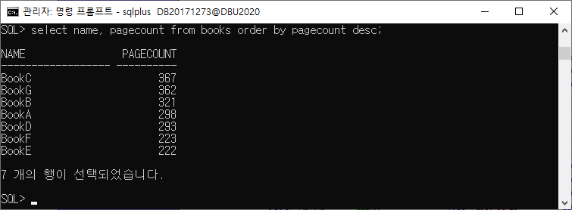

질의문 : select name, pagecount from books order by pagecount desc;

1. 반(class) 별로 학생 수를 구하라. (반, 학생 수 쌍으로 나열할 것.)

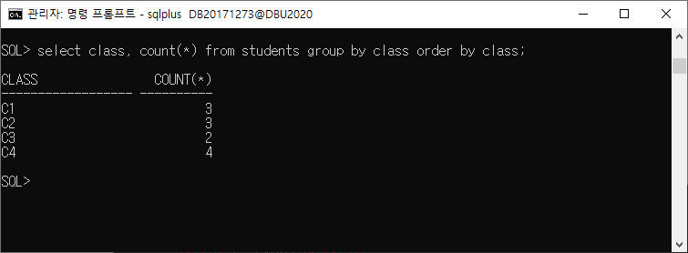

질의문 : select class, count(*) from students group by class order by class;

1. 반(class) 별로 남학생의 수를 구하라. (반, 학생 수 쌍으로 나열할 것.)

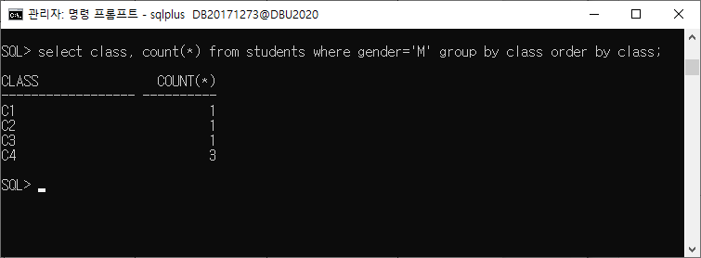

질의문 : select class, count(*) from students where gender='M' group by class order by class;

1. 책을 빌려간 모든 학생들의 이름과 그 학생들이 빌려간 책의 이름을 나열하라. (학생 이름, 책 이름의 쌍으로 나열할 것.)

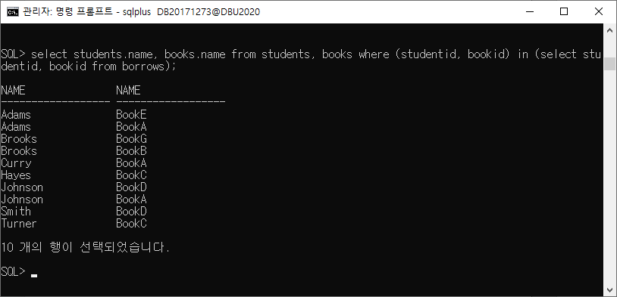

질의문 : select students.name, books.name from students, books where (studentid, bookid) in (select studentid, bookid from borrows);

1. C1반의 학생이 빌려간 모든 책의 이름을 나열하라. (중복은 제거할 것.)

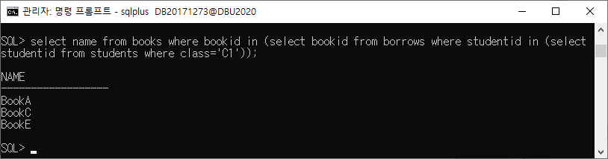

질의문 : select name from books where bookid in (select bookid from borrows where studentid in (select studentid from students where class='C1'));

1. C1반의 학생 별로 책을 읽은 횟수를 나열하라. (학생 이름, 횟수의 쌍으로 나열할 것.)

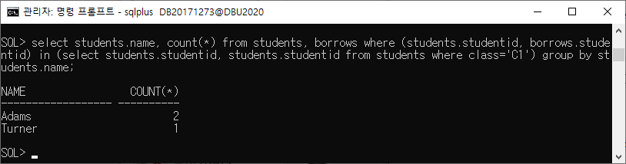

질의문 : select students.name, count(*) from students, borrows where (students.studentid, borrows.studentid) in (select students.studentid, students.studentid from students where class='C1') group by students.name;

1. C1 또는 C2반의 학생 중에 2021-02-15 ~ 2021-03-16 기간동안 책을 대여(dateOut)해간 학생의 이름을 나 열하라.

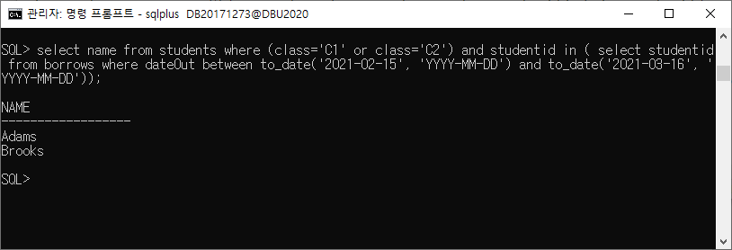

질의문 : select name from students where (class='C1' or class='C2') and studentid in ( select studentid from borrows where dateOut between to_date('2021-02-15', 'YYYY-MM-DD') and to_date('2021-03-16', 'YYYY-MM-DD'));

1. ‘Brooks’라는 학생이 읽은 책의 이름을 나열하라.

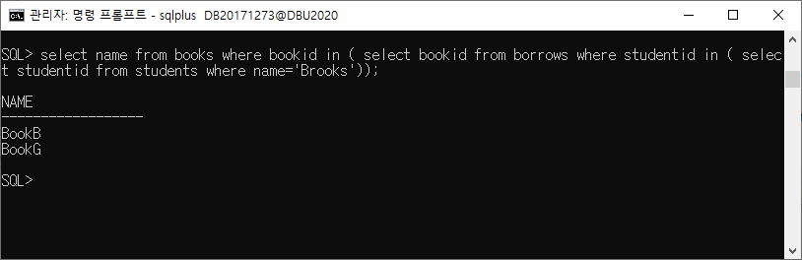

질의문 : select name from books where bookid in ( select bookid from borrows where studentid in ( select studentid from students where name='Brooks'));

1. 가장 많은 책을 쓴 작가의 이름을 찾아라. 2명 이상이면 모두 나열하라.

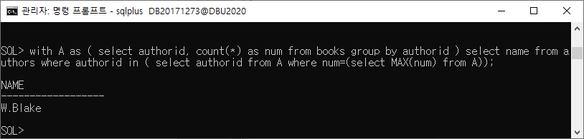

질의문 : with A as ( select authorid, count(*) as num from books group by authorid ) select name from authors where authorid in ( select authorid from A where num=(select MAX(num) from A));

1. 가장 많은 페이지 수를 지닌 책을 읽은 학생의 이름을 나열하라.

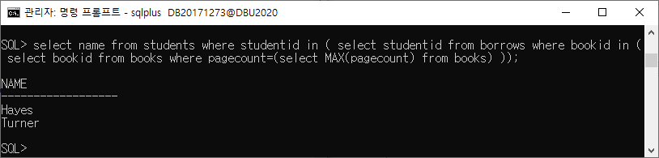

질의문 : select name from students where studentid in ( select studentid from borrows where bookid in ( select bookid from books where pagecount=(select MAX(pagecount) from books) ));

1. 가장 많은 책을 쓴 작가들의 책을 읽은 학생의 이름을 나열하라.

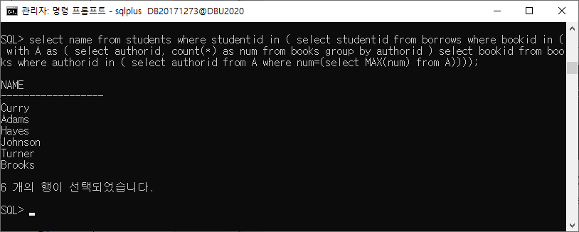

질의문 : select name from students where studentid in ( select studentid from borrows where bookid in ( with A as ( select authorid, count(*) as num from books group by authorid ) select bookid from books where authorid in ( select authorid from A where num=(select MAX(num) from A))));