When does N-acetylcysteine stop working? Treatment timing, ingestion pattern, and hepatic zonation in a model of acetaminophen hepatotoxicity

Study Highlights
What is the current state of knowledge?
- N-acetylcysteine (NAC), the standard antidote for acetaminophen poisoning,
loses efficacy when started more than ~8 h after ingestion; this 8-hour rule is empirical, derived from clinical cohorts rather than mechanism.
- Zonation-resolved models of acetaminophen hepatotoxicity predict injury but
contain no treatment term, and all impose literature-derived enzyme gradients rather than measured ones.
What does this study add?
- A PK-calibrated NAC term and a staggered-ingestion term embedded in a
zonation-resolved model, reproducing the clinical 8-hour rule from first principles.
- Measured human enzyme gradients widen the predicted antidote window
substantially relative to the assumed gradients used by prior models — the zonation assumption propagates into treatment predictions, not only injury predictions.
- At fixed total dose, staggered ingestion is metabolically neutral: the
clinical danger of staggered overdose reflects late presentation, not pattern-specific metabolism.

Abstract
N-acetylcysteine (NAC) is the standard antidote in acetaminophen poisoning, but its efficacy declines sharply when treatment starts more than ~8 h after ingestion — an empirical observation without a mechanistic model behind it. Zonation-resolved models of acetaminophen hepatotoxicity predict injury but have never represented treatment, and all impose literature-derived enzyme gradients. Here we embed a PK-calibrated NAC term in a 16-hepatocyte model of hepatic zonation whose enzyme gradients are taken from measured human spatial proteomics, and ask how treatment timing, ingestion pattern, and the zonation representation interact. NAC is modelled as a GSH-synthesis boost driven by the plasma profile of the standard 21-h IV protocol (elimination half-life 2 h), with the peak boost calibrated to the classic recovery criterion that NAC restores detoxification capacity rather than preventing initial glutathione depletion. The model reproduces the clinical 8-hour rule: protection collapses between 4 and 12 h at both the simulated 4 g and 16 g single doses. Under measured gradients — which are shallower and, for GSH synthesis, unzonated — the window widens substantially (protection at 8 h: 7% vs 1% at 4 g; 5% vs 1% at 16 g), because a uniform synthesis gradient maintains a larger pericentral detoxification reserve. At fixed total dose, staggered ingestion changes peak adduct burden by only −2 to −4%: the danger of staggered overdose reflects late presentation, not the pattern itself. Conclusions are robust to saturable kinetics and absorption rates. The zonation assumption a modeller makes propagates from injury prediction into treatment prediction — and the measured picture is the more optimistic one.

Keywords
acetaminophen; paracetamol; N-acetylcysteine; hepatotoxicity; liver zonation; pharmacokinetics/pharmacodynamics; mathematical model

Introduction
N-acetylcysteine (NAC) is the standard antidote in acetaminophen (paracetamol) poisoning. Acetaminophen is cleared mainly by sulfation and glucuronidation, but a minor oxidative pathway — mediated by CYP2E1, CYP1A2 and CYP3A4 — forms the reactive metabolite N-acetyl-p-benzoquinone imine (NAPQI), which is normally detoxified by glutathione (GSH) conjugation (1). When overdose exhausts hepatic GSH, NAPQI binds covalently to hepatocyte proteins and centrilobular necrosis follows. NAC works upstream of that endpoint: as a cysteine donor it fuels de novo GSH synthesis, restoring the detoxification capacity of hepatocytes whose GSH pool NAPQI is draining (2). Clinically, its benefit is strongly time-dependent: treatment started within ~8 h of ingestion is highly effective, whereas benefit declines sharply thereafter — the "8-hour rule" (3). That rule, however, is an empirical summary of clinical cohorts. No mechanistic model currently reproduces it, predicts how it shifts, or explains what sets its width.
Zonation is the obvious candidate mechanism. The enzymes of acetaminophen metabolism are zonated along the periportal–pericentral axis of the hepatic lobule (4), and a sequence of zonation-resolved models — a finite-element sinusoid (5), a transport-coupled extension (6), and most recently a 5,114-hepatocyte lobule coupled to whole-body pharmacokinetics (7) — has shown that the spatial arrangement of enzyme activity shapes the predicted toxic adduct burden. Two gaps are shared by this entire lineage. First, the enzyme gradients are imposed: qualitative, literature-derived profiles ultimately traceable to a rodent-derived review (4), with the largest current model stating explicitly that no omics data were integrated (7). Second — and more consequential for the present work — none of these models contains a treatment term. NAC appears in the most recent of them only as a clinical remark in the Discussion (7); whole-body quantitative systems toxicology platforms represent NAC but carry no zonal resolution. A model of zonation that cannot represent the antidote cannot ask the treatment question at all.
Two further developments make the question answerable now. First, human spatial omics has made the enzyme gradients measurable: single-cell spatial proteomics of human liver reports per-cell abundance along the porto-central axis for the relevant enzymes (8), cross-checked by a multi-species spatial transcriptomics atlas (9). Abundance-derived gradient folds differ from the assumed ones — most GSH-related activity is unzonated rather than strongly periportal — and protein abundance is a proxy for catalytic capacity, so the representation is a testable scenario rather than a ground truth. Second, the pharmacokinetics of the standard intravenous NAC protocol are reasonably characterised (10, 11), so a treatment term can be calibrated rather than invented.
Here we embed both pieces in a 16-hepatocyte model of the hepatic sinusoid (80 state variables) built on the Reddyhoff intracellular kinetics (1): a PK-calibrated NAC term (a time-limited, protocol-driven boost to GSH synthesis) and a staggered-ingestion term (a first-order gut compartment receiving scheduled doses). We ask three questions. Does the model reproduce the clinical 8-hour rule? Does the choice between assumed and measured enzyme gradients — an injury-modelling decision to date — propagate into treatment predictions? And does the ingestion pattern itself (single bolus versus staggered overdose at fixed total dose) alter the metabolic burden, or is the clinical danger of staggered overdose fully explained by late presentation? The answers — yes; yes, in the opposite direction to injury; and the latter — carry a practical implication: the zonation assumption a modeller makes changes when the antidote is predicted to stop working.

Methods

2.1 Intracellular kinetics
The per-hepatocyte kinetics follow the five-species acetaminophen metabolism model of Reddyhoff et al. (1), which tracks paracetamol P, the sulfation co-substrate PAPS S, the reactive metabolite NAPQI N, glutathione G, and covalent protein adducts C:
$$\frac{dP}{dt} = −k_{S}·S·P − k_{G}·P − k_{450}·P + k_{N}·N$$
$$\frac{dS}{dt} = −k_{S}·S·P + b_{S} − d_{S}·S$$
$$\frac{dN}{dt} = k_{450}·P − k_{N}·N − k_{GSH}·N·G − k_{PSH}·N$$
$$\frac{dG}{dt} = −k_{GSH}·N·G + b_{G} − d_{G}·G$$
$$\frac{dC}{dt} = k_{PSH}·N − k_{clear}·C$$
The first five terms are those of Reddyhoff et al.; we add a first-order elimination term to the adduct compartment (`k_clear = 0.42 d⁻¹`, from the measured human serum adduct elimination rate; James et al. (12)) so that C has the correct turnover. This rate is a calibrated input, not an independent test, and it enters only the adduct turnover, not the treatment analysis. Parameter values were taken from the original MATLAB source rather than the published table (whose parameter names appear transposed relative to their values) and reproduce the paper's stated dosing conversion exactly (Table 1). The model is human-scaled: simulated doses of 4 g and 16 g, 1.6055 × 10¹¹ hepatocytes, hepatic penetration 0.8, and human-derived glucuronidation and oxidation rates (1).
Table 1 — Kinetic parameters (Reddyhoff et al. 2015, as in source code).
Parameter | Value | Meaning
kS | 2.26 × 10¹⁴ · 10⁻¹² cell·mol⁻¹·d⁻¹ | PAPS-dependent sulfation
kG | 2.99 d⁻¹ | glucuronidation
k450 | 0.315 d⁻¹ | CYP450 oxidation
kN | 0.0315 d⁻¹ | NAPQI → APAP reverse
bS | 2.65 × 10⁻¹⁴ / 10⁻¹² mol·cell⁻¹·d⁻¹ | PAPS synthesis
dS | 2.0 d⁻¹ | PAPS decay
kGSH | 1.6 × 10¹⁸ · 10⁻¹² cell·mol⁻¹·d⁻¹ | GSH conjugation of NAPQI
kPSH | 110 d⁻¹ | NAPQI–protein binding
bG | 1.374 × 10⁻¹⁴ / 10⁻¹² mol·cell⁻¹·d⁻¹ | GSH synthesis
dG | 2.0 d⁻¹ | GSH decay
k_clear | 0.42 d⁻¹ | adduct elimination (James 2009)

2.2 Zonated extension
The intracellular model is run independently across N = 16 hepatocytes arrayed along a periportal→pericentral sinusoid (hepatocyte 1 periportal, 16 pericentral; 80 state variables total). Each hepatocyte receives the same initial APAP amount `P0 = dose · f / (MW · N_hep)`, with hepatic penetration `f = 0.8` and molecular weight `MW = 151 g·mol⁻¹`. Enzyme rates are modulated by a linear ramp along the sinusoid. For an enzyme with pericentral/periportal fold F, the per-hepatocyte multiplier is
$$m(x) = a + (b − a)·x, x = \frac{i − 1}{15}, a = \frac{2}{1 + F}, b = \frac{2F}{1 + F}$$
so that the arithmetic mean multiplier across the sinusoid is exactly 1 — total enzyme is conserved and only its location varies. (A geometric-mean-preserving ramp would not conserve total enzyme.)

2.3 Enzyme-gradient representations: assumed versus measured
Two gradient representations are compared throughout.
Assumed. The qualitative, Gebhardt-derived gradients carried by prior zonation models (4, 5, 7): CYP450 5× pericentral; glucuronidation 9× pericentral; sulfation, GSH conjugation and GSH synthesis 9× periportal.
Measured. Abundance folds re-derived from the single-cell spatial proteomics of human liver (8). That study's published "zonation coefficient" is the fixed-effect slope of a per-protein linear mixed model fitted to robust-scaled intensities — a regression slope, not a portal-to-central abundance ratio, and therefore not usable directly as a rate fold. The same supplement reports each protein's mean intensity in 20 equidistant bins along the porto-central axis (normalised to sum to 100%; bin 0 central, bin 19 portal). We take the fold as the ratio of the mean of bins 0–4 (central) to the mean of bins 15–19 (portal); the choice of five bins per end rather than the terminal bin reduces sensitivity to single-bin noise (single-bin ratios are within 30% and change no conclusion; full per-protein inputs in Supplementary Methods). Folds were cross-checked against mRNA log2(portal/central) ratios from the spatial transcriptomics atlas (9): the two datasets agree in direction but differ in magnitude, a genuine mRNA–protein discordance that we carry into the saturation scenario rather than average away. Because protein abundance is a proxy for catalytic capacity (no lobule-resolved activity data exist), the measured representation is a testable scenario, not a ground truth. Where several isoforms contribute to one parameter, the fold is the isoform-weighted combination using approximate relative contributions to human APAP oxidation (CYP2E1 ≈ 0.60, CYP1A2 ≈ 0.25, CYP3A4 ≈ 0.15; Laine et al. (13)).
Table 2 — Assumed versus measured zonation (pericentral/periportal fold).
Parameter | Enzyme | Assumed (prior models) | Measured (protein bin-ratio)
k450 | CYP450 | 5× pericentral | 3.4× (isoform-weighted; raw folds 1.9–6.9×)
kG | UGT | 9× pericentral | 1.4× (UGT2B7; 1.4–2.1× across isoforms)
kS | SULT | 9× periportal | unzonated (SULT1A1 0.99×)
kGSH | GST | 9× periportal | 1.2× pericentral (GSTA2; reversed direction)
bG | GSH synthesis | 9× periportal | unzonated (GCLC/GCLM/GSS ~1.0×)
The two representations differ most consequentially in GSH synthesis: the assumed gradient starves the pericentral zone of synthetic capacity (fold 0.2× relative to the mean), whereas the measured enzymes are unzonated, leaving the pericentral detoxification reserve intact. That difference is what the treatment analysis below exploits.

2.4 NAC term: PK-calibrated GSH-synthesis boost
NAC is represented where it acts: as a cysteine donor that raises hepatic GSH synthesis. The standard 21-h intravenous protocol drives the input — 150 mg/kg over 1 h, then 50 mg/kg over 4 h, then 100 mg/kg over 16 h (14). Plasma NAC follows first-order elimination with the reported intravenous half-life of ~2 h (10); the modelled plasma peak is ≈ 127 mg/kg. Because GSH synthesis support outlasts plasma NAC itself, the boost is driven by a cysteine-equivalent pool fed by plasma NAC and eliminated with a half-life of 6 h (a stated assumption, the midpoint of the NAC half-life and hepatocyte GSH turnover):
$$\frac{dA}{dt} = I(t) − k_{el}·A$$
$$\frac{dCys}{dt} = k_{in}·A − k_{out}·Cys$$
$$bG → bG + M_{max}·b_{G}·\frac{Cys}{Cys_ref}$$
where `I(t)` is the piecewise infusion rate and `Cys_ref` the pool peak for the standard protocol. The single free magnitude, `M_max`, is calibrated, not scanned arbitrarily. The criterion follows the classic mechanistic finding of Lauterburg, Corcoran and Mitchell (2): NAC does not prevent the initial GSH depletion caused by a toxic dose — it dramatically accelerates recovery of detoxification capacity through de novo synthesis. We therefore require that, at the simulated 16 g dose with NAC started at 0 h, pericentral GSH recovers to ≥ 50% of its own pre-dose steady state by 12 h post-ingestion. The smallest peak boost meeting the criterion is `M_max = 4×` basal synthesis (recovery 51.7% of baseline; `M_max = 2×` recovers only 9.6% and fails; Fig. 3). All efficacy scans below use this calibrated, protocol-driven treatment; a constant-boost scenario (the peak value held flat for 21 h) is reported in the supplement as an upper bound.

2.5 Ingestion term: single and staggered dosing
The instantaneous bolus is generalised with a first-order gut compartment (`ka = 60 d⁻¹`, absorption half-life ≈ 17 min; swept 17–60 d⁻¹, covering typical immediate-release absorption): ingested amounts enter the gut and are absorbed equally by all hepatocytes, with ingestion events applied at specified times by piecewise integration. Regimens compared at fixed total dose of 16 g: a single ingestion; 4 × 4 g every 2 h; 8 × 2 g every 1 h.

2.6 Saturation scenario and numerical analysis
The Reddyhoff kinetics are linear in substrate. To test whether the treatment conclusions depend on that simplification — the same one flagged by the largest current lobule model (7) — the glucuronidation and oxidation terms are replaced by a saturable form `v = k·P / (1 + P/Km)` with `Km = P0(16 g)/r`, where `r` interpolates between mild (r = 3) and strong (r = 1) saturation relative to the 16 g dose; `r → ∞` recovers the linear model. The 82-variable ODE system (80 cellular states plus the gut and plasma/pool compartments) was integrated with a stiff Radau solver (`solve_ivp`, rtol 10⁻⁵, atol 10⁻⁸) over 3 days. Metrics: peak pericentral adducts (C_pk), NAC protection (1 − C_pk(NAC)/C_pk(no NAC) at matched dose, gradient representation, and start time), and the pericentral GSH minimum. One-at-a-time attribution and multi-parameter sweeps are reported alongside.

Results

3.1 Two gradient representations, one consequence for GSH
The measured human zonation disagrees with the literature-derived gradients in direction and magnitude (Table 2, Fig. 1). The enzymes that generate and detoxify NAPQI keep their assumed direction — CYP450 and glucuronidation pericentral — but are far shallower than assumed (3.4× and 1.4× versus 5× and 9×). Sulfation and, critically, GSH synthesis are unzonated: the assumed gradients starve the pericentral zone of synthetic capacity (fold 0.2×), the measured enzymes leave it intact. GSH conjugation is weakly pericentral rather than strongly periportal. Because pericentral GSH is the rate-limiting defence in the zone where NAPQI is formed, this difference between representations is exactly where a treatment term should act.
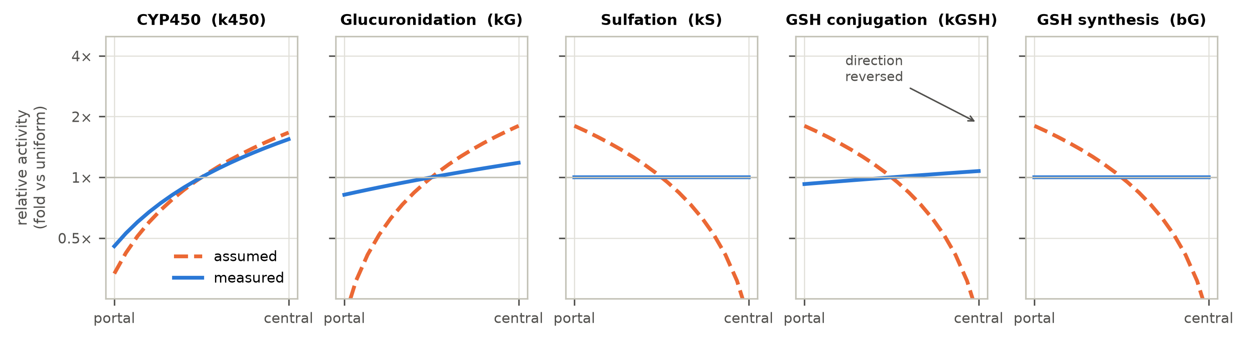
Fig. 1. Assumed versus measured zonation gradients for the five enzyme parameters, as fold-change relative to a uniform baseline (1×). Orange dashed: the Gebhardt-derived gradient carried by prior models; blue solid: the gradient re-derived from human spatial-proteomics bin profiles (isoform-weighted for CYP450). Sulfation and GSH synthesis are unzonated; GSH conjugation is reversed (weakly pericentral); CYP450 and glucuronidation retain direction but are shallower than assumed.

3.2 The model reproduces the clinical 8-hour rule
With the calibrated protocol-driven NAC term, protection — the reduction in peak pericentral adducts versus no treatment — collapses as the treatment start time is delayed (Fig. 2). At the simulated 4 g single dose, protection falls from 58% (assumed gradients) and 83% (measured) at 0 h to 5% and 27% at 6 h, 1% and 7% at 8 h, and ~0% by 12 h. At the simulated 16 g single dose the collapse is steeper still (31% and 42% at 0 h; 1% and 5% at 8 h). The model therefore reproduces, from first principles, the clinical 8-hour rule: the antidote must be started early because the pericentral GSH pool — once exhausted by NAPQI — cannot be rescued quickly enough by synthesis alone, however large the cysteine supply. The width of the useful window is set by the race between NAPQI-driven GSH consumption and treatment-supported GSH recovery, not by any parameter of the antidote's own pharmacokinetics.
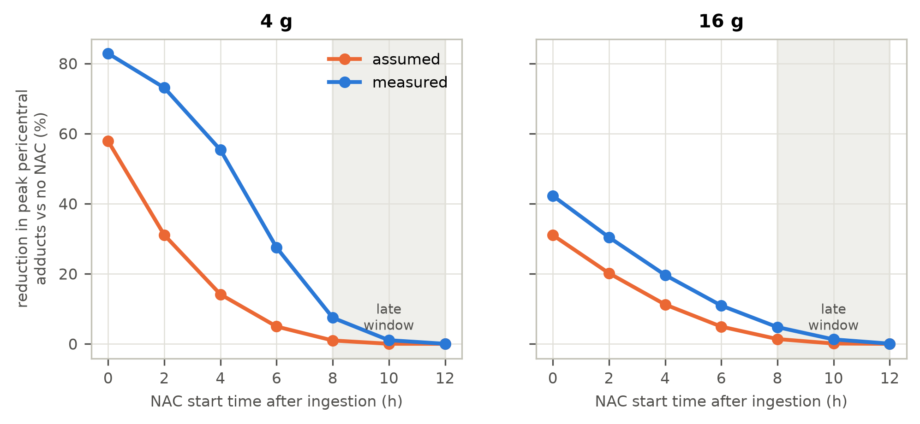
Fig. 2. Predicted NAC efficacy window: reduction in peak pericentral adducts versus no treatment, as a function of treatment start time after ingestion, at the simulated 4 g and 16 g single doses, under assumed (orange dashed) and measured (blue solid) gradient representations. Treatment is the calibrated, protocol-driven 21-h IV NAC input. Shading marks the late window beyond the clinical 8-hour rule.
The calibrated boost itself is shown in Fig. 3: without NAC, the pericentral GSH pool collapses and recovers only slowly; at `M_max = 4×` basal synthesis — the smallest peak boost meeting the recovery criterion — the pool recovers to 51.7% of baseline by 12 h, while `M_max = 2×` recovers only 9.6% and `M_max = 8×` overshoots. The criterion therefore discriminates sharply between treatment magnitudes rather than being satisfied trivially.
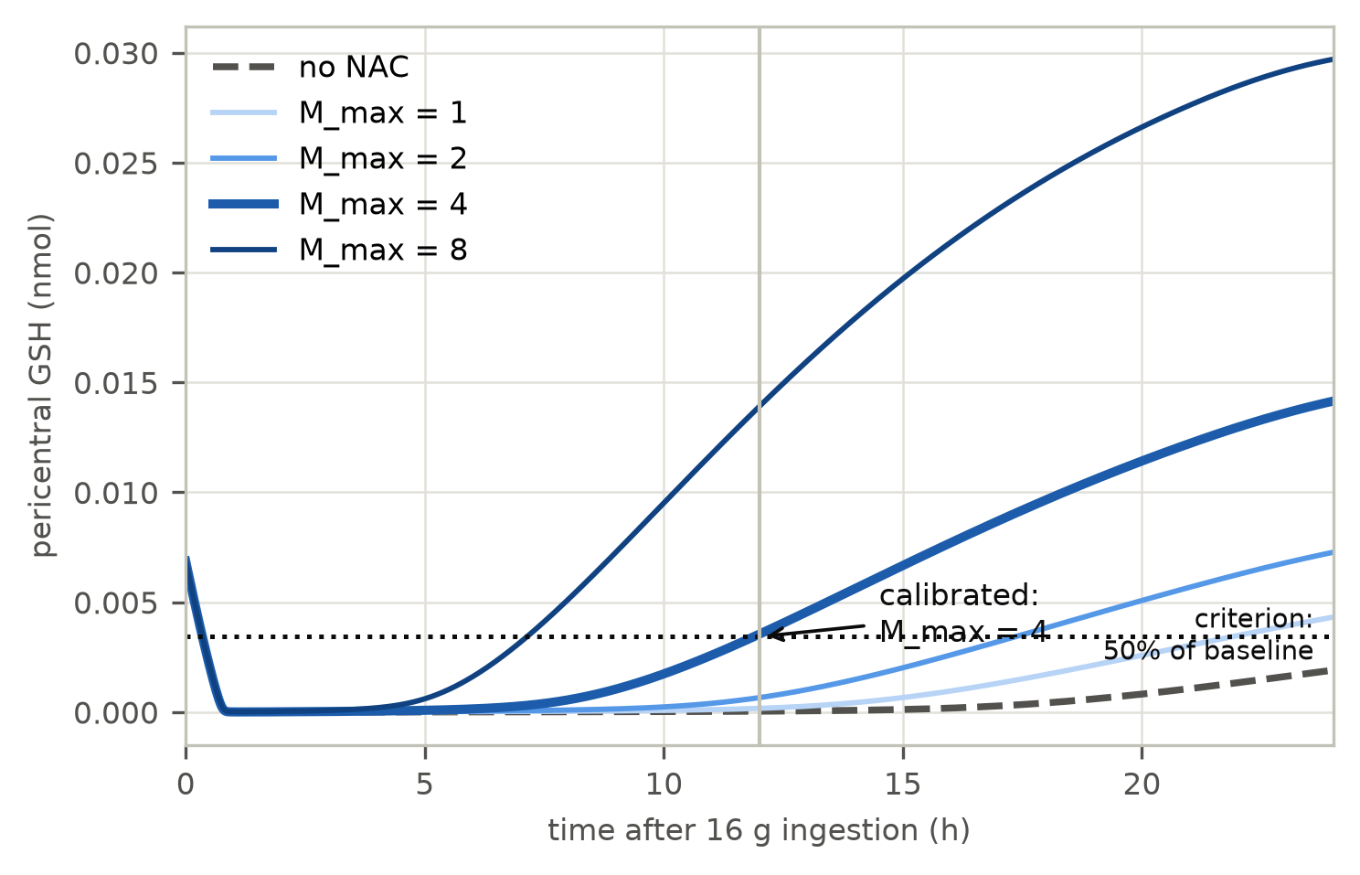
Fig. 3. Calibration of the NAC term. Pericentral GSH recovery after the simulated 16 g single dose with treatment started at 0 h, for the no-NAC reference (grey dashed) and peak boosts M_max = 1, 2, 4 (thick) and 8 (blue ramp). Dotted line: the recovery criterion (≥ 50% of the pre-dose steady state by 12 h); vertical line at 12 h. The calibrated peak boost (M_max = 4) is the smallest magnitude that meets the criterion.

3.3 Measured gradients widen the antidote window
At every start time and both doses, the measured representation predicts more treatment benefit than the assumed one (Fig. 2). The gap is largest where it matters most clinically: at 4 h, protection under measured gradients is 55% versus 14% at 4 g, and 20% versus 11% at 16 g; at 8 h, 7% versus 1% and 5% versus 1%. The mechanism follows directly from §3.1. Under the assumed gradients the pericentral zone begins with a quarter of the mean GSH-synthesis capacity and is drained to exhaustion within hours, after which no cysteine supply can act on a pool that no longer exists. Under the measured, unzonated-synthesis representation the pericentral reserve is larger from the start and depletes later, so treatment started in the late window still finds a pool worth refilling. Early protection is also higher (83% versus 58% at 0 h, 4 g) for the same reason. The zonation assumption a modeller makes therefore propagates from injury prediction into treatment prediction — with opposite sign: the representation that predicts less injury predicts more treatability.

3.4 Staggered ingestion is metabolically neutral at fixed total dose
At a fixed total dose of 16 g, ingestion pattern barely changes the metabolic burden. Peak pericentral adducts differ by −2.0% (assumed) and −4.0% (measured) between a single ingestion and 4 × 4 g every 2 h, and by −2.2% and −4.4% for 8 × 2 g every 1 h; the differences shrink or grow only marginally across absorption rates of 17–60 d⁻¹ (Table 3). The pericentral GSH minimum is in fact slightly higher under staggering (7.7 × 10⁻⁶ and 8.2 × 10⁻⁶ nmol versus 4.6 × 10⁻⁶ for the single ingestion, assumed gradients) because each smaller dose drains GSH less abruptly while synthesis continues between events. The model does not reproduce the clinical impression that staggered overdoses are more dangerous through pattern-specific metabolism. What it does show is that the danger of staggered overdose is a presentation-time phenomenon: staggered ingestions delay the patient's recognition that a toxic total dose has been accumulated, pushing treatment start into the collapsed part of the window in Fig. 2 — where, under measured gradients, a genuine residual benefit remains that the assumed gradients would miss.
Table 3 — Ingestion-pattern effect at fixed total dose (16 g; peak pericentral adducts, nmol).
Gradients | ka (d⁻¹) | Single | 4 × 4 g q2h | 8 × 2 g q1h
assumed | 17 | 3.458 × 10⁻² | 3.391 × 10⁻² | —
assumed | 60 | 3.490 × 10⁻² | 3.419 × 10⁻² | 3.415 × 10⁻²
measured | 17 | 3.425 × 10⁻² | 3.299 × 10⁻² | —
measured | 60 | 3.477 × 10⁻² | 3.338 × 10⁻² | 3.333 × 10⁻²
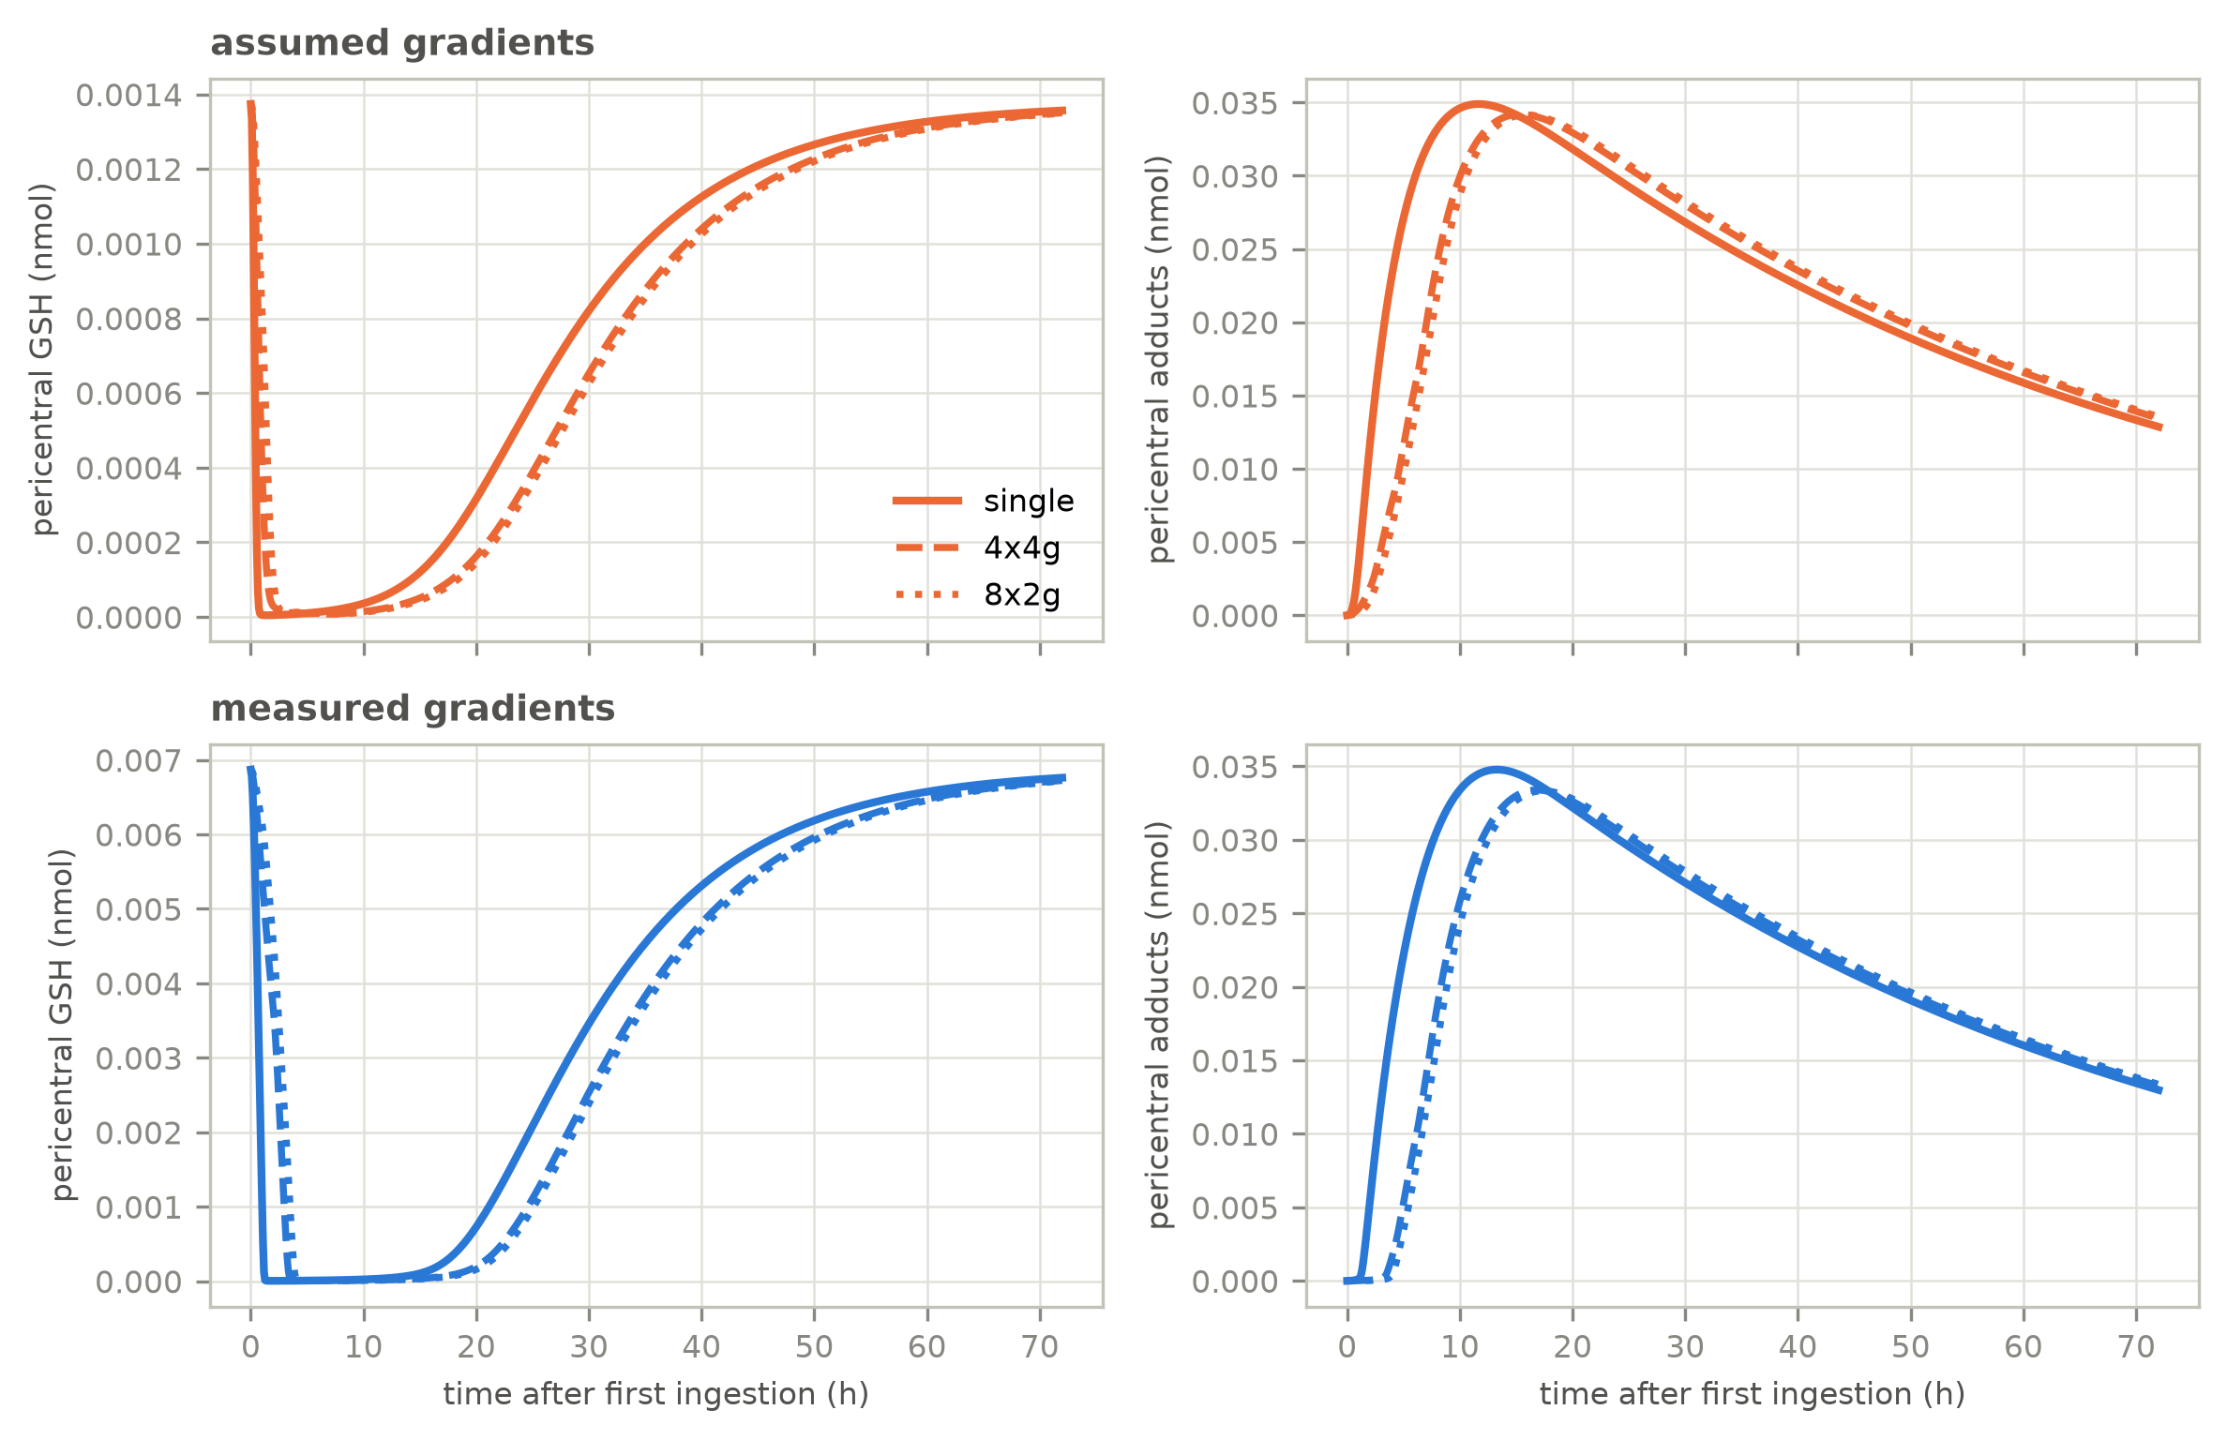
Fig. 4. Staggered versus single ingestion at fixed total dose (16 g): pericentral GSH (left column) and adducts (right column) over time, under assumed (top row) and measured (bottom row) gradient representations. Staggering slightly raises the GSH minimum and slightly lowers the peak adduct burden; the metabolic footprint of the pattern is small.

3.5 Robustness: boost magnitude, absorption, and saturable kinetics
The conclusions survive every scenario variation examined. First, the calibrated boost magnitude is not fragile: under measured gradients the late-window protection scales with `M_max` (protection at 4 h for 4 g: 11%, 14%, 16% for `M_max` = 1, 2, 4), while under assumed gradients the window remains closed at 4–6 h for every `M_max` — when the pool is gone, no synthesis boost can act (Fig. S2). Second, the ingestion-pattern result is absorption-rate-robust (Table 3). Third, saturable kinetics strengthen rather than break the treatment message (Table 4): with `Km = P0(16 g)/r`, NAC protection at overdose increases steeply with saturation (protection at 0 h, 16 g: 31–42% linear, 61–81% at r = 1, 86–98% at r = 3), because capping NAPQI formation lets treatment-supported synthesis keep pace with it — and the assumed-versus-measured ordering persists at every r, widening at 16 g (8-h protection: 62% versus 40% at r = 3). The linear model is thus the conservative case for treatment efficacy.
Table 4 — Saturation robustness (NAC protection, %, at matched start times; calibrated treatment).
Gradients | Dose | Kinetics | 0 h | 4 h | 8 h
assumed | 4 g | linear | 58% | 14% | 1%
assumed | 4 g | r = 3 | 90% | 43% | 10%
assumed | 4 g | r = 1 | 87% | 31% | 4%
measured | 4 g | linear | 83% | 55% | 7%
measured | 4 g | r = 3 | 84% | 68% | 37%
measured | 4 g | r = 1 | 87% | 69% | 26%
assumed | 16 g | linear | 31% | 11% | 1%
assumed | 16 g | r = 3 | 86% | 63% | 40%
assumed | 16 g | r = 1 | 61% | 37% | 14%
measured | 16 g | linear | 42% | 20% | 5%
measured | 16 g | r = 3 | 98% | 90% | 62%
measured | 16 g | r = 1 | 81% | 57% | 29%

Discussion
The antidote window is a modelled quantity — and it inherits the zonation assumption. Embedding a PK-calibrated NAC term in a zonation-resolved model produces three findings that no existing model in this field can generate, because none of them represents treatment. First, the model reproduces the clinical 8-hour rule from first principles: protection collapses between 4 and 12 h after ingestion at both simulated doses, because the width of the useful window is set by the race between NAPQI-driven GSH consumption and treatment-supported GSH recovery, not by any property of the antidote's own pharmacokinetics. Second, the representation of hepatic enzyme zonation — to date an injury-modelling decision — propagates into treatment prediction: the measured human gradients, being shallower and unzonated for GSH synthesis, maintain a larger pericentral detoxification reserve and therefore widen the window (protection at 4 h: 55% versus 14% at 4 g; at 8 h, 7% versus 1%). Third, at fixed total dose the ingestion pattern itself is metabolically neutral (−2 to −4%), which relocates the clinical danger of staggered overdose from metabolism to presentation time — the patient does not know to seek treatment early, and arrives in the collapsed part of the window.
Comparison with the state of the art. The zonated-modelling lineage — Gebhardt-derived gradients in Means & Ho (5) and Franiatte et al. (6), and the 5,114-cell lobule coupled to whole-body pharmacokinetics of Ghosh et al. (7) — has progressively refined the injury side: transport, cell states, dose-dependent zonal sensitivity. None of it models treatment; Ghosh et al. name NAC only as a clinical implication and identify biomarker-based validation and Michaelis–Menten kinetics as their own future work, while simulating only single-bolus overdoses. Conversely, whole-body quantitative systems toxicology platforms such as DILIsym model NAC explicitly — with dosing protocols, cysteine delivery and GSH repletion — but carry no zonal resolution, and so cannot ask where in the lobule the antidote's benefit is won or lost. The present model sits deliberately between the two: simple enough to expose the mechanism (a GSH-replenishment race in the zone where NAPQI is formed), calibrated enough to speak to the clinic (protocol-driven PK, recovery-anchored magnitude), and first to make the antidote window an output of a zonation-resolved model. Where our injury-side conclusions touch those of Ghosh et al., they are consistent — pericentral NAPQI formation drives the burden; GSH saturation governs overdose — but our treatment-side results have no counterpart in either literature.
Clinical reading — with its limits stated. Three model-supported statements are, we believe, clinically legible. (i) Early NAC dominates: the model quantifies how steeply protection decays between 4 and 12 h and identifies the exhaustion of the pericentral GSH pool as the mechanistic deadline, supporting the existing emphasis on rapid treatment rather than dose adjustment. (ii) Late treatment is not zero: under measured gradients a residual 5–7% adduct reduction persists at 8 h, and saturable kinetics raise late-window benefit further (up to 62% at 16 h-equivalent scenarios, Table 4) — a quantitative argument against therapeutic nihilism at the 8-hour boundary, which the empirical literature itself treats as a soft threshold. (iii) Staggered overdose calls for the same aggressive timeline as acute overdose: the pattern is metabolically benign at fixed dose, so the observed worse outcomes of staggered ingestion are consistent with delayed presentation and treatment, not with a intrinsically more toxic metabolic profile. We stress what these statements are not: they are not fitted to clinical outcome data, and the model's adduct compartment is a proxy for injury rather than necrosis itself; the 8-hour-rule agreement is a qualitative, order-of-magnitude correspondence of time scales, not a quantitative validation.
Why the assumed and measured pictures diverge so sharply for treatment. The assumed Gebhardt-derived gradients, being rodent-derived and qualitative, place GSH synthesis strongly periportal — precisely the wrong arrangement for the treatment question, since they leave the pericentral zone (where NAPQI is formed) with a quarter of the mean synthetic capacity and no reserve to refill. The measured human enzymes are unzonated for GSH synthesis (GCLC, GCLM, GSS folds ~1.0), consistent with the newer transcriptomic and proteomic atlases (8, 9) and with classical microdissection data showing that the classical "periportal GSH" pattern reflects substrate levels set by consumption, not enzyme distribution. For injury prediction this difference matters; for treatment prediction it matters more, because the treatment acts through the synthesis pathway. A modeller choosing the assumed representation is, in effect, simulating a liver whose antidote has less to work with in the injured zone than a real human liver appears to have.
Limitations. Protein abundance is a proxy for catalytic capacity; post-translational regulation, cofactor availability and isoform kinetics are not represented, and the isoform weights for CYP450 are approximate literature contributions (13). The cysteine-equivalent pool half-life (6 h) is a stated assumption bridging the NAC plasma half-life (2 h) and hepatocyte GSH turnover; the recovery criterion anchoring the calibrated boost (50% of baseline by 12 h) is a modelling choice formalising the Lauterburg et al. (2) phenomenology, not a fitted parameter. The model is a 16-cell sinusoid without transport, oxygen gradients or inflammatory response; the adduct compartment is a proxy for injury; the adduct elimination rate is a calibrated input (12); and the simulated 4 g and 16 g single doses are scenario anchors rather than descriptions of any particular clinical exposure pattern. The 8-hour-rule correspondence is qualitative — matching the empirical time scale, not fitted to outcome curves. Donor-level variability in the measured gradients is not represented; the proteomic folds are cohort means.
Outlook. The treatment question generalises along the same axes as the injury question. A transport-coupled version would ask whether portal-side delivery shifts the window; a necrosis-feedback version would let NAC timing interact with cell death rather than adduct accumulation; donor-level GSH and CYP variability would turn the window into a population distribution, identifying which patients lose treatability first. Each extension uses the same calibrated treatment term built here, and each would move the field from predicting injury toward predicting treatability — the quantity that actually decides clinical outcomes.

Code and data availability
The model code, the gradient-derivation inputs, the figures, and all calibration and sensitivity results are publicly available at [github.com/hwe001/apap-nac-zonation](https://github.com/hwe001/apap-nac-zonation). The submission version will be archived with a DOI via Zenodo and cited here on acceptance. Related prior work by the authors (the zonation-model stability analysis) is archived separately at [github.com/hwe001/apap-zonation](https://github.com/hwe001/apap-zonation).

References
1. Reddyhoff D, Ward J, Williams D, Regan S, Webb S. Timescale analysis of a mathematical model of acetaminophen metabolism and toxicity. J Theor Biol. 2015;386:132–146. doi:10.1016/j.jtbi.2015.08.021.
2. Lauterburg BH, Corcoran GB, Mitchell JR. Mechanism of action of N-acetylcysteine in the protection against the hepatotoxicity of acetaminophen in rats in vivo. J Clin Invest. 1983;71(4):980–991. doi:10.1172/JCI110777.
3. Smilkstein MJ, Bronstein AC, Linden C, Augenstein WL, Kulig KW, Rumack BH. Efficacy of oral N-acetylcysteine in the prevention of acetaminophen-induced hepatotoxicity: the Rocky Mountain Poison and Drug Center experience. N Engl J Med. 1988;319(24):1557–1562. doi:10.1056/NEJM198812223192401.
4. Gebhardt R. Metabolic zonation of the liver: regulation and implications for liver function. Pharmacol Ther. 1992;53(3):275–354. doi:10.1016/0163-7258(92)90055-5.
5. Means SA, Ho H. A spatial-temporal model for zonal hepatotoxicity of acetaminophen. Drug Metab Pharmacokinet. 2019;34(1):71–77. doi:10.1016/j.dmpk.2018.09.266.
6. Franiatte S, Clarke R, Ho H. A computational model for hepatotoxicity by coupling drug transport and acetaminophen metabolism equations. Int J Numer Method Biomed Eng. 2019;35(9):e3234. doi:10.1002/cnm.3234.
7. Ghosh D, Camara Dit Pinto S, Malka-Markovitz A, Cherkaoui M, Sadeghi R, Vierling JM, Gallo NR. Multiscale zonation-resolved modeling of dose-dependent determinants of acetaminophen-induced liver injury. Front Pharmacol. 2026;17:1789797. doi:10.3389/fphar.2026.1789797.
8. Weiss CAM, Brown LA, Miranda L, Pellizzoni P, Steigerwald S, Remmert K, Hernandez JM, Borgwardt K, Kleiner DE, Ben-Moshe S, Rosenberger FA, Porat-Shliom N, Mann M. Single-cell spatial proteomics maps human liver zonation patterns and their vulnerability to disruption in tissue architecture. Nat Metab. 2026;8(3):741–756. doi:10.1038/s42255-026-01459-2.
9. Yakubovsky O, Bahar Halpern K, Shir S, et al. A spatial atlas of the healthy human liver from live donors. Nature. 2026;653(8116):1148–1157. doi:10.1038/s41586-026-10377-y.
10. Prescott LF, Illingworth RN, Critchley JAJH, Stewart MJ, Adam RD, Proudfoot AT. Acetylcysteine treatment of paracetamol poisoning with intravenous acetylcysteine. Br Med J. 1979;2(6198):1097–1100. doi:10.1136/bmj.2.6198.1097.
11. James LP, Letzig L, Simpson PM, Capparelli E, Roberts DW, Hinson JA, Davern TJ, Lee WM. Pharmacokinetics of acetaminophen-protein adducts in adults with acetaminophen overdose and acute liver failure. Drug Metab Dispos. 2009;37(8):1779–1784. doi:10.1124/dmd.108.026195.
12. Laine JE, Auriola S, Pasanen M, Juvonen RO. Acetaminophen bioactivation by human cytochrome P450 enzymes and animal microsomes. Xenobiotica. 2009;39(1):11–21. doi:10.1080/00498250802512830.
13. Halpern KB, Shenhav R, Matcovitch-Natan O, et al. Single-cell spatial reconstruction reveals global division of labour in the mammalian liver. Nature. 2017;542(7641):352–356. doi:10.1038/nature21065.
14. Smilkstein MJ, Bronstein AC, Linden C, Augenstein WL, Kulig KW, Rumack BH. Acetaminophen overdose: a 48-hour intravenous N-acetylcysteine treatment protocol. Ann Emerg Med. 1991;20(12):1058–1068. doi:10.1016/S0196-0644(05)81303-9.

In-text citation mapping (to be renumbered at submission)
Current draft cites author-year; the numbers above follow first appearance: (1) Reddyhoff — kinetics; (2) Lauterburg — NAC mechanism/calibration; (3) the 8-hour rule (Smilkstein 1988: hepatotoxicity 2.7% when treated within 8 h, rising with each hour of delay, p = 0.001); (4) Gebhardt — zonation gradients; (5, 6, 7) Means & Ho, Franiatte, Ghosh — zonation-model lineage; (8, 9) Weiss, Yakubovsky — measured zonation; (10) Prescott — NAC IV PK; (11) James — adduct elimination; (12) Laine — CYP isoform weights; (13) Halpern — zonation background; (14) Smilkstein 1991 — the 150/50/100 mg/kg IV protocol (11,650 patients).
All references are now verified primary sources; no placeholders remain.

