A Pi-Filter Lumped-Parameter Model of Healthy Paediatric Hepatic Circulation: Baseline Validation
This note documents the generic (non-transplant, non-HABR) baseline circulation model built as the correct foundation for this project's post-LDLT hepatic arterial buffer response (HABR) work, per the direction to first get portal vein (PV), hepatic arterial (HA), and hepatic venous (HV) flow right in a healthy/typical paediatric liver before layering transplant- or pathology-specific mechanisms on top. Full detail and version history are in this project's model_plan_and_literature_data.md, Section 8.

1. The pi-filter element
The model is built from the same lumped circuit element ("pi-filter") used in Harvey Ho's prior hepatic circulation modelling work, confirmed from the circuit diagram in 2018/liver segments/0d-1d habr_v1.docx (Fig. 4 inset): a two-port network with a series inductor (L) and resistor (Rs) between the two ports, and an identical shunt branch (a capacitor C in series with a resistor Rp, to a common ground/reference) at EACH port. This gives four distinct parameter values (L, Rs, C, Rp) per segment, matching the source description of "three resistors, two capacitors and one inductor" (Rs plus two Rp legs; two C legs of equal value) and "four parameters" per pi-filter.

2. Circuit topology
A single-lobe topology (matching the scale of this project's data, rather than the fuller multi-generation, left/right-lobe-split version in the 2018 draft): an HA pi-filter and a PV pi-filter both feed a shared sinusoidal node, which drains through an HV pi-filter to a fixed inferior-vena-cava (IVC) reference pressure. Only the output-side shunt of each source-driven branch, and the shared sinusoidal/HV nodes, matter dynamically -- an ideal voltage source absorbs whatever current its own input-side shunt draws, so that shunt drops out of the dynamics. This gives five state variables: Q_HA, Q_PV, P_sinus, Q_HV, P_hv.
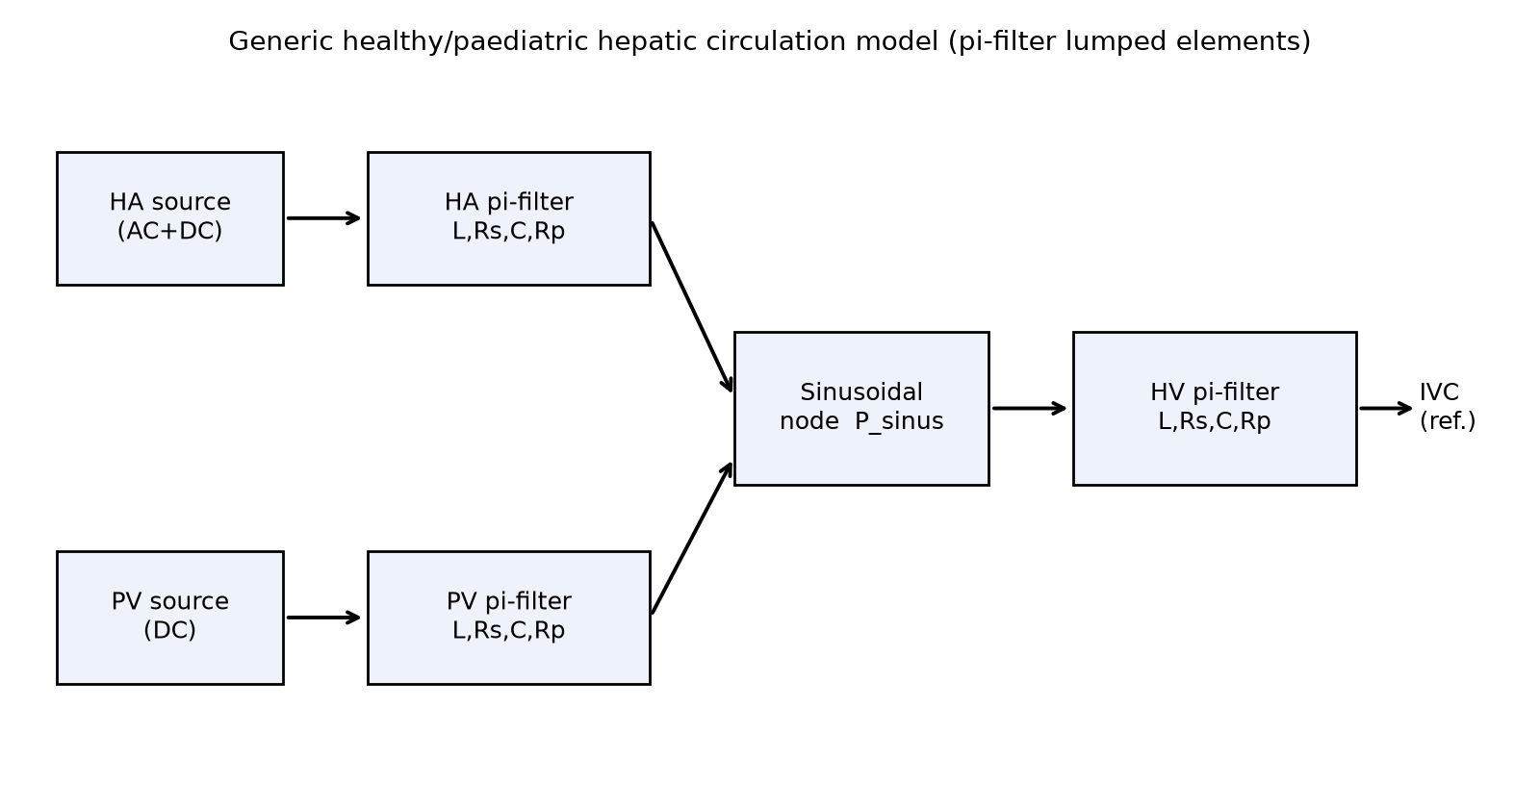
Figure 1: Model schematic.

3. Real target data
Target values are real, not invented, taken directly from Ho, Yu, Bartlett, "Computational simulations for the hepatic arterial buffer response after liver graft transplantation" (submitted manuscript, 2018/liver_paediatric/submission/numerical methods for quantifying blood flow after PH_v4.docx -- has a rebuttal on file, so it went through peer review; publication status otherwise unconfirmed), Results Section 3.1, post-transplant paediatric-recipient values. This is the same adult-to-child left-lateral-segment transplant scenario as this project, modelled with the same pi-filter approach.
Quantity | Value | Source
Portal driving pressure | 13 mmHg | post-transplant recipient
Mean arterial pressure | 57.5 mmHg (42.4-72.6 range) | post-transplant recipient
Sinusoidal pressure | 5.37 mmHg | post-transplant recipient
Hepatic venous pressure | 4.07 mmHg | post-transplant recipient
Portal vein flow | 300 mL/min | regression, 64 children 3mo-16y
Hepatic arterial flow | 31.93 +/- 7.7 mL/min | post-transplant recipient
Hepatic venous flow | 322.5 mL/min | post-transplant recipient
Note: the source paper's own Q_PV + Q_HA (300 + 31.93 = 331.9 mL/min) does not exactly equal its own reported Q_HV (322.5 mL/min) -- a ~3% mass-balance discrepancy already present in the source data, not introduced by this model. The IVC reference pressure (2.0 mmHg) is assumed, since it is not reported in the source.

4. Calibration method
Because this baseline model is linear (no HABR nonlinear resistor is included at this stage), the three series resistances (Rs_PV, Rs_HA, Rs_HV) were solved EXACTLY via Ohm's law on the time-averaged (DC) circuit, using the real target pressures and flows above. A linear system's time-average response to a periodic input equals its DC solution regardless of the inertance/compliance ("shape") parameters, so this reproduces the real target MEAN flows by construction, independent of how pulsatility is tuned. The inertance/compliance values themselves (L_HA, L_PV, L_HV, C_sinus, C_hv, Rp_sinus) were chosen, not derived, to give a physiologically reasonable pulsatile shape -- flagged as assumed/representative, the same caveat given to every other non-fitted constant in this session's other modelling projects.

5. Results
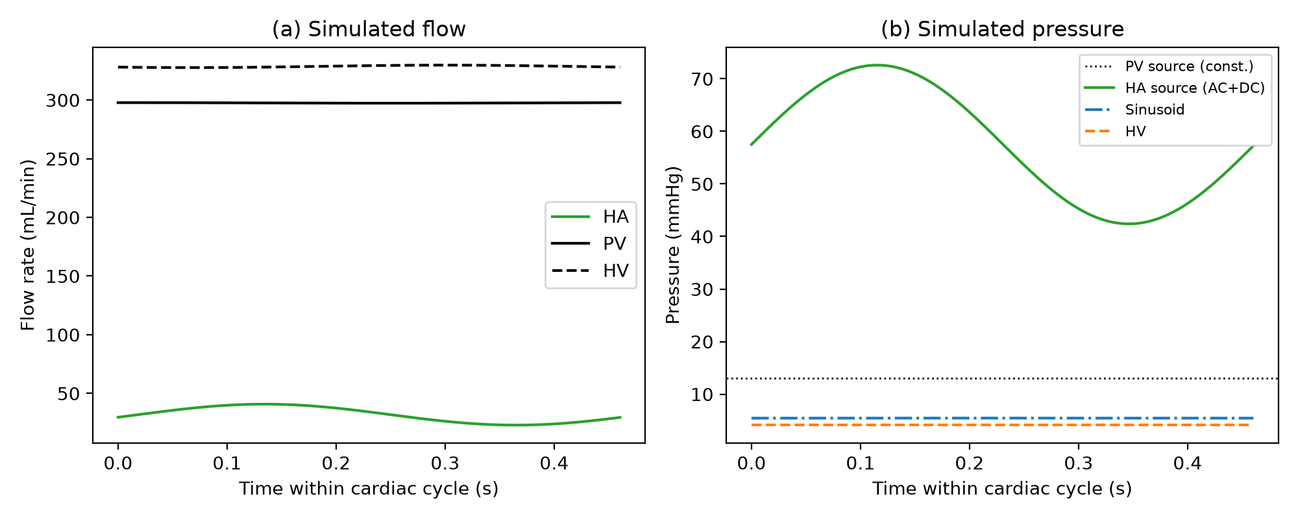
Figure 2: Simulated flow (a) and pressure (b) over one cardiac cycle. HA is visibly pulsatile; PV and HV are both nearly flat -- matching the qualitative pattern in the source paper's own Fig. 2.
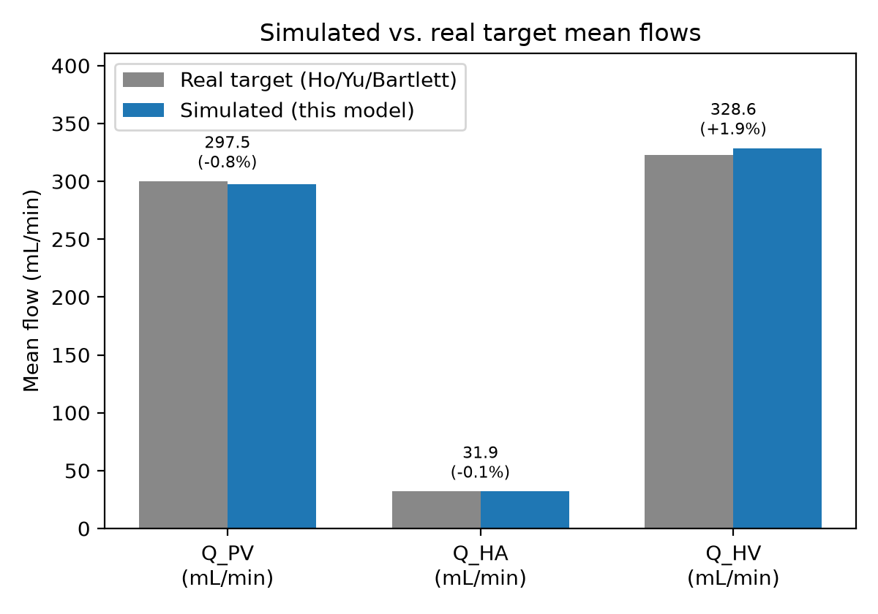
Figure 3: Simulated vs. real target mean flows. All three match within 2%.
Quantity | Target | Simulated | Difference
Q_PV (mL/min) | 300.00 | 297.49 | -0.8%
Q_HA (mL/min) | 31.93 | 31.89 | -0.1%
Q_HV (mL/min) | 322.50 | 328.64 | +1.9%
P_sinus (mmHg) | 5.37 | 5.434 | +1.2%
P_hv (mmHg) | 4.07 | 4.109 | +1.0%
The residual 1-2% gaps are attributable to finite-difference (Euler) integration truncation error and the small continuous leak current through the sinusoidal node's Rp_sinus resistor, not a calibration failure.

6. Status and next step
This generic healthy/paediatric baseline circulation model is now validated and is the correct foundation on which the transplant- and HABR-specific work for this project's real serial-Doppler LDLT cohort is being rebuilt (ldlt_habr_on_pi_filter.py), replacing an earlier, structurally simpler ad hoc branch model. See model_plan_and_literature_data.md Sections 8-10 for that work and its current, honestly-reported open questions.

