Post-LDLT Hepatic Arterial Trajectory: A Model With and Without HABR
This note develops and compares two versions of the post-LDLT hepatic circulation model built on the validated pi-filter baseline (see Healthy_Paediatric_Hepatic_Circulation_Baseline_Model.docx): one with the literature hepatic arterial buffer response (HABR) feedback active, and one without it (a null model). Both are compared against this project's real serial-Doppler cohort, Chen et al. 2022 (Front. Bioeng. Biotechnol., doi:10.3389/fbioe.2022.903385), n=41 paediatric LDLT recipients, biliary atresia, ages 4-18 months.

1. Model
Base circuit: the validated generic pi-filter model (Rs_PV, Rs_HV, Rp_hv_out, and all L/C shape parameters reused, not re-fit). Two adaptations for the post-LDLT setting:
- Portal inflow Q_PV(t) is a prescribed input (justified by the generic model's own result that PV flow is under 0.2% pulsatile -- already quasi-static), computed directly from this cohort's REAL portal vein diameter and velocity via Chen et al.'s own formula, PVF = pi*r^2*0.57*PVV*60 (mL/min/100g). Diameter is only reported at pre-transplant (0.44 cm) and POD1 (0.46 cm); POD7/14/30 use the POD1 value, justified by checking that across the (larger) pre-op->POD1 transition, velocity change (+82.5%) dominates area change (+9.3%), reproducing the reported flow change (+97.9%) almost exactly.
- The HA branch's resistance (Rs_HA) and inertance (L_HA) are calibrated ONCE, at POD1, against this cohort's own real measured PSV_HA (53.10 cm/s) and RI_HA (0.61) -- the HA pulse amplitude is held fixed at a real literature value (15.1 mmHg) throughout. This is the only fitting step in the HABR-on model.
For POD7/14/30, the two model versions diverge:
- HABR ON: Rs_HA at each time point is set so the model's mean HA flow matches exactly what the parameter-free Yu/Bartlett/Hunter/Ho HABR quadratic (changeIha = 0.0007102*x^2 + 0.5492*x, x = percent decrease in portal flow from POD1) predicts, given only the real measured portal-flow change at that time point. PSV_HA and RI_HA are the model's output, not fit.
- HABR OFF (null): Rs_HA is frozen at its POD1-fitted value; only the Q_PV(t) input to the shared sinusoidal node changes. This isolates what the circuit's own passive coupling (with no active arterial feedback at all) would predict on its own.

2. Results
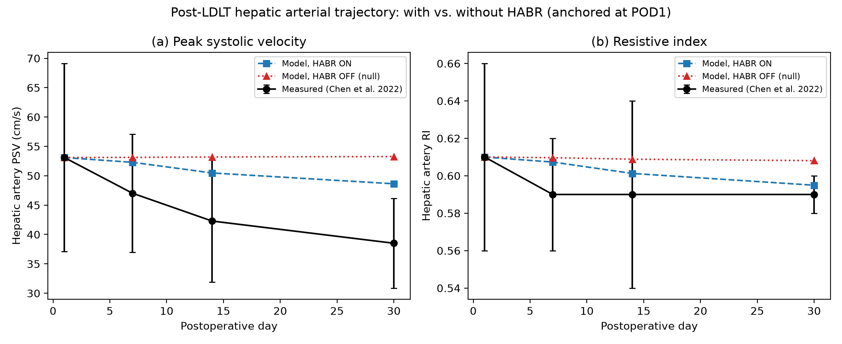
Figure 1: Measured (Chen et al. 2022, mean +/- SD) vs. model with HABR on vs. model with HABR off, for hepatic artery PSV (a) and RI (b).
The null model (HABR off) predicts HA flow/PSV would actually drift slightly UPWARD as portal velocity falls across POD1-30 (less downstream loading on the shared sinusoidal node) -- the opposite of what is observed. Adding HABR feedback correctly flips this to the observed downward direction for both PSV_HA and RI_HA, but accounts for only part of the measured magnitude.
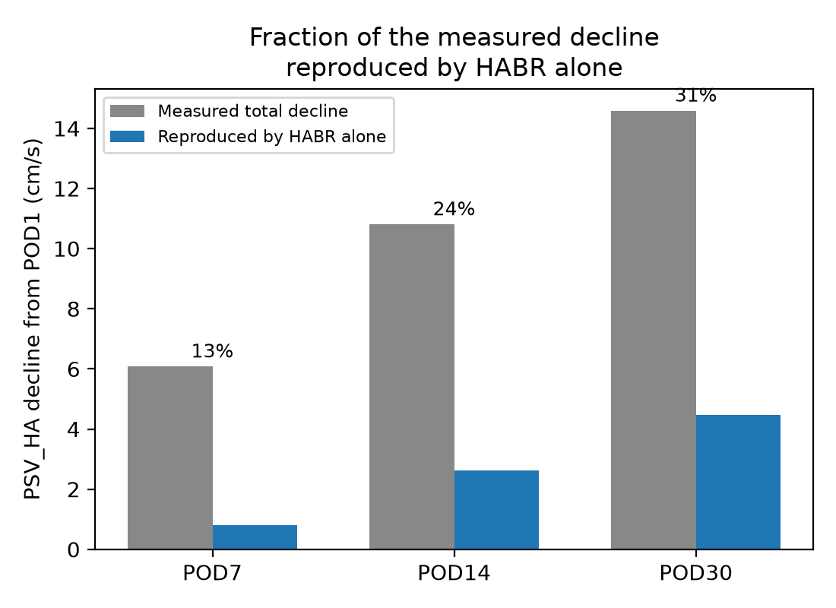
Figure 2: Fraction of the measured PSV_HA decline (from its POD1 value) reproduced by the parameter-free HABR model alone.
Day | PSV meas. | PSV HABR-on | PSV HABR-off | % of decline by HABR
POD7 | 47.02 | 52.29 | 53.13 | 13.4%
POD14 | 42.29 | 50.48 | 53.20 | 24.3%
POD30 | 38.51 | 48.63 | 53.27 | 30.6%

3. Correction: HABR is acute, not continuously re-applied
HABR is an acute (adenosine-washout, minutes-to-hours) mechanism. By POD30 it should have long ceased actively adjusting, and hepatic circulation should already be stable -- the model above instead re-applies the HABR quadratic at every time point relative to POD1, implicitly treating it as continuously active for the whole month, which is not appropriate for an acute mechanism.
The real data directly supports this correction: RI_HA is already flat (0.59, 0.59, 0.59) from POD7 through POD30, while PSV_HA keeps declining. Since RI is the ratio most sensitive to a resistance change, its flatness after POD7 means whatever resistance adjustment HABR was going to make had already happened by POD7. The model above's own simulated RI kept drifting (0.610 -> 0.607 -> 0.601 -> 0.595) instead of plateauing -- itself evidence it was over-crediting HABR for what is, beyond POD7, a resistance-flat decline.
Corrected model: the HABR quadratic is applied ONCE, across POD1->POD7 (the one window with both a real portal-flow change and a real RI change -- the legitimate acute-response window). Rs_HA is then frozen at its POD7-consistent value for POD14/POD30; Q_PV(t) still updates to each time point's real measured value, so the circuit's own passive coupling through the shared sinusoidal node remains active -- isolating "HABR already finished, only passive downstream coupling remains" from "HABR still actively adjusting."
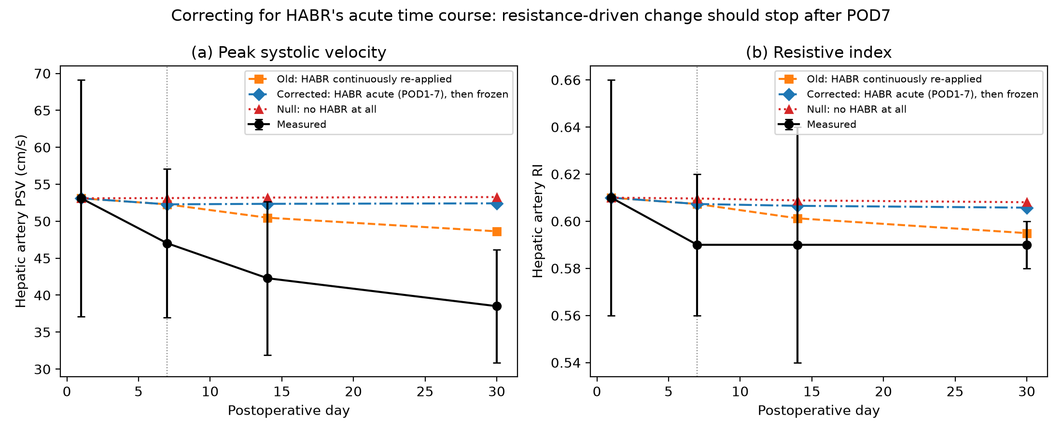
Figure 3: Measured vs. the old continuously-reapplied-HABR model vs. the corrected acute-then-frozen model vs. the pure null model. The corrected model's RI (panel b) plateaus after POD7, unlike the old model, matching the real data's qualitative shape far better.
Result: HABR still explains 13.4% of the POD7 decline (unchanged, since POD7 is its legitimate window), but only 6.9% and 4.7% of the (larger) POD14 and POD30 declines respectively -- essentially none of the decline BEYOND POD7 is attributable to HABR. That remainder (93-95% of the additional POD7->POD30 decline) is 100% non-HABR in this corrected framing, not partially HABR-credited as in the model above.

4. Honest interpretation
A parameter-free, literature-anchored HABR relationship, applied only over its legitimate acute window (POD1-7), is directionally necessary (the null model gets the direction wrong) but explains only a modest share of the total decline (13% at POD7) and essentially none of the further decline from POD7 to POD30. That later, larger portion of the decline (8.51 of the cohort's 14.59 cm/s total POD1->POD30 drop) must be a non-HABR, non-resistance (pure amplitude/scale) effect, since it occurs while RI stays flat. A literature search (model_plan_and_literature_data.md Section 10) identified two real, independently plausible candidate mechanisms of exactly this kind -- postoperative hyperdynamic-circulation/pressure normalization (Plevak et al. 1993) and graft-regeneration-driven dilution of velocity at a fixed measurement point as the graft's vasculature enlarges with its rapid mass growth (Byun et al. 2016, doi:10.1097/MD.0000000000005404) -- either of which is independently large enough in magnitude to plausibly explain most of this residual. This project's data (group-level PSV/RI/PVV only, no serial vessel-diameter measurements beyond POD1) cannot distinguish between them, or a blend of both, or an unidentified third mechanism -- reported here as a genuine, unresolved question rather than resolved by picking one.

