Supplementary Information
Testing the pharmacological consequences of liver zonation in MASLD using a spatial PK/PD framework
Harvey Ho | Rātā BioSim Lab, Auckland, New Zealand | harvey@ratalab.nz

S1. Purpose and scope
This Supplementary Information records the model structure, state definitions, parameter values, scenario design, and code organization used for the manuscript. The implementation contains two related but distinct components. The coupled transport prototype represents a ten-position CV-to-PV reduced mesh with zonated transporter fields, metabolite handling, bile advection, obstruction, and an injury state. The gadoxetate scaffold is a separate three-compartment calibration model with plasma, hepatocyte, and bile amounts plus parallel renal clearance. The normalized transport prototype is not a clinical dosing model and the coefficient fields are hypothesis parameters pending functional calibration.

S2. Model architecture
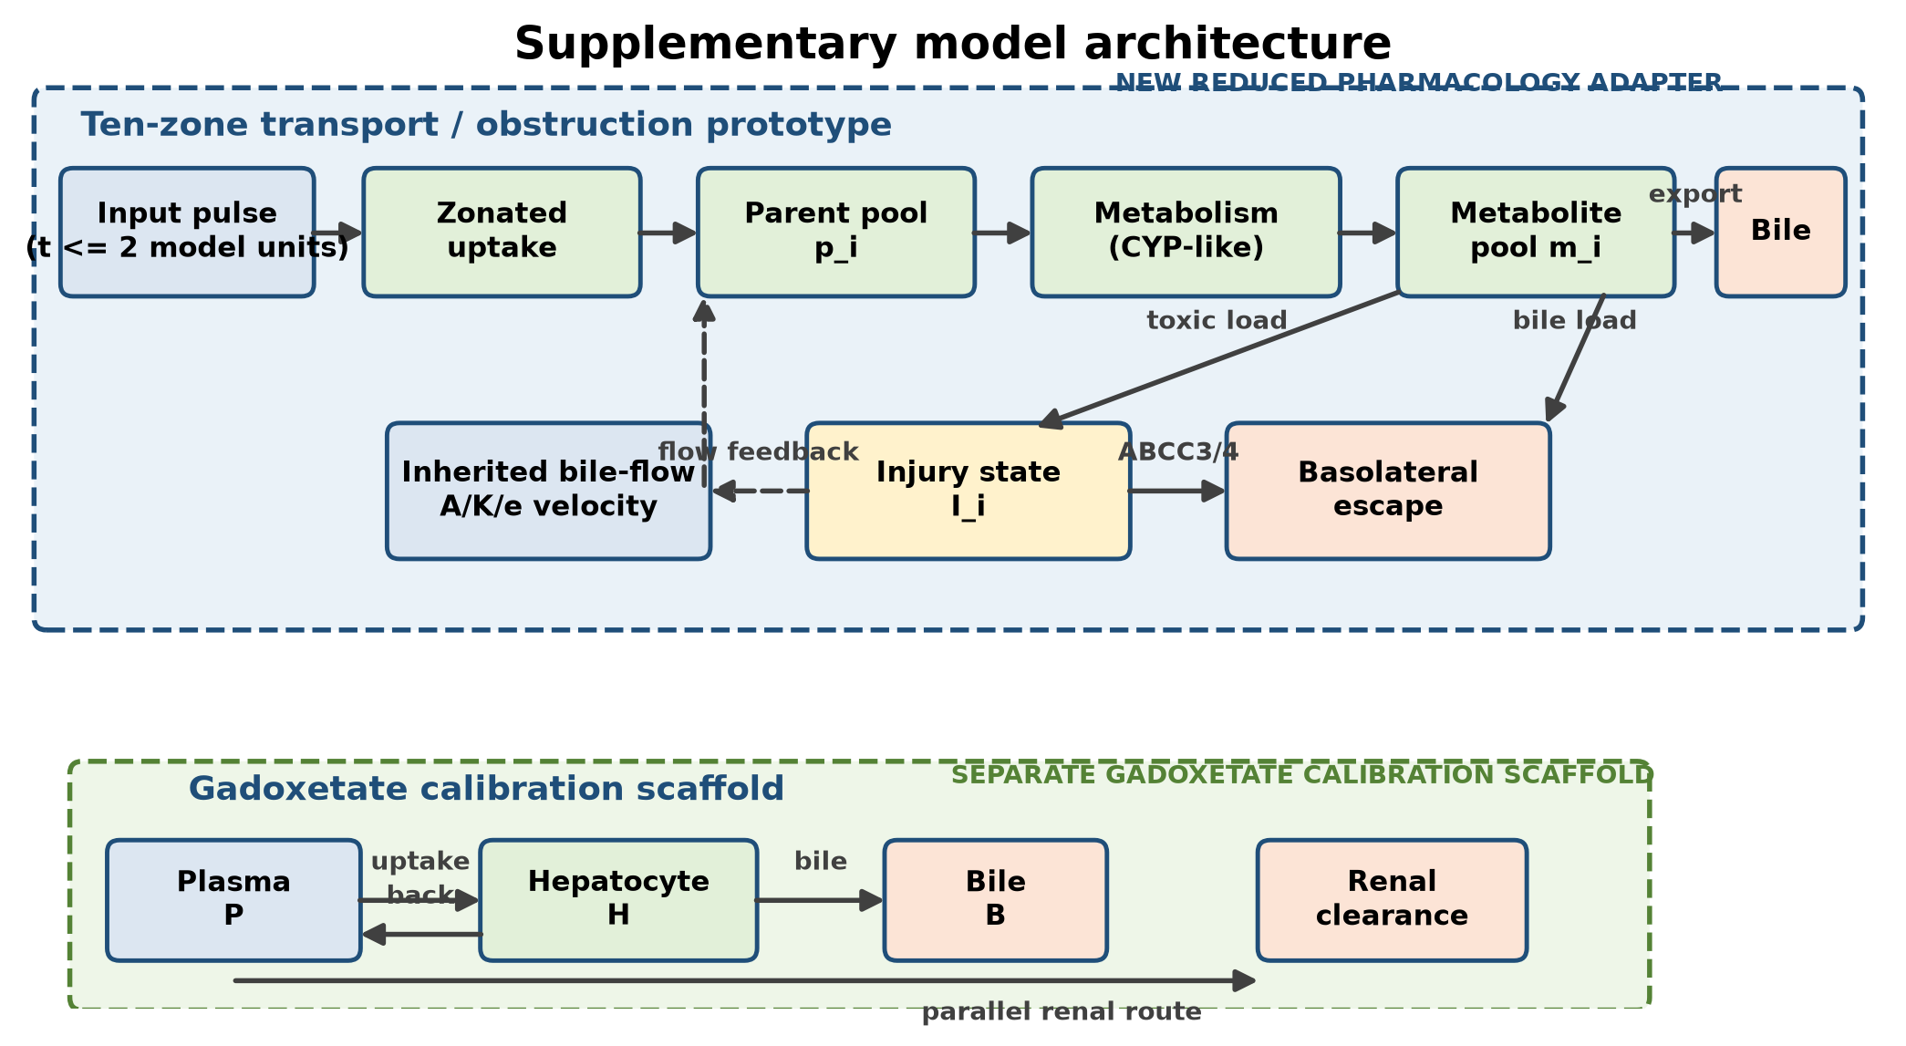
Figure S1. Computational architecture of the coupled transport prototype and the separate gadoxetate calibration scaffold. Disease state and transporter fields modify uptake, export, metabolism, injury susceptibility, and basolateral escape; obstruction scales local bile velocity. The upper layer is a new reduced pharmacology adapter using Michael Kuecken's input profile, not a reproduction of the original full bile-flow solver.

S3. Coupled transport prototype
The prototype uses ten reduced positions ordered from central to portal: central, central, mid, mid, mid, periportal, periportal, portal, portal, portal. Michael Kuecken's normal-control and steatosis input profiles provide the local quantities A, K, epithelial volume fraction e, and connectivity. A normalized carrier velocity is calculated as v_i = (A_i/K_i)e_i^-1 c_i / median[(A/K)e^-1 c]. Obstruction scales this velocity by (1 - obstruction).
The implemented state vector is y = [p_1...p_10, m_1...m_10, b_1...b_10, I_1...I_10], where p is the local parent pool, m is the metabolite/active hepatocyte pool, b is bile-side metabolite amount, and I is a normalized injury state. In this prototype, p_i is not a full plasma compartment; it is a zone-local parent pool driven by the input pulse.

S3.1 Governing equations
u_i = 0.10 * U_i * q_u * exp(-1.7 i/n) * 1(t <= 2)
r_i = 0.40 * CYP_i * p_i/(0.35 + p_i)
x_i = f_m * C_i * X_i * 0.30 * m_i/(0.25 + m_i)
dp_i/dt = u_i - r_i - 0.025 p_i
dm_i/dt = r_i - x_i - 0.020 m_i
db_i/dt = x_i/e_i + v_(i-1)b_(i-1) - v_i b_i
dI_i/dt = 0.020 J_i L_i - 0.004 I_i + 0.003 E_i I_i
Here U_i is the aggregated uptake capacity, C_i is the aggregated canalicular capacity, E_i is the aggregated basolateral escape capacity, J_i is the disease injury factor, f_m is the MRP2 activity factor, q_u is the uptake inhibition factor, and X_i is the disease export factor. The toxic load is L_i = max(0, m_i - 0.05 GSH_i) + 0.003 b_i. Local flow is max(0.08, v_i(1 - 0.80 I_i)). The first bile position receives an outflow term -v_1 b_1; upstream-to-downstream indexing follows the implementation's reduced CV-to-PV ordering.

S3.2 Fixed numerical settings
Item | Value | Interpretation
Time interval | 0-60 model units | Transport prototype simulation window
Time grid | 1201 points; delta t = 0.05 | Output grid supplied to solve_ivp
Input pulse | 1.0 for t <= 2.0; 0 otherwise | Dimensionless normalized input
Integrator | scipy.integrate.solve_ivp | Adaptive ODE integration
Relative tolerance | 1 x 10^-7 | Solver setting
Absolute tolerance | 1 x 10^-9 | Solver setting
Uptake inhibition | q_u = 0.5 | 50% activity condition
MRP2 activity | f_m = 1.0 or 0.35 | Baseline or 65% inhibition
Obstruction | 0.0, 0.5; LHS 0-0.75 | Fractional velocity reduction

S4. Spatial transporter and disease fields
The four-zone fields are dimensionless relative capacities. They are explicit hypothesis parameters, not direct compound-specific functional measurements. The ten-position mesh expands these values using the zone labels listed above. Uptake is the mean of SLC10A1, SLCO1B1, and SLCO1B3; canalicular export is the mean of ABCB11, ABCC2, and ABCB4; basolateral escape is the mean of ABCC3 and ABCC4; ductular capacity is the mean of CFTR and SLC4A2.
State | Field | Portal | Periportal | Mid | Central
Control | Uptake | 1.00 | 1.00 | 0.98 | 0.95
Control | Canalicular | 1.00 | 1.00 | 1.00 | 1.00
Control | Escape | 1.00 | 1.00 | 1.00 | 1.00
MASL | Uptake | 0.98 | 0.96 | 0.92 | 0.88
MASL | Canalicular | 1.00 | 0.97 | 0.92 | 0.88
MASL | Escape | 1.05 | 1.08 | 1.12 | 1.16
MASH | Uptake | 0.95 | 0.90 | 0.82 | 0.74
MASH | Canalicular | 1.00 | 0.90 | 0.78 | 0.68
MASH | Escape | 1.10 | 1.20 | 1.35 | 1.50

The individual gene-level fields, including ABCB11, ABCC2, ABCB4, CFTR, and SLC4A2, are preserved in zonated_transport_genes.py. The control, MASL, and MASH metabolism factors are respectively [1.00, 1.05, 1.00, 0.95], [0.95, 0.92, 0.88, 0.82], and [0.90, 0.85, 0.78, 0.68] from portal to central. Injury factors are [1.00, 1.00, 1.00, 1.00], [1.00, 1.05, 1.10, 1.15], and [1.05, 1.15, 1.30, 1.45].

S5. Michael input profiles
The full ten-row input arrays are embedded in couple_michael_bileflow.py. A, K, epithelial volume fraction e, and connectivity c are retained as source inputs for the normalized carrier field. The source file is the authoritative machine-readable parameter record; the summary below identifies the implementation and its use.
Input | Normal control | Steatosis | Use
Rows | 10 CV-to-PV positions | 10 CV-to-PV positions | Reduced spatial carrier
A | Source array in code | Source array in code | Conductance numerator
K | Source array in code | Source array in code | Conductance denominator
e | 0.0310-0.0419 | 0.00287-0.0411 | Velocity normalization
Connectivity c | 0.7719-0.9824 | 0.0100-0.9436 | Velocity weighting
Velocity scaling | median-normalized | median-normalized | Additional obstruction multiplier

Normal-control profile exact values
Position | A | K | e | Connectivity
1 | 58330.8300069 | 206648970055 | 0.03938394 | 0.771937
2 | 58015.3885886 | 231569264913 | 0.03587129 | 0.871142
3 | 60348.1516843 | 197300375840 | 0.03761081 | 0.961986
4 | 55483.9769685 | 241224419088 | 0.03386869 | 0.893793
5 | 50809.7838147 | 275488406384 | 0.03104042 | 0.860450
6 | 56828.2829065 | 206761011091 | 0.03528613 | 0.951386
7 | 62337.1137011 | 201794172784 | 0.03826954 | 0.931587
8 | 62899.9591253 | 158125453407 | 0.04185398 | 0.962679
9 | 57073.7531497 | 183625132415 | 0.03722097 | 0.982438
10 | 61712.335316 | 158677801762 | 0.04129924 | 0.969123

Steatosis profile exact values
Position | A | K | e | Connectivity
1 | 5511.00227666 | 4.22261517689e+14 | 0.00287280 | 0.010000
2 | 15457.0006401 | 7.80805723959e+12 | 0.00912449 | 0.122726
3 | 27433.9394063 | 1.3812107301e+12 | 0.01747601 | 0.313083
4 | 32671.5328449 | 521494282430 | 0.02145090 | 0.659835
5 | 45737.3481815 | 224778325303 | 0.03310722 | 0.775967
6 | 52698.5417437 | 142309810289 | 0.04105153 | 0.850081
7 | 51010.540328 | 163176507440 | 0.03915229 | 0.767174
8 | 46481.072531 | 181169167061 | 0.03378744 | 0.897114
9 | 51182.6085312 | 150523599528 | 0.03812766 | 0.943592
10 | 53032.4518063 | 152542928221 | 0.03950027 | 0.888000

S6. Gadoxetate calibration scaffold
The gadoxetate model is a separate three-state ODE system with a 24-hour simulation window. Amounts are in mmol for a 70 kg adult. The recommended dose is represented as 0.025 mmol/kg x 70 kg = 1.75 mmol. The label-inspired volume and clearance quantities are converted to an hour-based rate scale.
dP/dt = -(CL_renal/V_P)*renal*P - uptake*P + back*H
dH/dt = uptake*P - (back + bile)*H
dB/dt = bile*H
Scenario | uptake | back | bile | renal factor | Purpose
Healthy | 1.10 | 0.12 | 0.112 | 1.00 | Approximate 50:50 renal/hepatobiliary recovery
MASL/MASH exploratory | 0.88 | 0.16 | 0.090 | 1.00 | Reduced uptake and biliary handling
Severe hepatic impairment | 0.35 | 0.24 | 0.025 | 1.30 | Approximate 5% hepatobiliary recovery

Fixed quantity | Value
Body mass | 70 kg
Dose | 1.75 mmol
Vd approximation | 0.21 L/kg x 70 kg = 14.7 L
Total clearance | 0.250 L/min x 60 = 15.0 L/h
Renal clearance | 0.120 L/min x 60 = 7.2 L/h
Hepatic remainder | 7.8 L/h
Time grid | 0-24 h; 2401 points

S7. Analysis design and endpoints
The counterfactual comparison holds the mean spatial capacity constant and compares zonated versus well-mixed fields. Primary quantities are bile AUC, hepatocyte parent AUC, bile Cmax, time to bile Cmax, peak injury, and terminal injury.
A reproducible transporter stress test compares each disease state with its own baseline. At 50% uptake activity, bile-AUC ratios are 0.501, 0.502, and 0.502 for control, MASL, and MASH, while local parent-pool AUC ratios are 0.480, 0.480, and 0.482. At MRP2 activity of 0.35, bile-AUC ratios are 0.964, 0.939, and 0.911, while local parent-pool AUC ratios remain 1.000. These are normalized model outputs; they are not plasma AUC ratios or clinical DDI predictions because the current prototype has no full plasma victim-drug compartment.
Analysis | Scenarios / ranges | Output
Counterfactual | Zonated vs well mixed; baseline, 50% uptake inhibition, 65% MRP2 inhibition | Relative bile and hepatocyte AUC differences
Scenario grid | MRP2 = 1.0 or 0.35; obstruction = 0 or 0.5 | Bile Cmax, AUC, tmax, peak and terminal injury
LHS sensitivity | 160 samples per normal-control/steatosis profile; MRP2 0.20-1.20; obstruction 0-0.75 | Exposure and injury distributions
Gadoxetate | Healthy, exploratory MASL/MASH, severe impairment | 24-hour route recovery and amount-time curves

S8. Code map and reproducibility
File | Role
couple_michael_bileflow.py | Defines input profiles, ten-position mapping, disease factors, ODE, obstruction, export, bile advection, and injury feedback.
zonated_transport_genes.py | Stores four-zone gene-level relative fields and aggregates uptake, canalicular, escape, and ductular capacities.
compare_zonated_wellmixed.py | Runs the mean-preserving spatial counterfactual and writes main-manuscript Figure 2 plus metric CSV.
run_jpkpd_analysis.py | Runs scenario grids and seeded Latin-hypercube sensitivity analysis; writes main-manuscript Figure 3 and CSV outputs.
simulate_gadoxetate_pk.py | Runs the separate plasma-hepatocyte-bile calibration scaffold and writes main-manuscript Figure 4 and CSV outputs.
render_ddi_efficacy_figure.py | Plots the transporter stress-test ratios and the illustrative efficacy-mapping extension used in main-manuscript Figure 5.
create_second_paper_draft.py | Builds the main manuscript DOCX and inserts the five main figures.
create_supplementary_information.py | Builds this supplementary document and its model architecture diagram.

From the project root, run compare_zonated_wellmixed.py, run_jpkpd_analysis.py, simulate_gadoxetate_pk.py, and render_ddi_efficacy_figure.py to regenerate numerical outputs and figures. Then run create_second_paper_draft.py and create_supplementary_information.py to regenerate the DOCX files. The sensitivity generator uses numpy.random.default_rng(20260927).
The model is intentionally transparent rather than clinically validated. The next calibration release should replace relative transporter fields with zone-resolved protein or functional measurements, retain uncertainty distributions, and test predictions against independent gadoxetate and transporter-probe data.

S9. Relationship to the main manuscript
Figure S1 and the parameter tables provide implementation detail for the Methods and Results sections. The main manuscript reports normalized outputs and interprets them as structural-sensitivity results. No supplementary parameter should be interpreted as a clinical concentration, patient-specific coefficient, or validated toxicity threshold.

