To make screens for SUNDIALS documentation:
- Pull up xwindow on tux
- Cd to /usr/casc/sundials (to use srcdir, instdir, builddir as in Documentation)
- Change (Desktop) to Window 7 background (for light blue window border)
- Change title to “SUNDIALS install using CMake” (Terminal/Set Title…)
- ALT-PrintScreen to capture.
- Paste into this file
- For terminal screenshots, change the prompt to ‘%’ with
> PS1=”% “

cmakeinitial (not used)
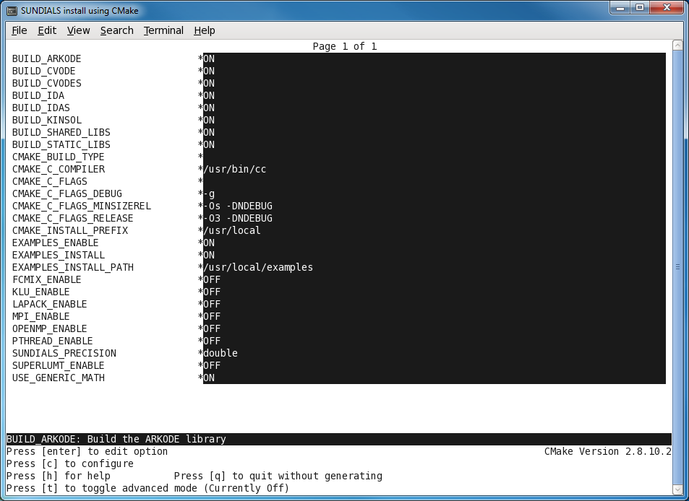

ccmakedefault
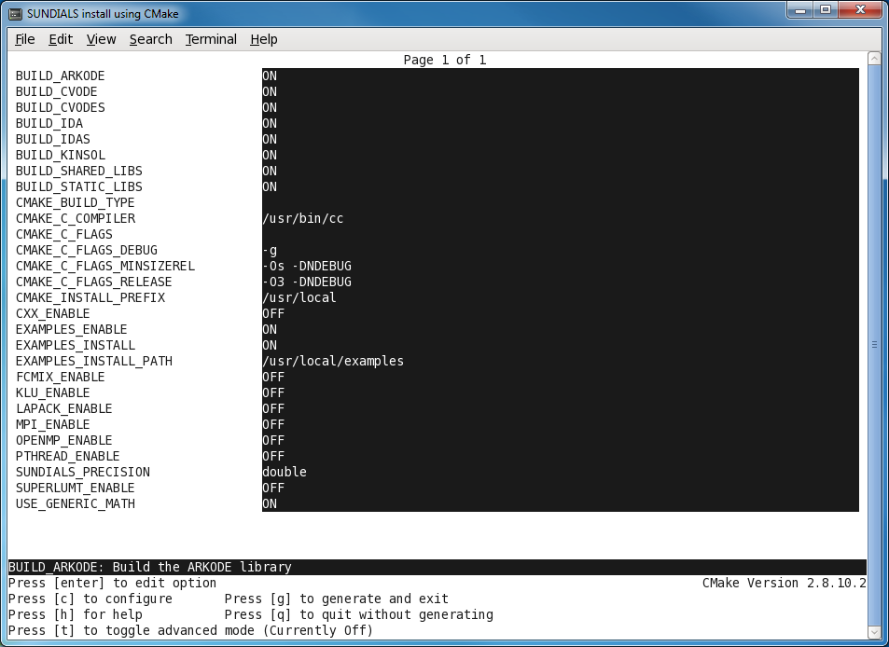

ccmakeprefix.png / eps
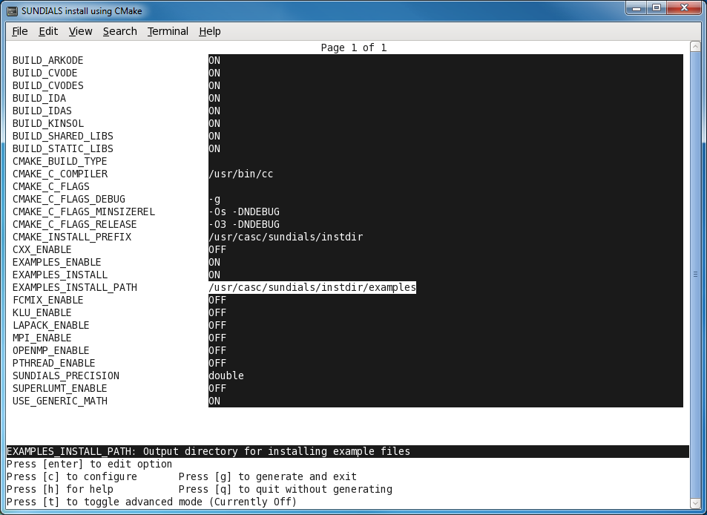
testrunnertop
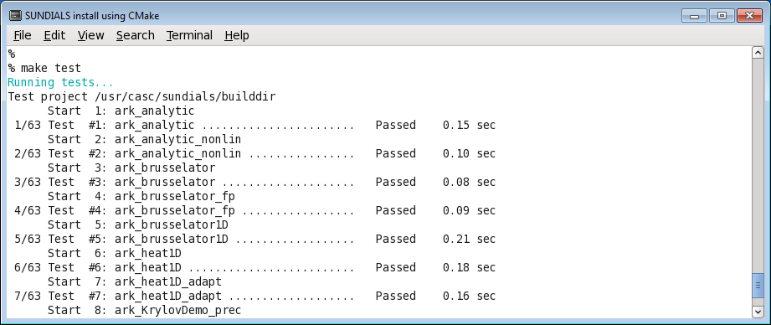

testrunnerbot
