**Gemini FPGA Programming Procedure**

Gemini_FPGAProg_ATP-828-62

**Purpose:** This procedure is used for programming the Hydra FPGA on the Gemini.

**Scope:** This procedure is used during troubleshooting, or as an alternative bring-up step if pre-programmed FPGAs are unavailable.

**Audience:** Test engineering and technicians.

**Training:** None.

**Revision History**

(Most Recent First)

|  |  |  |
| --- | --- | --- |
| **Date** | **Author** | **Description** |
| 15-Aug-2018 | Jeff Bouchard | * Initial release |

# Requirements

* Altera USB blaster, or Terasic USB blaster
* Computer w/Quartus installed (see appendix A) and USB blaster driver installed (see appendix B)
* 359-591-13 connector, or equivalent 10-pos RoHS header
* 090-489-00 cable, or equivalent IEC power cable
* Gemini Hydra FPGA programming file (.pof) obtained through team center

# Hardware Setup

1. Solder the 359-591-13 connector to J18 on the Gemini PCBA using lead-free solder. Note, you will need to remove the PCBA from the HLA to solder the header, then reassemble the HLA with the PCBA.

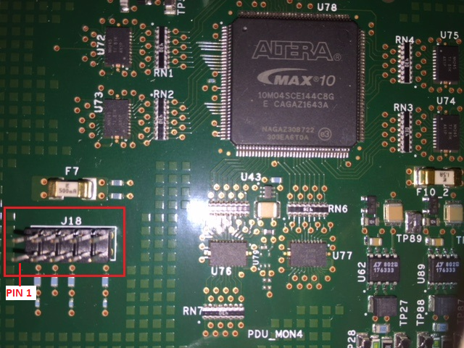

1. Connect the USB blaster to the computer, via USB, and to the Gemini, via J18. Note the orientation of pin 1 on the cable (red wire on Terasic USB blaster, white silk-screen on Altera USB blaster). Match this to pin 1 on J18.

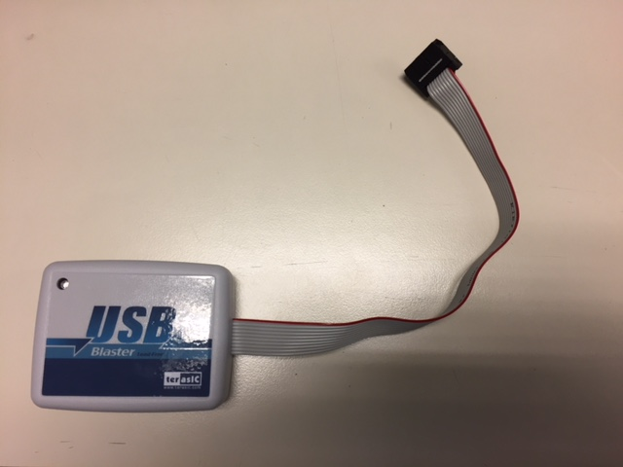

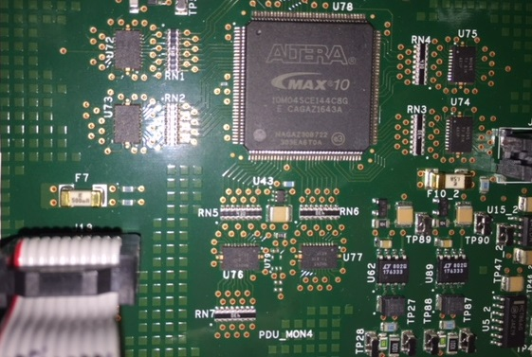

1. Connect the IEC power cable to the Gemini HLA power cable. Then connect the other end to a power source to turn on the Gemini HLA.

# Programming Procedure

1. Launch Quartus Prime Programmer (Start 🡪 type “Quartus Prime 16.1 Programmer” 🡪 select Quartus Prime 16.1 Programmer).
2. Select Hardware Setup

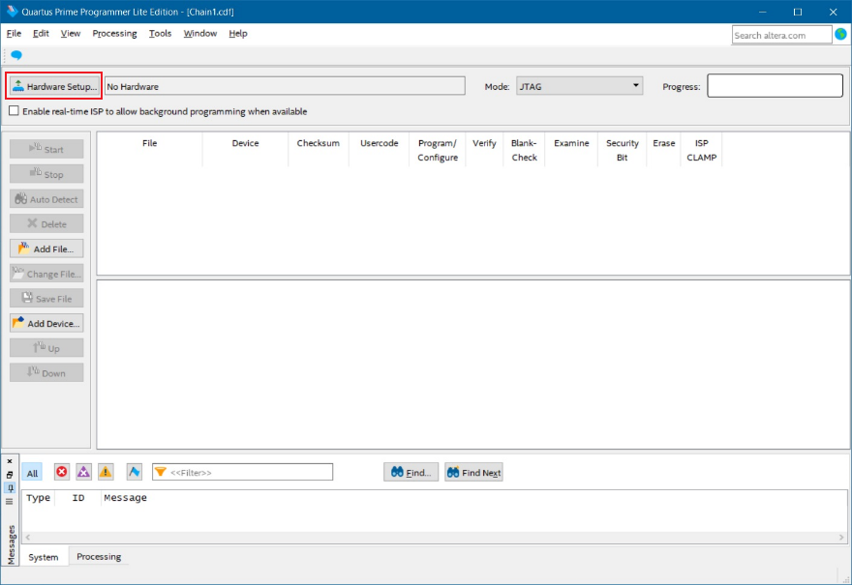

1. Select USB-Blaster [USB-0] from the currently selected hardware drop-down menu. Then select USB-Blaster in the available hardware items field. Then select close.

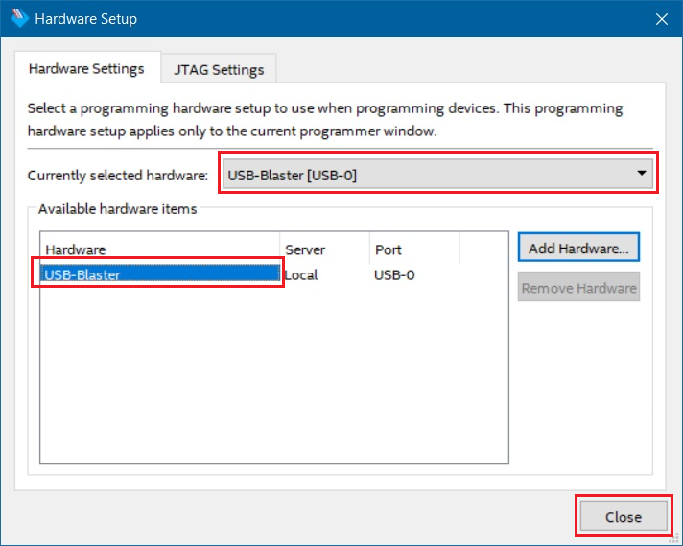

1. Select Add File.

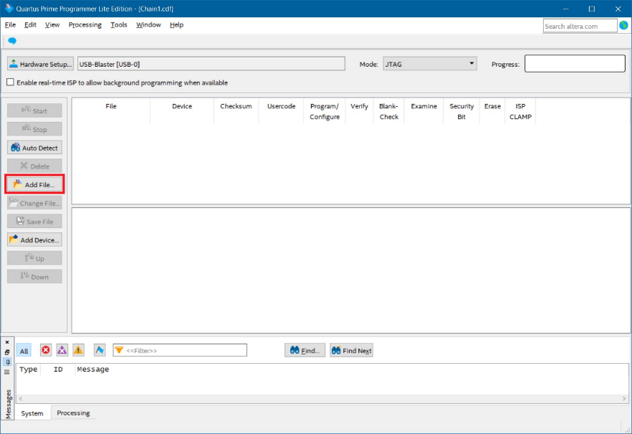

1. Select the .pof programming file, then Open.

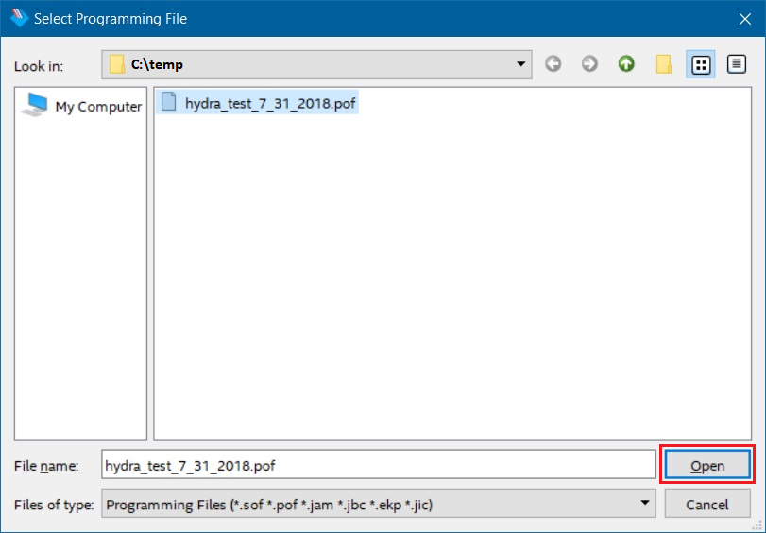

1. Select all three checkboxes under Program/Configure. Then select Start.

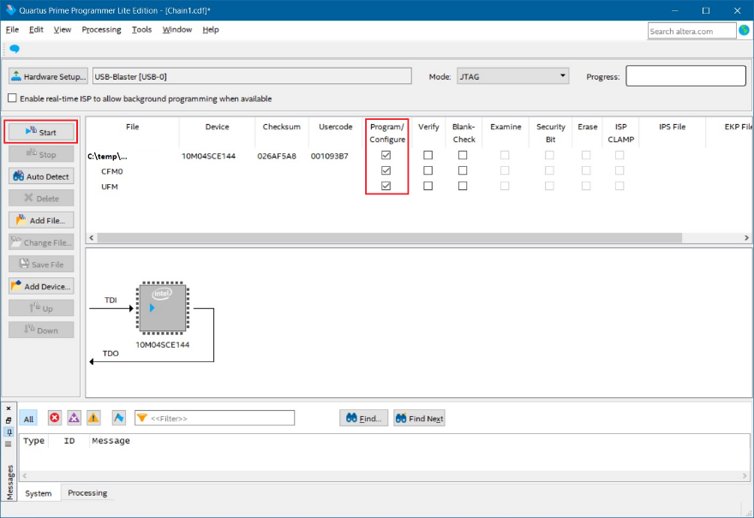

1. A message will display in the messages log stating “programming device” and the progress bar will show the percentage complete.

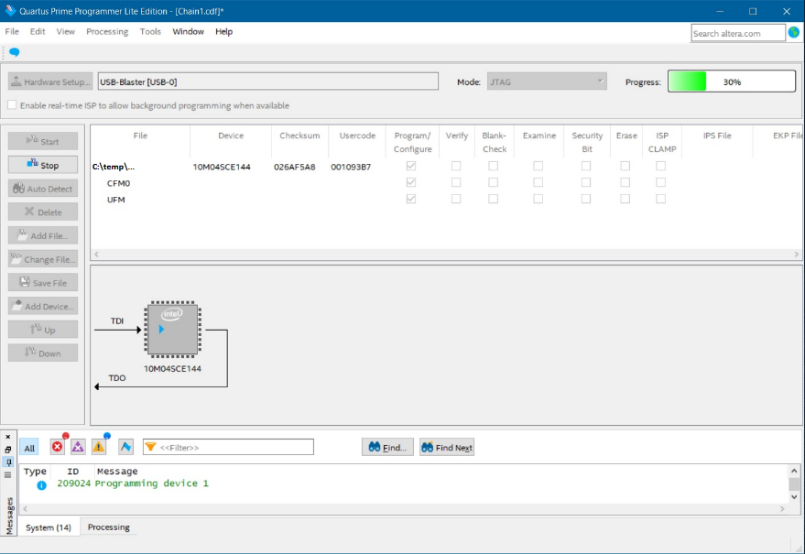

1. When completed, a message will display in the messages log stating “ended programmer operation” and the progress bar will state 100% (Successful).

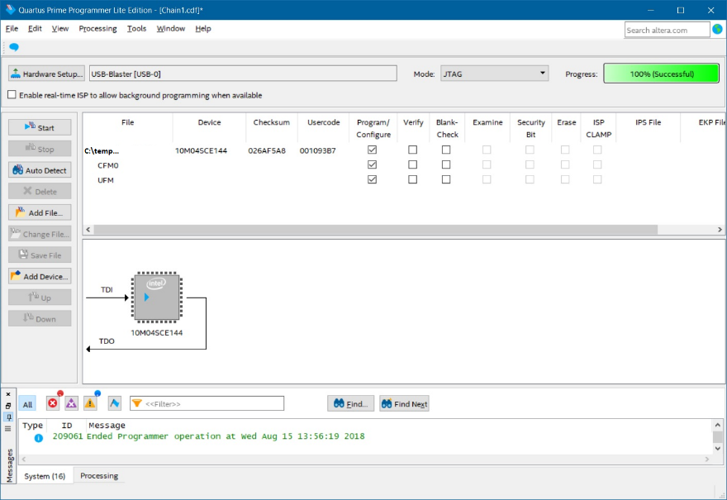

1. Close Quartus.

# Equipment Clean Up

1. Unplug the IEC power cable from the power source to turn off the Gemini HLA.
2. Disconnect the USB blaster from J18 on the Gemini and from the computer USB.
3. Remove the 359-591-13 header from J18. Note, the Gemini PCBA will need to be removed from the HLA in order to de-solder the connector, then the HLA will need to be reassembled with the PCBA.

# Appendix A: Quartus Installation

1. Run the Quartus installer as administrator from the location specified below. Follow the on-screen prompts for installation, selecting defaults and accepting any license agreements.

Teradyne: \\ter.teradyne.com\projects_ah\npiw\Dragon\development\Pilot Line Software\Release\Quartus

Flex: \\agate\NPI Projects\UltraFlex2\SW\Uflex2IGXLsync\Quartus

# Appendix B: USB Blaster Driver Installation

## Windows 10

1. Plug the USB-Blaster into your PC.
2. Open the Device and Printers (Control Panel | Devices and Printers).
3. Under Unspecified, USB Blaster should be listed. Right mouse click on this and then select Properties.
4. Select the Hardware tab and select Properties.
5. A new window should pop up with the General tab already selected. Select Change Settings.
6. Again a new window should pop up with the General tab already selected. Select Update.
7. Select browse my computer for driver software.
8. Find <Path to Quartus II installation>\quartus\drivers\

* (Note 1: Your altera file is located at the location you selected when you first installed Quartus. The location listed in this document is the default location)
* (Note 2: **Stop at the drivers folder**, i.e., do NOT go deeper by opening a folder within the drivers folder)

1. Select OK. Make sure the proper path was selected then select next.
2. If the Windows security window pops up Check the Always trust software from “Altera Corporation” box and select Install.

## Windows 7

1. Plug the USB-Blaster download cable into the PC. The following will appear on the screen: Device driver software was not successfully install. Select Click here for details.
2. Select Change settings…
3. Now cancel this by selecting Cancel
4. Open the Device Manager (Windows Key | Control Panel | Device Manage)
5. Under Other devices, USB Blaster should be listed. Right mouse click on this and then select Update Driver Software…
6. Select browse my computer for driver software
7. Find <Path to Quartus II installation>\quartus\drivers\, then select Next; (Note: **Stop at this folder**, i.e., do NOT go deeper by opening a folder within the drivers folder)
8. Check the Always trust … box and then select Install