1. **Model-View-Controller Diagram**

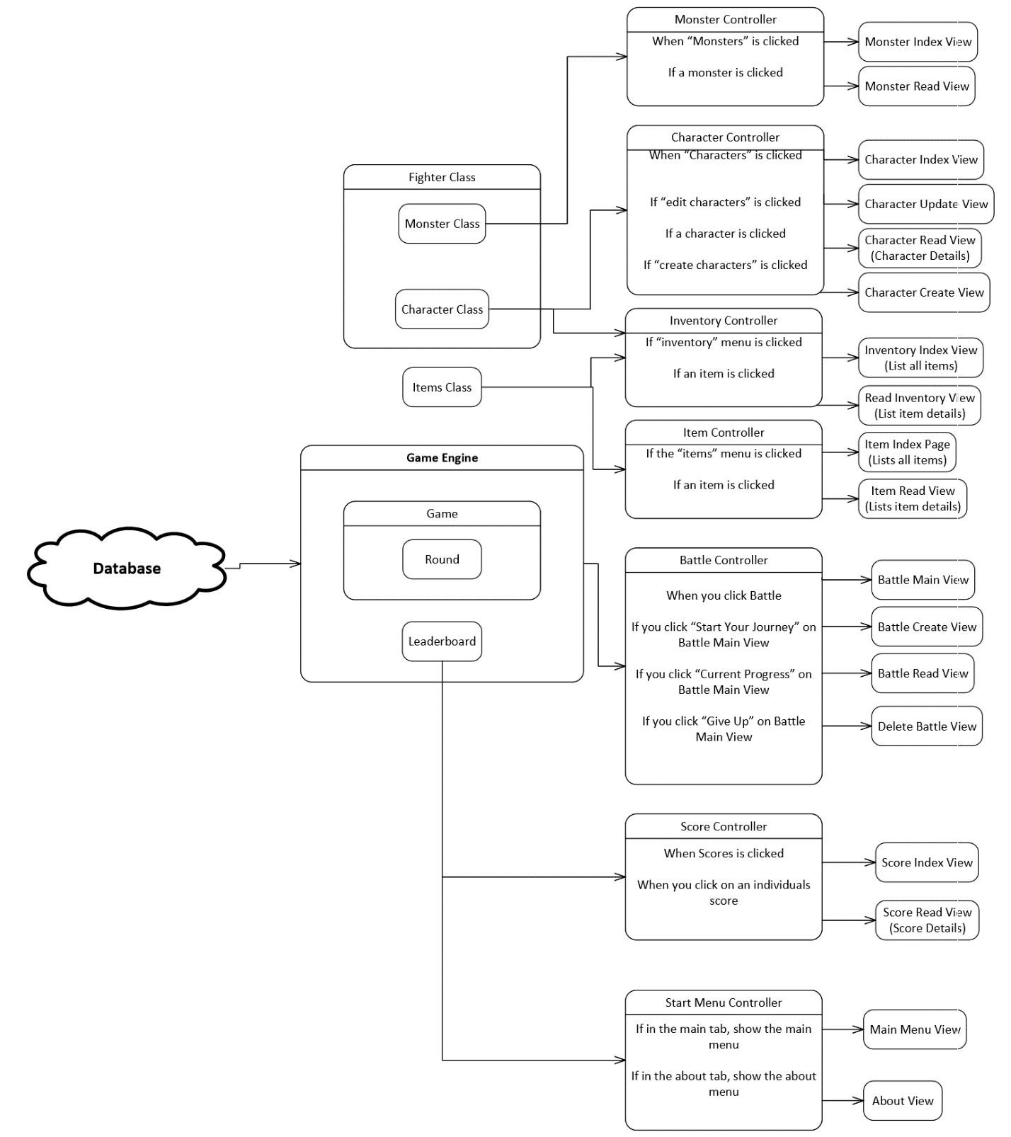

This is broken out with wireframes below.

1. 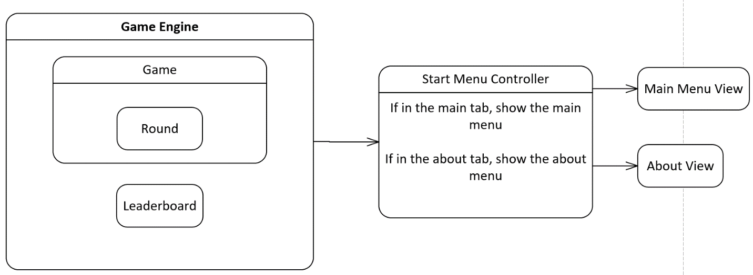**Screen Wireframes with MVC Integration**

**Main Menu View** – occurs in the default tab when the gam launches

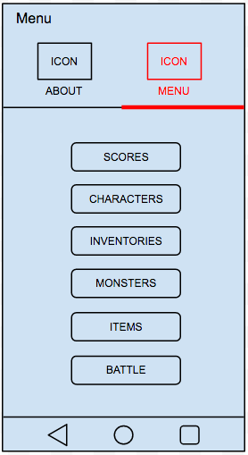

* Click on **Scores** to view high scores 🡪 jump to Scores Index View
* Click on **Characters** to view character list 🡪 jump to Character Index View
* Click on **Inventories** to view items your party has 🡪 jump to Inventory Index View
* Click on **Monsters** to view monster list 🡪 jump to Inventory Index View
* Click on **Items** to view all possible items 🡪 jump to Items Index View
* Click on **Battle** to view battle information 🡪 jump to Battle Main View

**About View**

* Occurs anytime you hit the items tab

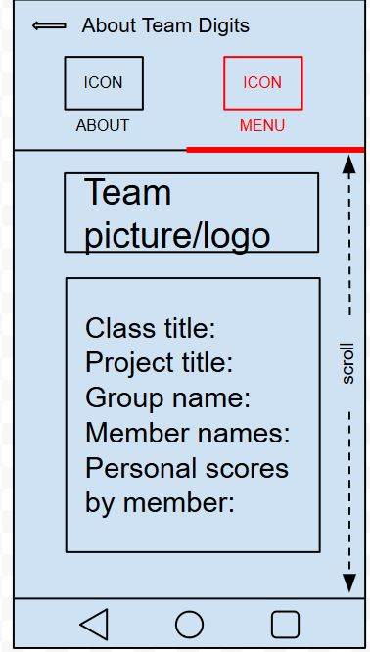

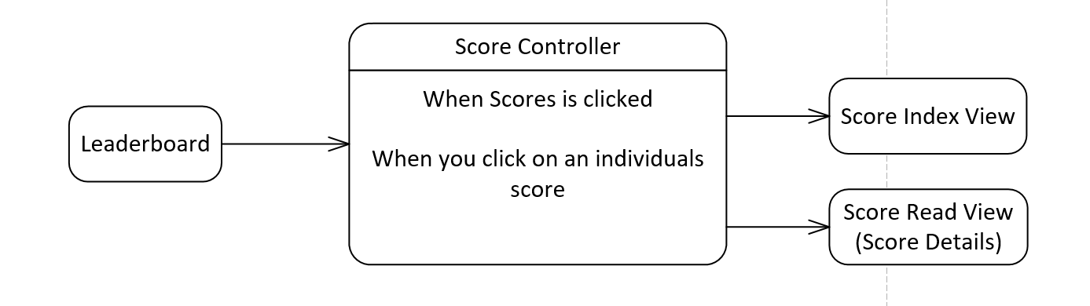

**Score Index View**

* *Empty List*

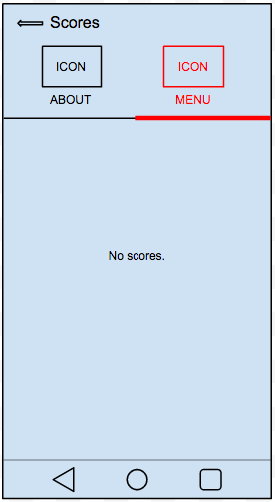

* 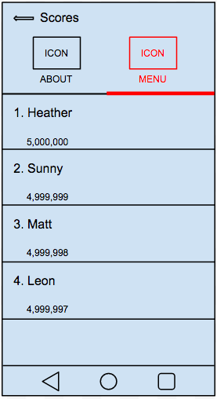*List with scores*
* Display a growing list with descending scores
* Click on a **Score Item** to view details 🡪 jump to Score Read View

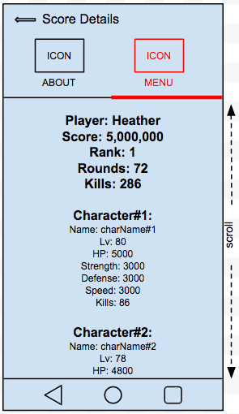**Score Read View**

* Shows details of a score

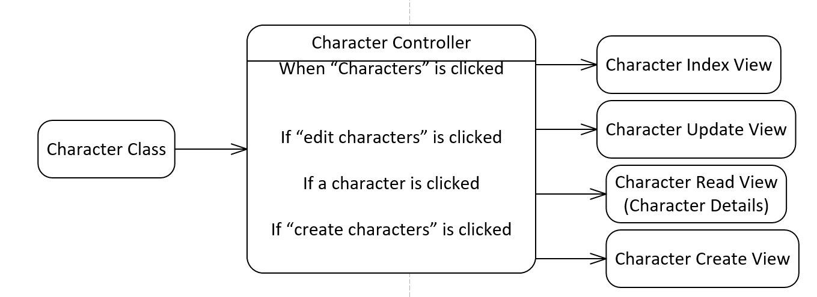

**Character Index View**

* *Empty List*

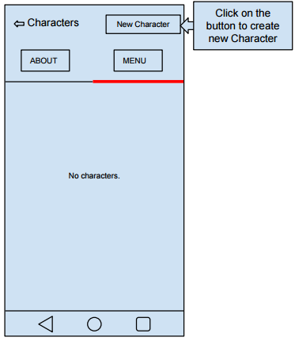

* Click on **New Character** to make new characters 🡪 jump to Character Create/Update/Delete View
* *List with Characters*

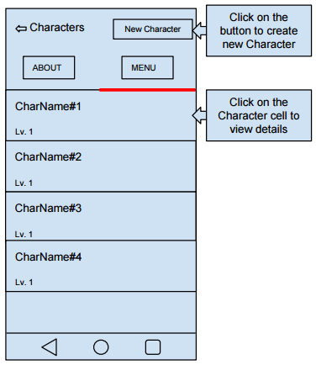

* Click on **Character cell** to view, update and delete characters’ info. 🡪 jump to Characters Create/Update/Delete View

**Character Create View**

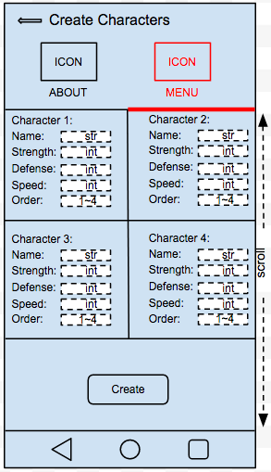

**Character Read View**

* Shows character details

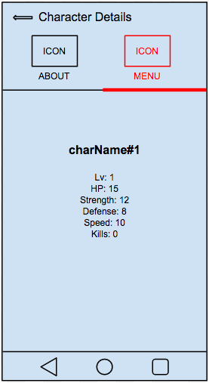

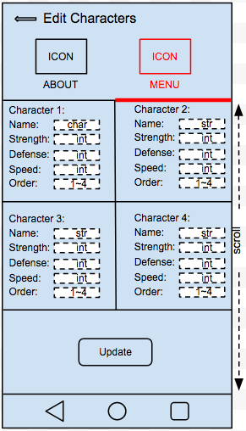**Character Update View**

**Notes:**

In order to play the game, the user must create four characters. The user is allowed to edit characters in Character Update View, but cannot delete characters.

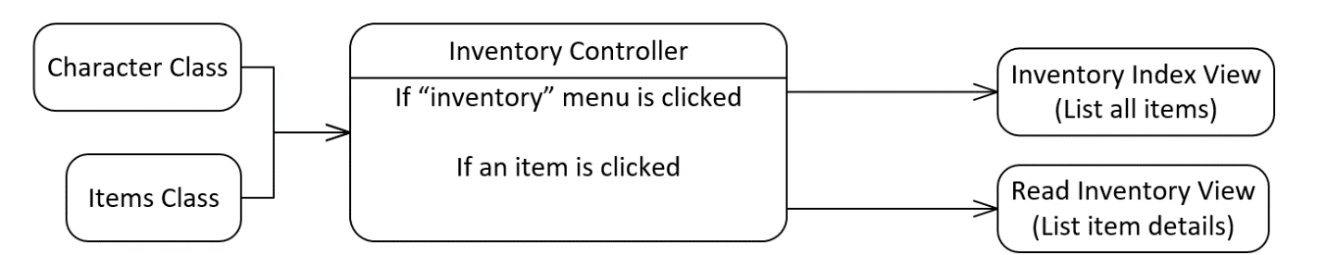

**Inventory Index View**

* Empty List

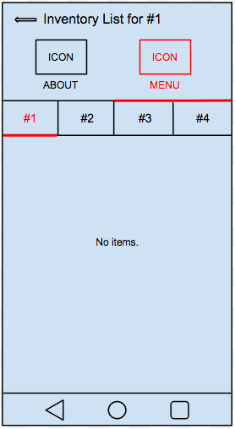

* List with items

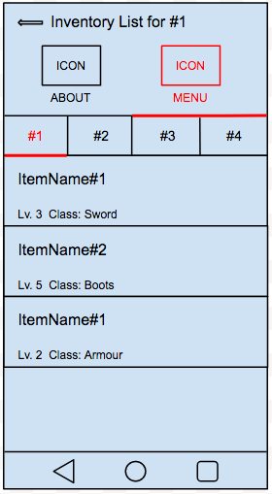

* Click on an **Inventory Item** to view details 🡪 jump to Read Inventory View

**Inventory Read View**

* Lists all item details

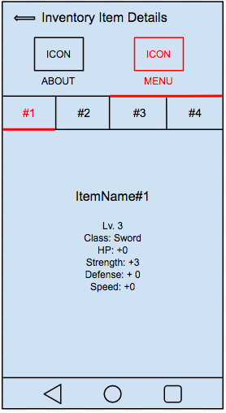

**Note:** Items are randomly generated upon victory against monsters during combat, so no create screen is necessary. Items stack infinitely, so no delete screen is necessary.

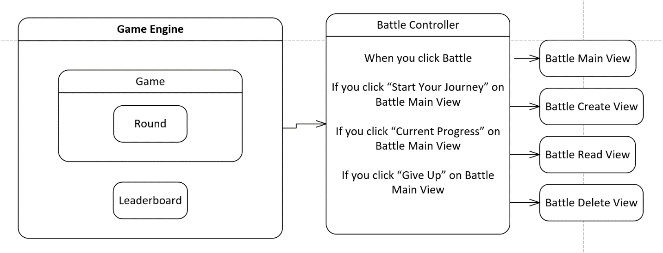

**Battle Main View**

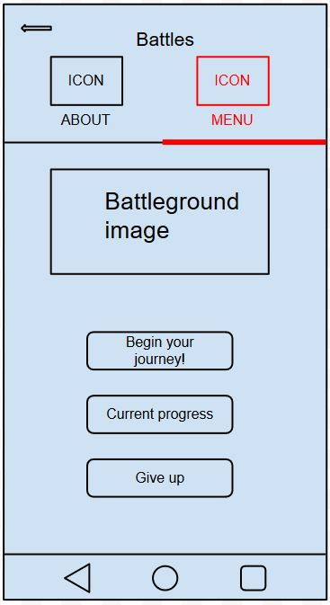

* Anytime you click battle, you end up here first.
* Click on **Start Your Journey** to start a battle 🡪 jump to Battle Create View
* Click on **Current Progress** to view the current battle 🡪 jump to Battle Read View
* Click on **Give Up** to stop the current game 🡪 jump to Battle Delete View

**Battle Create View**

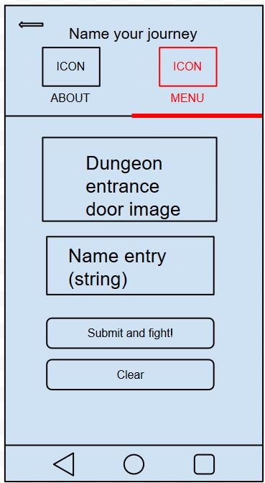

* Enter your name (for high score purposes) and begin the fight!

**Battle Read View**

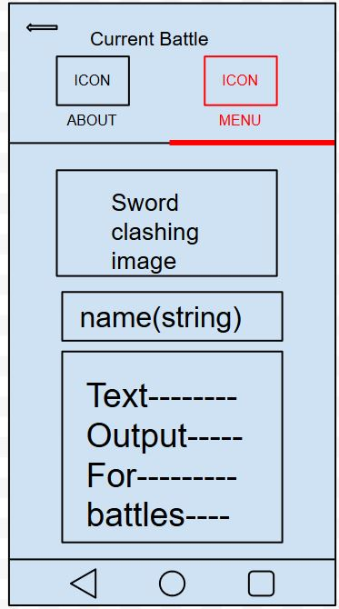

* See all of this game’s action

**Battle Delete View**

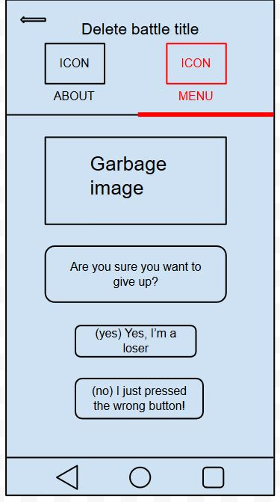

* Stop the current battle

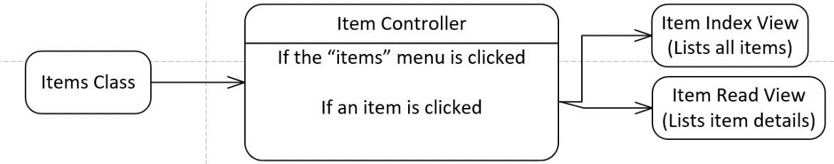

**Item Index View**

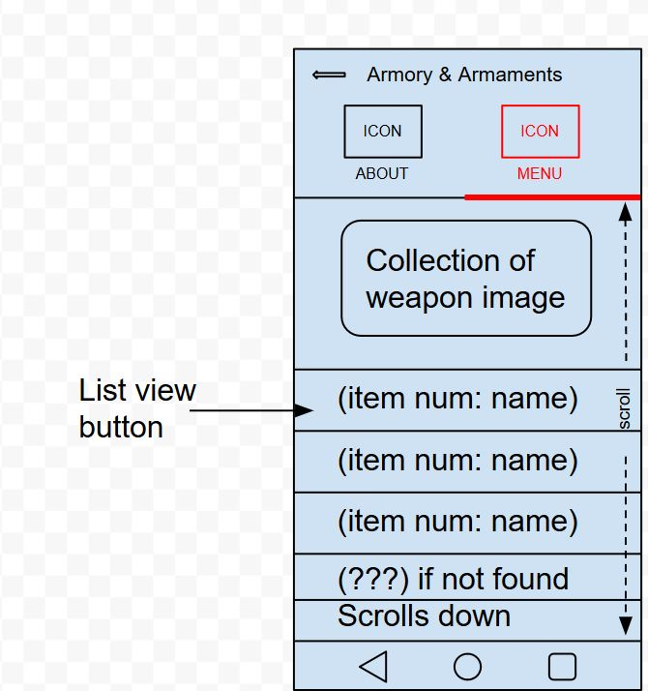

* Anytime you click Items, you come here.
* Click on an **Item** in the list to view its details -> jump to Item Read View

**Item Read View**

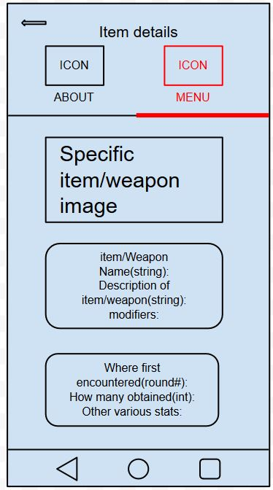

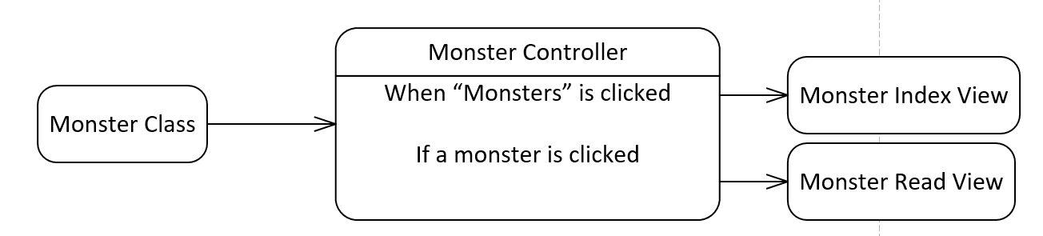**Monster Index View**



* Anytime you click Monster, you’ll come here.
* Click a **Monster** in the list to view its details 🡪 jump to Monster Read View.
* ????? are unencountered monsters. When you encounter a monster, their name will replace the ?????????. This idea definitely riff on a Pokédex in Pokémon.

**Monster Read View**

Unseen - Seen

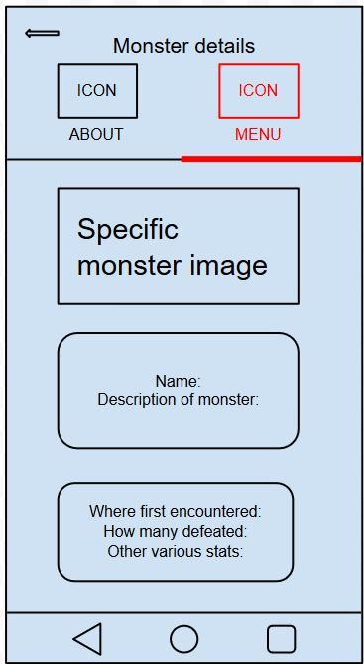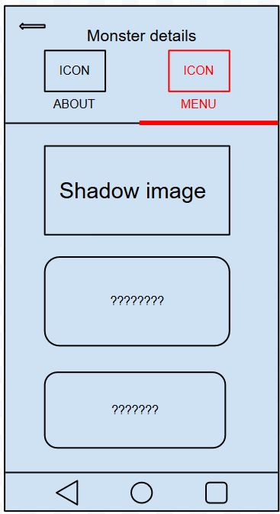

1. **Class Structure for All Components**

* 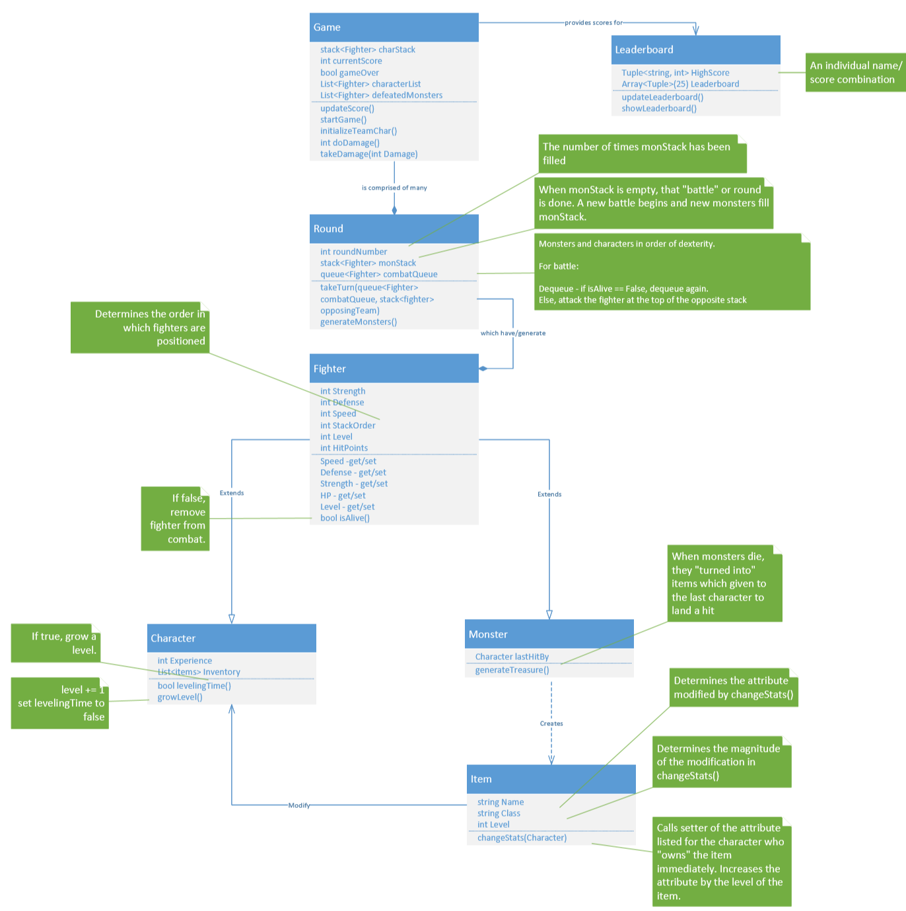We have a fighter superclass which contains all the attributes and combat functions shared between characters and monsters. Classes character and monster extend fighter.
* When monsters die, they generate items. Items modify character attributes (explained later).
* There’s a game class for individual games (creation, our main while loop, and determining who goes next) and a leaderboard class to store high scores

Fighter:

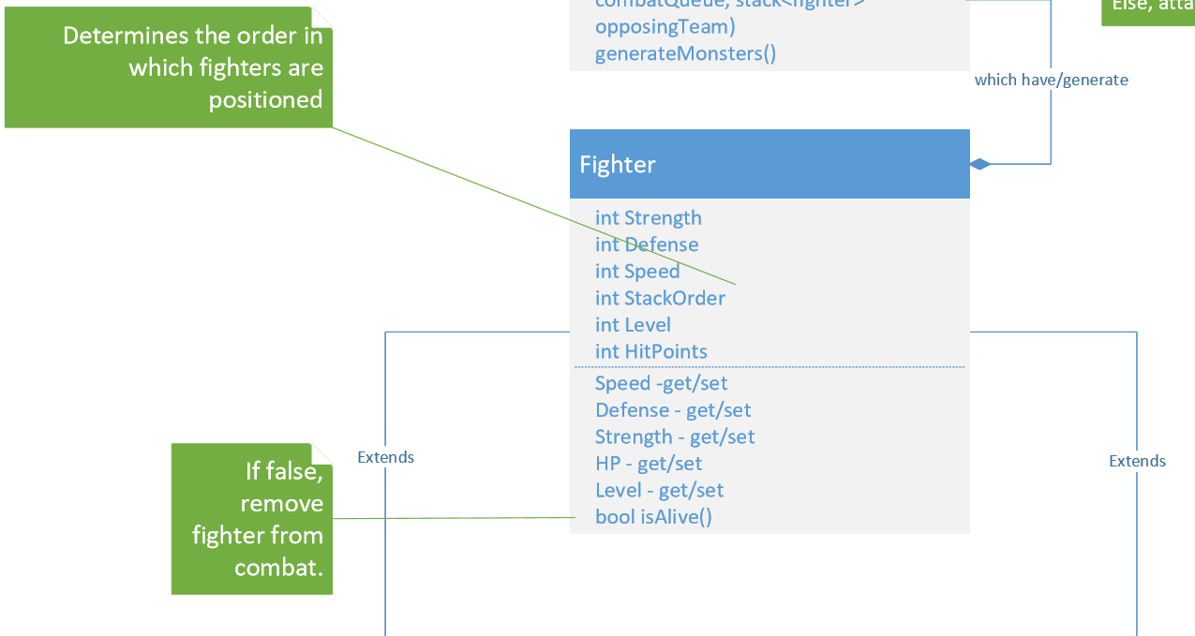

The Fighter class is the superclass for both Character and Monster, so it contains the common key attributes shared for both parties in the game. The attributes Strength, Defense determine the damage done within each turn, Speed determines the fight order for each turn (who goes first and second in our turn-based game), and HP determines how many damage points that one Fighter can take to remain alive. Once a Fighter is not alive or defeated, it will be popped out of the battle queue and the next remaining Fighter will take over and fight until one party’s queue become empty.

Monster:

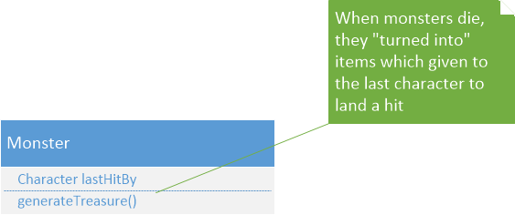

The class Monster is a child class of Fighter. Monsters are stored in a Monster queue that is generated by the Game class. A new queue is generated each round and when a monster queue is emptied, an item will be generated whose power is based on the total stats of all the monsters defeated. This item will be awarded to the character who delivered the killing blow to the final monster remaining.

Character:

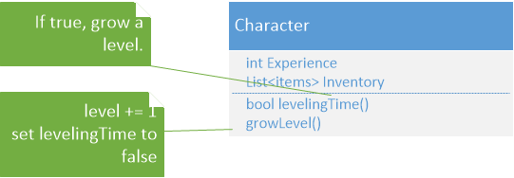

The class Character is a child class of Fighter. When a Character defeats a Monster, they will receive an item as a reward.  A Character can gain experience points and level up so that it will grow stronger as the game proceeds. The Character queue will be generated in the Game class, and this class will gain and share experiences as rounds are beaten and the team advances.

Item:

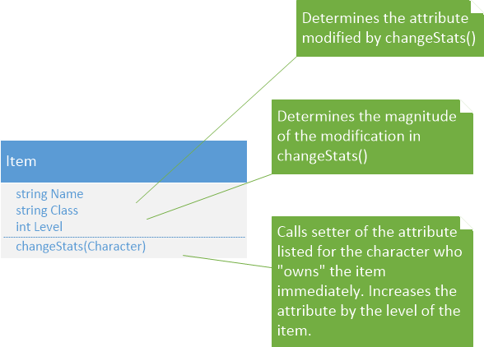

The Item dropped by defeated Monster will immediately enhance the Character that delivered the final blow. The items have different classes, such as armour, weapon, boots etc., as well as the ability to modify the different skills that a fighter has. The number of modification points provided by the weapon will be based on the overall power of the monster team defeated. Armour could potentially enhance the carrier’s Defense, a weapon, could increase the carrier’s Attack, a pendant could increase the carrier’s HPs and so on.

Game:

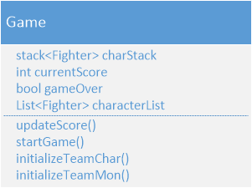

The Game class is where the majority of the game logic occurs (obviously). This is where the team of Characters is created, where game state is stored (game active or over, score). The Game class also initializes each round of fighting between the Team Characters and the Team Monsters. The Game class will create a round of fighting, which will cause a team of monsters for the team to fight. The power of the team of monsters will be based on the total stats of the living Characters. If the round is successfully passed by the Characters, their total score for the game is updated.

Round:

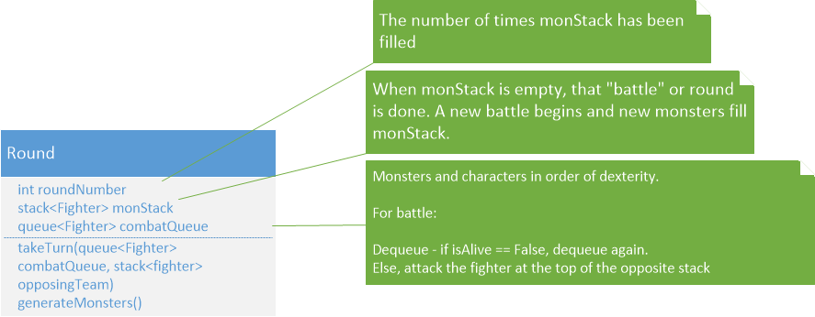

The Round class can have many instances depending on how many rounds the Team Characters can last through the battle against the Team Monsters. In each round, the  Character queue and a Monster instance will take turns based on individual speed. Turn order is tracked by a queue. Characters and Monster will be added to a queue, highest speed score first, slowest last and then the will be removed from the queue one at a time to make attacks against the opposing team’s tank. Before the Fighter is allowed to attack, it must be verified to be alive. This is where the combat logic for the game will reside.

Leaderboard:

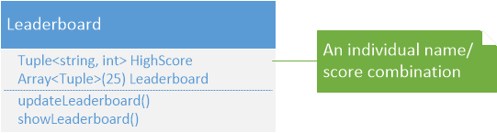

After a Game reaches the “gameOver” state, that Game instance will send a score to the Leaderboard so that the highest scores can be stored and viewable for the user in a specific screen. The Leaderboard will be updated once a game is done and allow the user to retrieve the score list in descending order from the highest to the lowest for a certain range, say, top 10 or 25.

**III. Game Information:**

Our game will run "tank-style." During creation of characters, you can auto-generate characters or allocate skill points yourself (as well as determining the order in a character stack. You can only hit the character at the top of the opposing team’s stack. When they die, they’re popped.

When all of your characters are dead, you’ll be given a score for your party based the amount of experience points gained (as well as some function of the party’s inventory). Therefore, there’s not necessarily a “winner” - just those who have created characters and ordered their battle queues with enough strategy to earn their entire party a place on the leaderboard.

**IV. Combat logic:**

When creating a new battle, all remaining characters are enqueued with the fresh batch of newly generated monsters in order of dex. This is the combatQueue, which determines move number.

1. Dequeue the combatQueue. If isAlive == false, dequeue again. Else, attack the fighter at the top of the opposite team’s stack.

Damage done is calculated by:

(1-20)(AttackerLevel + AttackerStrength) - (1-20)(DefenderLevel + DefenderDefense)

Where (1-20) is a simulated D20 dice roll equalling between 0.1 to 2.0. Negative scores are misses.

3. If there is a hit, DefenderHP -= Damage.

4. Check if the character is alive - isAlive(). If it is not alive, dequeue.  If the dead fighter is a monster, generate an item and grant it to the last character to land a hit. Update the score.

If the fighter is alive, enqueue the fighter in the combatQueue.

5. If there are characters remaining, repeat until one stack is empty. If not, go back to 1 and proceed with the next in line to attack.

5. If monster stack is empty but the character queue is not, display that you've entered a new portion of the dungeon. Generate a new round. (roundNumber++, new monsters, new combatQueue). Update the score. Start at 1.

8. When the character stack is empty, update the score and end the game. If applicable, add score (and name) to the leaderboard.

**V. How Items Work:**

Items are generated by monsters upon their death. They'll be given a name, an attribute they modify, and a level. They are given to the last character to land a hit. This character's base attribute listed they'll immediately increase by the level of the item.

Items are only setters. They are stored as a list.