Genetic architecture of transcriptome regulation and orthogonal tissue decompositon to improve transcriptome prediction

Heather E. Wheeler1, Nicholas Knoblauch2, GTEx Consortium, Nancy J. Cox3, Dan L. Nicolae1, Hae Kyung Im1

2015-05-15 13:32:48 1Department of Medicine, University of Chicago, 2Committee on Genetics, Genomics, and Systems Biology, University of Chicago, 3Division of Genetic Medicine, Vanderbilt University

# Abstract

*Lorem ipsum dolor sit amet, est ad doctus eligendi scriptorem. Mel erat falli ut. Feugiat legendos adipisci vix at, usu at laoreet argumentum suscipiantur. An eos adhuc aliquip scriptorem, te adhuc dolor liberavisse sea. Ponderum vivendum te nec, id agam brute disputando mei.*

# Introduction

Lorem ipsum dolor sit amet, est ad doctus eligendi scriptorem. Mel erat falli ut. Feugiat legendos adipisci vix at, usu at laoreet argumentum suscipiantur. An eos adhuc aliquip scriptorem, te adhuc dolor liberavisse sea. Ponderum vivendum te nec, id agam brute disputando mei.

Putant numquam tacimates at eum. Aliquip torquatos ex vis, mei et quando debitis appareat, impetus accumsan corrumpit in usu. Nam mucius facilis singulis id, duo ei autem imperdiet instructior. Cu ceteros alienum mel, id vix putant impedit, ex idque eruditi forensibus eum. Posse dicunt id usu. Ei iracundia constituto sed, duo ne exerci ignota, an eum unum conceptam.

Has audire salutandi no, ut eam dicat libris dicunt. Pri hendrerit quaerendum adversarium ea, dicat atqui munere et sea. Illum insolens eos ne, eu enim graece rationibus mea. At postea utamur mel, eius nonumes percipitur at vis. Numquam similique in per, te quo saepe utroque pericula.

Ea nonumy volumus usu, no mel inermis dissentias. Dico partiendo vituperatoribus eum et. Mea accusam convenire te, usu populo qualisque gloriatur ut. Eu eum oratio altera option, ad mea ignota scriptorem. Ne suas latine vix, eos oblique sanctus pertinax cu.

# Results

## Local genetic variation explains a large proportion of gene expression variance

We estimated the heritability of gene expression in whole blood from the Depression Genes and Networks (DGN) cohort (n=922) using a mixed-effects model (see Materials and Methods) and calculated variances using restricted maximum likelihood as implemented in GCTA [1]. We fit a joint model with a local GRM (SNPs within 1 Mb of gene) and a global GRM (SNPs that ar)

## The effect of local genetic variation on gene expression is sparse rather than polygenic

## Cross-tissue and tissue-specific gene expression by orthogonal tissue decomposition

## Plots

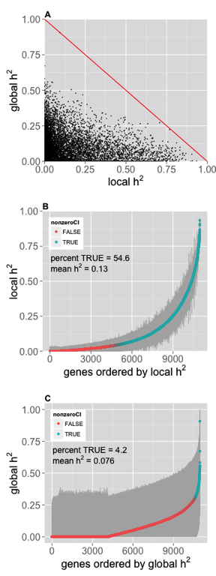

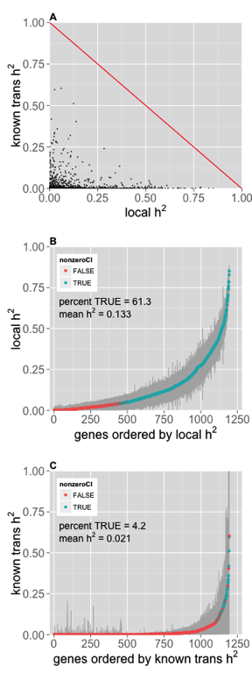

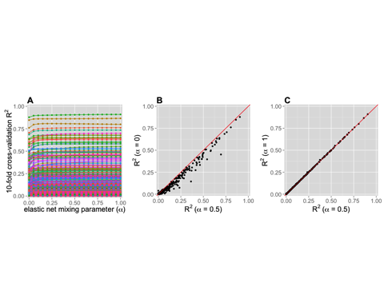

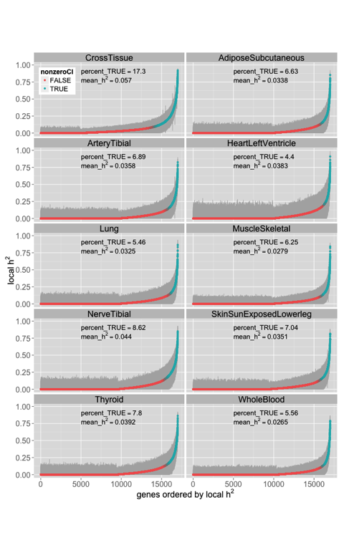

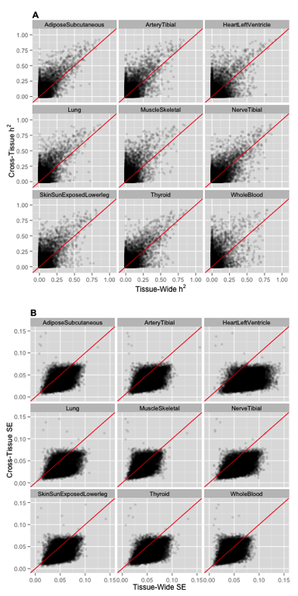

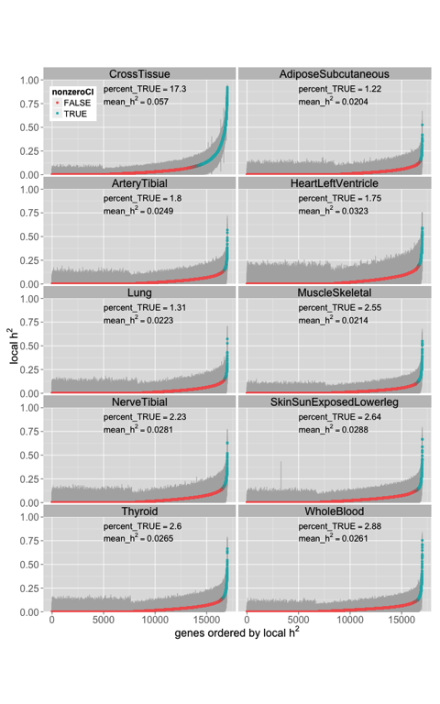

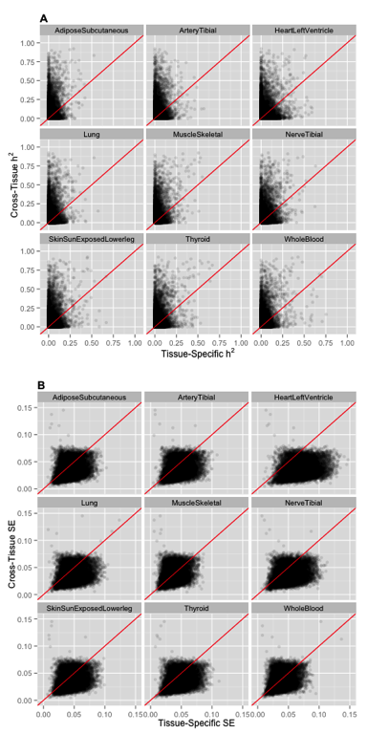

## Citations

The relationship was first described by Reference 2. However, there are also opinions that the relationship is spurious [3]. We used R for our calculations [4], and we used package knitcitations [5] to make the bibliography.

# Discussion

Lorem ipsum dolor sit amet, est ad doctus eligendi scriptorem. Mel erat falli ut. Feugiat legendos adipisci vix at, usu at laoreet argumentum suscipiantur. An eos adhuc aliquip scriptorem, te adhuc dolor liberavisse sea. Ponderum vivendum te nec, id agam brute disputando mei.

Putant numquam tacimates at eum. Aliquip torquatos ex vis, mei et quando debitis appareat, impetus accumsan corrumpit in usu. Nam mucius facilis singulis id, duo ei autem imperdiet instructior. Cu ceteros alienum mel, id vix putant impedit, ex idque eruditi forensibus eum. Posse dicunt id usu. Ei iracundia constituto sed, duo ne exerci ignota, an eum unum conceptam.

Has audire salutandi no, ut eam dicat libris dicunt. Pri hendrerit quaerendum adversarium ea, dicat atqui munere et sea. Illum insolens eos ne, eu enim graece rationibus mea. At postea utamur mel, eius nonumes percipitur at vis. Numquam similique in per, te quo saepe utroque pericula.

Ea nonumy volumus usu, no mel inermis dissentias. Dico partiendo vituperatoribus eum et. Mea accusam convenire te, usu populo qualisque gloriatur ut. Eu eum oratio altera option, ad mea ignota scriptorem. Ne suas latine vix, eos oblique sanctus pertinax cu.

# Methods

Lorem ipsum dolor sit amet, est ad doctus eligendi scriptorem. Mel erat falli ut. Feugiat legendos adipisci vix at, usu at laoreet argumentum suscipiantur. An eos adhuc aliquip scriptorem, te adhuc dolor liberavisse sea. Ponderum vivendum te nec, id agam brute disputando mei.

Putant numquam tacimates at eum. Aliquip torquatos ex vis, mei et quando debitis appareat, impetus accumsan corrumpit in usu. Nam mucius facilis singulis id, duo ei autem imperdiet instructior. Cu ceteros alienum mel, id vix putant impedit, ex idque eruditi forensibus eum. Posse dicunt id usu. Ei iracundia constituto sed, duo ne exerci ignota, an eum unum conceptam.

## Equations

The deterministic part of the model is defined by this **in-line equation** as $μ_{i}=β_{0}+β_{1}x$, and the stochastic part by the **centered equation**:

$$\frac{1}{\sqrt{2π}σ}e^{−(x−μ_{i})^{2}/(2σ^{2})}$$

## Tables

## Warning: package 'knitr' was built under R version 3.1.3

|  |  |  |  |  |
| --- | --- | --- | --- | --- |
|  | Estimate | Std. Error | t value | Pr(>|t|) |
| (Intercept) | -0.05 | 0.1 | -0.49 | 0.63 |
| x | 2.02 | 0.1 | 20.09 | 0.00 |

This is a GLM summary table.

# References

1. Yang J, Lee SH, Goddard ME, Visscher PM. GCTA: A tool for genome-wide complex trait analysis. The American Journal of Human Genetics. Elsevier BV; 2011;88: 76–82. doi:[10.1016/j.ajhg.2010.11.011](http://dx.doi.org/10.1016/j.ajhg.2010.11.011)

2. Halpern BS, Regan HM, Possingham HP, McCarthy MA. Accounting for uncertainty in marine reserve design. Ecol Letters. Wiley-Blackwell; 2006;9: 2–11. doi:[10.1111/j.1461-0248.2005.00827.x](http://dx.doi.org/10.1111/j.1461-0248.2005.00827.x)

3. Keil P, Belmaker J, Wilson AM, Unitt P, Jetz W. Downscaling of species distribution models: a hierarchical approach. Freckleton R, editor. Methods Ecol Evol. Wiley-Blackwell; 2012;4: 82–94. doi:[10.1111/j.2041-210x.2012.00264.x](http://dx.doi.org/10.1111/j.2041-210x.2012.00264.x)

4. R Core Team. R: A language and environment for statistical computing [Internet]. Vienna, Austria: R Foundation for Statistical Computing; 2014. Available: <http://www.R-project.org/>

5. Boettiger C. knitcitations: Citations for knitr markdown files [Internet]. 2014. Available: <http://CRAN.R-project.org/package=knitcitations>