IST 263

# Lab 03

## This lab covers:

1. File Paths
2. HTML Attributes, External Links and Target attribute
3. Mail Links
4. Images
5. Embedding Content

## File Paths

File paths are important for linking to other pages in your site, adding images to your site and for CSS and JavaScript which we will study later.

Examine this image of files. The ist263 folder is at the root. The lab01, lab02 and images folders are inside the ist263 folder. The images2 folder is inside the lab01 folder. The photo.png, map.jpg, and thumbnail.png files are inside the images folder. The bio.html and contact.html files are in the lab02 folder. The logo.gif file is inside the images2 folder.



Let’s say we are working on the contact.html file. Here’s the process of finding the file path.

* Determine the folder your file resides in.
* Traveling only along the lines figure out the path you want to travel to get to the folder that contains the file you want to link to.
  + Every time you go up to a parent folder you add a ../
  + Every time you go down to a sub folder you add a /folder_name where folder_name is the actual name of your folder
* Once you have arrived at the correct folder, add a /file_name to the end of your path where file_name is the actual name of your file.

**Example:** Write the path from bio.html to photo.png.

|  |  |
| --- | --- |
| ../ | We are starting in the lab02 folder and linking to the images folder. To get to the images folder we need to go up a level to the ist263 folder. |
| ../images | Next we go down a level to the images folder |
| ../images/photo.png | Last we reference the filename in that folder |

For the questions below write down the file paths.

1. Use the steps above to write a file path from photo.png to contact.html

../lab02/contact.html

1. Use the steps above to write a file path from contact.html to logo.gif

../lab01/images2/logo.gif

1. Imagine there was an index.html file in the ist263 folder. Write the relative path from the bio.html file to the index.html file.

../index.html

## Setup

1. Create a new page with the required HTML tags. If you forgot how to do this, refer to lab 1. The title of your page should be "Contact".
2. Create a new folder inside your Github folder called lab03
3. Save your new page there as contact.html

## HTML Attributes and Links

A basic link tag looks like this <a>text</a>. That tag is useless without an element attribute. Attributes are name value pairs that add additional info to the element. For the <a> tag the href attribute specifies the url the link forwards to. Following is a link to google.



I've added a second attribute into the tag, target="_blank". The target attribute specifies where you should open a link. Default is to open it in the same browser window as the link. If you want to do this, you don't need the target attribute. Another popular option is to choose _blank which opens the link in a new tab. Folks often do this when linking to a PDF or off their site. You can see all the values for that attribute at W3Schools here: <https://www.w3schools.com/tags/att_a_target.asp>.

We are going to start our work with links by creating a contact page for you. This page will contain your contact info, links to your professional social media presence and a map to your location.

1. Put a main header on the page called "Contact" – make sure you use the correct tag. Consult W3Schools or last week's lab for the correct syntax.
2. Let's add name and address under that heading. Use the correct tags. If you don't want to publish your personal address use the university's address.
3. On that page we are going to create a link to your LinkedIn page. You will need to look up and copy the URL of your LinkedIn page. If you don't have a LinkedIn page, then just create your link to the LinkedIn homepage.   
     
   Under your address add the text "My LinkedIn Profile" and use the <a> tag to create an external link to your LinkedIn page.

## Mail Links

We've just spent some time entering your contact info. Now let's add a clickable link for your email address. An email link follows the same format as a link to a page, we just add "mailto:" to the beginning of the href attribute. Here's how you would add an email link to me:



1. Add an email link to yourself on your contact page under the address.

## Images

1. We are going to add a LinkedIn logo to our contact page. To get started let's create a folder to separate the images from our web pages. In your github repository folder, create a folder called "images". Don't create this folder inside the lab03 folder. We are going to be using the images folder a lot moving forward for different labs.
2. LinkedIn provides official versions of its logo image for use. You can find them here: <https://brand.linkedin.com/downloads>. Read the use requirements to make sure you are following LinkedIn's rules.   
     
   You can right click, or control click on the logo you like best and choose to save it to the images folder you just created.
3. Now go back to your contact page. We are going to add this image as content inside the link to LinkedIn so that the user can either click on the "My LinkedIn Page" text or the image to get to your LinkedIn page. Some items to think through when creating the link:  
   1. Where is my image located and how do I write the path to that image – consult the lecture slides for reference
   2. What are the required attributes for the image tag
   3. Does the image tag need to be closed or is it a void tag  
        
      Note: Don't worry if your image is too large or too small. We'll deal with editing images in the future.

## Embedding

The last thing we are going to do on our contact page is embed a map of your location using Google maps. Put the map at the bottom of your HTML document. The first step is to type your address into Google maps. Then look for the embed code provided by Google. Once you find it paste the code into your contact page. If you do this correctly you will not have to write any of the code. Google gives it to you.

Consult the last section of the lecture video if you need reference on embedding.

## Validation and checking your work

1. Here's a screen shot of my bio page. Check it against the page you created to make sure everything is in the correct place and you haven't missed any parts.

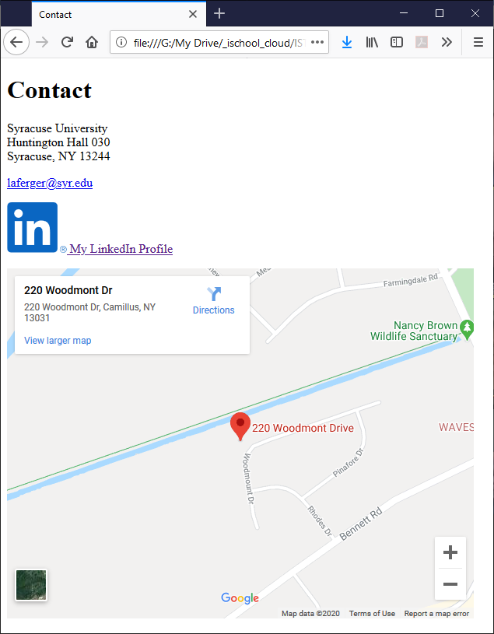

1. Before you finish you must validate you HTML. Go to the <https://html5.validator.nu/> and correct any errors that appear in validating.

## What will You hand IN?

Create a word document, pdf or use the "write submission" option in blackboard to provide the following:

1. Submit the file paths you wrote for #1, #2 and #3 above.
2. Submit the GitHub URL for this lab's web page.
3. Submit the link to the validation you did above.   
   Note: On this lab you will get a validation error for the iframe. You can ignore this one error. Fix everything else.
4. Submit answers to the following:
   1. What questions did you have about the lab?
   2. What was the hardest part of the lab?
   3. Rate your comfort level with this week's topics.  
      1 ==> I can do this on my own and explain how to do it.  
      2 ==> I can do this on my own without any help.  
      3 ==> I can do this with help or guidance from others.   
       If you choose this level, please indicate HOW this person helped you.  
      4 ==> I don't understand this at all yet and need extra help.