Assignment #5

- Consider the signal x=[3 -3 0 6 7 9]. Assume we expanded it to infinity module 6. Compute the value of the elements 100 and -100. Explain.
$x(extend)$=[…x x x …]=$\sum_{k=0}^{6-1}{h\left[k\right]*x{\left(n-k\right)}_{mod6}}$
$$x_{100}=x\left({\frac{100}{6}}_{mod}\right)=x(100-6*\left({100}_{mod6}\right)=x\left(100-96\right)=x\left(4\right)=7$$
$$x_{100}=x\left(6+{\frac{-100}{6}}_{mod}\right)=x\left(6-100-6*\left({-100}_{mod6}\right)\right)=x\left(6-100+96\right)=x\left(-4\right)=x\left(6-4\right)=0$$

- Write a MATLAB function to compute the circular convolution between two signals of equal length. Use: x=[0 0 1 2 1 0 0 ] and y=ones(1,7). Compare your result with the output of ‘cconv(a,b,length(a))’. Use the functions fliplr(x) to flip your signal x and circshift(x’,n) to shift your vector n places module N.
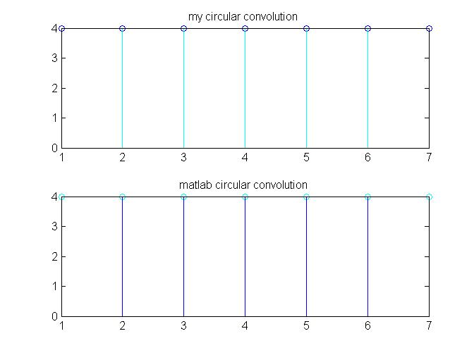

- Prove that y(n)=x(n^2) is linear but time-variant (hint, either use the technique shown in class or do x’(n)=x(n-1) and see what you get for y and y’ for n=2).
$$y\left[n\right]= x\left[n^{2} \right],∀n→5y\left[n\right]=2y\left[n\right]+3y\left[n\right]= 2x\left[n^{2} \right]+3 x\left[n^{2} \right]=5x\left[n^{2}\right]$$
$$x’\left(n\right)=x\left(n-1\right)→ ∴y’\left(n\right)=y\left(n-1\right)$$
$$y\left(n-1\right)=x\left({\left(n-1\right)}^{2}\right)≠x\left(n-1\right),∀n≠1$$

- Prove that matrix multiplication is a linear system.
$${\left[AC\right]}_{ij}=A_{i,1}C_{1,j}+A_{i,2}C_{2,j}+⋯+A_{i,n}C_{n,j}=\sum_{r=1}^{n}{A_{i,r}C_{r,j}}$$
$${\left[BC\right]}_{ij}=B_{i,1}C_{1,j}+B_{i,2}C_{2,j}+⋯+B_{i,n}C_{n,j}=\sum_{r=1}^{n}{B_{i,r}C_{r,j}}$$
$$\sum_{r=1}^{n}{B_{i,r}C_{r,j}}+\sum_{r=1}^{n}{A_{i,r}C_{r,j})=\sum_{r=1}^{n}{{(A}_{i,r}C_{r,j}}+B_{i,r}C_{r,j})={\sum_{r=1}^{n}{{(A}_{i,r}+}B}_{i,r}{)C}_{r,j}=}{\left[(A+B)C\right]}_{ij}={\left[AC\right]}_{ij}+{\left[BC\right]}_{ij}$$

- Consider the matrix: H=[1 2 3; 3 1 2; 2 3 1]; and the vector x=[ 5 6 7];
  - Compute y=H*x (manually and check in matlab).
$$y=H*x=\left(\begin{matrix}1 & ⋯ & 3 \\ ⋮ & ⋱ & ⋮ \\ 2 & ⋯ & 1\end{matrix}\right)*{\left(\begin{matrix}5 & 6 & 7\end{matrix}\right)}^{T}=\begin{matrix}1*5+2*6+3*7 \\ 3*5+6*1+7*2 \\ 2*5+3*6+1*7\end{matrix}={\left(\begin{matrix}38 & 35 & 35\end{matrix}\right)}^{T}$$
  - Compute y=H*x while the vector x is rotated once (e.g. y=H* circshift(x,1)) and twice.
$$y=H*x=\left(\begin{matrix}1 & ⋯ & 3 \\ ⋮ & ⋱ & ⋮ \\ 2 & ⋯ & 1\end{matrix}\right)*{\left(7 5 6\right)}^{T}=\begin{matrix}1*7+2*5+3*6 \\ 3*7+5*1+6*2 \\ 2*7+3*5+1*6\end{matrix}={\left(\begin{matrix}35 & 38 & 35\end{matrix}\right)}^{T}$$
$$y=H*x=\left(\begin{matrix}1 & ⋯ & 3 \\ ⋮ & ⋱ & ⋮ \\ 2 & ⋯ & 1\end{matrix}\right)*{\left(6 7 5\right)}^{T}=\begin{matrix}1*6+2*7+3*5 \\ 3*6+7*1+5*2 \\ 2*6+3*7+1*5\end{matrix}={\left(\begin{matrix}35 & 35 & 38\end{matrix}\right)}^{T}$$

  - Does the matrix H is time invariant for this vector x? Explain.
Yes, as each time we rotate vector x, the product vector is rotated accordingly.
  - Can you describe how one can rebuild the matrix H when you only know the first column of H?
each column is a circular shift of the former one, so one may shift the first column to re-create the second and then shift the second column to re-create the third

