Assignment #6
Let H be an LTI system. You want to characterize it so you provide a delta function of length 10. Delta=[1 0 0 0 0 0 0 0 0 0]; You obtained the following vector: y[n]= [1 2 1 0 0 0 0 0 0 0];
  - What is the h function that characterize this system
$$y\left(n\right)=\sum{h\left(n-m\right)δ\left(m\right)=h\left(n\right)=[1 2 1 0 0 0} 0 0 0 0]$$
  - Write a matlab function that build the matrix H from the vector h that represent this system
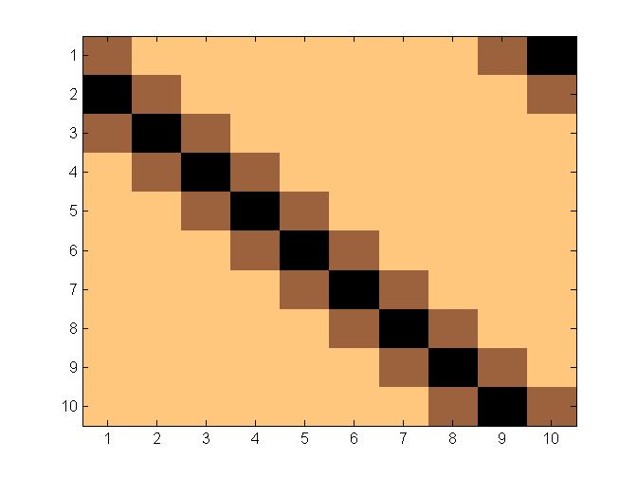
  - Describe in words what signal processing is performed by this system (e.g. scaling average etc)?
This system increase and smooth the signal.
  - Assume you have the following input vector: x=[0 -1 -2 3 4 3 4 1 2 0 ]’;
  - Using what you found in c, compute the transformation x will undergo by the system (e.g. if this is scaling, then scale the vector x )
0 | 2 | 1 | 4 | 3 | 4 | 3 | -2 | -1 | 0
 |  |  |  |  |  |  |  |  | 1 | 2 | 1 | 0 | 0 | 0 | 0 | 0 | 0 | 0
0 | 2 | 1 | 4 | 3 | 4 | 3 | -2 | -1 | 0
 |  |  |  |  |  |  |  | 1 | 2 | 1 | 0 | 0 | 0 | 0 | 0 | 0 | 0
0 | 2 | 1 | 4 | 3 | 4 | 3 | -2 | -1 | 0
 |  |  |  |  |  |  | 1 | 2 | 1 | 0 | 0 | 0 | 0 | 0 | 0 | 0
0 | 2 | 1 | 4 | 3 | 4 | 3 | -2 | -1 | 0
 |  |  |  |  |  | 1 | 2 | 1 | 0 | 0 | 0 | 0 | 0 | 0 | 0
0 | 2 | 1 | 4 | 3 | 4 | 3 | -2 | -1 | 0
 |  |  |  |  | 1 | 2 | 1 | 0 | 0 | 0 | 0 | 0 | 0 | 0
0 | 2 | 1 | 4 | 3 | 4 | 3 | -2 | -1 | 0
 |  |  |  | 1 | 2 | 1 | 0 | 0 | 0 | 0 | 0 | 0 | 0
0 | 2 | 1 | 4 | 3 | 4 | 3 | -2 | -1 | 0
 |  |  | 1 | 2 | 1 | 0 | 0 | 0 | 0 | 0 | 0 | 0
0 | 2 | 1 | 4 | 3 | 4 | 3 | -2 | -1 | 0
 |  | 1 | 2 | 1 | 0 | 0 | 0 | 0 | 0 | 0 | 0
0 | 2 | 1 | 4 | 3 | 4 | 3 | -2 | -1 | 0
 | 1 | 2 | 1 | 0 | 0 | 0 | 0 | 0 | 0 | 0
0 | 2 | 1 | 4 | 3 | 4 | 3 | -2 | -1 | 0
1 | 2 | 1 | 0 | 0 | 0 | 0 | 0 | 0 | 0

0*1
0*2+(-1)*1
1*0+-1*2+-2*1
0*0+-1*1+-2*2+3*1
0*0+-1*0+-2*1+3*2+4*1
0*0+-1*0+-2*0+3*1+4*2+3*1
0*0+-1*0+-2*0+3*0+4*1+3*2+4*1
0*0+-1*0+-2*0+3*0+4*0+3*1+4*2+1*1
0*0+-1*0+-2*0+3*0+4*0+3*0+4*1+1*2+2*1
0*0+-1*0+-2*0+3*0+4*0+3*0+4*0+1*1+2*2+0*1

Ans=[0 -1 -4 -2 8 12 14 12 8 5]
  - Compare it to the result of H*x
Ans=[2 -1 -4 -2 8 12 14 12 8 5]
When we use a window to increase the signal , we don’t effect the margin, as we cannot determine how to increase it, normally they suppose to stay unchanged, because of the length of h vec only one side isn't being effected . the correct vector for triangular increase is Isosceles [..0 1 2 1 0..]

  - Compare the result when using circular convolution (limited to 10 lags e.g cconv(x,h,10))
Ans=[2 -1 -4 -2 8 12 14 12 8 5]
When we use a window to increase the signal , we don’t effect the margin, as we cannot determine how to increase it, normally they suppose to stay unchanged, because of the length of h vec only one side isn't being effected .

