Assignment #7/ due 18/5
Unless stated, use matlab functions to solve the below

- Complex numbers
  - Let z = 0.9e^{iπ/3}. Draw this complex number in 2D plan (manually, do not use matlab).
  - What is the angle (in radians and degree) and amplitude of this complex number?
  - Draw in 2D z²,z³, z⁴ z⁵ z⁶ and z⁷ (e.g. z to the power of 2,3,…7). What are the angles and amplitudes of these new numbers?
  - Plot them on in 2D plan manually

- Shifting and scaling a signal
  - Let x=sin(2*pi*3*n/N) where N=20, n=0:N-1
  - Plot x using stem(n,x, ‘fill’)
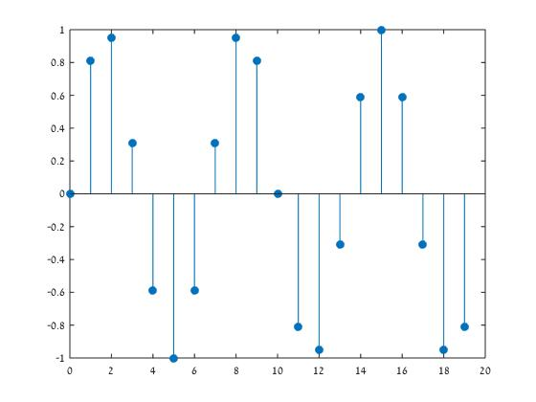
  - Let z = 2e^{iπ/4} ; compute y = x*z and plot y (use matlab)
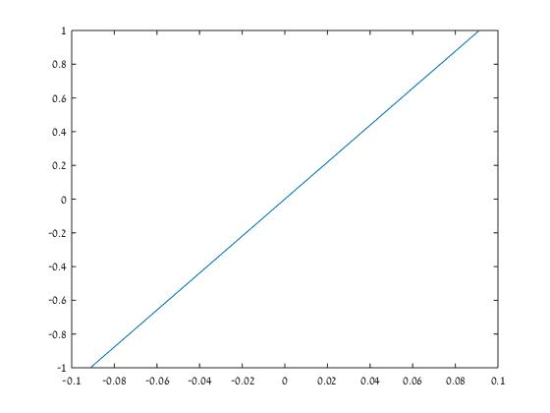
  - Compare the absolute value of y to x (e.g. abs(y)./abs(x)) how big is y compared to x? how this relate to the magnitude of z?
As we compare the values y to x we see they have identical values, Complex Magnitude that is the length of a vector from the origin to a complex value plotted in the complex plane .For a complex value, a+bi is defined as (a2+b2)^0.5.
  - Compute the angles of all y values and compare it to the angles of x and z. What did you find? explain
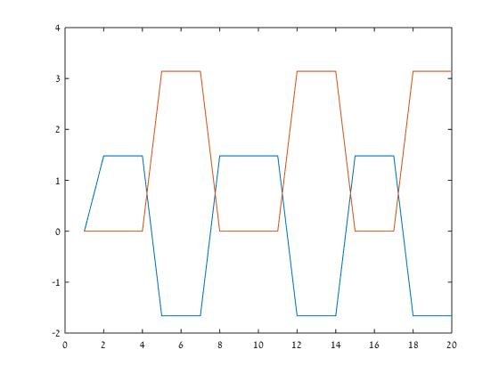
Table 1we can see a preservation of the angle as a function which "move" on the scale by multiping z in x (orange) –prouduct y in blue.
f. Summaries in words what does multiplying the signal x by z do to the signal x in terms of magnitude and angle
we can see there is no change in magnitude, while the change is only in angle , yet it is relative to the replication.

- Harmonic functions
  - Select a value at random from 40 to 100 and let N be that number. Let n=0:N-1. Plot the sin and cos parts of the function e^{-j2πkn/N} for k=5 and k=N-5 (round it if it is not an integer). Examine the plot and state how many cycles in N points you see for each k

  - Does the number of cycles for k=5 and k=N-5 the same? Why?
Ask is part of the ratio that represent the angle of the compex number, and as we use k between 40-100 we get Complementary angles, as fft is a symmetric function .
  - What is the k with the highest number of cycles?
The most cycles we will get if use k=N/2

- Eigenvectors of LTI system: in this exercise you will see that a harmonic function is an eigenvector of an LTI system. We will construct an LTI system and then compute the output of this system to an harm onic function
  - Let N=16;k=2;n=0:N-1; Let h = [round(10*randn(1,N))]'; Create a circulent matrix T from this h vector using the code you wrote in the previous exercise
  - y1=cos(2*pi*k*n/N; y2=sin(2*pi*k*n/N);
  - Plot y1 and y2
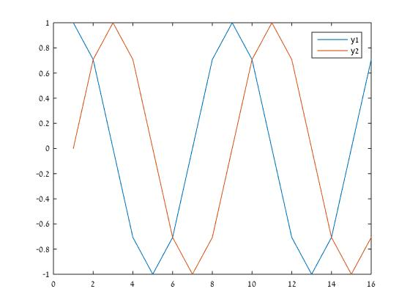
  - Let s2 = y1’- j*y2’; the harmonic function with 2 cycles (verify you see k cycles)
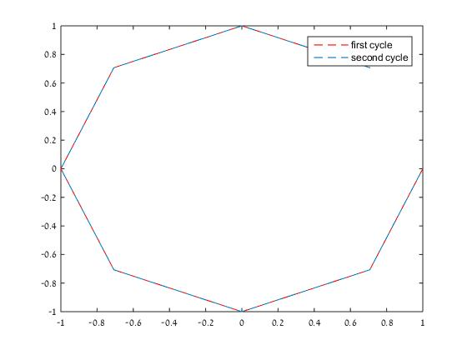
  - Compute z = T*s2 and plot it. Does z have 2 cycles also?
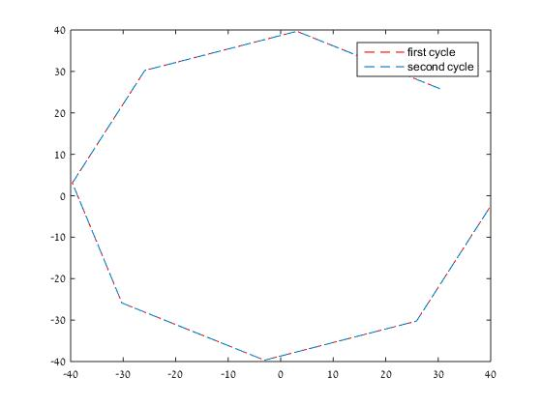
We can see it as 2 cycles and no more as there is a missing side in the octagon (created by dividing to vector z to two ) which is the connection between the first and last point- indicating if appear on the start of a new cycle .

  - How big is z relative to s2 (Compute z./s2)?
The real part is 26.3137 time bigger and the imaginary part is 7.729 time smaller
  - Compute the eigenvalues of T, using e=eig(T). Can you find an eigenvalue that has the same value you found in f? What is its index? No..
51.9411254969543 + 11.7867965644036i
51.9411254969543 - 11.7867965644036i
-15.9411254969543 + 54.2132034355965i
-15.9411254969543 - 54.2132034355965i
-38.2477743559038 + 52.9404472787222i
-38.2477743559038 - 52.9404472787222i
13.0000000000000 + 12.0000000000000i
13.0000000000000 - 12.0000000000000i
-18.0537408342612 + 6.89881671837960i
-18.0537408342612 - 6.89881671837960i
-67.4435246882201 + 2.69879652896061i
-67.4435246882201 - 2.69879652896061i
-43.0000000000000 + 0.00000000000000i
-47.0000000000000 + 0.00000000000000i
-48.2549601216149 + 0.657165968617994i
-48.2549601216149 - 0.657165968617994i
  - Compute the eigenvalue by using the formula we showed in class: <h,conj(s2)> did you get the same values as in g?
No I get -0.171572875253815 - 26.313708498984766i
  - Can you compute z by using convolution? write the matlab command
  - Summarized in words your finding:

