Assignment 10

- You performed an fft on a signal x and obtained a vector X. the sampling rate is 1000 Hz. The number of point’s used in the fft is 100.
  - What is the length of the vector X?
$$length\left(X\right)=\frac{\frac{1}{N}}{fs}=\frac{1000}{100}=100$$
  - Which frequency does the value in X(5) represents?
$$x\left(5\right)=fanalysis\left(5\right)=5×\frac{fs}{n}=50Hz$$
  - Which frequency does the value in X(0) represents?
$$x\left(0\right)=fanalysis\left(0\right)=0×\frac{fs}{n}=0Hz$$
  - Assume the value at X(5) = 1+2i what is the frequency content and phase?
$θ_{phase}=arc tan⁡(\frac{2}{1})$=1.107
$r_{frequency}=\sqrt{1^{2}+2^{2}}$=2.236

- A shift in time is modulation in frequency domain:
  - Construct a random signal: x=rand(1,20)
  - Perform a DFT of x
  - Circular shift the signal x by m points
  - Perform a DFT on the shifted signal
  - Show that the new DFT is phase shifted of the original signal DFT by exp(-j*2*pi*k*m/N)

- Convolution in the time domain is multiplication in the frequency domain.
  - Construct two random signals of length n (e.g. x=rand(1,n);)
  - Compute the cyclic convolution between the two signals
  - Perform a DFT on each of the two signals and show that the multiplication is the same as the convolution (note that we you do an FFT you must specify the size of the convolution so that the fft result will be of the same length as the convolution. i.e. X=fft(x, lengthOfTheConvolutionResult)

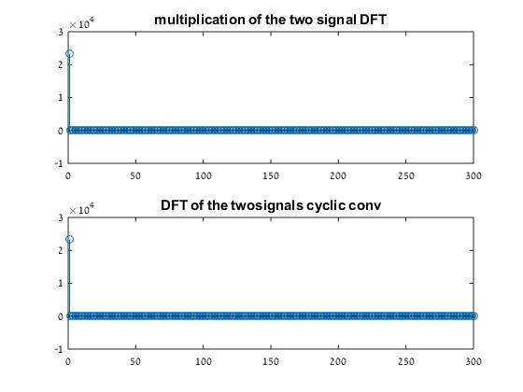
- Assume we have the signal: x=3*sin(2*pi*2*n/N)+sin(2*pi*32*n/N); N = 100.

  - Construct an ideal low pass filter that keeps the first 5 frequencies and remove all others. Plot h, H, x, X, conv(fftshift(h),x) and ifft(HX).

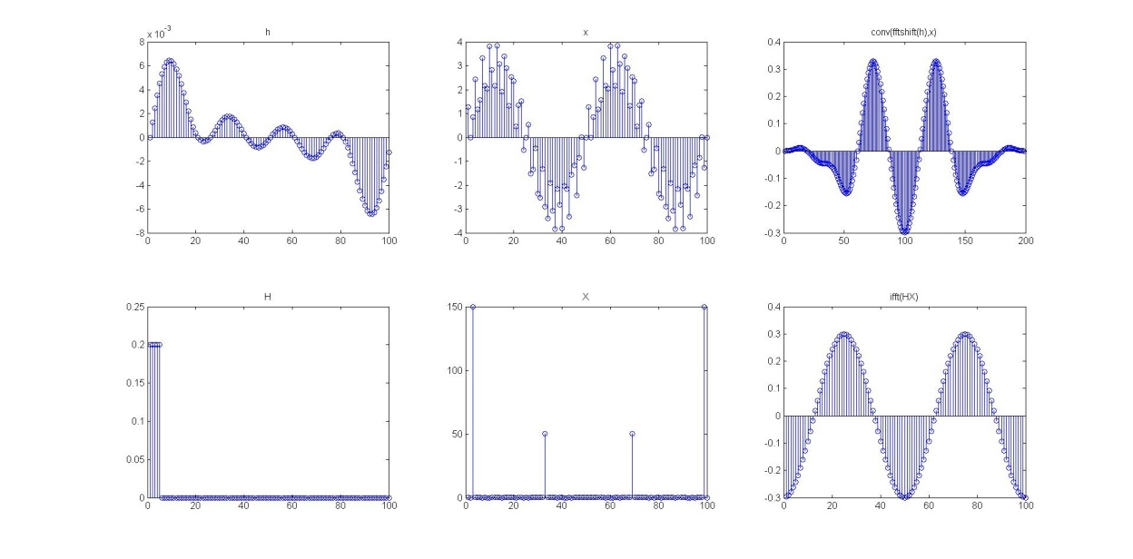

  - Construct an ideal high pass filter that remove the first 10 frequencies and keeps all others. Plot h, H, x, X, conv(fftshift(h),x) and ifft(HX).

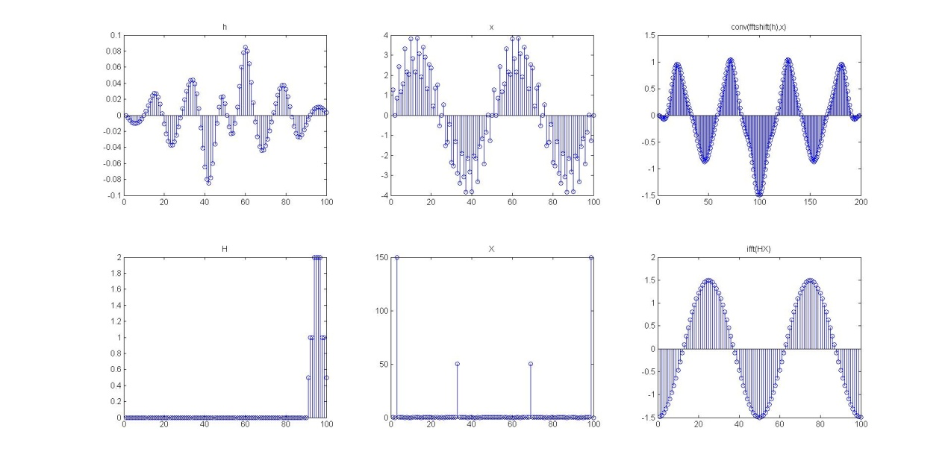

- Phase shift:
Construct two sinus signals one with 2 Hz and the second with 5 Hz (choose the number of points you want to work with). You apply a filter: h=[1 2 3 2 1] on this signal.

  - Plot the original signals, h, abs(H) and angle(H) (Hint: you need to pad h with zero to be of the sample length as your signal in order to get the phase values for each of the frequencies)
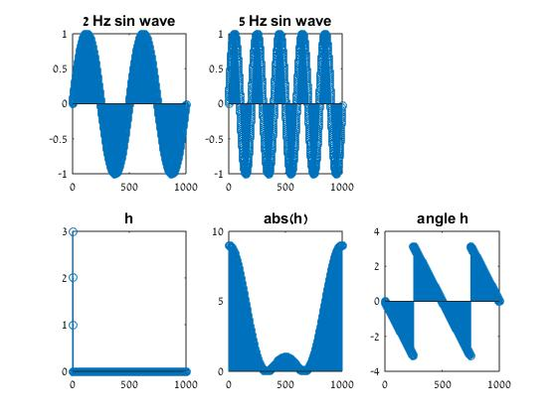
  - What are the phase shift angles each of your sinuses undergo?
The phase shift is zero.
  - Plot on the same figure the original signals and the filtered ones (in dashed lines)
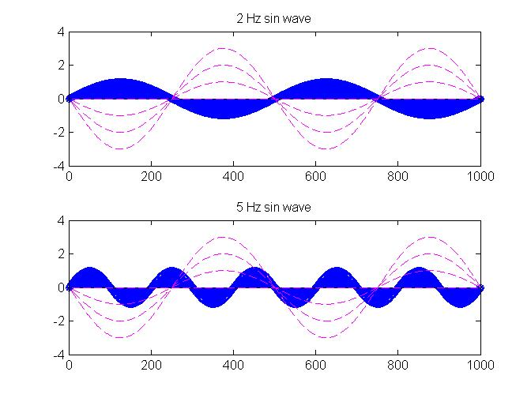
  - What is the delay (in samples) between the original signals and the filtered one?
$$delay=\frac{length(h)}{2}=2.5 seconds$$

- You recorded the following signal y=[1 2 3 4 1 2 3 4 8 9 1 2]; you know that this signal has been filtered by a low pass filter with a 5 taps filter h=[0.2 0.4 1 0.4 0.2];. Find the original signal and verify that y=conv(x,h)
X= [5 0 -10 30 -10 -100 215 80]
- True or false (when possible explain your selection):
  - Applying a FIR on a signal never changes the frequency of the composing signals
False, you can use it to increase or average the frequency.
  - Applying a FIR on a signal never changes the phase of the composing signals
False, but the phse change will be the same as long as the filter is symetric
  - Low pass filter attenuate high frequencies
true
  - An ideal band pass filter has a rectangular structure in the frequency domain
true
  - A FIR filter h1=[1 2 3 2 1] will have less ripples and smaller main lobe than h2=[1 1 1 1 1]
False, it will have less ripples but bigger main lobe as sharp change from zero cause more ripples and slow change cause bigger main lobe
  - FIR filters are more stable and faster than IIR filters
True.

