Assignment #4 –
By Harel Wilner
- Let x= sin(2*pi*3*t); t=0:0.001:1 and y= sin(2*pi*3*t+pi/3); t=0:0.001:2
  - Implement in matlab the cross-correlation function of two vectors x and y. Check your result by comparing it to the results you get from the matlab function xcorr(x,y).
Exist in code also in auto correlation (didn’t came close…)
  - Plot the auto-correlation of each of the above vectors: x and of y (use the code you wrote in a).
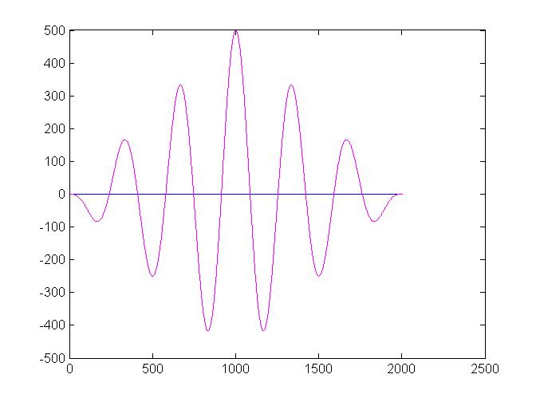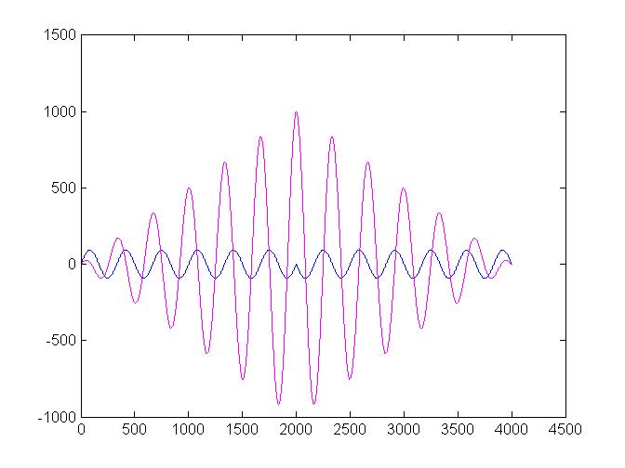

- Download the data spikeTrain, a matrix of 3x500000. Each row contains one spike train of a single different neuron. A value of 1 represent a spike.
  - Write a cross correlation function and compute all possible cross correlation of these spikes trains in a [-500 500] window and plot the result.
  - Test your result by running the matlab function y = xcorr(spikeTrain(i,:), spikeTrain(j,:), 500);

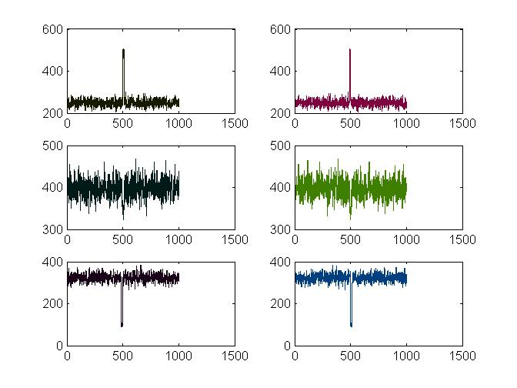
Fig2- matlab result
  - What is the synaptic relation between the three neurons?
As we can see in fig 1, between neuron 1&2 there is a monosynaptic drive where there is an excitatory synapse where neuron one is pre synaptic as he fire neuron 2 fires in a short interval.
Neuron 2&3 seen to be un correlated, as there is relatively uniform distribution.
between neuron 1&3 there is a monosynaptic drive where there is an inhibitory synapse where neuron one is pre synaptic as he fire neuron 3 cease-firing in a short interval.

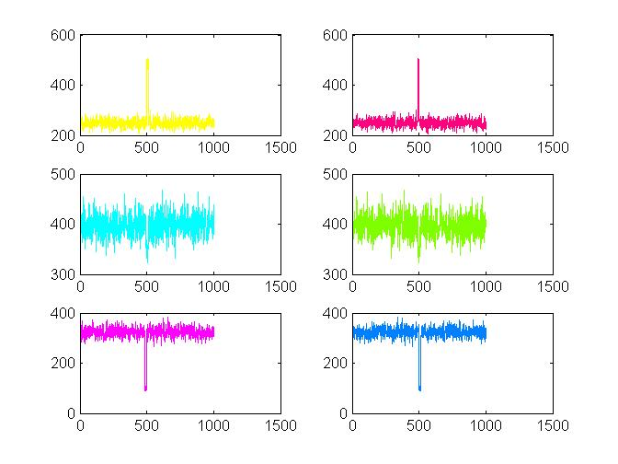
fig 1- top: cross correlation between 1-2 (top right) and 2-1 (top left), middle: cross correlation between 2-3 (middle right) and 3-2 (middle left) ,bottom: cross correlation between 3-1 (bottom right) and 1-3 (bottom left)

- Melfi and Poyser (2007) observed the behavior of 6 male colobus monkeys (Colobus guereza) in a zoo. By seeing which monkeys pushed other monkeys out of their way, they were able to rank the monkeys in a dominance hierarchy, from most dominant to least dominant. Melfi and Poyser (2007) counted eggs of Trichuris nematodes per gram of monkey feces, a measurement variable. The below table shows their result.
  - Using the matlab functions, compute the Pearson and Spearman correlations: r_{xy} and ρ_{xy}
r_{xy} = -0.9495
ρ_{xy}= - 0.9429
  - Which test is more appropriate?
As there is no real meaning to the values of dominance, and they are only used to describe an order of the variable the spearman test is more appropriate.

  - Compute the sum of squares: SS_{xx}, SS_{yy} and SS_{xy}. Note that SS_{yy} is also called SS_{total}.
SS_{xx}=~4581
SS_{yy=} 4.1833
SS_{xy}= -18194
  - Compute the r value using the above SS_{xx}, SS_{yy} and SS_{xy} values.
r –value= -0.9495

