CS274 – Lab 8

**DIRECTIONS:** To receive credit for any questions on this exam, you must show all work. Work must be written clearly, and your name must be on all work that you turn in.

1. In the Datapath diagram below, explain why there is a line from the PC register to both the Instruction Memory as well as the Adder. Why is the other input to the Adder hardcoded to “4”?

**The program counter, sends the address to the instruction memory control so that it start the instruction and it sends the address to the Adder because it needs to get the next instruction in the program, ie +4 since every instruction is 4 bits away.**

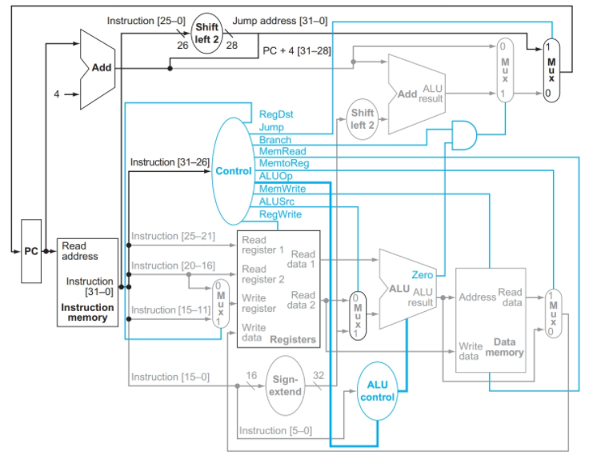

1. Give an example of an instruction for which the red circled mux is given a 0 on its control line. Explain.

**Add $t0, $t0, $t1 would use a 0 on the red mux because it is not getting anything out of memory but using the results from the ALU to put it in a register.**

1. Give an example of an instruction for which the red circled mux given a 1 on its control line. Explain.

**Lb $t0, 4($s0) would use a 1 on the red mux because it needs to get something out of memory, using the data memory control, and put it in a register ($t0).**

1. Give an example of an instruction for which the green circled mux given a 0 on its control line. Explain.

**Add $t0, $t0, $t1 would use a 0 on the green mux because it needs both registers ($t0,$t1) to complete the function.**

1. Give an example of an instruction for which the green circled mux given a 1 on its control line. Explain.

**Addi $t0, $t0, 10 would use a 1 on the green mux because in its instruction it only uses one read register, and the green is choosing weather to use another read register or not and since it only uses one. The green mux would be 1 to get the other apart of the addition from the bits [15-0].**