CS 376 – Operating Systems HW #1

For this assignment, you may use whatever resource you find helpful, however, be sure that the work is your own.

Edit this document with your answers and submit it in pdf form to Canvas by the due date.

1. Get to know your own machine

Using your computer’s interface, find out the following about the processor. Support your answers with screen grabs and/or urls to the information:

1. Model name, manufacturer

**VivoBook, ASUS laptop with a AMD Ryzen 3 3200U**

1. Processor speed

**2.6Ghz**

1. How many cores it has

**2 cores**

1. How many threads it has

**4 threads**

[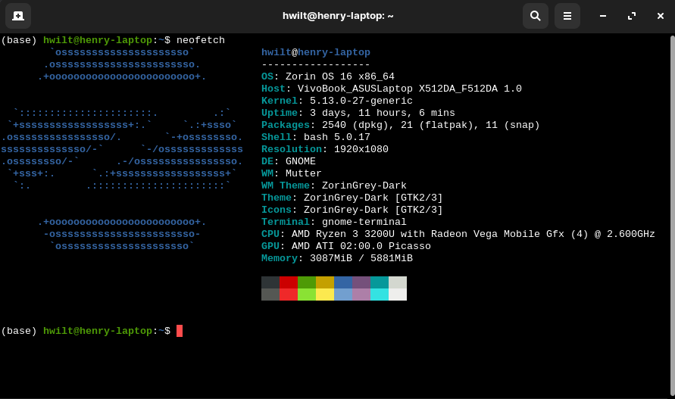https://www.amd.com/en/products/apu/amd-ryzen-3-3200u](https://www.amd.com/en/products/apu/amd-ryzen-3-3200u)

1. Find another type of device – it can be your phone, your tablet, your thermostat, your microwave. Do the same that you did for #1…. find out the following about the processor. Support your answers with screen grabs and/or urls to the information:
2. Model name, manufacturer

**Apple Iphone 12 mini, A14 Bonic chip**

1. Processor speed

**3.1Ghz**

1. How many cores it has

**6 CPU cores, 4 GPU cores**

1. How many threads it has

**6 threads**

<https://www.apple.com/iphone-12/specs/>

<https://en.wikichip.org/wiki/apple/ax/a14>

1. Compare these two devices. Could these processors be interchanged? Meaning could the processor in #1 be used in the device of #2 and vice versa? Why or why not?

**My laptop chip has 4 less cores and 2 less threads but the two processors can not be interchanged because they are build differently. My phone chip is based on the ARM architecture, while my laptop is based on the “Zen” core architecture.**

1. Recall that interrupts occur when the program does I/O operations. These could be to save something out to a file on the hard drive, to print something to a screen, to get keyboard input. Describe the process by which the processor would, say, receive input from the keyboard. (Section 1.2 may help)

**When a keyboard key is typed, the USB controller transfers the data from the device to its local buffer then it would put that data on the system bus. Which would take it to the CPU to do it’s operation on it and send it back out on the system bus where it would need to go. The interrupt is called when a key stoke is registered.**

1. Consider the following code. Consulting figure 1.5, what event might occur in this code? (Non-OS question – Does this code properly compute an average?)

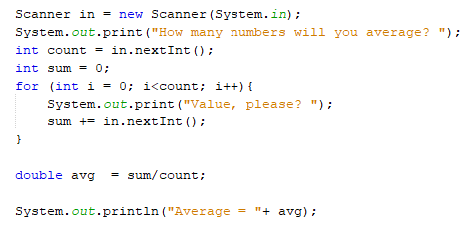

**There would be a system call and it would go into kernel mode/ wait for an interrupt key stroke. If you type a number that is not a int then the code would throw an error and would not work.**

1. Examine the following Java code. Would this code cause any instructions to be executed in kernel mode? Why or why not? (Hint: Section 1.4.2 and/or thinking in MIPS Assembly may help you out here)

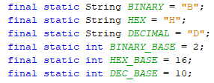

**Yes it would as it would have to be stored on the heap, which would need to be done by the kernel.**

1. Examine the following Java code. Would this code cause any instructions to be executed in kernel mode? Why or why not? (Hint: Section 1.4.2 and/or thinking in MIPS Assembly may help you out here)

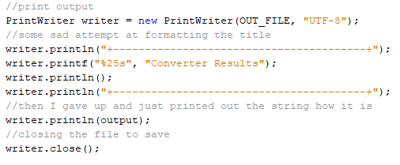

**Opening the file would cause the kernel mode to start up. Closing the file would cause kernel mode. Printing to the file is a system call which would cause kernel mode.**