Bioinformatics 1 – coursework 2
Report
Introduction
Data & Methods
Results
Part One – Autism Literature
- Task1 – plot a bar chart of the number of genes in each SFARI gene-score category (2 marks).
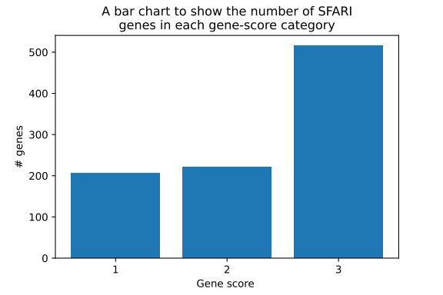
- Task2 – rank the genes by ‘number-of-reports’ and find the top 5 SFARI genes that are in gene-score category 1 (2 marks).
Rank | Gene Symbol | Number of reports
1 | NRXN1 | 94
2 | SHANK3 | 92
3 | MECP2 | 90
4 | SCN2A | 75
5 | SCN1A | 68

- Task3 – for each of these genes find the number of papers in PubMed that include include the gene AND are related to Autism (5 marks).
Gene | # PubMed autism-related articles
NRXN1 | 173
SHANK3 | 420
MECP2 | 517
SCN2A | 87
SCN1A | 68

- Task4 – from this data fill a table with genes as rows and paper count by year as column (3 marks).
Gene | # Articles Published
Gene | 1993 | 1999 | 2000 | 2001 | 2002 | 2003 | 2004 | 2005 | 2006 | 2007 | 2008 | 2009 | 2010 | 2011 | 2012 | 2013 | 2014 | 2015 | 2016 | 2017 | 2018 | 2019 | 2020 | 2021
NRXN1 | - | - | - | - | - | - | - | - | - | 1 | 6 | 12 | 8 | 17 | 16 | 17 | 16 | 16 | 5 | 11 | 8 | 18 | 10 | 12
SHANK3 | 1 | - | - | - | - | - | - | 1 | - | 4 | 7 | 9 | 5 | 18 | 16 | 19 | 31 | 27 | 39 | 38 | 49 | 44 | 53 | 59
MECP2 | 3 | 1 | 7 | 4 | 9 | 8 | 9 | 18 | 12 | 19 | 17 | 23 | 23 | 32 | 26 | 33 | 39 | 45 | 46 | 34 | 23 | 34 | 30 | 22
SCN2A | - | - | - | - | - | 1 | 2 | - | - | - | 2 | - | 1 | 1 | 1 | 2 | 5 | 4 | 7 | 8 | 11 | 16 | 9 | 17
SCN1A | 1 | - | - | - | - | 1 | 2 | 1 | - | - | 1 | 1 | - | 2 | 6 | 4 | 2 | 5 | 3 | 5 | 6 | 8 | 10 | 10

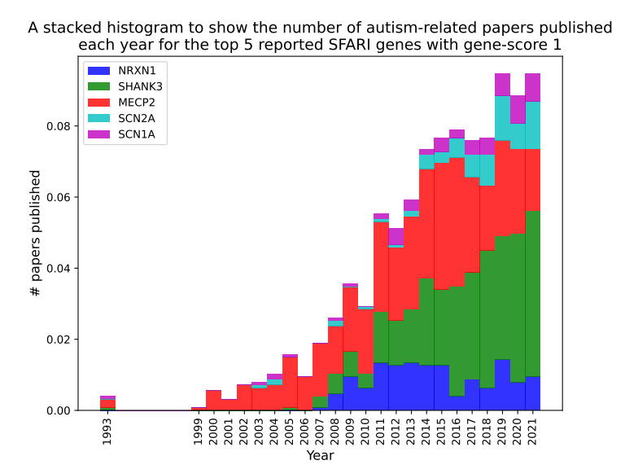
- Task5 – plot a single stacked histogram displaying the data from the table (3 marks).
- Comment on your results. You might want to think about the timescale over which papers have appeared, how different genes have fared over the years, how representative these 5 genes might be. Other factors to consider might be; how confident are you that the papers you have identified are related to Autism and why?
Possible extensions here might be to look at citation data, extend to more of the genes or even all of them.

Part Two – Autism Genes
Next we want to look at some of the functional terms that have been annotated to SFARI genes separating them out by their gene-score.
- Task 1 – Map the gene-symbol for every gene in the SFARI gene list to an NCBI UID (unique Entrez Gene identifier) (2 marks).
I completed this task using Python by iterating through each of the gene-symbols in the SFARI gene list, using Entrez.esearch to query the NCBI gene database, and using Entrez.read to read the results of the query. To be able to perform this query properly I made use of NCBI’s advanced search syntax which allowed me to filter my search by directly setting the gene symbol and the organism:
(<input gene-symbol>[sym]) AND homo sapiens[Organism]
When performing these queries a few of them returned more than 1 possible ID for a given gene-symbol, however, after further inspection I could see these IDs were typically for closely related genes or deprecated aliases, thus I always used the ID from the first/best hit found in my search.
In contrast, there were 3 gene symbols where the query did not return any hits: MSNP1AS, RP11-1407O15.2, RPS10P2-AS1.
All of the results for this task were appended to a dictionary data structure (allowing me to input the gene-symbol as a key and retrieve the relevant NCBI UID as the value), and a text file called “p2-t1.txt”.
Results summary statistics
# genes | # gene mappings found
1023 | 1020

- Task 2 – Using the gene2go file from NCBI that we worked with in week 8 find the Gene Ontology terms that have been annotated to all of the SFARI genes (4 marks).
I completed this task using Python.
Firstly, I filtered the gene2go file by taxonomic ID (where tax_id=9606) to ensure that we were only looking through human genes. Once this was done I iterated through every symbol in the SFARI gene list, retrieved it’s NCBI UID using the dictionary I created in task 1, and retrieved the Gene Ontology terms for the given gene-symbol.
All of the results for this task were appended to a dictionary data structure (allowing me to input the gene-symbol as a key and retrieve the relevant list of Gene Ontology terms) which was saved in a pickle file (“p2-t2-go-terms.pickle”).
After inspection of these results given some genes matched with multiple GO terms there were some repeated terms associated with some genes.
# of genes | # of genes with GO terms | Average # GO terms per gene (with repetitions) | Average # GO terms per gene (with no repetitions)
1023 | 1015 | 26.96 | 23.42

- Task 3 – Now split the genes up into three lists by their SFARI gene-score (1 mark).
I completed this task using Python.
Gene-score | Number of genes
1 | 206
2 | 221
3 | 515

- Task 4 – Create tables of the 10 most commonly annotated terms for each gene list. The tables should have the following columns: GO term ID, GO term Description, GO term count (3 marks).
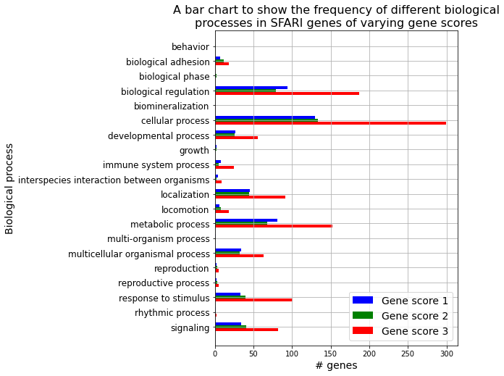
- Task 5 – Take the three lists of UIDs created above and use the PantherDB tool - http://pantherdb.org/ to perform a “Functional classification viewed in graphic charts” analysis reporting and select the “Bar chart” display option, using default settings. Once on the results page displaying the bar chart use the pull-down menu to change the ontology to “Biological Process”. Click the small (!) “export” button to download the results as a text file and us this to make your own bar chart (5 marks).
- Compare and contrast your results from Tasks 4 and 5 and any differences you find between the gene lists from the different gene-score categories in the SFARI gene lists. What can you say about Autism genes based on the results from these analyses?
Possible extensions here might be to explore other pathway analysis tools and websites such as KEGG and Reactome. You could also chose to perform a statistical analysis directly on the results from Task 4.
Part Three – Autism Gene Networks
We now want to see if there’s any evidence that these proteins work together. One way to look at this is to look at whether any of their proteins physically interact in a co-ordinated way. To assess this, you will now do some basic network analysis on protein-protein interaction data.
- Task 1 – Create a plain text file of the NCBI UIDs for all of the gene-score 1 SFARI genes. Then, using the STRING website (https://string-db.org/) upload the gene-score 1 gene list, select “homo sapiens” as the species and hit search then click continue to visualise the protein-protein interaction network. In this network the genes are the nodes and the interactions between them the edges (connections). Click the “analysis” option near the bottom and report the following statistics: “number of nodes”, “number of edges” and “average node degree” (3 marks).
Number of nodes = 204
Number of edges = 1376
Average node degree = 13.5
*Note: when performing a multiple protein search on https://string-db.org/ some reason some of my genes do not get matched. I input 206 genes, however, the clustered output reports there only being 204 nodes (where each node represents a gene). After reviewing my searches gene matches it seemed to only not be able to match a single gene (85358) where it gave me the following error: "Sorry, STRING found no proteins by this name in Homo sapiens". However, I know this ID is valid as shown here: https://www.ncbi.nlm.nih.gov/gene/?term=85358%5Buid%5D.
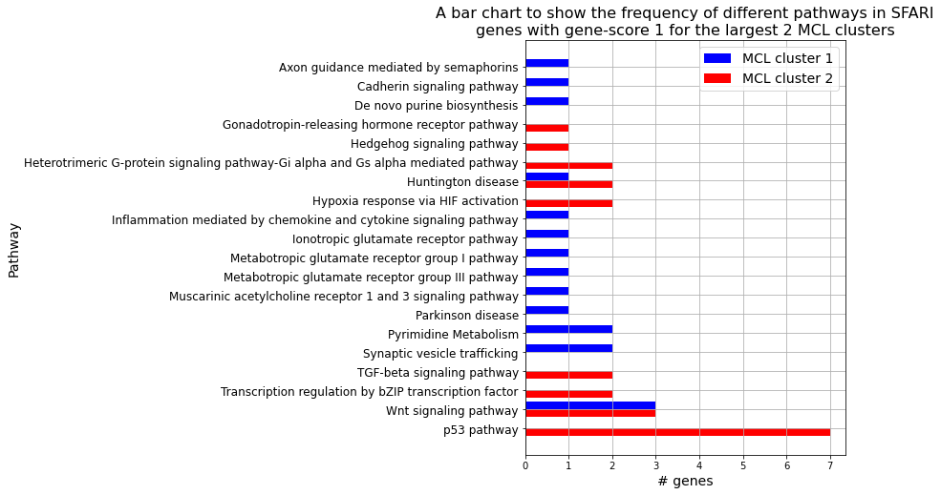
- Task 2 – Click the “cluster” option and select “MCL clustering” with the default option. Download the “MCL clusters in TSV format” file. From this, find the two biggest clusters produced by the MCL clustering and use the PantherDB tool as in Part Two to analyse the function of genes in these clusters. This time instead of selecting “Biological Process” ontology use the “Pathway” ontology (6 marks).
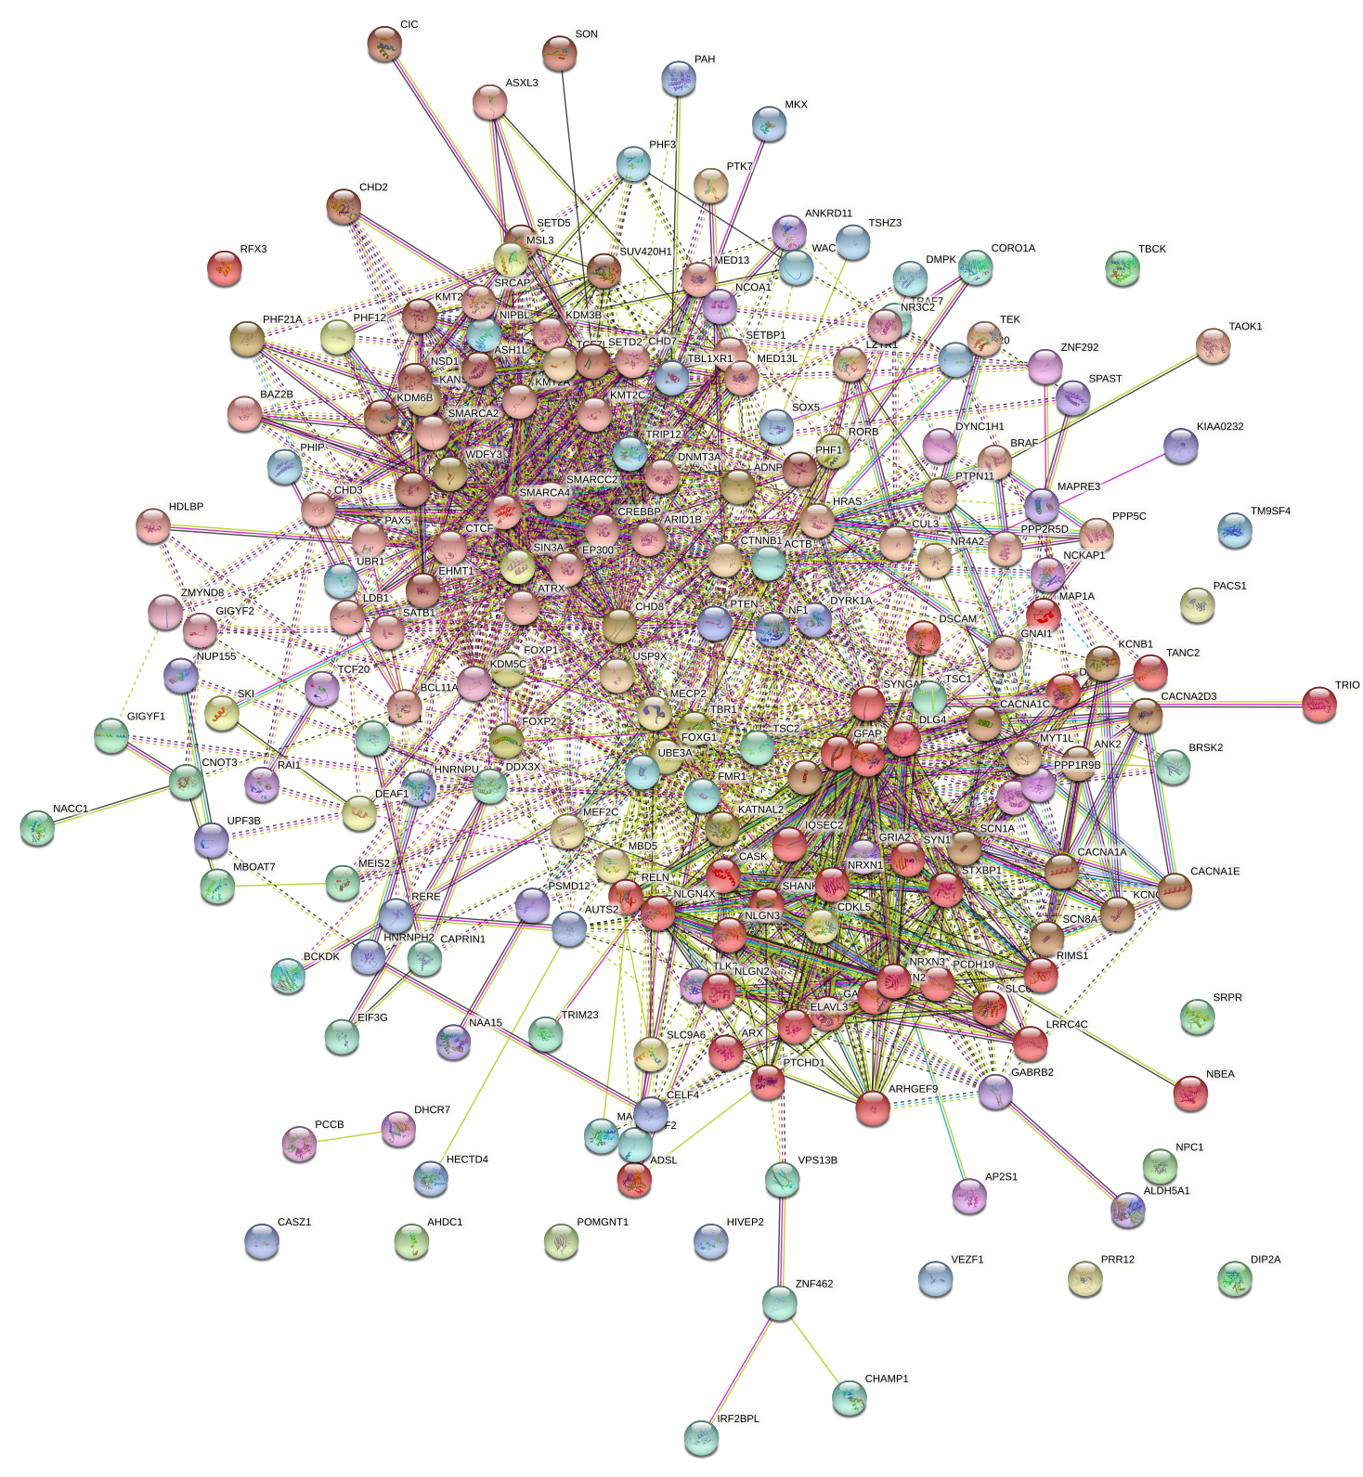
- Task 3 – Click the “exports” option and download the network as a “bitmap image” file (1 mark).
- Compare and contrast your results from the two clusters above, commenting on the functional differences highlighted by the Panther tool. Also, compare back to your findings from Part Two.
Possible extensions would be to repeat these analyses with other gene-score restricted lists and with them all combined. Also, using other ontologies with the Panther tool to explore cluster functions.

Discussion
References

