Chapter 1
Computer Networks and the Internet

1.1 What Is the Internet?

 | A Nuts and Bolt View | A Serivce View
접근  방식 | Bottom-up approach | Top-down approach
대상 | 인터넷을 구성하는 하드웨어 및 소프트웨어 컴포넌트 | distributed applications
특징 | 인터넷은 end system(또는 host)과  communication link으로 구성되어 있다.  인터넷을 구성하는 장치들은 TCP/IP 프로토콜을 실행한다.  End system은 router를 통해서 다른 system들과 간접적으로 연결되어 있다.  Internet is network of networks.  인터넷 표준(internet standards)을 통해 인터넷이 만들어지고, 테스트되며, 구현된다. IETF에서 이를 만들었고, RFC 문서를 제작하였다. | 인터넷은 distributed application을 통해서 데이터를 교환한다.  (웹은 분리된 네트워크라기 보다는 인터넷 서비스를 사용하는 분산 어플리케이션이라고 할 수 있다)  Communication Service  - Connection oriented service  - Connectionless service  현재의 인터넷은 데이터를 전송하는데 시간이 얼마나 걸리는지 보증하는 서비스를 제공하지 않는다.  인터넷은 infrastructure이다.
세부  사항 | End system(host)  Router  IETF: Internet Engineering Task Force  RFC: Request For Comments | Distributed application

1.2 What Is a Protocol?
 | A Human Analogy | Network Protocols
대상 | 사람 | 컴퓨터
의미 | 사람들 간의 의사소통 방식 | 네트워크에서 데이터를 주고 받기 위해 만들어진 규약
특징 | 사람들은 특정 메시지를 보내고, 그에 따른 응답을 하거나 어떤 행동을 취한다. 만약 응답이 없는 경우에는 다른 행동을 취하기도 한다. | (1) All communication activity is govern-ed by protocols.  (2) They define format, order of messa-ges sent and recei-ved among net-work entities, and actions taken on message transmi-ssion, receipt.

A human protocol and a computer network protocol
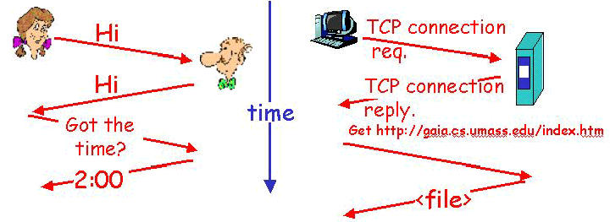

1.3 The Network Edge

1.3.1 End Systems, Client, and Servers
 | Concepts | Example
End System | - 네트워크에서 사용되는 컴퓨터(= host)
Client | - 서버에게 정보를 요청하거나 받는 컴퓨터
Server | - 클라이언트로부터 받은 요청에 따라 정보를 보내주는 컴퓨터
Client/Server  Model | - Client host requests, receives service from server.  - Assymetric | WWW client/server;  E-mail client/server
Peer-to-peer  Model | - Host interaction is symmetric. | Teleconferencing

End-System Interaction
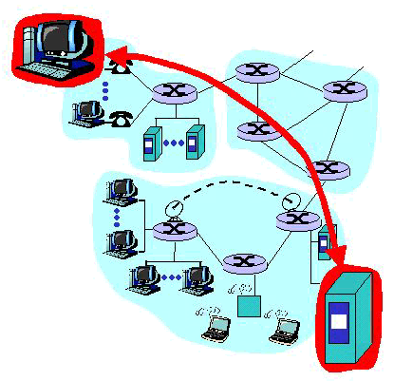

1.3.2 Connectionless and Connection-Oriented Services
 | Connection-Oriented Services | Connectionless Services
특징 | - Handshaking Procedure  - Client/server send control pac-  kets to each other before sen-  ding packets with real data.  - TCP(Transfer Control Protocol) | - No handshaking Procedure  - UDP(User Datagram Protocol)
Service | - Reliable data transfer  - Flow control  - Congestion control | - Unreliable data transfer  - No flow control  - No congestion control
장점 | - 데이터를 안전하게 전송 | - 데이터 전송 속도가 더 빠르다.
단점 | - Connectionless service보다는 전송 속도가 느리다. | - 중간에 데이터가 손실되어도 데이터를 다시 보내지 않는다.
Ex. | HTTP(WWW), FTP, Telnet, SMTP | Streaming media, Teleconferencing,  Internet telephony

(참고)
Service | Functions
Reliable Data Transfer | An application can rely on the connection to deliver all of its data without error and in the proper order.
Flow Control | Neither side of a connection overwhelms the other side by sending too many packets too fast.
Congestion Control | It helps prevent the Internet from entering a state of gridlock.

1.4 The Network Core

- How to transfer data through net?
- There are mesh of interconnected routers.
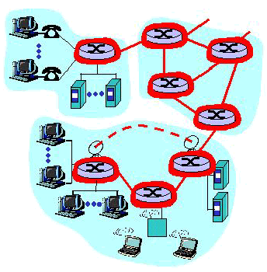

1.4.1 Circuit Switching, Packet Switching and Message
Switching

- Circuit Switching and Packet Switching
 | Circuit Switching | Packet Switching
특징 | - Dedicated circuit per call  - End-to-end resources reserved for call  - Link bandwidth, switch capacity  - Circuit cannot be shared | - Each end-to-end data stream divided into packets.  - Share network resources  - Each packet uses full link band-width one at a time  - Resources used as needed
 | - FDM  - Frequency Division Multiplexing  - TDM  - Time Division Multiplexing | - Store-and-forward  - Packets move one hop at a time
장점 |  | - More users can use networks
단점 |  | - Excessive congestion  → Packet delay and loss

Circuit Switching
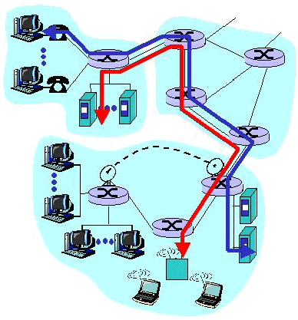

FDM & TDM
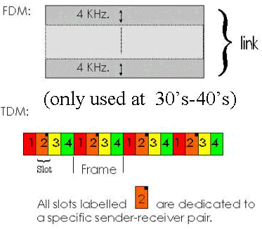

Packet Switched Network
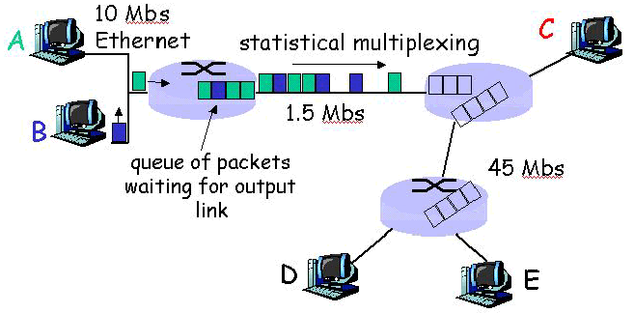
(Statistical multiplexing: Packets are sent whenever they happen to be present at the link.)

Store-and-forward Behavior
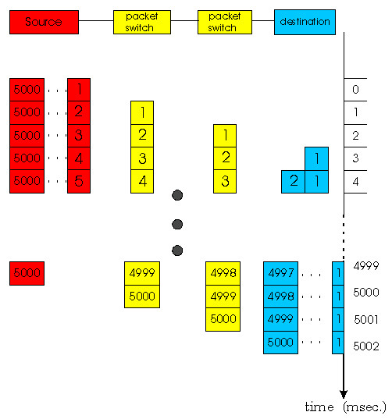

Message Switching
If the source do not segment messages, the packet-switched network performs message switching.

1.4.2 Routing in Data Networks

Two broad classes of packet-switched networks: virtual circuit networks and datagram networks.

 | virtual circuit networks | datagram networks
의미 | Any network that routes packets according to virtual circuit numbers | Any network that routes according to host destination addresses
특징 | It consists of  (1) path(a series of links and packet  switches)  (2) virtual circuit numbers  (3) entries in VC-number translation  tables in each packet switch along  the path.  Fixed path determined at call setup time, and remains fixed through call.  Network’s switches must maintain state information → expensive and better | Each packet that traverses the network contains in its header the address of the destnation.  When a packet arrives at a switch, the switch examines the address and indexes its table with this address to find the appropriate outbound link. The switch then sends the packet into this outbound link.  Datagram networks do not maintain connection-state information in their switches.
장점 | It can offer applications a wider variety of networking services.
단점 | More complex because it must main-tain connection-state information in their switches.

1.5 Access Networks and Physical Media

1.5.1 Access Networks

The physical link(s) that connect an end system to its edge router(to the first router on a path from the end system to any other distant end system).
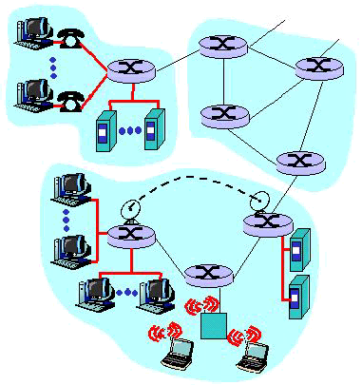

종류 | Residential  Access Networks | Institutional  Access Networks | Mobile  Access Networks
의미 | Connecting a home end system into the network | Connecting an end system in a business or educational institution into the network | Connecting a mobile end system into the network
특징 | The access network is sim-ply a point-to-point dialup link into an edge router. | A LAN is used to connect an end system to an edge rou-ter. | It uses the radio spectrum to connect a mobile end sys-tem
종류 | using modem  ISDN  ADSL  HFC | Ethernet | CDPD
Link | Twisted-pair line  Coaxial Cable(HFC) | Twisted-pair line  Coaxial Cable

Access network의 세부 종류
종 류 | 특 징 | 전송 속도
ISDN | All-digital transmission | 128Kbps
ADSL | New modem technology again running over exsi-ting twisted-pair lines. | up to 1Mbps home-to-router  up to 8Mbps router-to-home
HFC | Extensions of the current cable network used for broadcasting cable.  It requires special modem, cable modem. Cable modems divide the HFC network into 2 channels, a downstream and an upstream channel. | up to 10Mbps upstream  up to 1Mbps downstream
Ethernet | Shared or dedicated cable connects end system and router. | 10Mbps  100Mbps
Switched  Ethernet | It used multiple coaxial cable or twisted-pair Ethernet segments connected at a “switch”
CDPD | An emerging standard for wireless data networking.  Wireless access to ISP router via cellular network.  Currently intelligent handphones includes the functi-on of CDPD. | Tens of Kbits per second

1.5.2 Physical Media
For each transmitter-receiver pair, the bit is by propagating electromagne-tic waves or optical pulses across a physical medium. The physical medi-um can take many shapes and forms and does not have to be of the same type for each transmitter-router pair along the path.

Two categories
Guided Media | The waves are guided along a solid medium.
Unguided Media | The waves propagate in the atmosphere and in outer space.

Some popular Physical Media

(The actual cost of the physical link is often relatively minor compared with the other networking costs.)

종 류 | 특 징 | 장 점 | 단 점
Twisted-Pair  Copper Wire | Two insulated copper wires. | The least-expensive and most used media.
Coaxial Cable | Wire(signal carrier) within a wire(shield)
Fiber Optics | A thin, flexible medium that conducts pulses of light | Tremendous bit rates, up to ten or even hundreds of gigabits per second | The high cost of optical devices
Terrestrial and
Satellite Radio
Channels

Twisted-Pair Copper Wire
종 류 | 특 징 | 전송량
Category 3 | Traditional phone wires | 10Mbps
Category 5 | UTP(Unshielded Twisted Pair)  Used for LAN. | 100Mbps

Coaxial Cable
종 류 | 특 징 | 전송량
Baseband | Single channel on cable | 10Mbps
Broadband | Multiple channels on cable | 100Mbps
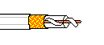

1.6 Delay and Loss in Packet-Switched Networks

1.6.1 Types of Delay

종 류 | 의 미 | 공 식
Processing  Delay | The time required to examine the packet’s header (checking bit errors) and determine where to direct the packet
Queueing  Delay | The time waiting at output link for transmission.  It depends on congestion level of router | La/R  (less than 1)
Transmission  Delay | The amount of time required to transmit all of the packet’s bit into the link | L/R
Propagation  Delay | The time required to propagate from the beginning of the link to router B | d/s
End-to-End  Delay | The delay from source to destination
(L: packet length(bits), R: link bandwidth(bps), a: average packet arrival
rate, d: length of physical link, s: propagation speed in medium)

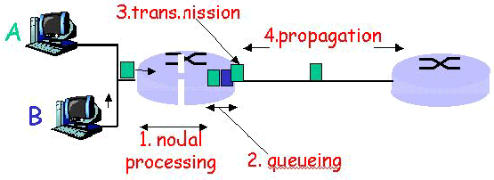

Packet Loss

With no place to store such a packet, a router will drop that packet.
→ Packet will be lost.

A lost packet may be retransmitted on an end-to-end basis, by either the application or by the transport layer protocol.

1.7 Protocol Layers and Their Service Models

1.7.1 Layered Architecture

의미 | Network protocols are organized in layers.
특징 | There’s a piece of layer n in each of network entities. These pieces commu-nicate with each other by exchanging layer-n messages.  When layer n of Host A sends an n-PDU to layer n of Host B, layer n of Host A passes the n-PDU to layer n-1 and then lets layer n-1 deliver its n-PDU to layer n of B.
장점 | It is much easier to change the implementation of service provided by the layer. As long as the layer provides the same serivce to the layer above it, and uses the same services from the layer below it, the remainder of the system remains unchanged when a layer’s implementation is changed.
단점 | (1) One layer may duplicate lower-layer functionality.  (2) Functionality at one layer may need information that is present only in  another layer.
(n-PDU: layer-n protocol data units, layer n messages)

Protocol Layering

Consider a network that organizes its communication protocols in n layers.
특징 | The application, operating at the highest layer, layer n, creates a messagen M(n-PDU). And within the contents of the entire message M is passed down the protocol stack to layer n-1. The procedure continues in the source, adding more header at each layer, until 1-PDUs are created.
Interface | In order for one layer to interoperate with the layer below it, the interfaces between the two layers must be precisely defined.

Layer Functions

Error Control | It makes the logical channel between the layers in two peer network more reliable.
Flow Control | It avoids overwhelming a slower peer with PDUs.
Segmentation and Reassembly | It at the transmitting side divides large data chunk into smaller pieces and at the receiving side reassembles them into the original large chunk
Multiplexing | It allows several higher-level sessions to share a single lower-level connection.
Connection Setup | It provides handshaking with a peer.

1.7.2 The Internet Protocol Stack

5 layers
Layers | 의 미 | Protocol | PDU
Application | Supporting network application  (Netscape, IE는 그보다 상위층의 application) | FTP, SMTP, HTTP | Message
Transport | Host-to-host data transfer | TCP, UDP | Segment
Network | Routing datagrams from one host to ano-ther | IP, routing  protocols | Datagram
Link | Data transfer between neighboring network elements(from one node to the next node) | Ethernet  PPP | Frame
Physical | Move the individual bits within frame from one node to the next |  | 1-PDU

Protocol Layering and Data
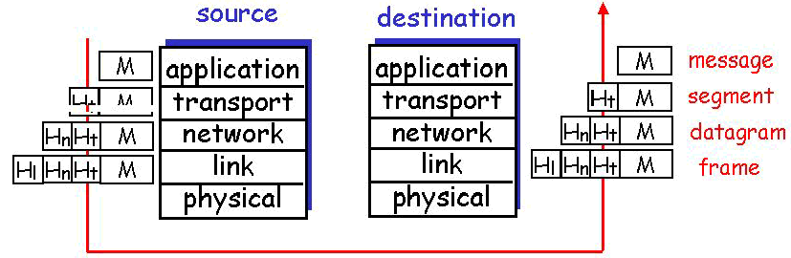

1.7.3 Network Entities and Layers

Network Entities |  |  | layer
end systems |  |  | 1 ~ 5
packet  switches | routers | No application layer, transport layer | 1 ~ 3
packet  switches | bridges | No application layer, transport layer, network layer | 1, 2

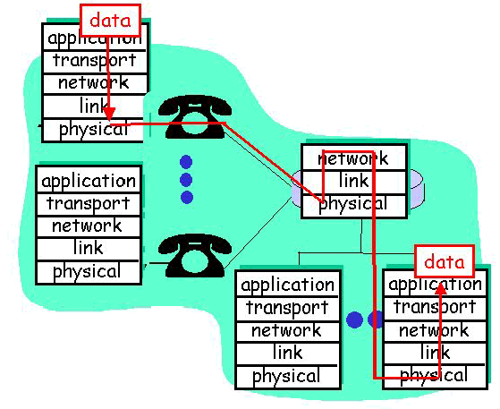

1.8 Internet Backbones, NAPs, ISPs

NAPs and ISPs |  | 특 징
ISP | Local ISP | End systems is connected to it
ISP | Regional ISP | The Local ISPs are connected to it.
NSP(National Service Provider) |  | The national ISP residing at the very top of the hiararchy
NAP(Network Access Point) |  | It interconnects the NSPs

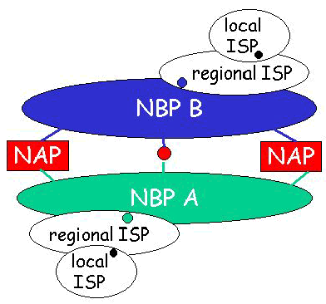

1.9 A Brief History of Computer Networking
and the Internet

1.9.1 Development and Demonstration of Early Packet
Switching Principles: 1961 ~ 1972

언제? | 누가? | 무엇을?
1961 | Kleinrock | Queueing Theory(shows effectiveness of packet switching)
1964 | Paul Baran | Investigating the use of packet switching for secure voice over military networks.
1967 | Advanced Research Projects Agency | ARPAnet  - The first packet switched network  - A ancestor of today’s public internet
1969 |  | First ARPAnet node operational
1972 | Robert Kahn | ARPAnet was given its first public demonstration.  The first host-to-host protocol was completed: NCP  (Network Control Protocol)
1972 | Ray Tomlinson | The first e-mail program was written
1972 |  | ARPAnet has 15 nodes

1.9.2 Internetworking, and New and Proprietary Networks
: 1972 ~ 1980

언제? | 누가? | 무엇을?
중반 |  | ALOHAnet(satelitte network) in Hawaii
1973 | Metcalfe’s Ph.D | He laid out the principle of Ethernet.
1974 | Vinton Cerf,  Robert Kahn | Pioneering network on interconnecting networks in essence creating a network of networks
1975 | Digital Equipment  Corporation | It released the 1st version of the DECnet.
 | Xerox, IBM | Other players(SNA, XNA, respectively)
1979 |  | ARPAnet has 200 nodes

1.9.3 A Proliferation of Networks: 1980 ~ 1990

언제? | 누가? | 무엇을?
1983 |  | The official deployment of TCP/IP
1983 |  | Domain Name System, its 32-bit IP address was developed.
1985 |  | FTP
1988 |  | Import extensions were made to TCP to implement host-based congestion control.
후반 |  | 100,000 hosts connected to confederation of networks

1.9.4 Commercialization and the Web: The 1990s

언제? | 누가? | 무엇을?
초반 |  | ARPAnet ceased to exist.
1991 |  | NSFNET lifted its restrictions on commercial use.
초반 |  | The release of the World Wide Web
초반 | Tim Berners-Lee | Developed initial versions of HTML, HTTP, a Web server,  and a browser.
1993 | Marc Andreesen | GUI browser, Mosaic is released.
후반 |  | Commercialization of the WWW  Est. 50 million computers on Internet  Est. 100 million users  Backbone links running at 1 Gbps

