Chapter 2 Application Layer

2.1 Principle of Application Layer Protocols

2.1.1 Application Layer Protocols

Applications and Application Layer Protocol
Jargon | Concepts
Networking  Applications | Communicating, distributed processes.  They exchanges message to implement application.  It has application layer protocols
Application  Layer Protocols | One piece of a network application.  Protocol defines messages exchanged by applications and ac-tions taken.

Process and User Agent
Jargon | Concepts
Process | - A program that is running within a host.  - Within the same host, 2 processes communicate with  interpro-cess communication defined by the OS.  - Processes running in different hosts communicate with and  application-layer protocol.
User Agent | - An interface between user and network application.  (Ex.) Web browser, Mail reader, Media player

Client and Servers
 | Concepts | Example
Client | It typically requests service to server  It initiates contact with server(“speaks first”). | Web browser  Mail reader/sender
Server | It provides requested service to client | Web server, Mail server
A host can actually acts as both a client and a server at the same time.

Processing Communicating Across a Network
 | Concepts
Socket | A process sends messages into, and receives message from, the network through its socket. It is the interface between appli-cation layer and the transport layer within a host.
API | Socket API defines interface between application and transport layer

Addressing Processes
Question | How does a process identify the other process with which it wants to communicate?
Answer | IP address of host running other processes  Port number allows receiving host to determine to which local process the message should be delivered.

2.1.2 What Services Does an Application Need?

Dimension | Meaning
Data Loss | - Text service require 100% relieable data transfer.  - Multimedia applications can tolerate some loss.
Bandwidth | - Realtime multimedia applications require minimum amount of band-  width to be effective. (Bandwidth-sensitive applications)  - Other applications make use of whatever bandwidth they get.  (Elastic applications)
Timing | - Interactive real-time applications require low delay to be effective.

2.1.3 Services Provided by the Internet Transport
Protocols
TCP Services | UDP Services
Reliable transport | Unreliable data transfer
Connection-oriented | Connectionless
Flow control | No flow control
Congestion Control | No congestion control
Both TCP and UDP provides no guarantee on delay

2.2 The World Wide Web: HTTP
(HyperText Transfer Protocol)

2.2.1 Overview of HTTP

Some Jargon
Jargon | Concepts
Web Page | It consists of objects(simply files), and is addressed by a URL.  Most web pages consists of base HTML page, and several referenced objects.
URL | It has 2 components: host name and path name  (Ex.) Host name: www.someSchool.edu  Path name: /someDept/pic.gif
Browser | It’s a user agent for the Web.  Web browsers also implement the client side of HTTP.
Web Server | It houses Web objects, and implements the server side of HTTP.  (Ex.) Apache, MS Internet Information Server
HTTP | It defines  (1) How Web clients request Web pages from servers,  (2) How servers transfer Web pages to client.

The HTTP Protocol: More
HTTP | Meaning
HTTP  over TCP | Step 1 | Client initiates TCP connection(create socket) to server, port 80
HTTP  over TCP | Step 2 | Server accepts TCP connection from client
HTTP  over TCP | Step 3 | HTTP messages exchanged between browsers and web servers.
Stateless | Server maintains no information about past client requests.  Cookies are not state in strict sense.

2.2.2 Nonpersistent and Persistent Connections

Nonpersistent Connections | Persistent Connections
HTTP/1.0 | HTTP/1.1
An object can be sent on a TCP connection | Multiple objects can be sent on A TCP connection
Server parses request, responds, and closes TCP connection | Server parses request, responds, parse new request, ……
 | Client sends requests for all referenced objects as soon as it received base HTML.
2RTTs to fetch each object | Fewer RTTs and less slow start

2.2.3 HTTP Message Format

- Two types of HTTP messages: request, response
- HTTP request message: ASCII(human-readable format)

- Request Message
Request Line | GET /somedir/page.html HTTP/1.0
Headlines | User-agent: Mozilla/4.0  Accept: text/html, image/gif, image/jpeg  Accept-language: fr

- Response Message
Status Line | HTTP/1.0 200 OK
Headlines | Date: Thu, 06 Aug 1998 12:00:15 GMT  Server: Apache/1.3.0 (Unix)  Last-Modified: Mon, 22 Jun 1998 … . . .  Content-Length: 6821  Content-Type: text/html
Entity Body | data data data data data …

- Response Status Code
Code | Meaning
200 | OK
301 | Move Permanently
400 | Bad Request
404 | Not Found
505 | HTTP Version Not Supported

2.2.4 User-Server Interaction
: Authentication and Cookies

 | Authentication | Cookies
의 미 | Requirement that An user need an username and a password. | 웹 브라우저에서 현재의 상태를 보관하기 위해 임시로 사용하는 데이터 파일의 이름
목 적 | Control access to server documents | An alternative mechanism that sites can use to keep track of users.
특 징 | Stateless  - Client must present authori-zation in each request  - Browser가 이를 대신 해줌  Authorization  - name, password  - Header line in request  - Without it, server refuses access, sends. | Server sends cookies to client in response message.  Set-cookie: 1678453  - Client presents cookies in later requests.  Cookie: 1678453  - Server matches presented-cookie with server-stored information.

2.2.5 The Conditional GET

Cond. GET | Concepts
의미 | A mechanism that allows the client to employ caching while still ensuring that all objects passed to the browser are up to date.
Goal | Don’t send object if client has up-to-date stored (cached) version.
Client | It specify date of cached copy in HTTP request.  If-modified-since: <date>
Server | It response contains no object if cached copy is up-to-date.  HTTP/1.0 304 Not Modified

2.2.6 Web Cashes

Web Cashes | Concepts
의 미 | They have its own disk storage and keeps in this storage copies of recently requested objects.
Goal | Satisfy client request without involving origin server.
역 할 | If there are objects at web cache, it immediately returns objects in HTTP.  - Else the server request objects from origin server, then returns HTTP response to client.
Why Web  Cashing? | (Assume: Cache is closer to client.)  It reduces response time.  - It can reduce traffic.  (Distant servers link out of institutional/local ISP.)  (This part is major bottleneck in Internet.)

2.3 File Transfer: FTP

- A protocol for transferring a file from one host to another host.
- Described in RFC 959.
- Client/Server Model
 | Functions
Client | A side that initiates transfer(either to/from remote)
Server | Remote host  FTP servers maintain “state”  (current directory, earlier authentication.)

- FTP uses 2 Parallel TCP Connections
 | Fuctions | Port
Control  Connection | Used for sending control information.  Exchanges commands, responses between client/server. | 21
Data  Connection | Used to actually send data to/from server | 20

2.3.1 FTP Commands and Replies

Commands | Responses
- They are sent as ASCII text over control channel | - Status code and optional message following the code
- USER username  - PASS password  - LIST  - RETR filename  - STOR filename | - 331 Username OK, password re-quired  - 125 data connection already open; transfer starting  - 425 Can’t open data connection  - 452 Error writing file

2.4 Electronic Mail in the Internet

- 3 Major Components
Components | Concepts
User Agent | It allows users to read, reply to, forward, save, and compose messages.  Mail Reader
Mail Server | It has mailboxes that contain incoming messages for user  It has message queue of outgoing mail messages.
SMTP | Simple Mail Transfer Protocol  It transfers messages from senders’ mail servers to the recipients’ mail servers.  It has 2 sides  Client side: executes on the sender’s mail server  Server side: executes on the recipient’s mail server.

2.4.1 SMTP

- Defined in RFC 821
- SMTP uses TCP to reliably transfer e-mail message
- SMTP uses persistent connections
- Direct Transfer
- Port: 25

- 3 phases of transfer
  - Handshaking(greeting)
  - Transfer of message
  - Closure

- Command/Response interaction
Commands | Responses
- ASCII text | - Status code and phrase

- Message must be in 7-bit ASCII.
- Certain characters strings are not permitted in message.
  - (Ex.) CRLF.CRLF(CR: Carriage Return, LF: Line Feed)
    - CRLF.CRLF used by SMTP server to determine end of message.
  - Thus message has to be encoded
    - usually into either base-64 or quoted printable

2.4.2 Comparison with HTTP

 | HTTP | SMTP
Transfer | - from Web server  - to user agent | - from one mail server  - to another mail server
Connection | - Persistent Connection
Protocol | - Pull Protocol  - Users use HTTP to pull the information from the server | - Push Protocol  - The sending mail server pushes the file to the receiving mail server
How is a do-cument han-dled? | - Each object is encapsula-ted in its own response message | - Multiple objects message sent in a multipart message

2.4.3 Mail Message Formats and MIME

- Mail Message Format
  - Header Line
    - (1) To: (2) From: (3) Subject:
    - Example
From: alice@crepes.fr
To: bob@hamburger.edu
Subject: Searching for the meaning of life.
  - Blank Line: It separates the header line and the body
  - Body
    - The message
    - ASCII characters only

- The MIME Extension for Non-ASCII Data
  - MIME
    - Multipurpose Internet Mail Extensions
  - Message Format
의 미 | Message Format
MIME version  Method used to encode data  Multimedia data type, subtype  Encoded data | From: alice@crepes.fr  To: bob@hamburger.edu  Subject: Picture of yummy crepe.  MIME-Version: 1.0  Content-Transfer-Encoding: base64  Content-Type: image/jpeg  base64 encoded data ……  ……………………………………………………………………  ……base64 encoded data

2.4.4 Mail Access Protocol

- It transfers from a recipient mail server to a local PC.
(Recall that SMTP is a push protocol, not pull protocol)
- Popular mail access protocol
  - POP3(Post Office Protocol version 3)
    - Authorization(agent ↔ server) and download
  - IMAP(Internet Mail Access Protocol)
    - More features(→ more complex)
    - Manipulation of stored messages on server

2.5 DNS

- Hostname
  - One identifier for a host
  - Host are also identified by IP address.

- IP Address
  - It consists of 4 bytes(32 bits).
  - Used for addressing datagrams

- Domain Name System(DNS)
  - A directory service: hostnames → IP addresses

2.5.1 Services Provided by DNS

- Domain Name System(DNS)
  - Distributed database implemented in a hierarchy of name servers
  - Application-layer protocol that allows hosts and name servers to communicate in order to provide the translation service

2.5.2 Overview of How DNS Works

- DNS is not centralized. Why?
  - Single point of failure
  - Traffic volume
  - Distant centralized database
  - Maintenance

- No one name server has all of the mapping for all of the hosts in the Internet.(distributed)

- 3 Types of name servers
Name Server | Functions
Local  Name Server | Each ISP has a local name server.  When a host issues a DNS query message, the message is first sent to the host’s local name server..
Root  Name Server | Whan a local name server can’t satisfy a query from a host, it behaves as a DNS client and queries one of root name servers.  If the root name server doen’t have a record for the hostna-me, it contacts authoritative name server.  Dozen root name servers worldwide..
Authoritative  Name Server | It stores that host’s IP address, name.  It can perform name/address translation for that host’s name..

- Simple DNS example
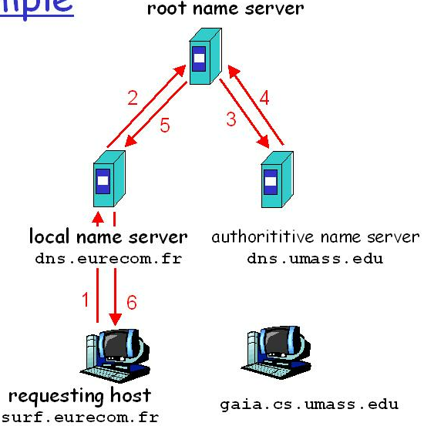

- Recursive Queries and Iterative Queries
Queries | Assumption | Functions
Recursive  Queries | When a host or name server A makes a query to a name server B, | Then name server B, then name server B obtains the requested mapping on behalf of A and then forwards the mapping to A.
Iterative  Queries |  | If name server B does not have the requested mapping, it immediately sends a DNS reply to A that contains the IP address of the next name server in the chain, say, name server C.

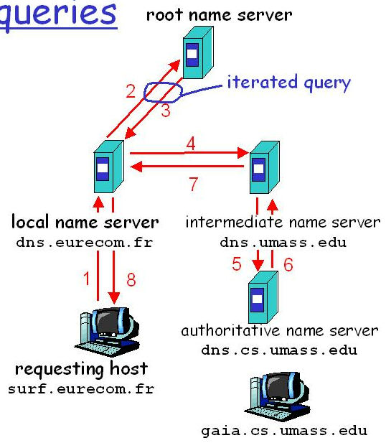

- DNS Caching
  - When a name server receives a DNS mapping for some hostname, it caches the mapping in local memory(disk or RAM).
  - In order to deal with ephemeral hosts, a cached record is discarded after a period of time(often set to 2 days).

