Chapter 3
Transport Layer

3.1 Transport Layer Services and Principles

- What is transport service?
  - Transport services provide logical communication between application processes running on different hosts.
  - Transport protocols run in end systems.

- Transport services vs Network services
Transport Services | Network Services
- Data transfer between processes | - Data transfer between end systems

- Types of Transport Service
TCP | UDP
- Reliable, in-order unicast delivery  - Congestion  - Flow control  - Connection setup | - Unreliable, unorder unicast or multicast delivery  (Multicast는 router가 지원한다는  조건 아래 이루어진다.)
- Not provided serices
  - Real-time
  - Bandwidth guarantees
  - (Reliable) Multicast

3.2 Multiplexing and Demultiplexing Applications

- What are multiplexing, demultiplexing?
Multiplexing | Demultiplexing
- Gathering data from multiple appli-cation processes, enveloping data with header | - Delivering received segments to correct application layer process
- Based on sender, receiver port numbers, IP addresses

Source port number  (16 bits) | Destination port number  (16 bits)
Other header files
Application data
(Message)

  - Why needs destination port-number field?
- An end system may be running 2 processes of the same type at the same time, and thus the port destination number of an application may not suffice to identify a specific process.

  - What happen if the same port number x is used for 2 different hosts?
- Servers use the IP address in the IP datagrams carrying these segments.

- Examples
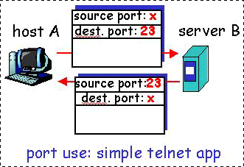
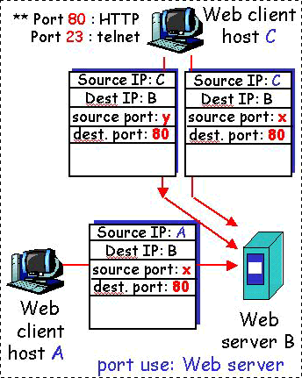

3.3 Connectionless Transpot: UDP

- What is UDP?
  - No-frills(cheap decoration), bare-bones transport protocol.
  - UDP does just about as little as a transport protocol can do.
  - Best effort service
  - UDP segments may be
    - lost
    - delivered out of order to applications
  - Connectionless
    - No handshaking between UDP sender, receiver

- Why UDP?
- No connection establishment (→ less delay)
- Simple: No connection state at sender, receiver
- No congestion control (unregulated send rate)
- Small segment header

  - Using UDP
(1) Streaming multimedia application
(2) DNS (It don’t want overhead, but want quick reply.)
(3) SNMP: Emergent reply

- UDP Segment Format
Source port number  (16 bits) | Destination port number  (16 bits)
Length | Checksum
Application data
(Message)
  - Length: The length of the UDP segment (including the header)
  - Checksum: In order to check if error have been introduced.

3.4 Principle of a Reliable Data Transfer

- It is the responsibility of a reliable data transfer protocol to implement the service abstraction.
- This task is made difficult by the fact that the layer below the reliable data transfer protocol may be unreliable.
- Reliable data transfer: Service model and service implementation
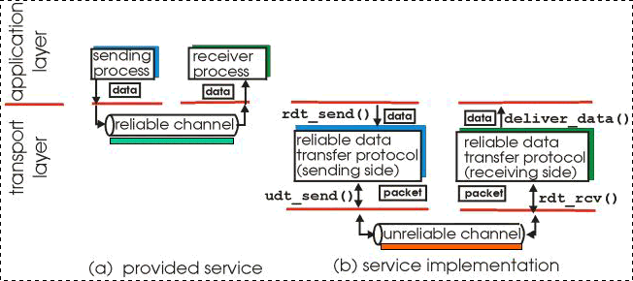

Function | When called? | Which side?
rdt_send() | When passed data to deliver to receiver upper layer. | Sending side
rdt_rcv() | When a packet arrives from the receiving side of the channel. | Receiving side
deliver_data() | When the rdt protocol wants to deliver data to the upper layer. | Receiving side
udt_send() | When they send packets to the other side | Both

- Assumption
  - Unidirectional data transfer
(But control information will flow on both directions!)

3.4.1 Building a Reliable Data-Transfer Protocol

- Finite-State-Machine(FSM)
  - Used to specify sender, receiver
  - Arrows indicates the transition of protocol from one state to another

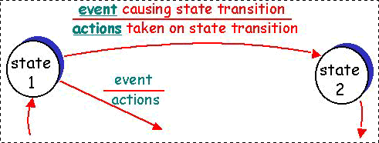
(event: 당하는 일, action: 하는 일)

- rdt
rdt | Features
rdt 1.0 | Reliable data/ACK channel
rdt 2 | Unreliable data channel and reliable ACK channel
rdt 3.0 | Unreliable data/ACK channel

- rdt 1.0
  - Reliable data transfer over a perfectly reliable channel
    - Peer operates normally
    - Underlying channel is perfectly reliable
  - FSM are running separately at sender, receiver
    - Sender sends data into underlying channel
    - Receiver reads data from underlying channel

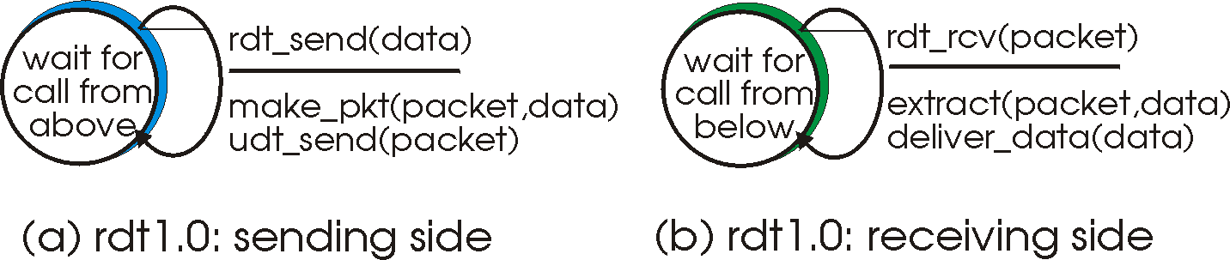

  - 문제점
    - Actually, bits in a packet may be corrupted.

- rdt 2.0
  - How to recover from bit errors?
    - It is to use
- (Positive) Acknowledgement(ACK)
- Negative acknowledgement(NAK)
  - ARQ(Automatic Repeat reQuest) Protocol
    - It is based on retransmission
    - 3 capabilities
- Error detection
- Receiver Feedback
- Retransmission
  - Stop-and-wait Protocol
    - The Sender don’t send a new piece of data until it is sure that the receiver has correctly received current packet.
  - FSM representation
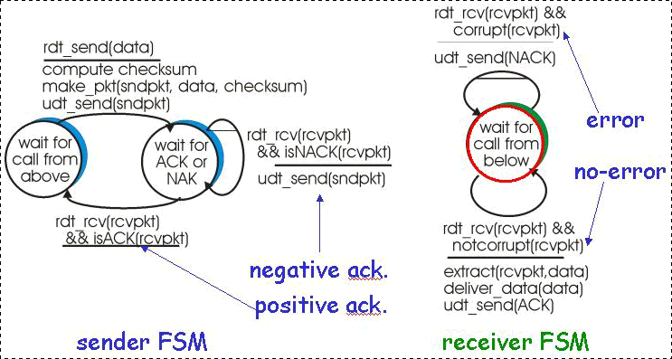

  - Fatal flaw
    - ACK, NAK packet can be corrupted!
→ Sender can’t know whether the receiver has correctly received.
    - Solution
- Sender ACK/NAK, receiver ACK/NAK (bad idea)
- Add checksum bit
- Resending data packet
        - Sender resends the current data packet when it receives a garbled ACK or NAK. (→ Duplicate packets handling)
        - Sender adds sequence number
(Because receiver can’t know whether an arriving packet is a retransmission.)

- rdt 2.1
Sender | Receiver
- Sequence number is added to a packet.  - Two sequence number: 0, 1  - The sender must check if received ACK/NAK corrupted.  - Twice as many states  - State must “remember” whether “current” packet has 0 or 1 | - Receiver must check if received packet is duplicate  - State indicates whether 0 or 1 is expected packet number  - Note  - The receiver does not know if its last ACK/NAK received OK at the senter

- rdt 2.2
  - A NAK-free protocol
(Same functions as rdt 2.1, without NAKs)
Sender | Receiver
- Duplicate ACK at the sender results in same action as NAK  → retransmit current packet | - Instead of NAK, receiver sends ACK for last successfully received pac-ket  - NAK0 → ACK1  - NAK1 → ACK0

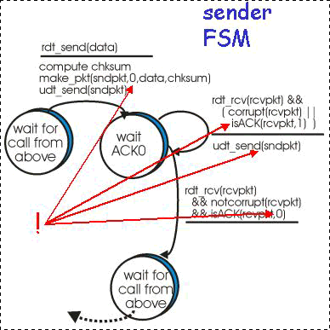
- rdt 3.0
  - Reliable data transfer over a Lossy channel with bit error
  - New Assumption
    - Underlying channel can also lose packets(data or ACKs)
  - How to deal with loss?
    - The sender waits until certain data or ACKs lost,
then retransmits them
  - Approach: The sender waits until “reasonable”
    - Sender retransmits if there’s no ACK received in this time
    - If a packet(or ACK) is just delayed(not lost)
      - Retransmission will be duplicate, but use of sequence numbers already handle this.
      - Receiver must specify a sequence number of a packet being ACKed.
    - Timer is required.

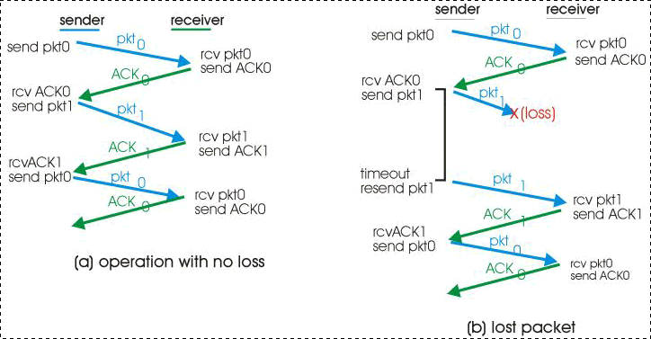
(rdt 3.0 in action)

3.4.2 Pipelined Reliable Data Transfer Protocols

- Performance of rdt 3.0
  - rdt 3.0 works, but performance stinks(low throughput)
  - Example
    - C: Transmission rates of the link (bps)
    - SP: Packet size (bits/packet)
    - T_{transmit}: Transmission delay (= SP / C)
    - T_{prop}: Propagation delay
    - Sender busy sending: (T_{transmit} + T_{prop}) * 2
    - Utilization: U_{sender} = T_{transmit} / Sender busy sending
    - 문제: 1KB packet을 1Gbps link를 통해 전송한다고 하자. 여기서
end-to-end propagation delay는 15msec이다. 그러면 tra-
nsmission delay는 얼마인가? 그리고 utilization of sender는
얼마인가?

- Pipelining
  - The sender is allowed to send multiple packets without waiting for acknowledgement
  - Consequences for rdt protocols
- The range of sequence numbers must be increased.
- The sender and receiver sides of protocols may have to buffer more than one packet
  - 2 generic forms of pipelined protocols
    - Go-Back-N (GBN)
    - Selective Repeat

3.4.3 Go-Back-N (GBN)

- The sender is constrained to have no more than some maximum allowable number, N, of unacknowledged packets in the pipeline.
  - Which condition satisfied to achieve maximum throughput in pipelined Stop-and-repeat(GBN)?
(1) Determined by packet transmission time
(link speed * packet length)
(2) Maximum window size
Transmission delay from the first till the last packet within window size should be longer than RTT.
(RTT: Routing Trip Time)

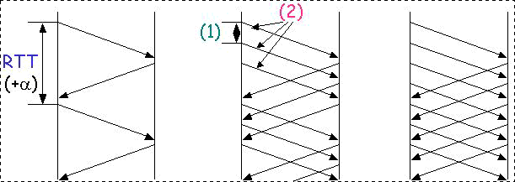
( (1): Transmission delay, (2) Propagation delay )

- Window
  - The range of permissible sequence numbers for transmitted but not-yet-acknowledged packets can be viewed as a “window” of size N (N: window size)
  - As the protocol operates, this window slides forward over the sequence number
(GBN is sliding-window protocol)

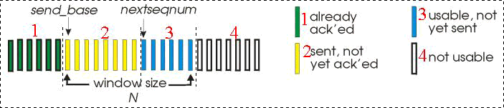

Sender | Receiver
- k-bits sequence number in the packet header: [0, 2^{k}-1]  - ACK(n)  - All packets with a sequence number up to and including n have been correctly received at the receiver  → Cummulative ACK  - may deceive duplicate ACKs  - Timer for each in-flight packet  - timeout(n)  - Retransmit packet n and all higher sequence number packets in window | - The receiver always send ACK for correctly-received packet with highest in-order sequence number  - may generate duplicate ACKs  - needs only to remember expectedseqnum  - Out-of-order packets  - The receiver discards them  (→ don’t buffer)  - The receier sends ACK packet with highest in-order sequence number

- Timer
When restarts? | When stops?
- When an ACK is received but there are still additional transmitted-but-yet-to-be acknowledged packet | - When there are no outstanding unacknowledged packets.

- Advantage and Disadvantage
Advantage | Disadvantage
- The simplicity of receiver buffering | - The subsequent retransmission of that packet might be lost or garbled  → Even more retransmission

- GBN in Operation
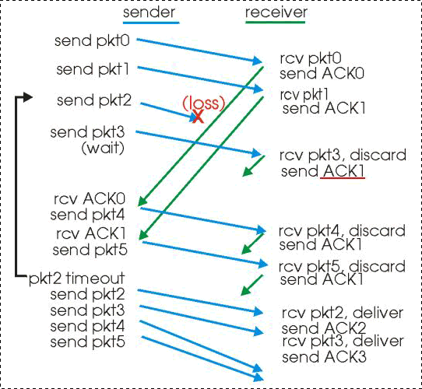

3.4.4 Selective Repeat (SR)

- SR protocols avoid unnecessary retransmissions
Sender | Receiver
- The sender only resends packets for which ACK is not received.  - Sender window  - N consecutive sequence num-bers  - It limits sequence numbers of sent, unACKed packets again | - The receiver acknowledges a correctly received packet whether or not it is in-order.  - Out-of-order packets are buffed until any missing packets are received.

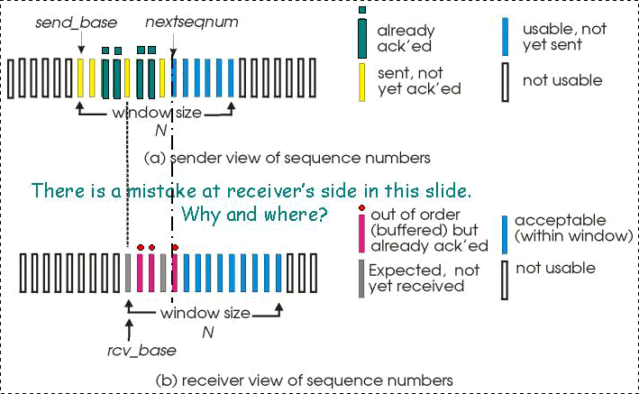

- SR operation
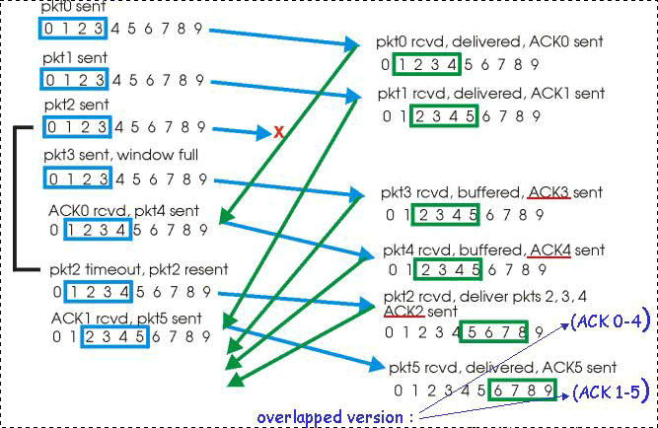

- SR dilemma
  - Example
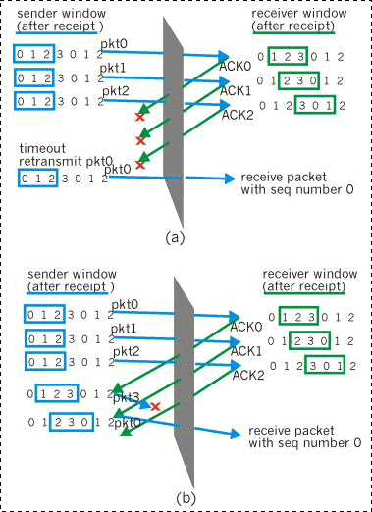
(Destination sees no difference in two senarios (a), (b)!
(In (a), incorrectly passes duplicate data as new.)

  - What relationship between sequence number size S and window size W?
    - W = S/2 – 1
(W must be less than or equal to half the size of the sequence number space for SR protocols.)

3.5 Connection-Oriented Transport: TCP

3.5.1 The TCP Connection

- 3 way handshake
  - Disconnected → Connected state (Initialization)
(Data is transmitted only at the connected state between the two application processes.)
  - Connected → Disconnected state (Termination)
Client | Server
(1) The client sends a special TCP  segment | (2) The server responds
(3) The client responds with a 3rd spe-
cial segment

- Full duplex data transfer
  - Bi-directional data flow in a connection
- Point-to-point
  - Single sender, single receiver
  - Multicast is not impossible.

- Send & receive buffers
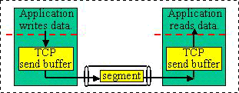

- Flow controlled
  - Sender will not overwhelm receiver nor routers
- Pipelined
  - TCP congestion and flow control set window size in transmitting TCP data.

3.5.2 TCP Segment Structure
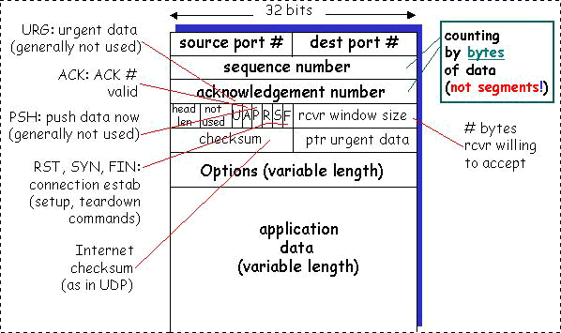

3.5.3 Sequence Numbers and Acknowledgment
Numbers

- They are two of the most important fields in TCP segment.
- In-order byte stream
Sequence Number | Acknowledgment Number
The byte stream number of the first byte in the segment. | The sequence number of the next byte the receiver is expecting from the sender.
  - MSS (Maximum Segment Size)
    - The maximum amount of application-level data in the segment
(Not including headers)
    - Common value: 1500, 532, or 512

- What does a host do when it receives out-of-order segments in a TCP connection?
(1) | (2)
- Receiver immediately discards it. | - The receiver keeps it and waits for the missing bytes
- More simplified | - More efficient

3.5.4 Telnet: A Case Study for Sequence and
Acknowledgment Numbers

- Each character typed by a user(at the client) will be sent to the remote host
→ The remote host will send back a copy of each other
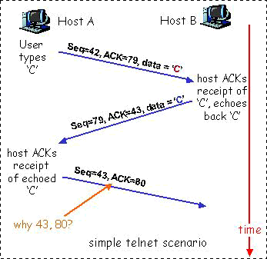

  - Piggybacking
  - For bi-directional TCP connection, TCP sometimes shares one more channel
  - 위의 그림에서 1, 2번째 화살표가 이에 해당함

3.5.5 Reliable Data Transfer

