1. Please describe the architecture of the current chatbot system. Identify the components and check where they are running now.

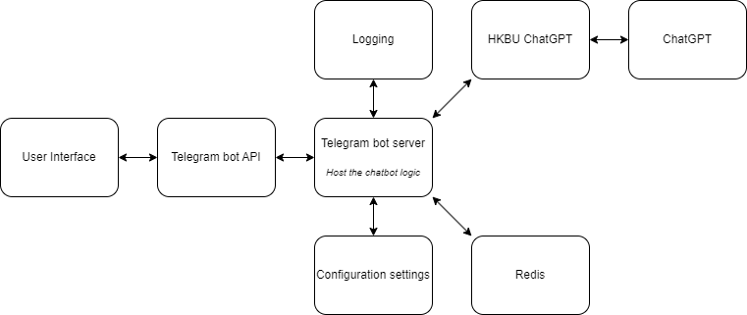

|  |  |  |
| --- | --- | --- |
| *System components* | *Run on* | *Description* |
| User interface | User device | As an interface |
| Telegram bot API | Telegram server | As an intermediary between bot server and the user interface |
| Telegram bot Server | Telegram server | Host the python code of the bot application |
| Logging | Telegram server | Logging events and messages |
| Configuration settings | Local | Read by the bot server during initialization |
| Redis | Redis server | Open source in memory storage |
| HKBU ChatGPT | Local | As a bridge between telegram bot and official ChatGPT |
| ChatGPT | ChatGPT server | AI model developed by OpenAI |

1. Explain how do your chatbot handles the special command. You need to trace the code and explain that.

There are currently 2 special commands in my chatbot, namely /add and /help, a third special command /hello will be added later too.

The ‘/add’ command will trigger the add function to count the number of same inputs.

Steps:

1. The ‘CommandHandler’ will call the add function and check the user input.
2. If no keyword is added after typing ‘/add’, the system will execute the except block and return a message ‘Use: /add <keyword>’
3. If the system detects an input, the system will log the first argument passed in the input. For instance, the first argument of ‘/add my name is’ will be ‘my’.
4. The system then passes the argument to Redis and increment the argument count associated with the argument stored in Redis
5. Finally, the system replies with a message indicating the argument and the number of times the Redis has stored.

The ‘/help’ command will trigger the ‘help_command’ and output ‘Helping you helping you’.

Steps:

1. The ‘CommandHandler’ will call the ‘help_command’ function.
2. The system will reply with the message ‘Helping you helping you’.

Detail code:

1. Update your code so that when user type /hello Kevin, it will reply ‘Good day, Kevin!’ Write down the changes you have made.

Output:

Changes made:

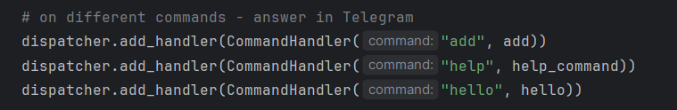

1. Added a dispatcher line

1. Defined the hello function
2. Make a few screen caps to prove that you have applied your own Redis account, used it in your chatbot, and push the code on GitHub (at least 2 commits – lab3/lab4)

Redis Account registration:

Used in the chatbot:

9 commits in total:

