**Design Document**

**Date: May 05, 2015**

**Version:** Release 2

**Team: Team B**

**1.0 Architectural Model**

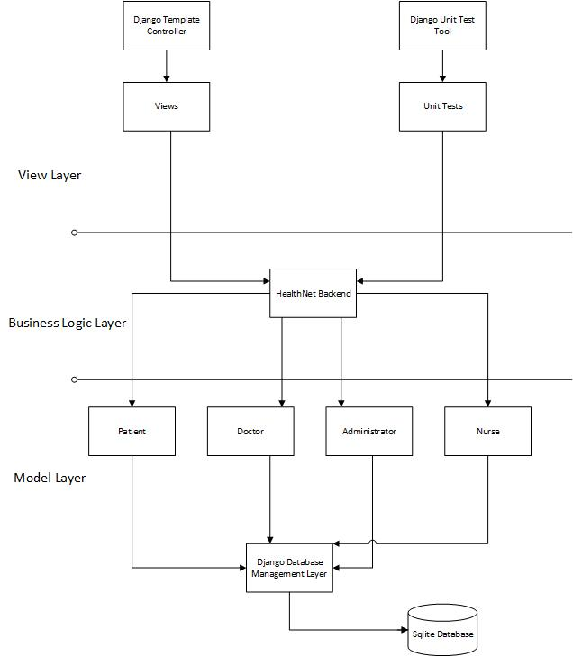

**2.0 Deployment Diagram**

Final Project Configuration Deployment Diagram

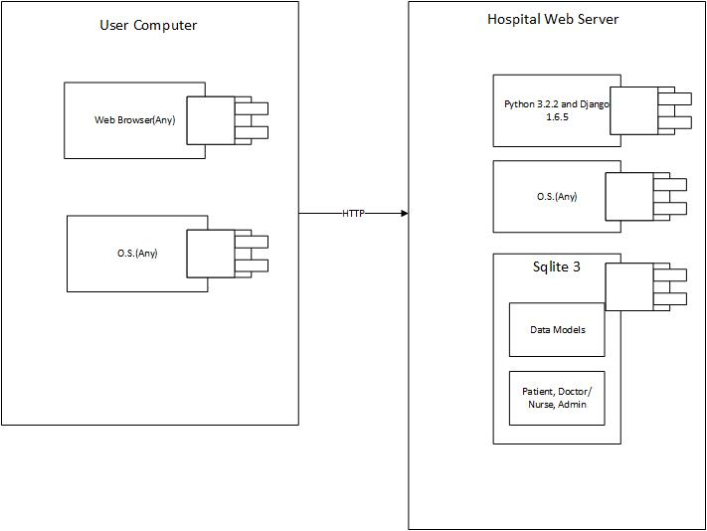

Acceptance Testing Deployment Diagram

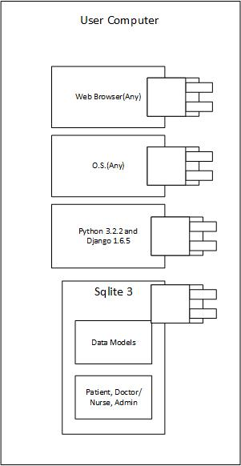

# **3.0 Components and Classes**

|  |  |
| --- | --- |
| **Component ID** | **Description** |
| **DES-001** | **HealthNet**  ***Component State***   * **Whether or not a specific database entry has been entered** * **Stores user and data information**   ***Component behavior***   * **Permits the Access Component (DES-002) to transfer data.** |
| **DES-002** | **User**  ***Component state***   * **Receiving input** * **Delivering information to HealthNet (DES-001)**   ***Component behavior***   * **Transfers input to database** * **Transfers database information to the Display Component (DES-004)** |
| **DES-003** | **Logging Component**  ***Component state***   * **Waiting for system changes** * **Notifying the Access Component (DES-002) of changes** * **Notifying the System Administrator of errors.**   ***Component behavior***   * **Records changes in the system state.** * **Records and reports security and system errors.** |
| **DES-004** | **Display Component**  ***Component state***   * **Updating user view** * **Waiting for notification from the Access Component (DES-002)**   ***Component behavior***   * **Displays the information provided by other system components.** |
| **DES-005** | **Data Component**  ***Component state***   * **Storing new information.**   ***Component behavior***   * **Represents prescription, appointment, and document objects.** |

# **3.1 Class Diagrams**ClassDiagram.png

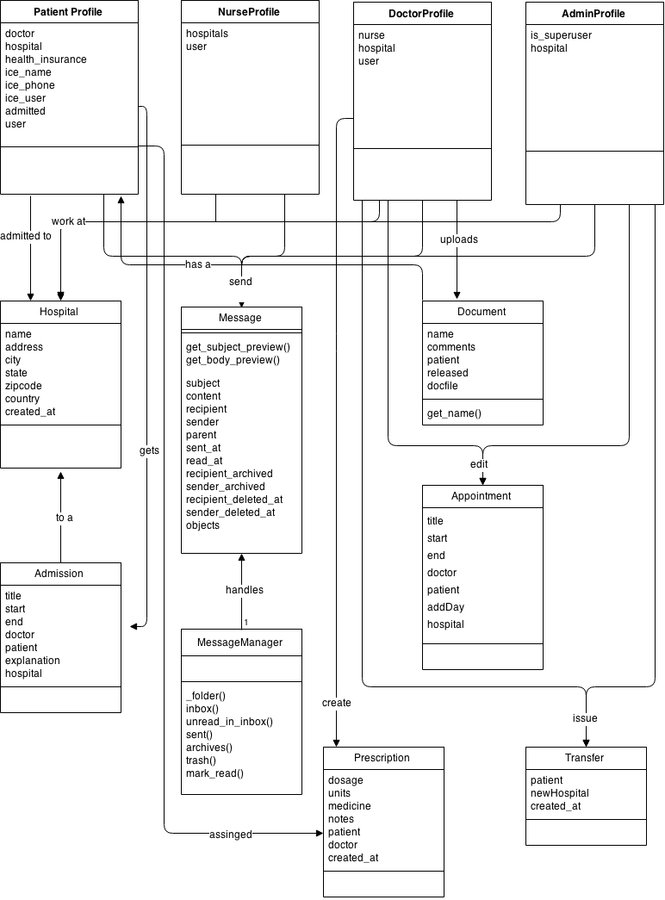

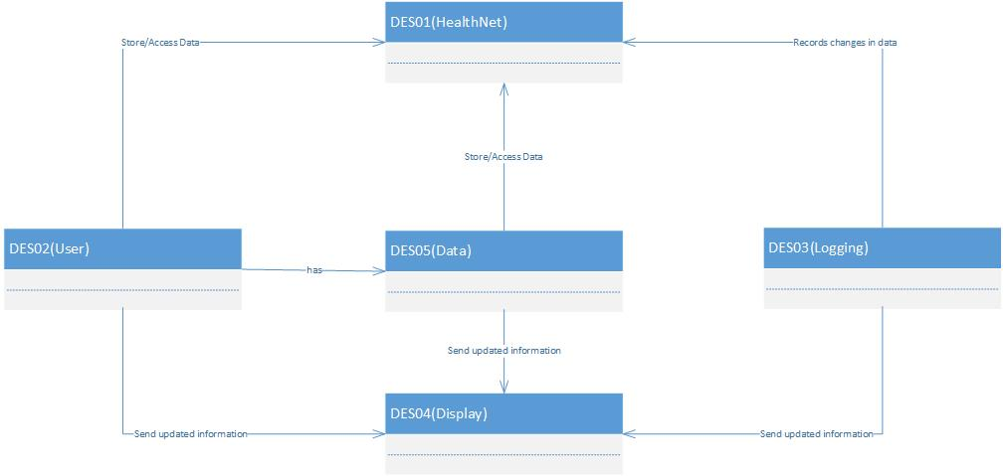

**3.2 Sequence Diagram(s)**

UC-01

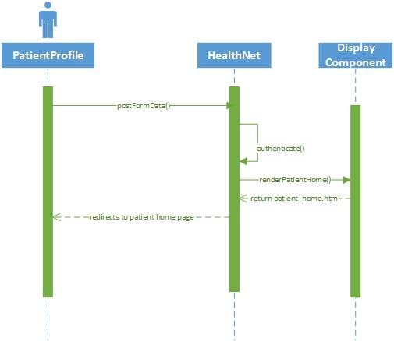

UC-02

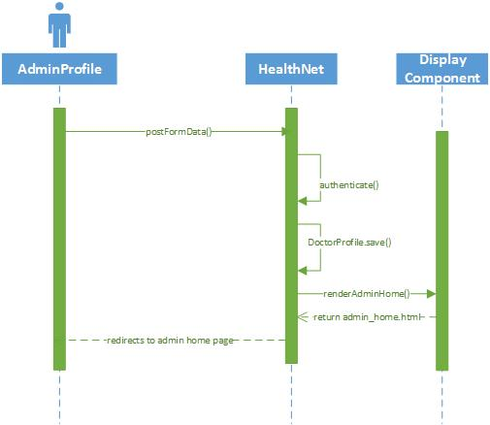

UC-03

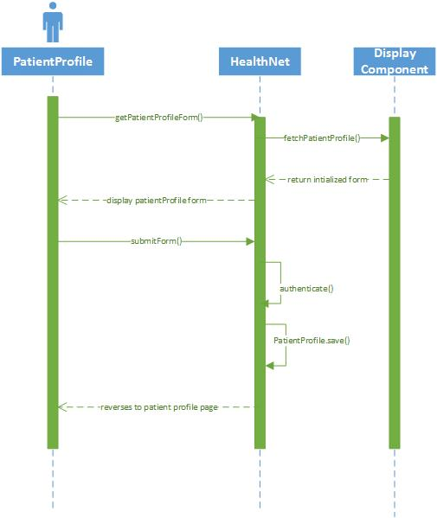

UC-12

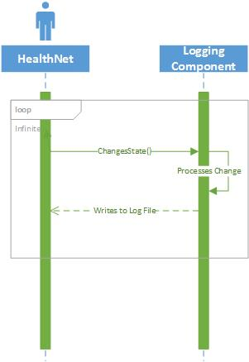

UC-14

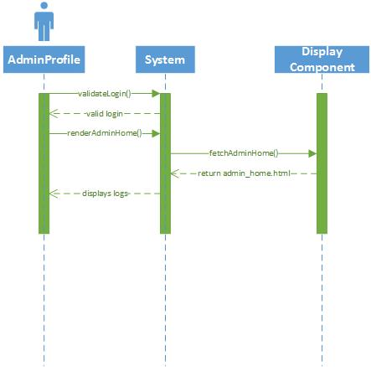

# **3.3 State Diagrams - Screen (Web Page) Flow Diagr**am

**Admin:**

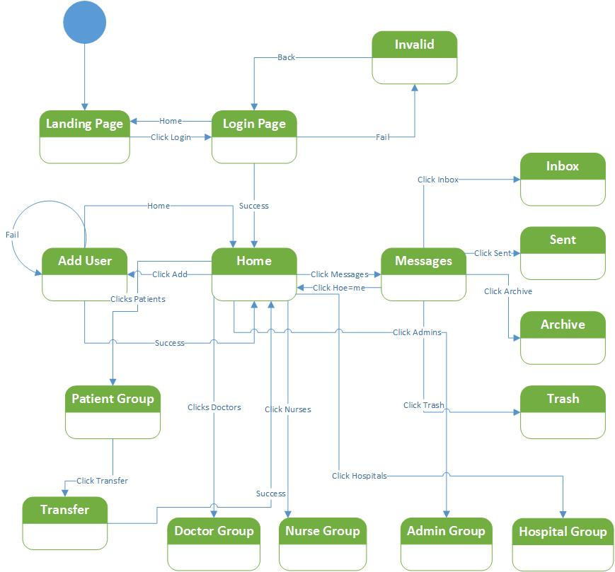

**Patient:**

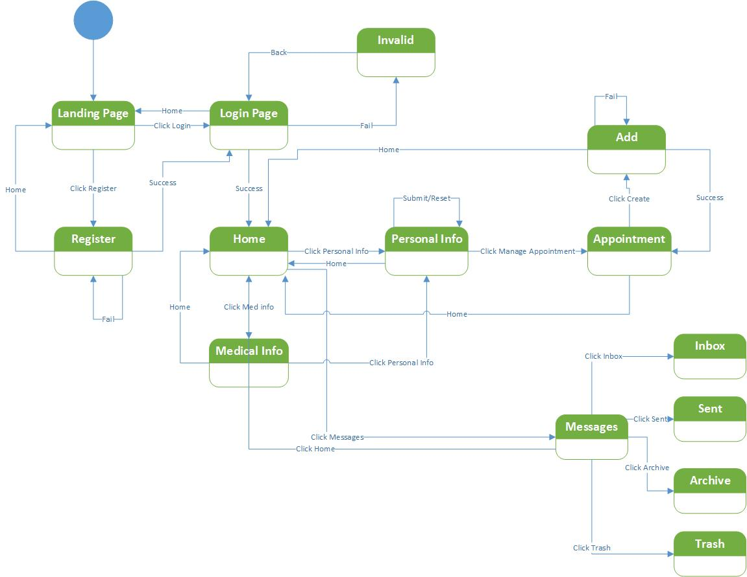

**Nurse:**

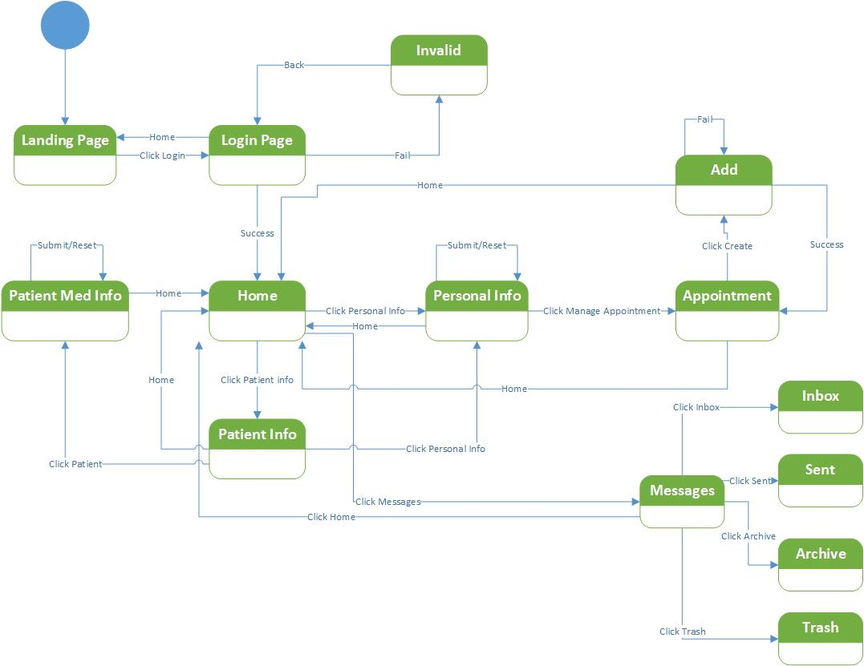

**Doctor:**

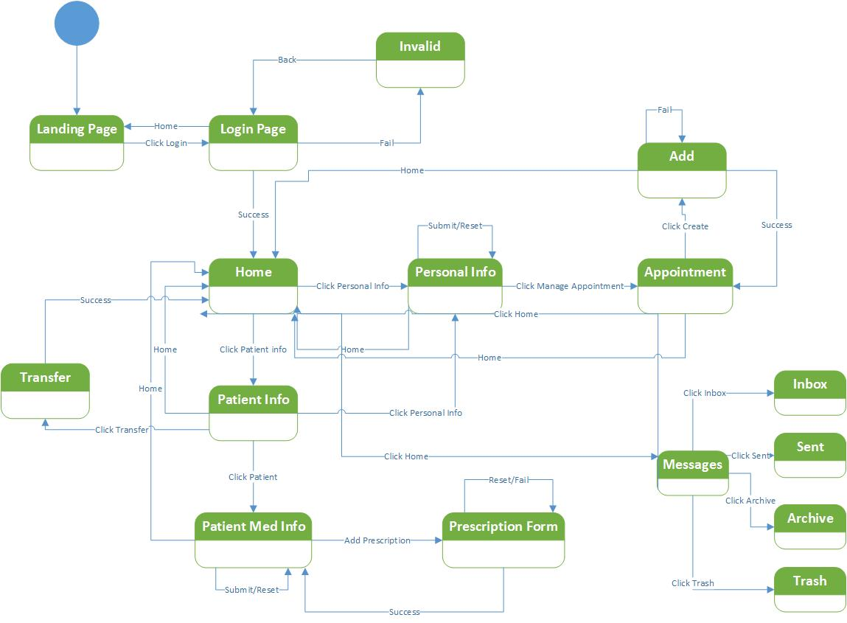

**4.0 Design Rationale**

After reviewing the requirement document, we abstracted three general requirements for HealthNet system. (1) The system needed to store data. This data includes patient medical information, staff information, and hospital information. (2) The system needed to be able to transfer this data throughout the system. User input needed to be able to update the database, and changes in the data base needed to be reflected on the user’s screen. (3) System errors and updates needed to be logged in some capacity. Patient statistics, system changes, and security errors needed to be recorded and relayed to the system administrator. Based on the three aforementioned requirements, we decided to implement a modified version of the Model-View-Controller system.

Initially, we thought the model would represent our three main users: patients, hospital staff, and system administrators. After charting basic use cases involving our users, we decided to split up the hospital staff into two different users: doctor and nurse. The change would help address the use cases in which the permissions of the doctors and the nurses differed. When designing our system, we decided our storage component (DES-001) would act as our model component. In our discussions, we concluded that decomposing that component into two models, people and hospitals, made since because of their different data fields and functionality. The view of our application will be developed using the Django template structure. Our Access Component (DES-002) will act as our application controller. The associated modules will be responsible for relaying data, such as patient information, between other system components. Finally, we needed a way to monitor our system and keep track of all security and user errors. For this, we decided to build a logging component. One of the primary responsibilities of this component will be to inform the system administrator of any changes in the system state, including any errors. Additional functionality will include logging generic metrics regarding patient data.

**5.0 Document Change Log**

|  |  |  |  |
| --- | --- | --- | --- |
| ***Document Version Number*** | ***Revision Date*** | ***Summary of Changes*** | ***Author(s)*** |
| Initial | 02/21/2015 | First draft of Design | Roland Sanford, Derek Popp, Tyler Shank, Harry Longwell |
| R1 | 03/08/2015 | Fixed Class, Sequence, and State diagrams | Roland Sanford, Derek Popp, Tyler Shank, Harry Longwell |
| R2 Planning | 04/04/2015 | Fixed problems with clauses 3.0, 3.1, 3.2, and 3.3 | Roland Sanford, Derek Popp, Tyler Shank, Harry Longwell, Ross Kinsey |
| R2 | 05/05/2015 | Fixed problems with clauses 3.1, 3.2, and 3.3 | Roland Sanford, Derek Popp, Tyler Shank, Harry Longwell, Ross Kinsey |