Table of contents
1How to add a new entry in the PorDB 1
2How to make changes to an existing entry in PorDB 1
3How to add a new actor 2
4Some hints for using the graphical user interface 3

How to add a new entry in the PorDB

- Put the image file into the working directory (or navigate to it)
- Working directory is in the installation path of PorDB3 and is named “mpg”
- Press F5 or click on the new entry button in the left corner
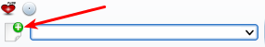

or double click on the thumbnail
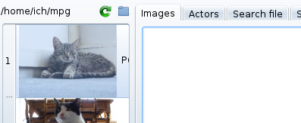

- The new entry dialog will open.

- Enter all desired data, separate actors with comma
- You can add additional titles (e. g. In different languages)
- You can add the required actors by marking them in the actor lists
- When adding more than one scene of a video, the original title can be automatically repeated with clicking on button
- Click on the save button or press enter for saving your data

How to make changes to an existing entry in PorDB
- Enter some search criteria in the search field
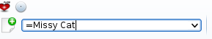

Hint: by adding an equal sign in front of the search criteria search will be done with the exact entry in the search field. This is useful when you have actors with same characters at the beginning, e.g. “Missy” or when searching for original video titles with the same characters in the beginning.

- Click on the appropriate button for you search criteria, in this case “search for actor”
- You can search for actors, titles, storage media, original titles
- Search result will be shown in the main window:

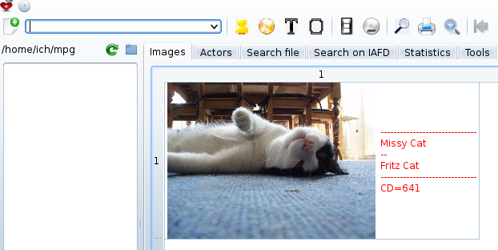
- Double click on the result, the dialog for entries will be shown as in chapter 1
- Enter your changes and press save

How to add a new actor
The best way for adding a new actor is to do it from the IAFD, if this new actor is known there.
- Click on the IAFD tab:
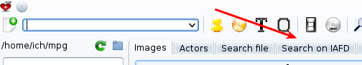

- Search for the desired actor
- Click on this button:
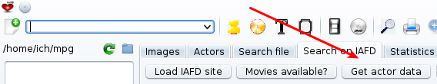

- A popup will appear with the actors data
- Adopt the actors data.

Some hints:
- Only these hair colors will be accepted: bl (blond), br (brown), s (black), r (red)
- You can change any field

When adding a new scene with an unknown actor, a pop-up will appear where you can enter the actors data manually (or correct the data from typing errors).

Some hints for using the graphical user interface
- You can change the tabs by pressing F2 (backward) of F3 (forward)
- When the greater-than signs >>>>>>>>>>>>>>>> are shown at the top of the search result, you can scroll down by pressing F8, scroll up by pressing F7.
- Nearly on every widget in the graphical user interface you can get help by pressing Shift + F1. Holding the mouse on a widget will give some hints.
- When entering a new video it is useful to add the year of publication in brackets, e. g. (2012) in field original title for a statistical overview.
- When adding a video cover from an online video shop which has 2 pictures: 1 front cover and 1 back cover, you can create 1 cover in one picture by marking both pictures and press F5. Order of clicking the pictures determines if the front or the back cover is on the left site of the result.
- If you want to upgrade an existing picture in the database with a better picture, save it in the working directory and drag and drop it on the one in the database.

