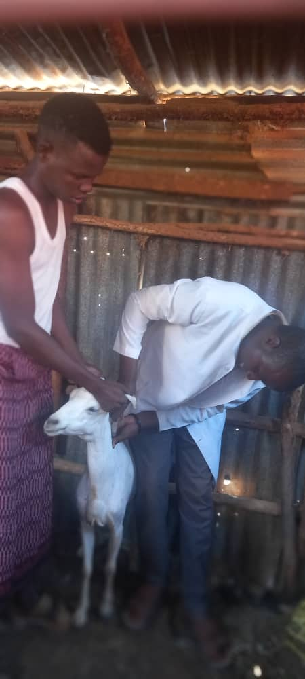

***MERCY CORPS ETHIOPIA***

***DREAMS PROJECT VOUCHER DISTRIBUTION POST DISTRIBUTION MONITORING (PDM) REPORT***

***BY: DOLLO ADDO OFFICE DREAMS TEAM***

MERCY CORPS

February 2024

Dollo-Addo,SOMALI REGION

**The program** 3

**2.****Purpose and Objectives** 5

3. Survey methods and preparations. 6

3.1. Survey design. 6

3.3. Survey area and population. 6

3.3. Sampling units and respondents 7

Given that the basic sampling unit for the post-distribution monitoring study is households and respondents selected from shoot fattening groups who received vouchers for drug subsidies from private veterinary pharmacies supported by Mercy Corps. 7

3.4. Survey team and training of data collectors. 7

*3.5.**Data Analysis* 7

**Executive summery**

Mercy Corps is a leading global organization powered by the belief that a better world is possible.   
In disaster, in hardship, in more than 40 countries around the world, we partner to put bold solutions   
into action — helping people triumph over adversity and build stronger communities from within.   
Now, and for the future.

#### **The program**

Mercy Corps has been operating in Ethiopia since 2004, working in rural, peri-urban, and urban areas in five regional states - Somali, Oromia, Afar, Southern Nations Nationalities and Peoples, Amhara - and the capital city of Addis Ababa. We engage in both development and humanitarian work and seek to integrate approaches, programs, and geographies as much as possible. Our partners include government, academic institutions, development and private sector actors, civil societies, and communities.

The DREAMS program aims to improve the well-being of 100,000 women, children, and men over five years for refugees and host communities in the Somali region of Ethiopia. Working with refugees and host communities in the Somali region of Ethiopia. The program will integrate two proven models – poverty graduation and Market Systems Development – layering these approaches in a new way that will ensure that the poorest households can improve their income and well-being significantly and maintain Mercy Corps will lead the Market Systems component of the program and will be responsible for developing market access pathways to ensure those businesses can be successful and supporting the operating environment for businesses and communities to thrive

1. **Introduction**

DREAMS is a five-year IKEA and Hilton Foundation-funded consortium project led by Village Enterprise (VE) and implemented by VE, Mercy Corps, and ID Insight. DREAMS aims to support economic opportunities for refugees and host communities in Dollo Ado & Bokolmayo woredas, with a focus on women. It combines two evidence-based models to support the extremely poor to achieve self-reliance sustainably through Delivering Resilient Enterprises (Graduation Approach) and Market Systems Development (MSD Approach). First, DREAMS will support the extremely poor and enable graduates out of extreme poverty by providing training, savings groups, seed capital and ultimately mentoring them which enables them to establish resilient enterprises. Through the second, DREAMS will facilitate refugees’ access to products and services to grow their businesses in a sustainable and scalable way.

Mercy corps have conducted post monitoring assessment for shoot fattening groups voucher distribution at Helaweyn, Kobe and Melkadida refugee camps to monitor and analyze the impact of the project. The PDM event were participated 75 (25 participants each) participants randomly selected from the shoot fattening business groups across these three camps.

Before the official data collection kickoff, action after action review (AAR) was conducted at Melkadida were the project stakeholders such as the Bokolmayo and Dollo-Addo woreda livestock and cooperative offices, RRS Programs of Kobe, Melkadida and Helaweyn as well as Local authorities were participated.

The After-Action Review (AAR) process is a valuable tool for teams and stakeholders to learn from their actions and improve future performance. By reflecting on the process, products, and quality of the action, participants can gain insights into what went well and what could be improved.

Exploring whether the intentions of the action were achieved helps to align future actions with organizational goals. Considering the assumptions made during the action/activity can highlight any potential biases or blind spots that may have influenced decision-making.

Analyzing what happened and why it happened the way it did can uncover underlying causes of success or failure. By identifying key lessons learned, teams can apply these insights to future activities to enhance performance.

Finally, identifying improvements for future actions promotes adaptive management and supports ongoing learning within the program or agency. By continuously reviewing and adjusting strategies based on AAR findings, organizations can become more agile and responsive to changing circumstances.

# **Purpose and Objectives**

The purpose and objectives of post-distribution monitoring (PDM) for voucher distribution program included the followings:

1. **Assessing the reach and coverage of the voucher distribution:** PDM helps to determine the extent to which vouchers have been distributed to the target population, whether they have reached all eligible beneficiaries, and if there are any underserved or excluded groups.

2. **Monitoring the redemption and utilization of vouchers**: PDM tracks how many vouchers have been redeemed by beneficiaries, where they have been used, what goods or services have been purchased, and whether the vouchers are being utilized as intended.

3. **Evaluating the impact on beneficiaries**: PDM assesses the outcomes and impacts of the voucher distribution program on beneficiaries, such as improvements in access to essential goods or services, changes in behavior or practices, and overall well-being.

4. **Identifying challenges and opportunities for improvement**: PDM helps to identify any barriers or challenges faced by beneficiaries in redeeming vouchers, as well as opportunities for enhancing the efficiency, effectiveness, and sustainability of the program.

5. **Ensuring accountability and transparency**: PDM provides evidence-based information on the performance and impact of the voucher distribution program, helping to ensure accountability to stakeholders, donors, and beneficiaries.

# Survey methods and preparations.

## Survey design.

The design for the study is a household community based, cross sectional survey where the participants will be visited in their house to conduct the data.

* 1. **Data collection tools**:

To conduct reliable data, we have Develop structured questionnaires or survey instruments to collect relevant data on voucher distribution, redemption, utilization, and impacts.

## Survey area and population.

The post distribution data was conducted in Hilaweyn, Kobe and Melkadida refugee camps where DREAMS Arm Project are active and implementing.

## Sampling units and respondents

## Given that the basic sampling unit for the post-distribution monitoring study is households and respondents selected from shoot fattening groups who received vouchers for drug subsidies from private veterinary pharmacies supported by Mercy Corps.

## Survey team and training of data collectors.

Five individuals were hired from Melkadida, Helaweyn and Bokolmayo area to collect the data from each camp. They received one day training on the survey including the following: becoming familiar with the format; obtaining consent from beneficiaries; interviewing techniques; data recording; household selection through a systematic random sampling method; and learning the duties of data collectors and supervisors.

### *Data Analysis*

Qualitative data were collected by using Comcare Collect application and collected data was uploaded to server and analyzed by using the Power BI and Microsoft excel. Results are described using frequency distribution tables, pie chart, bar chart and histogram to interpret the results.

1. **Results**
   1. **Demographic characteristics of respondents**

The post distribution data assessment was participated 75 respondents of which 63 (84%) of the total respondents are Female respondents while the remaining12 (16%) of the total respondents are Male respondents. In addition to this, 50 (66.67%) of total respondents are from refugees while 25 (33.33%) of the respondents were from Host community. In terms of kebele/camp each camp/kebele was selected the same number, which is 25 participants however, 50 (66.67%) of total respondents are from Bokolmayo woreda while 25 (33.33%) of the respondents were from Dollo-Addo woreda.

Underneath table summarizes the breakdown of the respondents.

|  |  |  |  |  |  |  |
| --- | --- | --- | --- | --- | --- | --- |
| Woreda/Kebele | Female | | Male | | Total # | Total % |
| # | % | # | % |
| Bokolmayo | 43 | 86.0% | 7 | 14.0% | 50 | 66.7.0% |
| Kobe | 20 | 80.0% | 5 | 20.0% | 25 | 50.0% |
| Melkadida | 23 | 92.0% | 2 | 8.0% | 25 | 50.0% |
| Dollo Addo | 20 | 80.0% | 5 | 20.0% | 25 | 33.3.0% |
| Helawyn | 20 | 80.0% | 5 | 20.0% | 25 | 100.0% |
| **Grand Total** | **63** | **84.0%** | **12** | **16.0%** | **75** | **100.0%** |

As the blow chart summarizes, 41.3% of the total respondents are above family size 10 and above, 38.7% of the respondents are family size 7-9, and 18.7% of the respondents also are family size 4-5. With this regard, most of the respondents participated this PDM are family size 10 and above.

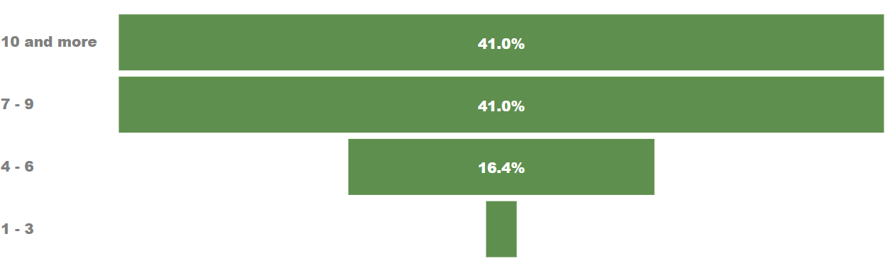

Table 1 Population breakdown of surveyed population

* + 1. **Veterinary Advisory services.**

In this case, most of the participants owned goats while some of them owned both goats and sheep. The following chart depicts that, total of 57 participants which is equivalent of 76% of total population owned by goats while 18 participants (24%) of total population owned by both Goats and sheep. As the result shows, none of the participants owned either camel, cattle, or poultry.

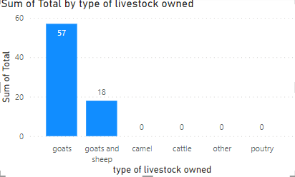

*Chart 1. Populations type of livestock owned.*

Based on the above chart, the below chart also summarizes type of livestock owned respondents per camp, 84.4% of the total respondents from Kobe camp owned by goats while 19.6% of the respondents of Kobe are also owned by sheep. From the Melkadida respondents, 82.5% of them owned by goats while 17.5% of them owned by sheep. Among the Helaweyn respondents, 94.5% of them owned by goats and the remaining 5.6% of them owned by sheep. Below are the summary of type of livestock respondents owned per camp.

* + 1. **Type of livestock acquired through DRAMS project.**

Although most of the respondents already owned livestock, the following chart also summarizes respondents’ type of livestock acquired through DRAMS project. Out of the total 75 respondents 41 (54.67%) of them acquired 3 goats, 20 out of 75, which is 26.67% acquired 3 goats and sheep, 6 out of 75 respondents which is 8% acquired 4 goats, 5 (6.67%) acquired 5 goats while 3(4%) acquired 3 goats and 3 sheep.

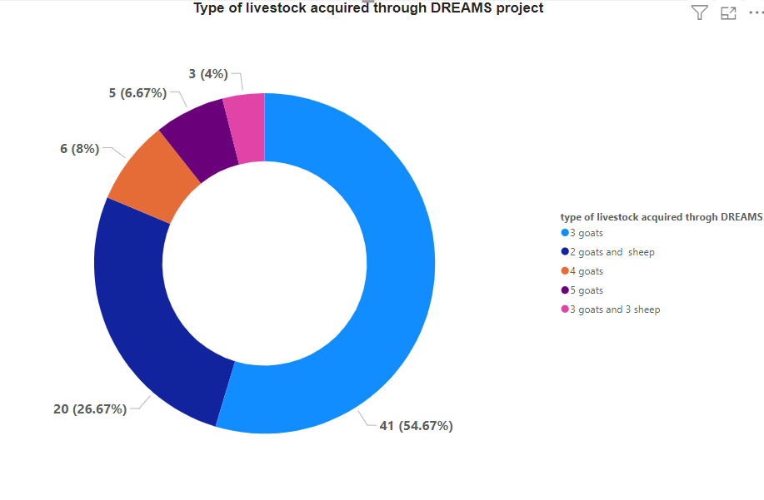

Chart2 type of livestock acquired through DREAMS Project

* + 1. **Drug accessibility before DREAMS project intervention.**

Mercy corps facilitated and capacitated the establishment of Private veterinary pharmacies in the camps of DREAMS project intervention. How ever all 75 respondents asked Before DREAMs how you were acquiring drugs and other services? And provided the same response which is they were purchasing the drugs local Private veterinary pharmacies.

The following charts point up the how the community accessed the drugs before DREAMS project.

* + 1. What advisory service did you receive from the PVP?

Based on the PDM assessment conducted, the beneficiaries received from the PVPs product knowledge as 48 respondents which is 64% of the total participants responded, 16 (21.33%) f the respondents also responded that they have been received the PVPs product knowledge and husbandry processes. 8 (10.67%) of the respondents said that they have received from the PVPs product knowledge, breeding and husbandry process while the remaining 3 (4) of the respondents responded all which means they have been revoicing the PVPs all necessary information.

Chart 4 advisory services received from the PVPs.

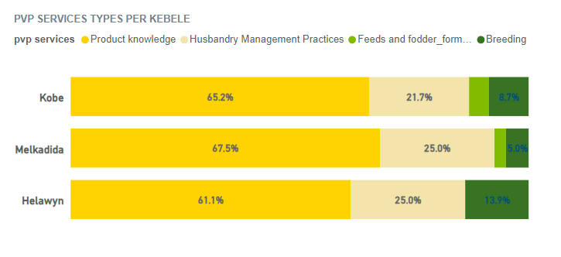

The above chart also depicts that PVP service types per Kebele/camp and 65.2%, 67.5%, and 61.1% of the respondents from Kobe, Melkadida and Helaweyn received from the PVP product knowledge respectively, 21.7%, 25.0%, and 25.0% of the respondents from Kobe, Melkadida and Helaweyn received from the PVP husbandry process and 8.7%, 5% and 13.9% from Kobe, Melkadida and Helaweyn received from the PVP breeding.

* + 1. **What herd size in terms of numbers was treated or fed?**

Regarding the question of What herd size in terms of numbers was treated or fed? 42 (56%) of total respondents responded that they have been treated or fed 3 herd sizes, 12 (16%) of the total respondents also said that they have been treated 4 herd sizes, 11 (14.67%) of total respondents said they have been treated 5 herd sizes.

In addition to this, 3 (4%) of the total respondents responded that they have been treated 6 herd sizes while 2 (2.67%) of the respondents said they have been treated 7 herd sizes, in similar number of respondents also said they have been treated 2 herd sizes while 1 (1.33%) of the respondents said they have been treated 10, 11 and 15 herd sizes respectively.

The following chart easily summarizes the number of herd size treated per household.

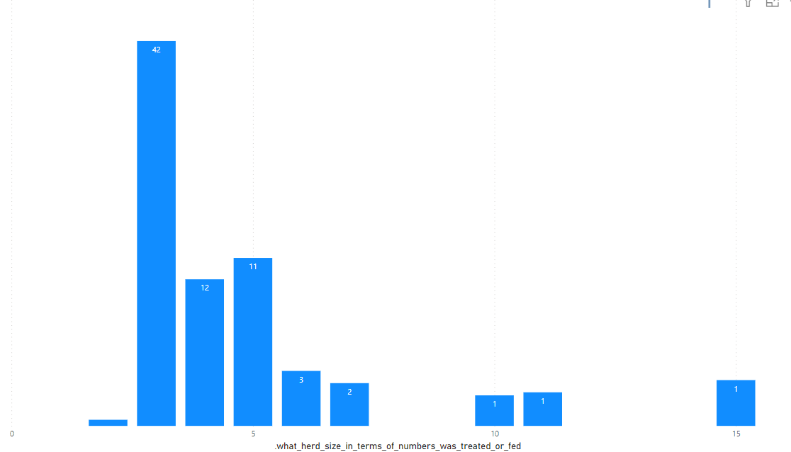

Chart 6 number of herd size treated per household.

* + 1. **Do you sell 3 goats you have purchased?**

In this time, it was found that out of the 75 respondents who were interviewed, 61 (81.33%) reported that the 3 goats they had purchased were sold, while the remaining 14 (18.67%) stated that their goats were not sold.

A follow-up question was posed to those who did not sell their goats, inquiring about the reason behind their decision. It was revealed that the goats had been purchased during the rainy season when they were fat and expensive. However, with the change in price and season, it was decided that it was better to keep and feed them at home rather than selling them.

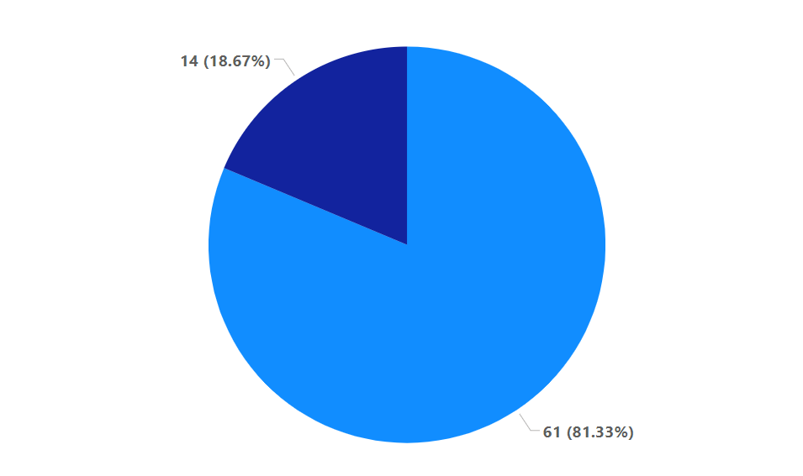

*Chart 7 This char summarizes the total households sell their goats and those keep.*

* + 1. **What is the total purchase price of the 3 goats using the startup capital?**

As shown in the following chart, 23 respondents (38.87%) had their 3 goats purchased for a total amount of 18000 ETB, resulting in an average of 6000 ETB per goat. For 17 respondents (27.19%), the purchasing price for the three goats was 18100 ETB, which was almost in the same range as the previous amount.

A purchasing price of 21000 ETB was reported by 5.91% of the respondents, translating to 7000 ETB per goat. Additionally, 5.96% of the total respondents indicated that their purchasing price was 15000 ETB, averaging 5000 ETB per goat, while the least purchasing price was 12000 ETB, meaning 4000 ETB per goat, which was almost responded to by 1.13% of the total respondents.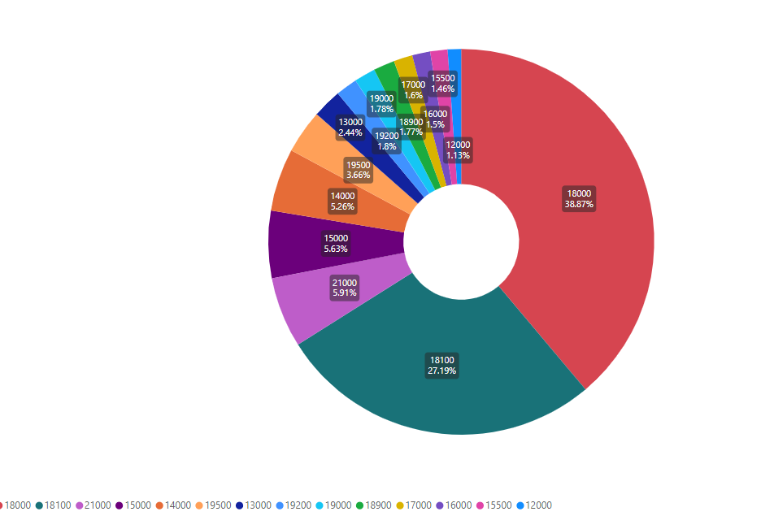

Chart 8 description of total purchasing price using the startup capital.

* + 1. **How long did you fed the goats before selling.**

Based on the responses obtained from the program beneficiaries, it was assessed that 30 (41.18%) of the total respondents who sell their goats have them kept and fed at home for a duration of one week. Additionally, 21 (34.43%) of the respondents have their goats kept and fed at home for almost two weeks before they are sold. A feeding period of three weeks was reported by 9 (14.75%) of the total respondents who sell their goats.

Lastly, it was reported that 1 (1.63%) of the total respondents has his/her goats kept and fed at home before the selling period with a duration of four weeks.

*Chart9 description of feeding period before selling*

* + 1. **What is the total cost you incurred in keeping the goat for the feeding period?**

On average, a respondent spend around 17,500 to purchase the three goats, it differs from Kebele to kebeles & ranges from 1,500 to 21,000. The mean expenditure for fattening these 3 goats estimated to be around 1,700 which totals an average of of around 19,142 to purchase and fatten the 3 goats.

On average people sold the three goats they purchase after fattening around 20,386 with an average of 6.5% profit margin from their initial investment. The profit margin differs from kebele to kebele, Helawyn Kebele (13.5%) registered highest profit margin compare to the other two. Please see graph below for more information.

**What is the total sale price of the 3 goats after you practiced short fattening?**\ **Do you think fattening goats is profitable business?**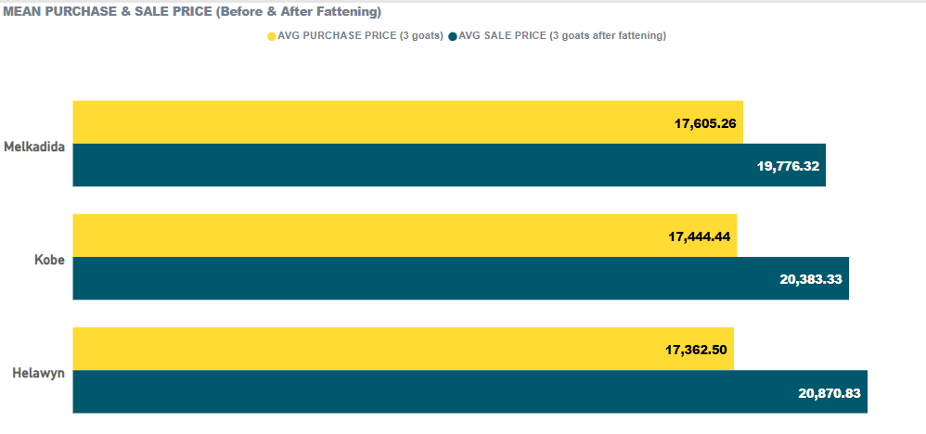

Based on the results gathered, it was agreed by 74 (99%) of the total respondents that shoot fattening is a profitable business.

As shown in the chart, only one respondent, which is 1% of the total respondents, indicated that the business is not profitable based on their point of view. Overall, it can be concluded that shoot fattening is considered a profitable business by 100% of the respondents, as this business is commonly known in this community.

*Chart10 summarizing whether shoot fattening is business profitable or not.*

4.1.13 **what is your plan regarding goat fattening business?**

According to the program beneficiaries interviewed, 52 (69.333%) of the total respondents said that they are planning to continue this business without project support. Additionally, it was reported by 21 (28%) of the respondents that they are planning to continue this business with more scale without project support.

Furthermore, it was reported by 1 (1.33%) respondent that he/she is planning to stop this business here, while also reporting that he/she is planning to shift to another business. Overall, it can be understood that this business is profitable to the community and that the community themselves are committed to continuing this project even if the project support is stopped.

.

The following chart is a full summary of this question and the required information.

*Chart 11 summary of respondents’ future business plan related to shoot fattening business.*

1. **Voucher distribution and drug acquisition.**
   1. **Were you satisfied with the range of products or services available through the voucher program?**

75 (100%) of the total respondents were satisfied with the range of products or services available through voucher program. It's great to see that all respondents were satisfied with the range of products or services available through the voucher program. This high level of satisfaction indicates that the community has embraced the program and is finding value in the offerings.

It's also encouraging to note that the initial challenges faced in explaining how the voucher system works have been overcome, as evidenced by the positive feedback from the community. This shows that the efforts put into educating the community about the program have paid off and that the community now understands and appreciates the benefits of using the voucher card.

The responses from the targeted sample respondents from the three camps of the DREAMS project intervention were reported to have the same response and satisfaction rate with the voucher program.

* 1. **what type of veterinary drugs and or equipment did you buy**

The question related the type of medicine the respondents buy from the PVP, 59(78.69%) of the total respondents responded they buy both Antibiotic and Multivitamin, 5(6.67%) of the total respondents reported that they buy from the PVP Multivitamins, 2 (2.67%) of respondents also reported that they buy from the PVP Antibiotics only, while the same number of respondents also reported that they buy from the multivitamins and acaricides, Antibiotics, Dewormers and acaricides as well as Dewormers, Antibiotics and multivitamins.

Only 1 (1.33%) of the respondents reported that he/she bought from the PVP Dewormers and multivitamins while the same number of respondents also reported that he/she bought acaricides and pour on.

*Chart13 type of medicine buy from the PVP.*

Based on the above chart, the most used veterinary drug is Antibiotic and multivitamin which means these drugs are very important for the shoot fattening groups.

* 1. **Did you receive the quantities you needed for your herd size?**

As we can see the below char 75(100%) of the total respondents said that they have received the quantity of medicine they needed for their herd size.

This means the total respondents indicated that the quantity of medicine needed for their herd size was received by them.

* 1. **Was the distribution of the drug done at the time of season?**

The distribution of the drug was done at the time of season as most of the respondents reported. 74 (98.67%) of the respondents responded “Yes” that means the distribution of the drug was done at the time of the season.

1(1.33%) of the respondents said “No”. based on the results of this question we can easily examine that the time of distribution was the most convenience season for distribution.

*Chart 15 is the distribution done at the right time.*

* 1. **Were you satisfied with the voucher system process?**

As we can see from the respondent’s feedback 75(100%) of the total respondents responded that they have been satisfied with the voucher system process.

Although there were many challenges in the beginning regarding the implementation of the voucher system, the system was eventually adopted and admired by the community after efforts were made by the Mercy Corps team to make the community and stakeholders clear about the system.

Another following question was asked the respondents about what they like about voucher system, and they responded that this system is easier compared the other system they used to know, “this system is easier and help full system” responded most of the respondents.

1. **Did you purchase the drugs/equipment?**
   1. **What is the reason for buying as a group of 3?**

As we can see the below chart 17, 66(88%) of the total respondents purchased the drug as a group of 3 while the remaining 9(22%) 0f the total respondents purchased the drug as an individual.

Based on the information on chart 18, the reason for purchasing the drug as a group of three is that money was not sufficient as 60(90.91%) of the respondents responded My money was not enough, and I had to combine with my friend. 6(9.09%) of the respondents also said that my herd size is small, that is why we purchased the drug as a group of 3.

*Chart 17 how they buy the drug chart 18 reason for buying as group.*

**6.2 Did you have to send someone to buy the drugs for you? And if yes, why?**

With respect to this question, 68 (90.67%) of the respondents said “No” and instead of sending someone else on behalf of them, they collected themselves personally.

**A** follow up question was asked about why you sent someone on behalf of you for those who responded Yes and 60 (90.67%) of the total respondents said that I was sick that is the reason for sending someone else on behalf of them, 4(5.33%) of the respondent selected other and specified their reason availability during the distribution wile the remaining 2(2.67%) of the respondents.

* 1. **Rank the ease with which you collected your vouchers. (1 being the least and -5 being the highest)**

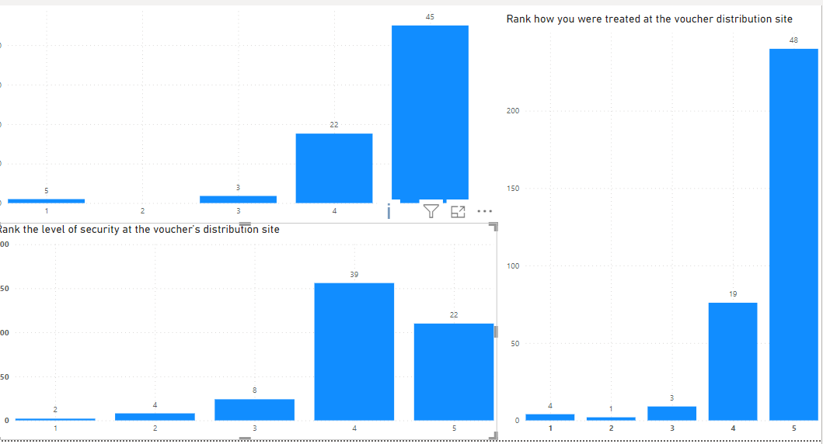

As the above first chart indicates, Rank the ease with which you collected your vouchers, 45 (60%) of the respondents rated 5 of being highest, 22(29.33%) of the respondents rated 4, while 1(1.33%) of the respondents are rated the least.

The respondents were also asked Rank how you were treated at the voucher distribution site (1 being the least and 5 being the highest), 48(64%) of the respondents was rated 5 which is highest and 19(25.33%) of the respondents also rated 4, and the least was rated only 4(5.33%) of the respondents was rated the least.

As we can see from the third chart, the respondents were also asked to rate the level of security at the voucher’s distribution site. (1 being the least and 5 being the highest), 22(29.33%) of the respondents rated 5 meaning the highest and 39(52%) of the respondents rated 4, in this case only 1(1.33%) respondent was rated the least.

The respondents were asked whether the time of distribution was convenient for them and 75(100%) of the respondents said Yes and agreed the time of distribution as favorable for them. In addition to this the respondents were also asked whether it takes time to reach the distribution center and most of them responded it was not taken time to reach the distribution center.

The total respondents of this PDM were also asked if they face any challenges during the distribution and they 100% responded there was any challenges encountered during this distribution.

None of the respondents reported that the drug distribution caused a conflict in their household and 75(100%) of the respondents reported No.

* 1. **How was the quality of the drugs you received?**

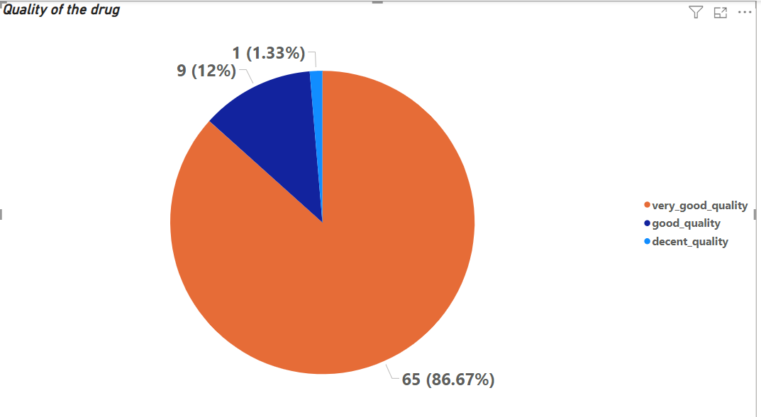

In this regard, 65(86.67%) of the respondents answer back the quality of the drug they received was very good quality, 9(12%) of the respondents said the quality of the data was good while the remaining 1(1.33%) of the respondents said the quality of the drug was decent quality.

In this case it summarizes the quality of the distributed drug was very good as most of the respondents agreed.

* + 1. **Was this what you were told that you would receive**?

75(100%) of the respondents responded this was what they told before the distribution as all of them responded.

Did you have to pay a fee, gift, tip or do a favor to receive the seeds? All of the respondents responded no and said that no one asked them to pay either gift, fee or favor to get the drug.

1. **Market dynamics**
   1. **Did you sell/share some of the drugs you received?**

None of the respondents interviewed responded yes when asked this question, 75(100%) of the respondents said no, that means none of them shared or sold the distributed drugs rather, they used.

* 1. **What do you think of the prices of the drugs you brought compared to market prices?**

Regarding this question, 29(38.67%) of the respondents said the price of the drug is very expensive compared to the market price, 25(33.33%) of the respondents also said that the price of the drug is cheap compared to the market price, 11(14.67%) of the respondents also said that the price is expensive, 6(8%) of the respondents said the price is very cheap compared to the market price while the remaining 4(5.33%) of the respondents also said that it’s the same price with the local market price.

1. **Utilization and husbandry practices**
   1. Did you use all the drugs bought after 2 weeks of distribution?

All the respondents reported that, they used the drug right after 2 weeks of the distribution. 75(100%) of the respondents said “Yes” meaning they have used the drug.

* 1. **How do you rate the quality of drugs you got?**

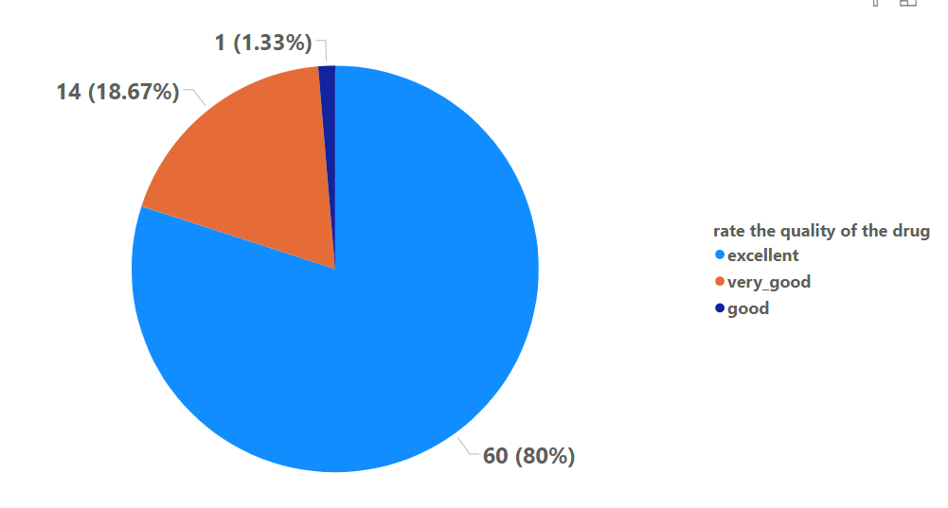

**A**s the above chart depicts, 60(80%) of the respondents rated the quality of the data excellent, 14(18.67%) of the respondents also responded very good while the remaining 1(1.33%) of the respondents responded very good.

In this case we can simply analyze that the quality of the distributed drug was excellent, and the users admired it.

* 1. **If some of the drugs were used to treat sick animals, how would you rate the efficacy?**

As we can see below chart, 59(78.67%) of the respondent said that they can rate the efficiency of the drug if some of the drug were used to treat sick animals is effective by disappearing the clinical signs and symptoms, 9(12%) of the respondents said that they can rate the efficiency through the improvement of feeding and water intake, 5(6.67%) of the respondents also said they can rate the efficiency of the drug through the increasement of the milk yields.

1(1.33%) of the respondents said they can rate the efficiency of the drug by None the animal conditions remained the same as well as 1 (1.33%) of the respondents said the animal died after the animal died after administering the drug.

* 1. **How confident are you as a livestock farmer/trader after receiving knowledge on drug use and husbandry practices?**

69(92%) of the total respondent reported that they are very confident as a livestock trader after receiving the knowledge on drug use and husbandry practices from the PVP. 5(6.67%) of the respondents responded that they are very confident while the remaining 1(1.33%) of the respondents responded that he/she is more confused.

With this respect we can analyze that the respondents are very confident with the knowledges and husbandry practices received as a trader/livestock trader and the knowledges provide was useful to them.

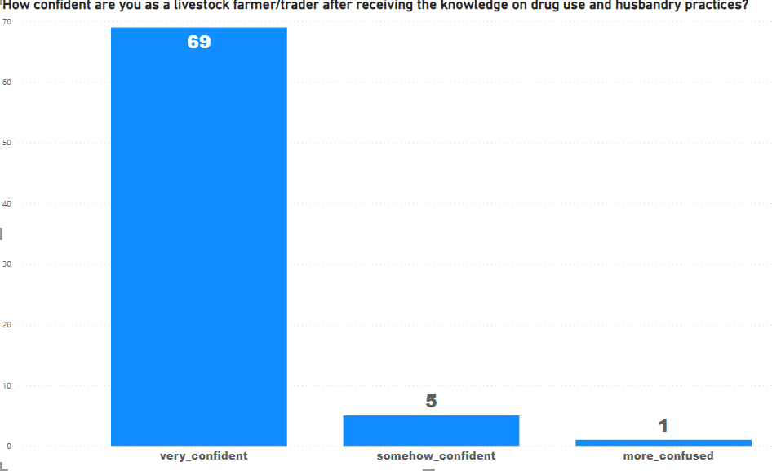

According to the follow up questions asked saying, how many animals’ dead after receiving this drug, the death of 6 goats was reported from 6 different respondents.

1. **CARM**
   1. **Are you aware of the complaints and Feedback mechanism in case you want to report any issue?**

Based on the questions related CARM, 52(69.33%) of the respondents are aware of the CARM while the remaining 23(30.67%) of the respondents said “No” and as the procedures of the data brief explanation related CARM was provide by Data Enumerators though they were trained about CARM during the data collection training day.