**Mercy Corps**

**Program: Enter Energy Ethiopia**

**Tittle: Baseline Survey report**

**Place: Sheder refugee camp**

**Prepared by –**

**Abdifatah Yasin-MEL Specialist**

**Date September 11,2023**

**List of Acronym**

EEE- Enter Energy Ethiopia

HH-households

BS-baseline survey

RRS-refugee and returnee services

MC-mercy corps

LGP- Liquefied petroleum gas

Table of Contents

**Executive summary** 4

**1.** **Program overview** 6

**2. Purpose of the survey** 7

**3.** **Methodology** 8

3.1. Sampling and sample size 8

3.2. Team Composition, Roles & Responsibilities 9

3.3. Timeframe / Schedule 9

**4.** **Result and Discussion** 10

4.1. Respondent Information 10

4.1.1. Demographic Characteristics 10

4.1.2. Work permit and Proof of registration 10

4.1.3. Access to financial institution 11

4.1.4. Health and Education service 11

4.1.5. Main source of electricity in the area 12

4.2. Household Energy Utilities 13

4.2.1. Household Appliances 13

4.2.2. Household technologies for energy utility 13

4.2.3. Household cooking Energy 14

4.2.4. Time spent on firewood collection. 15

4.2.5. Safety during firewood collection 15

4.3. Household Source of lightening, consumption, and gender 16

4.3.1. Household source of lightening and consumption 16

4.3.2. Business and its type that requires electricity. 16

4.3.3. Business monthly earning and electricity spending 17

4.3.4. Business hindered electricity and their type. 17

4.3.5. Challenges related on electricity. 17

4.3.6. Safety and gender related issues 18

4.3.7. Copying mechanism 18

**5.** **Recommendation** 19

Annex 19

# **Executive summary**

The baseline survey was conducted in Sheder refugee camp with all the three zones of the refugees and tried to randomly reach out the blocks under each zone ,thus, with a total of 338 households interviewed, and among this 259 (76.63%) were female respondents and 79 (23.37%) were male respondents. In addition to this, most of the respondents were between the range ages of 29-55years old with a mean age of 42 years old and with a household size of 7 (mean).

Some Sheder refugees do have work permit and majority them do have proof of registration, thus, only 114 (34%) have a work permit and can have the access and engagement to business related activities-which RRS have provided with the support and contribution of MC-STEDE program on the delivery of work permit to help on the smooth implementation and business activities like establishment of cooperative and having license for their business and getting access for credit from financial institutions. Majority of the refugee 316 (97%) do have proof of registration which identifies them as being refugees and this can help for future tracking on program participants and provision on work permit with RRS and UNHCR, and only 22 (7%) said that they don’t have proof of registration at their hand-those are households that household-heads weren’t showed up and those couldn’t be able to show for other reasons.

The majority of Sheder refugees have access to micro-finance institution where 128 (38%) said that they have the access and use ***E-Birr***institution which have and links with KAAFI micro-finance and works under Oromia Bank. This is because, as the participants stated, this financial institution doesn’t charge any fee on the transactions and withdrawal of cash from its agents by their customers.

Reys Microfinance has a branch office in Awbare woreda and provides services to both refugees and host communities in the area. While some customers have opened bank accounts in their branch, most of them use their agent to withdraw and deposit electronic money. Depending on the customer's willingness, Reys Microfinance is willing to open an agent office in Sheder after consulting the head office located in Jigjiga. They said mobile agent would be too expensive for Reys microfinance as they don't have transportation at woreda level.

On the other hand, 38 (11%) of the respondents said that they access and participate in Village and social loan association. The main reason why saving is low is due to scarcity of refugee ration which WFP was delivering to the refugees has held for the last three to four months. 12 (4%) of them created a bank account, 7 (2%) have access and participate in RUSaCco and only 3 (1%) use other informal savings.

Most of Sheder refugees 324 (96%) have no copying mechanism for exchanging assets or household items to either electricity consumption payment or other household needs, whereas only 14 (4%) have said they do have copying mechanism. Out of the 4%, they use copying mechanism for substitute of 7 (50%) household bill, and 3 (21.4%) for both electricity bill and gas respectively, whereas 1 (7.1%) said charcoal.

There are number of challenges that came due to scarcity of electricity access of which, the main challenge stated by Sheder refugees are affordability of the amount to pay which is expensive as they pay ETB200 for one bulb for lightening and ETB200 for one socket for charging which they believe is not compatible to the amount of consumption per households besides accessibility and low of power that can generate household items and business appliances, besides the duration of which the access is very low (between 6:00pm to 11:30pm EAT) which isn’t sufficient and can’t meet the demand of refugees.

In addition to this, darkness and movement restriction is also one of the challenges as there is limitation on the accessibility of electricity within household compounds and to nearby areas for either business or other necessary needs by the refugees like not being able to cook because of the darkness, and even fear of theft.

# **Program overview**

The Enter Ethiopia Energy aimed to enable 14,616 refugees, community institutions and humanitarian organizations in Somali region of Ethiopia access clean, reliable and sustainable energy. Mercy Corps partnered with Shell in this program that will contribute to Ethiopia’s target of universal electrification by 2025, peaceful integration of refugees in the national development plans (CRRF), and environmental preservation.to access clean, reliable and sustainable energy. This will contribute to Ethiopia’s target of universal electrification by 2025, peaceful integration of refugees in the national development plans (CRRF), and environmental preservation. Enter Energy Ethiopia seeks to achieve two specific objectives:

* SO1 aims to create a replicable, market- based model to provide clean, sustainable, reliable and affordable energy services for refugee camps.
* SO2 aims to improve market mechanisms to enable refugee and host community to access energy products, services, financial instruments and improve productive use of energy opportunities.

The Project’s vision is to test an energy access model for long term service provision that can replicate and scale. To do so, the Project will leverage innovative partnerships between humanitarian actors and private sector companies focused on energy access. Mini grids are increasingly being proven as the least- cost method for rural electrification across the developing world today. Even within the humanitarian context, minigrids could represent a cost-effective and highly impactful approach due to rapid technology cost reduction during the past decade. Applying the proposed Mini grid model to the refugee camp model in Ethiopia represents the next frontier.

# **2. Purpose of the survey**

Mercy Corps is planning to conduct an internal baseline survey to assess the current condition of access and sources of energy and related issues based on the following key indicators that the program wants to bring change during the life of the program.

1. Number of people or refugee households using Tier 2 (improved energy access) energy access levels (at least 200 Wh/day by end of the program)
2. Number of institutions and businesses reached by Mini grid and adequate solutions.
3. Percent of households with improved incomes/profitability due to HH-level small businesses by end of the program
4. Percent of households with improved standard of living due to energy access

The main objective of the assignment is to establish detailed baseline survey data on key project indicators to enable changes in refugees and host communities to be measured over the course of the project. The assignment will cover checking the validity of indicators through conducting household visits of the project. The thematic areas to be covered by this baseline survey include:

* Household source of electricity, access (%), type of electricity in the HH, Household expenditure on electricity.
* Assess the living conditions of the refugee households (household equipment like fridge, different machines etc.)
* Household cooking (access, type, and time of primary cooking, monthly spend on cooking fuels and technologies (spend in ETB).
* Energy for displaced enterprises (Access %, type of energy in enterprises with access, business/ enterprises monthly spend electricity (spend ETB).
* Household access to financial services, education services (schooling), and health services.
* Availability of improved financial service providers.
* Gender mainstreaming and protection/safety concerns on gender based violences.
* Challenges when it comes to electricity access and negative coping mechanisms used.

# **Methodology**

A mix of qualitative and quantitative approaches was used for undertaking this baseline survey assessment to ensure the triangulation and validation of information in the areas of interest. The team will combine different tools and collect information/data through Focus Group Discussions (FGDs), Key Informant Interviews (KIIs) and Individual Household interviews to gather data from the sampled respondents in the targeted Sheder refugee camp. This will be implemented as follows:

* **FGDs** – Male and female group FGs were conducted in each zone of sheder refugee camp. In total 2 male FGD and 2 female FGD were conducted
* **KIIs** 5 Key informant interview was conducted with RRC chairperson, Business owners, Microfinance institutions and mobile banking agents.
* **Household Interviews** – In Total 338 refuge households were surveyed regarding access, affordability and cost of lightning and cooking energy and livelihood and income patterns of the refuge household.

## Sampling and sample size

As of July 31, 2023, the total number of refugees/HHs in Sheder is 2,760 and the project is intended to provide power access for about 2,000 HHs. The baseline survey was population based and taken the sample from the general population which is 2760HHs. Using the Mercy Corps standard sample size calculator, the total sample for this survey will be 338 households.

The key informant interviewees were selected based on the position they have, to influence decisions, share information and provide services in the area. The focus group discussion was conducted with a random household in the refugee camps to triangulate the information and data collected from the survey.

# **Result and Discussion**

## 4.1. Respondent Information

**consent: All the 338 refuge households were agreed to participate in the survey.**

### Demographic Characteristics

From the total 338 survey respondents 258 (76.56% were female respondents and 79 (23.44%0 were male respondents. The baseline study purposely increases the proportion of female respondents to get accurate and more reliable data with regard to energy consumption as women are more involved in most of the household chores.

The respondents age ranges from 18-75 years old among which youth respondents count for ___% and adults were __%.

According to a survey most refugee households has large family size; 22.6% has family size of 10 and more, 36% from 7-9, 27.9% from 4-6 and 13.4% of the respondents has 1-3 family sizes.

### Work permit and Proof of registration

Some Sheder refugees do have work permit and majority of them do have proof of registration, only 114 (34%) have a work permit and can have the access and engagement to business related activities-which RRS have provided with the support and contribution of MC-STEDE program on the delivery of work permit to help on the smooth implementation and business activities like establishing business and getting access for credit from financial institutions. Majority of the refugee 316 (97%) do have proof of registration which identifies them as being refugees and this can help for future tracking on program participants and provision on work permit with RRS and UNHCR, and only 22 (7%) said that they don’t have proof of registration at their hand-those are households that household heads weren’t showed up and those others households that couldn’t be able to show for other reasons.

### Access to Services

**Health and Education**

In the refugee camps health and education services are provided by the United Nation Higher Commissioner for Refugees (UNHCR), hence 98.8% respondents confirmed that they have access to health and education services in their nearby area.

**Access to finance:**

According to the survey and the key informant interview, there is a high dominance of micro finance institutions in the area as a major financial service provider. Somali Micro finance, RAIYS micro finance and E-Birr has a high dominance in the area through their mobile banking agents. However no formal financial institution has a branch office in the area for the provision of better financial services like credit. Only RAIYs Micro finance has branch office in Awbare town which is closer to Sheder refugee camp. According to the survey50.9% of the respondents says that they have access for financial services; 68% MFI, 20% VSLA, 6.4% bank, 3.7% RUSACCO and 1.6% uses other informal savings.

### Main source of electricity in the area

**Access to Electricity:**

Both in the survey, KII and FGD discussion Diesel generator is found to be the major source of energy for the refugee households. According to Mohammed Omer, which is one of the generator owners, there are 5 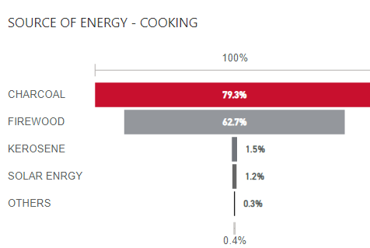generator service providers in the refugee camps, and all are using the same tariff and service provision for the refugees. The power will be on from 6pm to 6am for an average of 6 hours per day and they charge 400 brr per one bulb and one plug, another 400 if the household owns a TV and 1500 if the household has a washing machine.

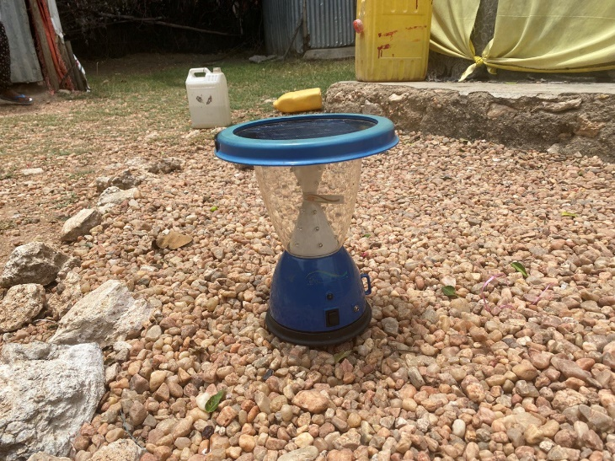In the survey 95.2% of the respondents said that they are using energy from the generator service providers paying 200 birr per month for one bulb and for an average of 6 hours per day, but duration can vary based on the service provider’s willingness. It is observed that other means of lightning are rarely practiced by the refugees like solar lantern and solar home systems, 3.3% of the household use Solar lantern and 1.5% say they have solar home systems.

The number of refugees with household appliances which consume electric energy is not that quite significant. The most energy consuming item which is listed by the respondents is a cell phone with 62.6% of response, which implies that their energy consumption will increase by 200 birrs at household level and 20.3% own TV which increase their energy related cost by 400 birr and 5.3% has washing machines which costs then 1500 birr for energy in a monthly basis. In average refuge households spent 658 birr per month for lighting purposes.

**Cooking Energy:**

The major source of cooking energy in the refugee camps was found to be charcoal and firewood with 79.3% and 62.7% responses from the surveyed households. The household in the focus group discussions and the refuge central committee chairperson during the key informant interview also mentioned that the refugees use charcoal as a major source of cooking energy and cost them 1605 birr in average per month.

The firewood, the refugees are collecting it from the bush around their camps for free, but investing their time, labor and sometimes facing safety issues. According to the survey 39.8% and 18.5% of the respondents are spending 4 hours or more for firewood collection and 13.7% said that they spent 3 hours for firewood collection. Refugee households also mentioned that they are facing safety concerns during firewood collection; rape, physical attack, and wild animal attack are some of the safety issues mentioned by the respondents.

## Energy for Business.

The number of refugees who are engaged in income generating activities or businesses which require electric power are 39 which counts for 11.5% of the total respondents. Among these 46% are engaged in a cafeteria and restaurant business, 17.9% own a small shop with refrigerator to sell cold drinks and 12.8% sell cold drink in their house and 23% are engaged in other businesses like, hair salon and photo shop. These refugee household businesses earn an average of 6,276 birr per month and spent an average of 2,932 birr for energy consumption for business related energy expenses which is 46.7% of their total earnings.

A key informant from the host community who owns a milling business mentioned that the power from the main grid is very inconsistent in Sheder area and there are times that they run out of power for more than a month. Every Miller in the area owns a generator as an alternative source of power. They are purchasing fuel for the generator with almost double price (100 birr per litter) from black market due the shortage of fuel in the area. The key informant mentioned that the milling price is doubled when they use generator power than power from the main grid. Poor and vulnerable households will be forced to travel to Awbare which is the nearby town to get the milling service with a lesser price.

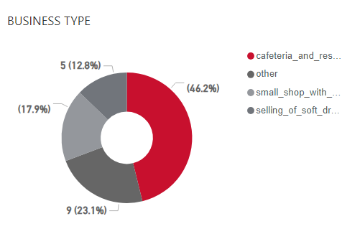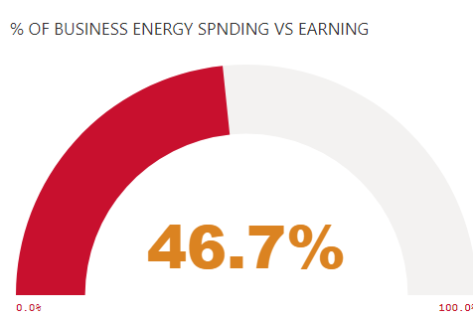

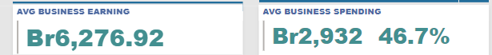

Among the surveyed household 28% (84) of the respondents said that they have plans to do business if there is an affordable and sustainable power supply in the area. Ice cream shops, hair salons, laundry service, printing and copy service and cafeteria business are among the lists mentioned by the refugee households.

### Challenges related to access to energy.

From the challenges mentioned by surveyed households, affordability and duration are the major ones. Given the income of the refugee household the price which is charged by the generator power providers is very unaffordable and the duration is for a very limited and even in consistent which doesn’t give a flexibility for the households for their social and economic activities. The households also mention that their surroundings are very dark at nighttime which brings safety issues like wild animal attacks, theft and physical violence, as they cannot put light out of their house due to affordability.

In addition to this, darkness and movement restriction is also one of the main challenges for refugees as there is limitation on the accessibility of electricity within household compounds and to nearby areas for either business or other necessary needs by the refugees like not being able to cook because of the darkness, and even fear of theft.

### Copying mechanism

The refugee households are engaging with available income generating activity in the area, like daily labore, collect firewood, small shop and vegetable trade which are among the positive coping mechanisms to cover energy related expenses. In the worst scenario some refugee households are forced to sell the food ration which they receive from WFP.

# **Recommendation**

Based on the findings from the baseline survey both the quantitative and qualitative data collection, below are the main recommendations for better planning, improvement, and input on the impactful and successful implementation of the Enter Energy program.

* There is high expectation to the program implementation from Sheder refugees and waiting with high interest for changing and improving their business and livelihoods. This helps and would be part of smooth program implementation with community participatory approach.
* All Sheder refugees use and have access to ***E-birr*** financial institutions and can pay their electricity bills through these financial institutions who have agents in Sheder refugee like their other business.
* The study suggests that the Enter Energy program, to work on provision of Sheder refugees on work permit for business and agreement facilitation with refugee stakeholders like RRS and UNHCR as there is low percentage of access to work permit.
* There is high electricity volume demand from Sheder refugees, and the program is expected to provide and cover that with cheaper and affordable prices compared to diesel generator price; the refugees pay ETB200 for one bulb.
* There is high interest in electricity consumption and the start of business which hindered due to shortage of electric power for its duration and high value price.
* The payment for connection for electricity access at each household to be cheaper compared to that of diesel generator; the refugees paid ETB200ETB for connection, thus, purchased the wires and other necessary materials for electricity connection.
* The electricity access to be very powerful, which can generate all household appliances and business-related materials and can meet their demand on electricity accessing.
* The electricity to be available/accessible for 24hours for household consumption in their kitchens and to properly do their household chores.
* To think of expanding the lightening of streets for better improvement of security and minimize refugee movement restriction, fears and maximize movement within neighbors, household needs and business access.
* Support on the facilitation of credit for Sheder refugees on household appliances like washing machines, and other technologies after electricity connection.
* There is a need for
* Data collection tools to be translated into local language for better data quality and detailed digestion of information for decision making.

# Annex

