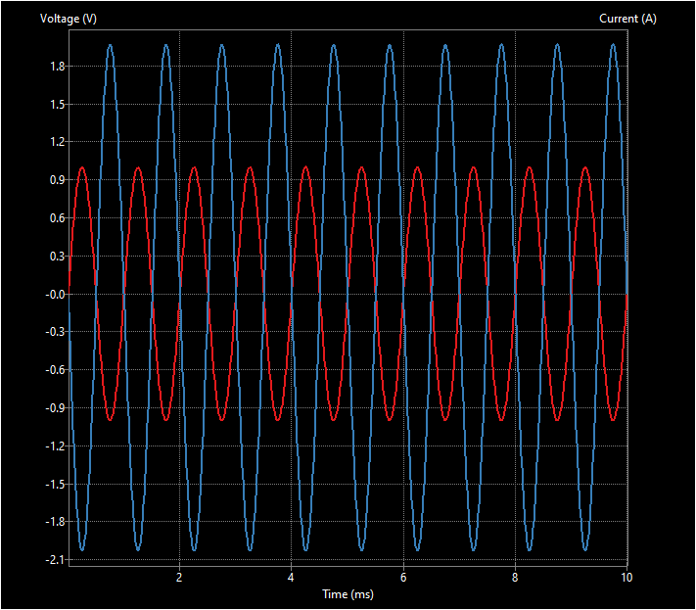

The red curve on this graph is the input and the blue curve is the output. This is the expected result because we made an inverting amplifier circuit. This means that the output is opposite of the input, and can be seen in the graph as alternating sine waves. The amplitude is two times the input.

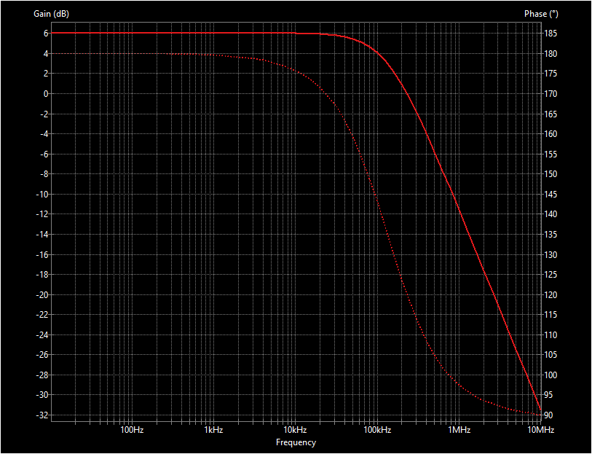

This graph shows the gain (bold line) and the phase (faded line). The gain decreases because the op-amp has a single pole inside it. This results in an RC behavior which means that at high frequency, the gain and phase decrease.