The last HTML elements we will explore are involved in metadata processes. You can think of these elements as the “brains” of a webpage because they communicate vital information to the web browser, but are not visible to a webpage visitor.
- <!DOCTYPE html>: Tells the web browser to expect an HTML document.
- <html>...</html>: The root of the HTML document and parent of all other HTML elements on the webpage.
- <head>...</head>: Enclose other metadata about the site, such as its title.
- <title>...</title>: Contains the site’s title, which is one way users can find your site through a search engine, like Google.
- <meta charset="utf-8"/>: Tells the web browser which character set to use. In this case, the character set is “utf-8”.
- html: stands for hypertext markup language, and is used to give a webpage structure.
- css: stands for cascading style sheets, and is used to style HTML elements.

HTML Elements
- h1 - h6: indicate text headings on a webpage. h1 is the largest heading; h6 is the smallest.
<h1>Heading</h1>
- p: used for non-heading text, such as the bodies of articles or company descriptions.
<p>Description of company here.</p>
- a: short for anchor and used to add links to other webpages. Anchor elements typically have an href attribute:
<a href="http://codecademy.com">Click here</a> to learn how to make a website!
- img: used to add an image to a webpage. Image elements are self-closing and do not require a closing tag:
<img src="https://images.com/favorite.png">
- video: used to add videos to a webpage, and uses multiple attributes and a nested source element:
- <video width="320" height="240" controls>
- <source src="https://movies.io/great-clip.mp4" type="video/mp4">
</video>
- unordered list: used to create lists on a webpage and requires li elements inside a ul:
- <ul>
- <li>list item</li>
- <li>another item</li>
- <li>yet another</li>
</ul>
- div: used to organize HTML elements into different groups, which can be given a class attribute:
- <div class="main">
- <h2>Subheading!</h2>
</div>
- metadata tags: provide metadata about a webpage.

Web Concepts
- parent/child elements: used to describe HTML elements that enclose or are enclosed by other elements. For example, below the ul is the parent and the li items are children:
- <ul>
- <li>...</li>
- <li>...</li>
- <li>...</li>
</ul>

About link:
- The link element uses three attributes:
-rel: Specifies the relationship between the current file and the file being linked to: in this case, the rel attribute is “stylesheet”.
-type: Specifies the type of file linked to.
-href: Provides the URL of the file being linked to.
- Like the HTML image element, link is self-closing. It does not need a closing tag.

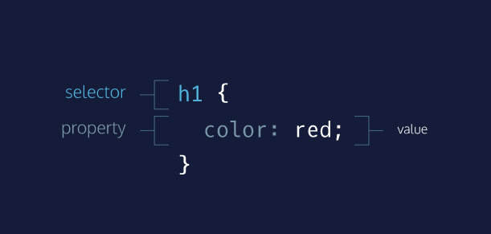
- rule: a list of CSS instructions for how to style a specific HTML element or group of HTML elements.
- selector: specifies exactly which HTML elements to style. Here h1 is the selector.
- properties and values: located inside the { } brackets, properties and values specify what aspect of the selector to style. In the diagram’s example, the color property is set to red, which will display all h1 elements in red.

In CSS, size can be assigned in pixels (px), rems, or ems.
- pixel (px): Standard unit of measurement for sizing fonts and other HTML elements.
- rem: Represents the default font size for the web browser. Rems can be used to ensure that HTML elements scale in proportion to each other on various web browsers and screen sizes. On most web browsers, 1rem is equivalent to 16px, 2rem is equivalent to 32px (a doubling), 3rem is equivalent to 48px (a tripling) and so on.
- em: A relative value that changes in proportion to the font-size of the element on which em is used. Because font-size is an inherited property, this usually means the em value will change in proportion to the font-size of the parent element unless a font-size is explicitly set on the element on which em is used. For example, if a parent element has font-size: 20px;, child elements with font-size: 1em; would be equivalent to 20px. Child elements with font-size: 0.5em; would be equivalent to 10px (a halving) and so on.

- CSS: Language used to style websites. Colors, fonts, and page layouts for a site are managed using CSS.
- CSS Selectors: specifies exactly which HTML elements to style
  - class selectors: used to target classes of HTML elements
  - id selectors: used to style an HTML element which has an id attribute.
- External Stylesheet: CSS file that styles an HTML file externally via the HTML link element.

CSS Properties
- font-family: sets font for a CSS selector.
- color: sets font color for the CSS selector.
- font-size: sets font size for text.
- background-image: sets a background image of your choosing for a given selector.

link elements have three attributes:
a. rel
b. type
c. href
Here is an example:
<link rel="stylesheet" type="text/css" href="main.css"/>

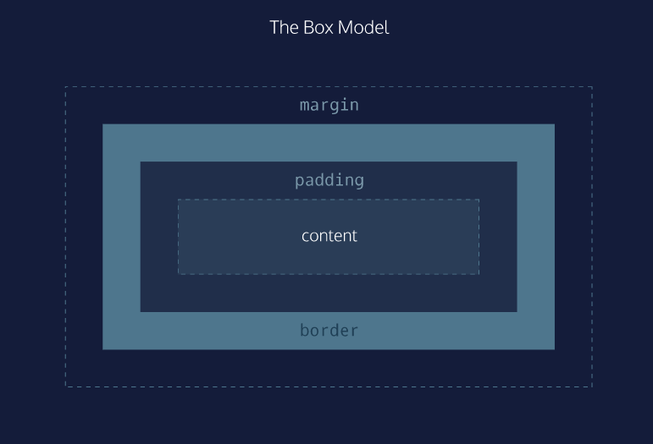
- content: Includes text, images, or other media contained within an HTML element.
- padding: The space between the content and the border. You can think of this like inner space.
- border: The outline of an HTML page element. You can think of it like a picture frame that contains the element.
- margin: The space between the HTML page element and the next nearest element(s).

In CSS, the border property’s value requires three parts:
- thickness: Sets the thickness of the border, using pixels, ems, or rems.
- type: Sets the border type. Common options are solid, dotted, and dashed. There are many others.
- color: Sets the border’s color, using named colors, HEX, or RGB values.

The CSS padding property controls the empty space between the page element’s content and its border. Increasing a page element’s padding makes the space around the content more spacious, while decreasing it makes the space more compact.
p {
padding: 20px;
}

The CSS margin property controls the space between different HTML elements on a webpage. Use margin to bring page elements closer together or to move them further apart.
The CSS below ensures 2rems of space between elements with the class answer and surrounding page elements.
.answer {
margin: 2rem;
}

- margin-top: Sets the top margin.
- margin-bottom: Sets the bottom margin.
- margin-left: Sets the left margin.
- margin-right: Sets the right margin.
Not all HTML elements are displayed on a page in the same way. Display types determine how HTML elements will be arranged in relation to each other.
In the diagram, notice:
- The two dotted rectangles represent webpages.
- HTML heading, paragraph, and unordered list elements are block level: each appears on its own line on the webpage.
- HTML image and anchor elements are displayed inline: they appear on the same line as their neighboring elements on the webpage.
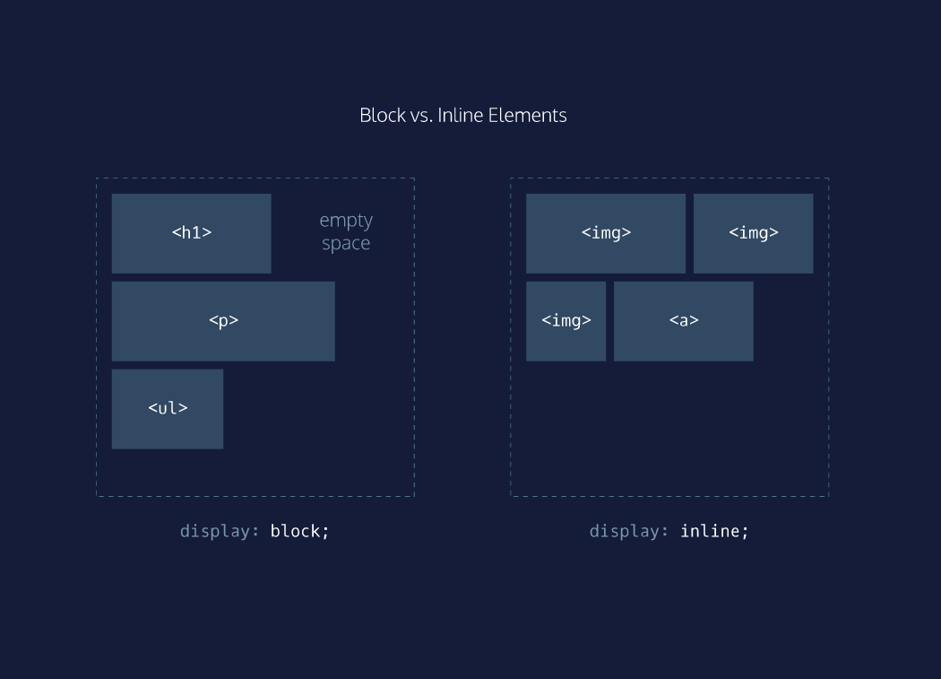

In the example code below, there is a div with class parent:
<div class="parent">
...
</div>
To make children of the div align horizontally on the webpage, in CSS we can use:
.parent {
display: flex;
}
Children elements of the div with class parent will now align horizontally. We can make sure no child element moves off the page by using flex-wrap: wrap;:
.parent {
display: flex;
flex-wrap: wrap;
}
Finally, to center rows of children elements, we can use justify-content: center;:
.parent {
display: flex;
flex-wrap: wrap;
justify-content: center;
}
The CSS position property enables you to position HTML elements in exact locations on a webpage. One useful value for this property is relative. This value positions page elements on a webpage relative to where they would normally appear!
By first setting position: relative;, you can then use the CSS properties top, left, bottom, and right to shift an element away from where it would have normally appeared on the page.
The code snippet below moves a div with the class container 10px away from the up and 20px away from the left side of the page.
.container {
position: relative;
top: 10px;
left: 20px;
}
Ever click a button on a webpage that seemed to move down and then back up like a real-life button? We can implement this trick using the position property.

CSS Skills
- border: sets the outline of an HTML page element, like a picture frame that contains the element.
- padding: sets the amount of space between an element’s content and its border.
- margin: sets the amount of space between an HTML element and the next nearest element(s).
- display: property that determines how the selected element will be arranged in relation to other HTML elements on the page.
- inline: display value used to arrange HTML elements on the same line as neighboring elements.
- flex: display value that allows us to easily align multiple page elements vertically or horizontally.
- float: property used to float HTML elements left or right of neighboring elements.
- position: property used to position HTML elements in exact locations on a webpage.

One of the reasons Bootstrap and frameworks like it are so popular is because they offer grids. A grid makes it possible to organize HTML elements using preconfigured columns. Using a grid, you can customize responsive page layouts quickly and reliably.
The Bootstrap grid contains 12 equal-sized columns, as seen in the diagram on the right. HTML elements are arranged to span different numbers of columns in order to create custom page layouts.

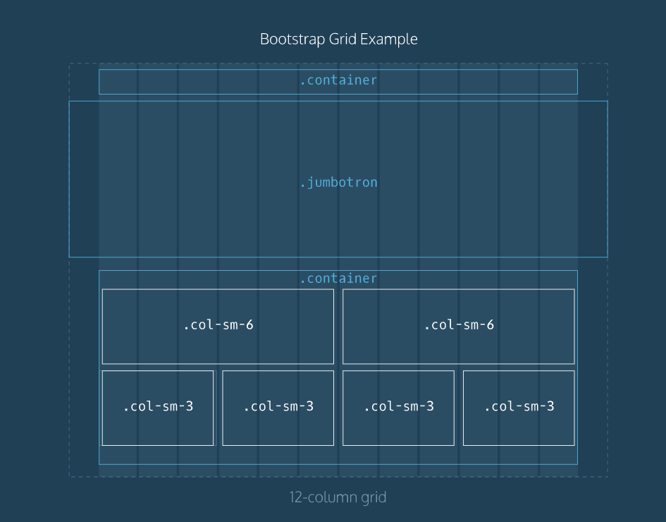

In the diagram, observe the following:
- Bootstrap’s grid columns are represented by 12 vertical bars. The boxes represent HTML elements.
- The words “container”, “jumbotron”, “col-sm-6” and “col-sm-3” refer to Bootstrap classes.
- The element with class “jumbotron” spans the entire width of the webpage, beyond the borders of the grid.
- Elements inside the second “container”, such as “col-sm-6” and “col-sm-3” are contained within the grid columns.
- Elements labeled “col-sm-3” take up three grid columns; elements labeled “col-sm-6” take up six grid columns.

Let’s use Bootstrap’s grid to create a simple header with navbar.
In the example code below, an HTML header element with Bootstrap’s predefined container class is used:
<header class="container">
...
</header>
Inside the header, a row is created by using a div with Bootstrap’s row class:
<header class="container">
<div class="row">
</div>
</header>
Finally, the row is cut into two parts:
<header class="container">
<div class="row">
<h1 class="col-sm-4">Heading</h1>
<nav class="col-sm-8 text-right">
<p>nav item 1</p>
<p>nav item 2</p>
<p>nav item 3</p>
</nav>
</div>
</header>
The first part consists of the h1 with Bootstrap’s class col-sm-4. It will take up the first four columns on the grid. The second part consists of the nav element with class col-sm-8. It will take up the remaining eight grid columns. text-right indicates that text will be arranged on the right side of the nav.

In addition to a header/navigation, many websites have a large showcase area featuring important content. Bootstrap refers to this as a jumbotron. Below is an example implementation of a jumbotron.
First, a new section element is created and assigned the jumbotron class:
<section class="jumbotron">

</section>
Next a div with the Bootstrap class container is used:
<section class="jumbotron">
<div class="container">
...
</div>
</section>
A div with the Bootstrap class row text-center can center subsequent child elements which will contain text:
<section class="jumbotron">
<div class="container">
<div class="row text-center">
...
</div>
</div>
</section>
The ... is a placeholder for HTML elements containing text, such as h2, p or anchor elements.
Many websites have a supporting content area. Supporting content can be arranged using Bootstrap’s grid. Below is an example implementation of a supporting content area.
First, an HTML section element with the container class is used:
<section class="container">

</section>
Next, div elements with the row class are added:
<section class="container">
<div class="row">
</div>
<div class="row">
</div>
</section>
Finally, the rows are divided by using divs with Bootstrap’s col-sm-... class.
<section class="container">
<div class="row">
<div class="col-sm-6">
...
</div>
<div class="col-sm-6">
...
</div>
</div>
<div class="row">
<div class="col-sm-6">
...
</div>
<div class="col-sm-6">
...
</div>
</div>
</section>
Above, two rows are divided into two equal parts. Each part takes up 6 of bootstrap’s 12 columns. Using the col-sm-6 class ensures that this layout will appear when the user’s screen is the width of a tablet device(768 pixels). On narrower screens, such as an iPhone, only one image per row will appear.
Below is one possible implementation for a footer section using Bootstrap:
First, a footer element with Bootstrap’s container class is used:
<footer class="container">

</footer>
Inside the footer, a div with Bootstrap’s row class is added to hold footer content:
<footer class="container">
<div class="row">
...
</div>
</footer>
Finally, the row is divided into parts using Bootstrap’s grid. Here is one suggestion:
<footer class="container">
<div class="row">
<p class="col-sm-4">...</p>
<ul class="col-sm-8">
<li class="col-sm-1">...</li>
<li class="col-sm-1">...</li>
<li class="col-sm-1">...</li>
</ul>
</div>
</footer>
Above, the row is broken into three parts: a p element that takes up four columns, a ul which takes up 8 columns, and li items which take up 1 column each. The lis could hold navigation menu items or social media icons.

Again, because the col-sm-... class is used, this layout will appear on tablet-width screens and wider. Screen sizes smaller than tablet-width (768 pixels), will not maintain this layout.
Web Concepts
- CSS Framework: Set of prewritten CSS rules designed to help you build webpages faster.
- Bootstrap Grid: 12 equal-sized columns which can be utilized via Bootstrap classes to build responsive page layouts quickly and reliably.

Bootstrap classes
- row: Arranges HTML elements in rows, and can be useful when building headers/navigation menus, main feature sections, supporting content sections and footers.
- jumbotron: Used to create large showcase sections featuring important content.
- col-sm-*: Used to span a specified number of columns on the Bootstrap grid. The “sm” is short for “small”, and maintains desired CSS layouts on small screens (tablet-sized).
- text-right: Bootstrap class used to orient text to the right side of the webpage.
- btn btn-primary: Bootstrap class used to style page elements as buttons.

The <form> element is a great tool for collecting information, but then we need to send that information somewhere else for processing. We need to supply the <form> element with both the location of where the <form>‘s information goes and what HTTP request to make. Take a look at the sample <form> below:
<form action="/example.html" method="POST">
</form>
In the above example, we’ve created the skeleton for a <form> that will send information to example.html as a POST request — the action attribute determines where the information is sent and the method attribute is assigned a HTTP verb that is included in the HTTP request. (Note: HTTP verbs like POST do not need to be capitalized for the request to work, but it’s done so out of convention. In the example above we could have written method="post" and it would still work)
The <form> element can also contain child elements. For instance, it would be helpful to provide a header so that users know what this <form> is about. We could also add a paragraph to provide even more detail. Let’s see an example of this in code:
<form action="/example.html" method="POST">
<h1>Creating a form</h1>
<p>Looks like you want to learn how to create an HTML form. Well, the best way to learn is to play around with it.</p>
</form>
The example above doesn’t collect any user input, but we’ll do that in the next exercise. For now, let’s practice making the foundation of an HTML <form>!

If we want to create an input field in our <form>, we’ll need the help of the <input> element.
The <input> element has a type attribute which determines how it renders on the web page and what kind of data it can accept.
The first value for the type attribute we’re going to explore is "text". When we create an <input> element with type="text", it renders a text field that users can type into. It’s also important that we include a name attribute for the <input> — without the name attribute, information in the <input> won’t be sent when the <form> is submitted. We’ll explain more about submissions and the submit button in a later exercise. For now, let’s examine the following code that produces a text input field:
<form action="/example.html" method="POST">
<input type="text" name="first-text-field">
</form>
Here’s a screen shot of how the rendered form looks like on a web page for the Chrome browser (different browsers have different default rendering). When initially loaded, it will be an empty box:
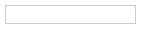
After users type into the <input> element, the value of the value attribute becomes what is typed into the text field. The value of the value attribute is paired with the value of the name attribute and sent as text when the form is submitted. For instance, if a user typed in “important details” in the text field created by our <input> element:
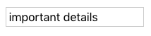
When the form is submitted, the text: "first-text-field=important details" is sent to /example.html because the value of the name attribute is "first-text-field" and the value of value is "important details".
We could also assign a default value for the value attribute so that users have a pre-filled text field when they first see the rendered form like so:
<form action="/example.html" method="POST">
<input type="text" name="first-text-field" value="already pre-filled">
</form>
Which renders:
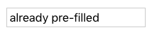
Time to put this knowledge into practice!

In the previous exercise we created an <input> element but we didn’t include anything to explain what the <input> is used for. For a user to properly identify an <input> we use the appropriately named <label> element.
The <label> element has an opening and closing tag and displays text that is written between the opening and closing tags. To associate a <label> and an <input>, the <input> needs an id attribute. We then assign the for attribute of the <label> element with the value of the id attribute of <input>, like so:
<form action="/example.html" method="POST">
<label for="meal">What do you want to eat?</label>
<br>
<input type="text" name="food" id="meal">
</form>
The code above renders:
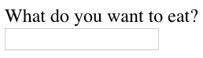
Look, now users know what the <input> element is for! Another benefit for using the <label> element is when this element is clicked, the corresponding <input> is highlighted/selected.
Let’s see the <label> element in action!

Datalist Input
Even if we have an organized dropdown list, if the list has a lot of options, it could be tedious for users to scroll through the entire list to locate one option. That’s where using the <datalist> element comes in handy.
The <datalist> is used with an <input type="text"> element. The <input> creates a text field that users can type into and filter options from the <datalist>. Let’s go over a concrete example:
<form>
<label for="city">Ideal city to visit?</label>
<input type="text" list="cities" id="city" name="city">

<datalist id="cities">
<option value="New York City"></option>
<option value="Tokyo"></option>
<option value="Barcelona"></option>
<option value="Mexico City"></option>
<option value="Melbourne"></option>
<option value="Other"></option>
</datalist>
</form>
Notice, in the code above, we have an <input> that has a list attribute. The <input> is associated to the <datalist> via the <input>‘s list attribute and the id of the <datalist>.
From the code provided, the following form is rendered: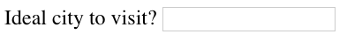
And when field is selected: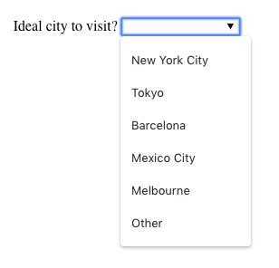
While <select> and <datalist> share some similarities, there are some major differences. In the associated <input> element, users can type in the input field to search for a particular option. If none of the <option>s match, the user can still use what they typed in. When the form is submitted, the value of the <input>‘s name and the value of the option selected, or what the user typed in, is sent as a pair.
Now it’s time to make a <datalist> of our own!

Textarea element
An <input> element with type="text" creates a single row input field for users to type in information. However, there are cases where users need to write in more information, like a blog post. In such cases, instead of using an <input>, we could use <textarea>.
The <textarea> element is used to create a bigger text field for users to write more text. We can add the attributes rows and cols to determine the amount of rows and columns for the <textarea>. Take a look:
<form>
<label for="blog">New Blog Post: </label>
<br>
<textarea id="blog" name="blog" rows="5" cols="30">
</textarea>
</form>
In the code above, an empty <textarea> that is 5 rows by 30 columns is rendered to the page like so:
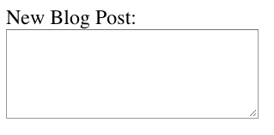
If we wanted an even bigger text field, we could click and drag on the bottom right corner to expand it.
When we submit the form, the value of <textarea> is the text written inside the box. If we want to add a default value to text to <textarea> we would include it within the opening and closing tags like so:
<textarea>Adding default text</textarea>
This code will render a <textarea> that contains pre-filled text: “Adding default text”.
But don’t just take our word for it, let’s test it out!

Submit Form
Remember, the purpose of a form is to collect information that will be submitted. That’s the role of the submit button — users click on it when they are finished with filling out information in the <form> and they’re ready to send it off. Now that we’ve gone over how to create various input elements, let’s now go over how to create a submit button!
To make a submit button in a <form>, we’re going to use the reliable <input> element and set the type to "submit". For instance:
<form>
<input type="submit" value="Send">
</form>
Which renders:
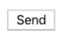
Notice in the code snippet that the value assigned to the <input> shows up as text on the submit button. If there isn’t a value attribute, the default text, Submit shows up on the button.
Let’s now add this element to make our <form>s complete!

Review
Nice work interacting with the extremely common and useful <form> element!
In this lesson we went over:
- The purpose of a <form> is to allow users to input information and send it.
- The <form>‘s action attribute determines where the form’s information goes.
- The <form>‘s method attribute determines how the information is sent and processed.
- To add fields for users to input information we use the <input> element and set the type attribute to a field of our choosing:
  - Setting type to "text" creates a single row field for text input.
  - Setting type to "password" creates a single row field that censors text input.
  - Setting type to "number" creates a single row field for number input.
  - Setting type to "range" creates a slider to select from a range of numbers.
  - Setting type to "checkbox" creates a single checkbox which can be paired with other checkboxes.
  - Setting type to "radio" creates a radio button that can be paired with other radio buttons.
  - Setting type to "list" will pair the <input> with a <datalist> element.
  - Setting type to "submit" creates a submit button.
- A <select> element is populated with <option> elements and renders a dropdown list selection.
- A <datalist> element is populated with <option> elements and works with an <input> to search through choices.
- A <textarea> element is a text input field that has a customizable area.
- When a <form> is submitted, the name of the fields that accept input and the value of those fields are sent as name=value pairs.
Using the <form> element in conjunction with the other elements listed above allows us to create sites that take into consideration the wants and needs of our users. Take the opportunity to take what you’ve learned, and apply it!
Download the Forms: Cheat Sheet to help you remember the content covered in this lesson.
Sometimes we have fields in our <form>s which are not optional, i.e. there must be information provided before we can submit it. To enforce this rule, we can add the required attribute to an <input> element. Take for example:
<form action="/example.html" method="POST">
<label for="allergies">Do you have any dietary restrictions?</label>
<br>
<input id="allergies" name="allergies" type="text" required>
<br>
<input type="submit" value="Submit">
</form>
This renders a text box, and if we try to submit the <form> without filling it out we get this message:
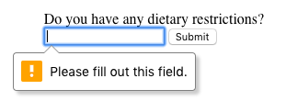
The styling of the message varies from browser to browser, the picture above depicts the message in a Chrome browser. We’ll also continue to show these messages as they appear in Chrome in later exercises.

Another built-in validation we can use is to assign a minimum or maximum value for a number field, e.g. <input type="number"> and <input type="range">. To set a minimum acceptable value, we use the min attribute and assign a value. On the flip side, to set a maximum acceptable value, we assign the max attribute a value. Let’s see this in code:
<form action="/example.html" method="POST">
<label for="guests">Enter # of guests:</label>
<input id="guests" name="guests" type="number" min="1" max="4">
<input type="submit" value="Submit">
</form>
If a user tries to submit an input that is less than 1 a warning will appear: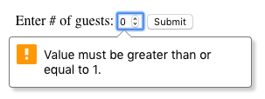

Matching a Pattern
In addition to checking the length of a text, we could also add a validation to check how the text was provided. For cases when we want user input to follow specific guidelines, we use the pattern attribute and assign it a regular expression, or regex. Regular expressions are a sequence of characters that make up a search pattern. If the input matches the regex, the form can be submitted.
Let’s say we wanted to check for a valid credit card number (a 14 to 16 digit number). We could use the regex: [0-9]{14,16} which checks that the user provided only numbers and that they entered at least 14 digits and at most 16 digits. To add this to a form:
<form action="/example.html" method="POST">
<label for="payment">Credit Card Number (no spaces):</label>
<br>
<input id="payment" name="payment" type="text" required pattern="[0-9]{14,16}">
<input type="submit" value="Submit">
</form>
With the pattern in place, users can’t submit the <form> with a number that doesn’t follow the regex. When they try, they’ll see a validation message like so:
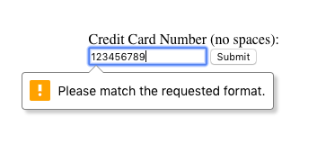
If you want to find out more about Regex, read more at MDN’s regex article.
To see it in practice, let’s use the pattern attribute in our HTML!

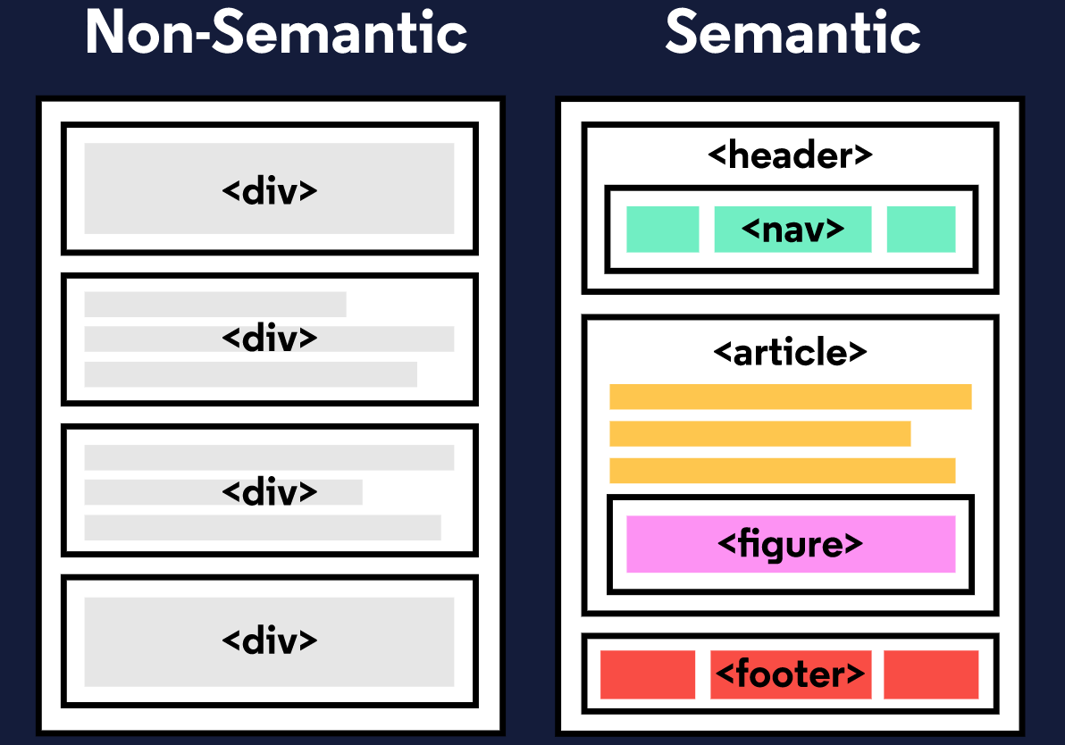
When building web pages, we use a combination of non-semantic HTML and Semantic HTML. The word semantic means “relating to meaning,” so semantic elements provide information about the content between the opening and closing tags.
By using Semantic HTML, we select HTML elements based on their meaning, not on how they are presented. Elements such as <div> and <span> are not semantic elements since they provide no context as to what is inside of those tags.
For example, instead of using a <div> element to contain our header information, we could use a <header> element, which is used as a heading section. By using a <header> tag instead of a <div>, we provide context as to what information is inside of the opening and closing tag.
Why use Semantic HTML
- Accessibility: Semantic HTML makes webpages accessible for mobile devices and for people with disabilities as well. This is because screen readers and browsers are able to interpret the code better.
- SEO: It improves the website SEO, or Search Engine Optimization, which is the process of increasing the number of people that visit your webpage. With better SEO, search engines are better able to identify the content of your website and weight the most important content appropriately.
- Easy to Understand: Semantic HTML also makes the website’s source code easier to read for other web developers.
To better understand this, you can think of comparing non-semantic HTML to going into a store with no signs on the aisles. Since the aisles aren’t labeled, you don’t know what products are in those aisles. However, stores that do have signs for each aisle make it a lot easier to find the items you need, just like Semantic HTML.

With <aside>, we learned that we can put additional information next to a main piece of content, but what if we wanted to add an image or illustration? That is where <figure> and <figcaption> come in.
<figure> is an element used to encapsulate media such as an image, illustration, diagram, code snippet, etc, which is referenced in the main flow of the document.
<figure>
<img src="overwatch.jpg"/>
</figure>
In this code, we created a <figure> element so that we can encapsulate our <img> tag. In <figure> we used the <img> tag to insert an image onto the webpage. We used the src attribute within the <img> tag so that we can link the source of the image.
It’s possible to add a caption to the image by using <figcaption>.
<figcaption> is an element used to describe the media in the <figure> tag. Usually, <figcaption> will go inside <figure>. This is different than using a <p> element to describe the content; if we decide to change the location of <figure>, the paragraph tag may get displaced from the figure while a <figcaption> will move with the figure. This is useful for grouping an image with a caption.
<figure>
<img src="overwatch.jpg">
<figcaption>This picture shows characters from Overwatch.</figcaption>
</figure>
In the example above, we added a <figcaption> into the <figure> element to describe the image from the previous example. This helps group the <figure> content with the <figcaption> content.
While the content in <figure> is related to the main flow of the document, its position is independent. This means that you can remove it or move it somewhere else without affecting the flow of the document.

Audio and Attributes
Now that we learned about text-based content, let us dig into <audio>! Surely everyone needs <audio>— how else would you listen to your Korean hip hop?
The <audio> element is used to embed audio content into a document. Like <video>, <audio> uses src to link the audio source.
<audio>
<source src="iAmAnAudioFile.mp3" type="audio/mp3">
</audio>
In this example, we created an <audio> element. Then we created a <source> element to encapsulate our audio link. In this case, iAmAnAudioFile.mp3 is our audio file. Then we specified the type by using type and named what kind of audio it is. Although not always necessary, it’s recommended that we state the type of audio as it helps the browser identify it more easily and determine if that type of audio file is supported by the browser.
We linked our audio file into the browser but now we need to give it controls. This is where attributes come in. Attributes provide additional information about an element.
Attributes allow us to do many different things to our audio file. There are many attributes for <audio> but today we’re going to be focusing on controls and src.
- controls: automatically displays the audio controls into the browser such as play and mute.
- src: specifies the URL of the audio file.
As you might have noticed, we already used the src attribute. Most attributes go in the opening tag of <audio>. For example, here’s how we could add both autoplay functionality and audio controls:
<audio autoplay controls>

Congrats on completing this lesson on Semantic HTML! Now that you know the benefits of Semantic HTML and how to use it, you can incorporate semantic elements into your website to make it more accessible and to make the code easier to read.
Let’s review some of the topics we covered throughout the lesson:
- Semantic HTML introduces meaning to a page through specific elements that provide context as to what is in between the tags.
- Semantic HTML is a modern standard and makes a website accessible for people who use screen readers to translate the webpage and improves your website’s SEO.
- <header>, <nav> , <main> and <footer> create the basic structure of the webpage.
- <section> defines elements in a document, such as chapters, headings, or any other area of the document with the same theme.
- <article> holds content that makes sense on its own such as articles, blogs, comments, etc.
- <aside> contains information that is related to the main content, but not required in order to understand the dominant information.
- <figure> encapsulates all types of media.
- <figcaption> is used to describe the media in <figure>.
- <video>, <embed>, and <audio> elements are used for media files.
Now, apply this knowledge to become a better Web Developer.

Perfect! We successfully separated structure (HTML) from styling (CSS), but the web page still looks bland. Why?
When HTML and CSS code are in separate files, the files must be linked. Otherwise, the HTML file won’t be able to locate the CSS code, and the styling will not be applied.
You can use the <link> element to link HTML and CSS files together. The <link> element must be placed within the head of the HTML file. It is a self-closing tag and requires the following three attributes:
- href — like the anchor element, the value of this attribute must be the address, or path, to the CSS file.
- type — this attribute describes the type of document that you are linking to (in this case, a CSS file). The value of this attribute should be set to text/css.
- rel — this attribute describes the relationship between the HTML file and the CSS file. Because you are linking to a stylesheet, the value should be set to stylesheet.
When linking an HTML file and a CSS file together, the <link> element will look like the following:
<link href="https://www.codecademy.com/stylesheets/style.css" type="text/css" rel="stylesheet">
Note that in the example above the path to the stylesheet is a URL:
https://www.codecademy.com/stylesheets/style.css
Specifying the path to the stylesheet using a URL is one way of linking a stylesheet.
If the CSS file is stored in the same directory as your HTML file, then you can specify a relative path instead of a URL, like so:
<link href="./style.css" type="text/css" rel="stylesheet">
Using a relative path is very common way of linking a stylesheet.

Specificity is the order by which the browser decides which CSS styles will be displayed. A best practice in CSS is to style elements while using the lowest degree of specificity, so that if an element needs a new style, it is easy to override.
IDs are the most specific selector in CSS, followed by classes, and finally, tags. For example, consider the following HTML and CSS:
<h1 class="headline">Breaking News</h1>
h1 {
color: red;
}

.headline {
color: firebrick;
}
In the example code above, the color of the heading would be set to firebrick, as the class selector is more specific than the tag selector. If an ID attribute (and selector) were added to the code above, the styles within the ID selector’s body would override all other styles for the heading. The only way to override an ID is to add another ID with additional styling.
Over time, as files grow with code, many elements may have IDs, which can make CSS difficult to edit, since a new, more specific style must be created to change the style of an element.
To make styles easy to edit, it’s best to style with a tag selector, if possible. If not, add a class selector. If that is not specific enough, then consider using an ID selector.

n addition to chaining selectors to select elements, CSS also supports selecting elements that are nested within other HTML elements. For instance, consider the following HTML:
<ul class='main-list'>
<li> ... </li>
<li> ... </li>
<li> ... </li>
</ul>
The nested <li> elements are selected with the following CSS:
.main-list li {

}
In the example above, .main-list selects the .main-list element (the unordered list element). The nested <li> are selected by adding li to the selector, separated by a space, resulting in .main-list li as the final selector (note the space in the selector).
In the last exercise, instead of selecting all h5 elements, you selected only the h5 elements nested inside the .description elements. This CSS selector was more specific than writing only h5. Adding more than one tag, class, or ID to a CSS selector increases the specificity of the CSS selector.
For instance, consider the following CSS:
p {
color: blue;
}

.main p {
color: red;
}
Both of these CSS rules define what a p element should look like. Since .main p has a class and a p tag as its selector, only the p elements inside the .main element will appear red. This occurs despite there being another more general rule that states p elements should be blue.

Important
There is one thing that is even more specific than IDs: !important. !important can be applied to specific attributes instead of full rules. It will override any style no matter how specific it is. As a result, it should almost never be used. Once !important is used, it is very hard to override.
The syntax of !important in CSS looks like this:
p {
color: blue !important;
}

.main p {
color: red;
}
Since !important is used on the p selector’s color attribute, all p elements will appear blue, even though there is a more specific .main p selector that sets the color attribute to red.
The !important flag is only useful when an element appears the same way 100% of the time. Since it’s almost impossible to guarantee that this will be true throughout a project and over time, it’s best to avoid !important altogether. If you ever see !important used (or are ever tempted to use it yourself) we strongly recommend reorganizing your CSS. Making your CSS more flexible will typically fix the immediate problem and make your code more maintainable in the long run.

Incredible work! You used CSS to alter text and images throughout a website. Throughout this lesson, you learned concepts including:
- CSS declarations are structured into property and value pairs.
- The font-family property defines the typeface of an element.
- font-size controls the size of text displayed.
- font-weight defines how thin or thick text is displayed.
- The text-align property places text in the left, right, or center of its parent container.
- Text can have two different color attributes: color and background-color. color defines the color of the text, while background-color defines the color behind the text.
- CSS can make an element transparent with the opacity property.
- CSS can also set the background of an element to an image with the background-image property.

